16.10.19 Learning to use fastq-dump

Finally worked after «restore-defaults»:

/media/secondary/apps/sratoolkit.2.9.2-ubuntu64/bin/vdb-config --restore-defaults

So, I could download one of the samples to the home directory.

/media/secondary/apps/sratoolkit.2.9.2-ubuntu64/bin/fastq-dump --outdir /media/main/sandbox/Liverworks --gzip --skip-technical --readids --read-filter pass --dumpbase --split-3 --clip -X 10000 SRR8205840

/media/secondary/apps/sratoolkit.2.9.2-ubuntu64/bin/fastq-dump --outdir /media/main/sandbox/Liverworks --gzip --skip-technical --readids --dumpbase --split-3 --clip SRR8205840

Making a reference

COX1 of Eulimnogammarus verrucosus mitochondria was taken from https://www.ncbi.nlm.nih.gov/nucleotide/NC_023104.1

Needed gene was extracted using python code:

f = open('path_to_file')
mitoch = f.read()
f.close()
mit = mitoch.replace("\n", "")
coi = mit[1633:3167]
Remember, the "\n" should be removed!

17.10.19 Alignment

An index file was built.

bowtie2-build Ever_coi.fasta coi

Alignment using bowtie2

bowtie2 -p 3 -x coi -1 /media/tertiary/transcriptome_raw/Eulimnogammarus_verrucosus/Sample_EveT12_1/Sample_EveT12_1._R1.fastq.gz -2 /media/tertiary/transcriptome_raw/Eulimnogammarus_verrucosus/Sample_EveT12_1/Sample_EveT12_2._R1.fastq.gz --no-unal -S Eve1.sam

Analyzing the .sam file using ugene showed 5 replacements. There were also quite a lot mismatches especially at the ends of the reads.

19.10.19 Fastqc analysis of Sample_EveT12_1 showed good quality of the reads (see the fastqc files).

Trimming by trimmomatic-0.39 with strict parameters was used.

java -jar /media/main/sandbox/Liverworks/trimmomatic-0.39.jar PE /media/tertiary/transcriptome_raw/Eulimnogammarus_verrucosus/Sample_EveT12_1/Sample_EveT12_1._R1.fastq.gz /media/tertiary/transcriptome_raw/Eulimnogammarus_verrucosus/Sample_EveT12_1/Sample_EveT12_1._R1.fastq.gz Trimmed1.fq Trimmed1trash.fq Trimmed1rev.fq Trimmed1revtrash.fq LEADING:30 TRAILING:30 SLIDINGWINDOW:10:20 MINLEN:20

TrimmomaticPE: Started with arguments:
/media/tertiary/transcriptome_raw/Eulimnogammarus_verrucosus/Sample_EveT12_1/Sample_EveT12_1._R1.fastq.gz /media/tertiary/transcriptome_raw/Eulimnogammarus_verrucosus/Sample_EveT12_1/Sample_EveT12_1._R1.fastq.gz Trimmed1.fq Trimmed1trash.fq Trimmed1rev.fq Trimmed1revtrash.fq LEADING:30 TRAILING:30 SLIDINGWINDOW:10:20 MINLEN:20
Quality encoding detected as phred33
Input Read Pairs: 28863013 Both Surviving: 28849398 (99.95%) Forward Only Surviving: 0 (0.00%) Reverse Only Surviving: 0 (0.00%) Dropped: 13615 (0.05%)
TrimmomaticPE: Completed successfully

20.10.19. To improve coverage at the ends of the reference I made it 100 nucleotides longer at both ends.

bowtie2 -x coi100 -1 /media/tertiary/transcriptome_raw/Eulimnogammarus_verrucosus/Sample_EveT12_1/Sample_EveT12_1._R1.fastq.gz -2 /media/tertiary/transcriptome_raw/Eulimnogammarus_verrucosus/Sample_EveT12_1/Sample_EveT12_1._R2.fastq.gz --no-unal -S Eve100.sam
28863013 reads; of these:
28863013 (100.00%) were paired; of these:
28779311 (99.71%) aligned concordantly 0 times
83702 (0.29%) aligned concordantly exactly 1 time
0 (0.00%) aligned concordantly >1 times
----
28779311 pairs aligned concordantly 0 times; of these:
3435 (0.01%) aligned discordantly 1 time
----
28775876 pairs aligned 0 times concordantly or discordantly; of these:
57551752 mates make up the pairs; of these:
57549132 (100.00%) aligned 0 times
2620 (0.00%) aligned exactly 1 time
0 (0.00%) aligned >1 times
0.31% overall alignment rate

The coverage at the ends of the gene became better. There was found a new replacement after the stop-codon.

Then different alignment parameters were used.

bowtie2 -x coi100 -1 /media/tertiary/transcriptome_raw/Eulimnogammarus_verrucosus/Sample_EveT12_1/Sample_EveT12_1._R1.fastq.gz -2 /media/tertiary/transcriptome_raw/Eulimnogammarus_verrucosus/Sample_EveT12_1/Sample_EveT12_1._R2.fastq.gz --no-unal --very-sensitive-local -S Eve100sens.sam
28863013 reads; of these:
28863013 (100.00%) were paired; of these:
28777996 (99.71%) aligned concordantly 0 times
85008 (0.29%) aligned concordantly exactly 1 time
9 (0.00%) aligned concordantly >1 times
----
28777996 pairs aligned concordantly 0 times; of these:
4271 (0.01%) aligned discordantly 1 time
----
28773725 pairs aligned 0 times concordantly or discordantly; of these:
57547450 mates make up the pairs; of these:
57540432 (99.99%) aligned 0 times
7016 (0.01%) aligned exactly 1 time
2 (0.00%) aligned >1 times

bowtie2 -x coi100 -1 /media/tertiary/transcriptome_raw/Eulimnogammarus_verrucosus/Sample_EveT12_1/Sample_EveT12_1._R1.fastq.gz -2 /media/tertiary/transcriptome_raw/Eulimnogammarus_verrucosus/Sample_EveT12_1/Sample_EveT12_1._R2.fastq.gz --no-unal --fast-local -S Eve100fast.sam
28863013 reads; of these:
28863013 (100.00%) were paired; of these:
28778018 (99.71%) aligned concordantly 0 times
84986 (0.29%) aligned concordantly exactly 1 time
9 (0.00%) aligned concordantly >1 times
----
28778018 pairs aligned concordantly 0 times; of these:
4263 (0.01%) aligned discordantly 1 time
----
28773755 pairs aligned 0 times concordantly or discordantly; of these:
57547510 mates make up the pairs; of these:
57541072 (99.99%) aligned 0 times
6437 (0.01%) aligned exactly 1 time
1 (0.00%) aligned >1 times
0.32% overall alignment rate

bowtie2 -x coi100 -1 /media/tertiary/transcriptome_raw/Eulimnogammarus_verrucosus/Sample_EveT12_1/Sample_EveT12_1._R1.fastq.gz -2 /media/tertiary/transcriptome_raw/Eulimnogammarus_verrucosus/Sample_EveT12_1/Sample_EveT12_1._R2.fastq.gz --no-unal --very-fast-local -S Eve100Vfast.sam
28863013 reads; of these:
28863013 (100.00%) were paired; of these:
28778030 (99.71%) aligned concordantly 0 times
84974 (0.29%) aligned concordantly exactly 1 time
9 (0.00%) aligned concordantly >1 times
----
28778030 pairs aligned concordantly 0 times; of these:
4253 (0.01%) aligned discordantly 1 time
----
28773777 pairs aligned 0 times concordantly or discordantly; of these:
57547554 mates make up the pairs; of these:
57542711 (99.99%) aligned 0 times
4842 (0.01%) aligned exactly 1 time
1 (0.00%) aligned >1 times
0.32% overall alignment rate

Reports about .bam files quality were made using qualimap.

General error rate was 1,06% with default alignment parameters, 0,84 with default alignment parameters after trimming. About 50% of reads were lost while trimming.
General error rate after local alignment with different sensibility was from 0,53 to 0,54.

So, it was decided to use --very-fast-local alignment.

25.10.19. Reads to variants

Script readstovars.sh was tested on Sample_EveT12_1.

Seqtk seq, fastq_to_fasta and sed -n '1~4s/^@/>/p;2~4p' could not work with .fastq file made by vcfutils.pl. Because there are some extra «\n».

26.10.19. Ran readstovars.sh

Sample_EveB24h_? directories have no «h» in their .fastq files, for Sample_EveB24h_2 is needed to use fixed files.

28.10.19

.Fastq was turned to .fasta using http://sequenceconversion.bugaco.com/converter/biology/sequences/fastq_to_fasta.php

Some annotations should be added to every consensus next time.
Added the sample names using python code:

inputFile = open('path/sample.fasta', 'r')
sampleFile = open('path/ls.txt', 'r') # file with sample names in a right order
sample = []
for line in sampleFile:
sample.append(line.strip())
outputFile = open('path/goodfasta.fasta', 'w')
i = 0
iter_samp = sample[i]
for line in inputFile:
str = line.strip()
if str[0] == '>':
str = ">" + iter_samp
i += 1
if i != 63: iter_samp = sample[i]
outputFile.write(str)
outputFile.write('\n')
outputFile.close()
29.10.19
COI sequences of from different sites were downloaded from https://static-content.springer.com/esm/art%3A10.1186%2Fs12862-019-1470-8/MediaObjects/12862_2019_1470_MOESM2_ESM.txt

There were 187 samples, sequence length was 602 n.
Transcriptome sequences were cutted to the same length using python code.
But at first extra «\n» were removed.
inputFile = open('path/goodfasta.fasta', 'r')
outputFile = open('path/input.fasta', 'w')
lineCount = 0
for line in inputFile:
lineCount += 1
str = line.strip()
outputFile.write(str)
if lineCount % 30 == 0 or lineCount % 30 == 1: # all reads have the same length
outputFile.write('\n')
_______________________________________________________________________________
inputFile = open('/path/input.fasta', 'r')
outputFile = open('/path/output.fasta', 'w')
lineCount = 0
for line in inputFile:
lineCount += 1
str = line.strip()
if lineCount % 2 == 0:
str = str.upper()
str = str[196:799]
outputFile.write(str)
outputFile.write('\n')
These two parts were joined into one fasta file.
Net was builded with SplitsTree4 with default parameters.
31.10.19 The net was colored using „phangorn“ R package.

November. 18S RNA
Three references of other amphipod species were used: Gammarus pulex (https://www.ncbi.nlm.nih.gov/), Gammarus duebeni (https://www.ncbi.nlm.nih.gov/), Parapallasea lagowski (https://www.ncbi.nlm.nih.gov/).

The least number of SNPs showed aligning to Parapallasea lagowski.

The problem was that too many reads align to the ribosome — from 20 to 35%. It makes .sam and .bam files too large.

Different parameters were tried.

bowtie2 -x pl18 -1 /media/tertiary/transcriptome_raw/Eulimnogammarus_verrucosus/Sample_EveT12_1/Sample_EveT12_1._R1.fastq.gz -2 /media/tertiary/transcriptome_raw/Eulimnogammarus_verrucosus/Sample_EveT12_1/Sample_EveT12_1._R2.fastq.gz --very-sensitive --qc-filter --no-unal -S PL18s.sam

28863013 (100.00%) were paired; of these:
20129124 (69.74%) aligned concordantly 0 times
8733889 (30.26%) aligned concordantly exactly 1 time
0 (0.00%) aligned concordantly >1 times
----
20129124 pairs aligned concordantly 0 times; of these:
957735 (4.76%) aligned discordantly 1 time
----
19171389 pairs aligned 0 times concordantly or discordantly; of these:
38342778 mates make up the pairs; of these:
38066757 (99.28%) aligned 0 times
276021 (0.72%) aligned exactly 1 time
0 (0.00%) aligned >1 times
34.06% overall alignment rate

The least number of reads was with using sensitive with filtering.

bowtie2 -x gp18 -1 /media/tertiary/transcriptome_raw/Eulimnogammarus_verrucosus/Sample_EveT12_1/Sample_EveT12_1._R1.fastq.gz -2 /media/tertiary/transcriptome_raw/Eulimnogammarus_verrucosus/Sample_EveT12_1/Sample_EveT12_1._R2.fastq.gz --very-sensitive --qc-filter --no-unal -S GP18s.sam

28863013 reads; of these:
28863013 (100.00%) were paired; of these:
22083675 (76.51%) aligned concordantly 0 times
6779338 (23.49%) aligned concordantly exactly 1 time
0 (0.00%) aligned concordantly >1 times
----
22083675 pairs aligned concordantly 0 times; of these:
896190 (4.06%) aligned discordantly 1 time
----
21187485 pairs aligned 0 times concordantly or discordantly; of these:
42374970 mates make up the pairs; of these:
40914638 (96.55%) aligned 0 times
1460332 (3.45%) aligned exactly 1 time
0 (0.00%) aligned >1 times
29.12% overall alignment rate

Also to reduce number of reads only a part of each .fastq data file was used. Tried to use 100, 300, 1000 thousands of reads and results were similar. Desided to use 2 million:

gunzip -c /media/tertiary/transcriptome_raw/Eulimnogammarus_verrucosus/$i/$i._R1.fastq.gz | head -n 8000000 > ~/R1.fastq;
gunzip -c /media/tertiary/transcriptome_raw/Eulimnogammarus_verrucosus/$i/$i._R2.fastq.gz | head -n 8000000 > ~/R2.fastq;

So, aligning parameters were changed and the number of reads was reduced. Other parts of the pipeline were the same as for COI.
Fasta files were made using python code:

with open("/path/Eve_18s.fastq", "r") as before:
with open("/path/Eve_18s_cut.fastq", "w") as after:
for line in before:
line = line.strip()
if line[0:3] == "@Sa" or (line[0] == "+" and len(line) == 1):
after.write('\n')
after.write(line)
after.write("\n")
else:
after.write(line)

i = 0
fasta = open("/path/Eve_18s.fasta", "w")
with open("/path/Eve_18s_cut.fastq", "r") as fastq:
for line in fastq:
i += 1
if i % 4 == 2:
title = ">" + line
if i % 4 == 3:
fasta.write(title)
fasta.write(line)
fasta.close()
18s sequences from different sites were downloaded from https://static-content.springer.com/esm/art%3A10.1186%2Fs12862-019-1470-8/MediaObjects/12862_2019_1470_MOESM3_ESM.txt

Plenty of degenerate bases were found in new consensuses. Some of them were in the very beginning of the consensus and a due to poor coverage at the reference ends. They were cut.
Position 1482 had K in all the consensuses and some degenerate bases were located from 205 to 231 positions.

Chromatograms of 18s sequences from different sites did not show any variation sites.

All the sequences were aligned together using MUSCLE in Ugene.

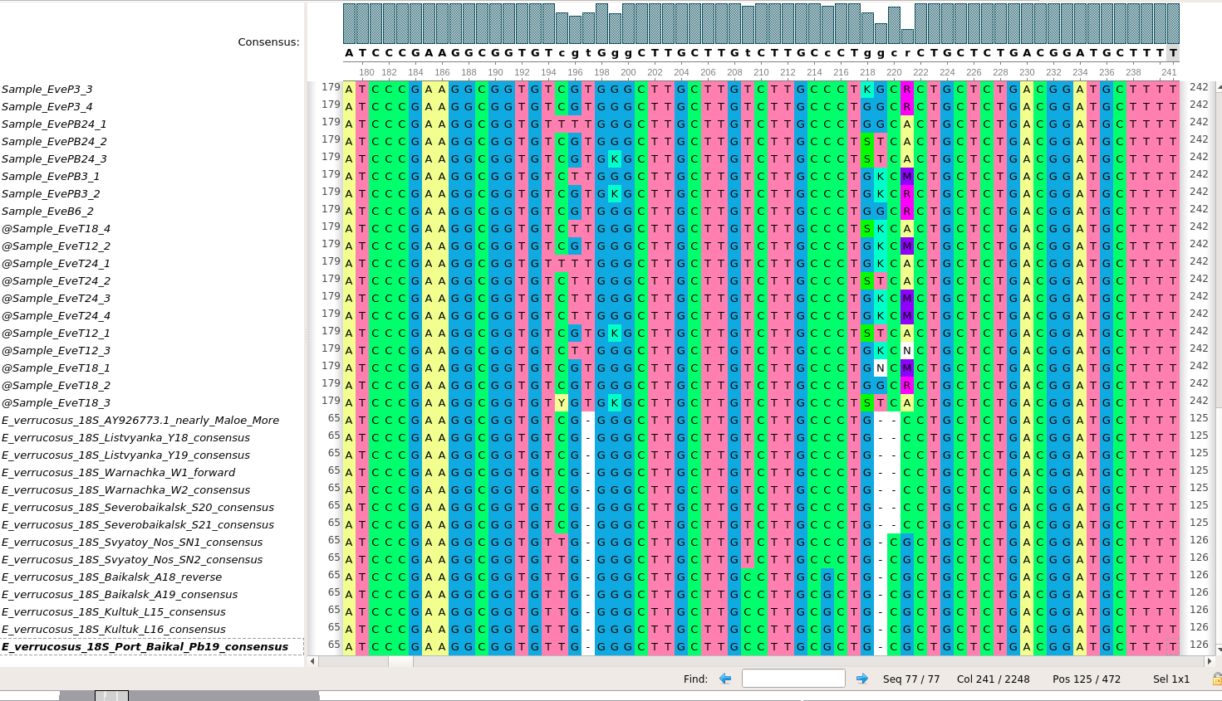
This picture showed that the variation sites could be caused by the two deletions in Eulimnogammarus verrucosus.
Gammarus pulex lacks one of the insertions and alinging to Gammarus pulex reference shows no variation at this site.
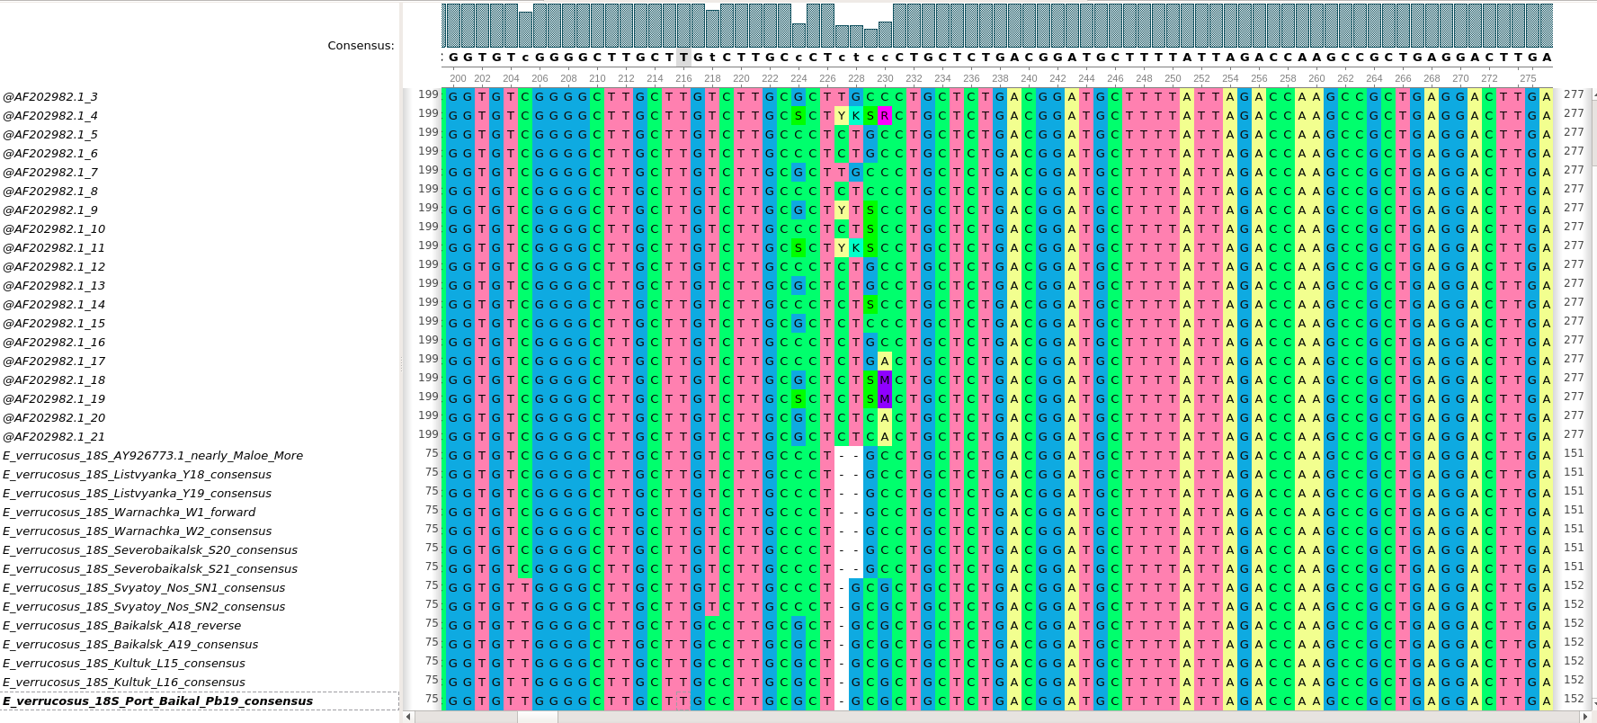
So, a hybride reference was made using Parapallasea lagowski sequence and Eulimnogammarus verrucosus marker sequence.
Variation of 205-231 sites disappeared.

Nexus were built with SplitsTree4 default parameters and phangorn using the same code.

