Data
Protonemata: oldprot — 30.05.19
newprot — 22.01.20

Gametophores: oldgam — 26.06.19
newgam — 15.01.20
newgam0220 — 19.02.20

Sequencing quality control
MinionQC.R was used

Rscript MinIONQC.R -i path/to/sequencing_summary.txt -o name/of/experiment
The reports can be found in qc_reports.

Basecalling
guppy v.3.4.5 was used. For experiments newgam0220, newgam, newprot — real-time basecalling while sequencing.

Oldprot, oldgam were re-basecalled

C:\Program Files\OxfordNanopore\ont-guppy-cpu\bin\guppy_basecaller.exe --input_path fast5_pass --num_callers 16 --save_path g33 --flowcell FLO-MIN106 --kit SQK-RNA002
Alignment and consensus
Pipeline fqtocons.sh or later fqtobed.sh with different modifications was used for the alignment.
Reference fasta (~/minimap2/Ppatens_318_v3.fa) or the same fasta with control sequence added (/media/ilia/anna/nanomoss.fasta) were used.
Secondary alignments could be saved or discarded.

For visualisation all protonemata and all gametophore bams were merged into two files:
samtools merge -@ 10 gams.bam new_gam0220_sorted.bam new_gam_sorted.bam oldgam2_pass_fastq_sorted.bam

For getting number of read per chromosome:
samtools idxstats gams_filt2_sort.bam > gf2_sorted.txt
samtools idxstats protonemata_filt2_sorted.bam > pf2_sorted.txt

Analysis of unmapped reads
Isolating the unmapped reads
samtools view -f 4 ~/anna/g33_sorted.bam > unmapped_gamold.sam

samtools view -Sb unmapped_gamold.sam > unmapped_gamold.bam
bamToFastq -i unmapped_gamold.bam -fq unmapped_gamold.fastq
~/minimap2/minimap2 -ax splice -uf -k14 -G10k -t 10 /media/ilia/anna/eno2.fasta unmapped_gamold.fastq > unmapped_gmold_c.sam # control sequence

samtools view -f 4 unmapped_gamold_c.sam > unmapped_gamold_c.sam
samtools view -Sb unmapped_gamold_c.sam > unmapped_gamold_c.bam
bamToFastq -i unmapped_gamold_c.bam -fq unmapped_gamold_c.fastq

Many of unmapped reads are found in the same reference by BLAST.
Blast search of unmapped sequences
makeblastdb -in ~/minimap2/Ppatens_318_v3.fa -parse_seqids -title "Ppg" -dbtype nucl

cat ~/anna/unmapped_oldprot_cut.fasta | blastn -db ~/minimap2/Ppatens_318_v3.fa -outfmt 6 -out ~/anna/oldprot_again

200-500 reads per experiment are aligned to chloroplast and mitochondria sequence.

Nucleotide modifications
A search for methylation sites was conducted using Nanocompore — pipelines metprep.sh, then:

nanocompore sampcomp --file_list1 /media/ilia/anna/new_gam0220/out_eventalign_collapse.tsv,/media/ilia/anna/new_gam/out_eventalign_collapse.tsv,/media/ilia/anna/old_gam/out_eventalign_collapse.tsv --file_list2 /media/ilia/anna/old_prot/out_eventalign_collapse.tsv,/media/ilia/anna/new_prot/out_eventalign_collapse.tsv --label1 G --label2 P --overwrite --fasta /media/ilia/anna/transcriptome_dupl.fa --outpath /media/ilia/anna/methilation_full_new &

and met.py.
We used two transcriptomes — transcriptome from Phytozome and trascriptome produced from annotation:
bedtools getfasta -bed ~/anna/Ppatens_318_v3.3.gene.gff3 -fi ~/minimap2/Ppatens_318_v3.fa -s -fo /media/ilia/anna/transcriptome.fa
For removing duplicates from the fasta file script from https://github.com/yodeng/Remove-duplicate-fasta was used.

The consensus of the k-mers was made with https://weblogo.berkeley.edu/logo.cgi.

Differential expression
Annotation was turned to .saf format using bedtosaf.R. Then featureCounts:

./featureCounts -a /media/ilia/anna/annot.saf -s 1 -F SAF -L -O -o /media/ilia/anna/fc_old_prot ~/anna/protn1219_sorted.bam
-s 2 option was also used to get _rev reads

Only genes can be extracted from the annotation using

grep ^ID=Pp /media/ilia/anna/fc_old_prot | perl -pe 's|;+.*?\t|\t|' > genes

For visualisation DeSeq2 was used. Script dif_exp.R.

Produced heatmap of 50 most differentially expressed genes with annotation from PhytoMine (https://phytozome.jgi.doe.gov/phytomine/begin.do):
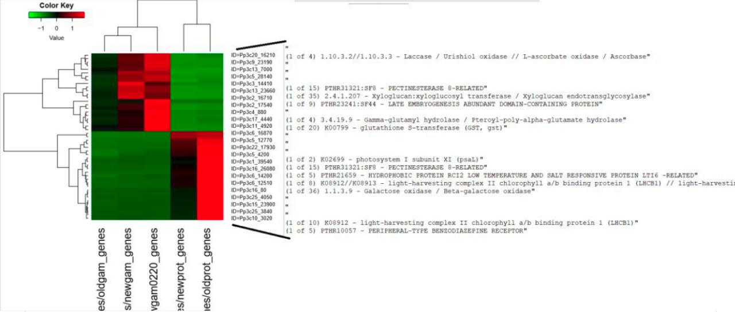
Lists of differently expressed genes were taken in python as full[(full.padj < 0.05) & (full.log2FoldChange > 0)] and full[(full.padj < 0.05) & (full.log2FoldChange < 0)]. Constantly expressed genes: full[(full.padj >= 0.05) & (full.baseMean > 32)].
To get GO terms adapted python2 script from phytozome was used: go_search.py.
The most presented GO terms can be seen with python:
genes = pd.read_csv('diff_exp_gams.tsv', sep='\t', header=None)
counts = genes.iloc[:, 4].groupby(genes.iloc[:,5]).count()
counts.sort_values()

PolyA tails

Recommended Nanopolish pipeline was used. Example of the commands:
cat ~/anna/oldgam2_pass_fastq/pass/*fastq > /media/ilia/anna/old_gam.fastq

./nanopolish index -d /media/ilia/fast5/g1_pass -d /media/ilia/fast5/g1_fail /media/ilia/anna/old_gam.fastq &

./nanopolish polya --threads=8 --reads=/media/ilia/anna/old_gam.fastq --bam=/home/andrey/anna/oldgam2_pass_fastq_sorted.bam --genome=/home/andrey/minimap2/Ppatens_318_v3.fa > polya_results_old_gam.tsv &

grep PASS polya_results_old_gam.tsv > polya_results_old_gam_pass.tsv

Further processing was conducted in python and can be found in polya.ipynb.

LncRNAs

The pipeline of lncRNA expression proving is in lncRNAs.ipynb.

