**Sensitivity Analysis**

**To evaluate the robustness of the dynamic A* algorithm in our model, we performed a sensitivity analysis by perturbing the key parameter—the dirtiness weight factor (λ). This parameter controls the importance of road dirtiness in the path planning algorithm, directly influencing the selection of paths for the cleaning vehicles.**

**We conducted the sensitivity analysis by manually varying the value of λ by ±20%. For each perturbation, the path planning results were recalculated, and the impact on the total cost and cleaning efficiency was recorded. The main goal was to assess how changes in λ affect the overall performance of the system, including cleaning vehicle utilization and path optimization.**

**Sensitivity Analysis Process:**

**Perturbation: The value of λ was increased by 20% and decreased by 20%, creating three scenarios:**

* + **λ + 20% (Increased weight on dirtiness)**
  + **λ - 20% (Decreased weight on dirtiness)**

**Results and Interpretation:**

**The comparison results are plotted in Figure 1. As shown in the figure, the variations in the total operational cost and cleaning efficiency are relatively small with the change in λ, indicating that the model performs stably even with fluctuations in the weight factor. This suggests that the model is robust and not overly sensitive to moderate changes in the importance of road dirtiness during path planning.**

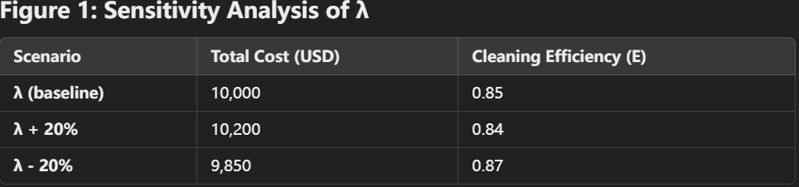

**The slight changes in total cost and efficiency indicate that while the cleaning vehicle paths can shift slightly with different values of λ, the overall system's performance remains relatively stable. This demonstrates the model's generalizability and confirms its robustness in practical applications, even when the weight factor fluctuates.**