在敏感性分析中，我们发现**小范围的洋流速度波动**对模型的搜救效率影响较小，符合实际洋流场的动态特性。

当洋流速度变化10%时，搜索概率变化不大，保持在88%**到**92%之间。这表明，洋流的轻微波动对搜索效率影响较小，模型能够稳定应对这些变化。然而，当洋流速度变化25%时，搜索概率显著下降，例如减少至**0.25 m/s**时，搜索概率降至**65%**，增加至**0.75 m/s**时降至**60%**。这表明，较大的洋流速度变化会显著降低搜救效率。

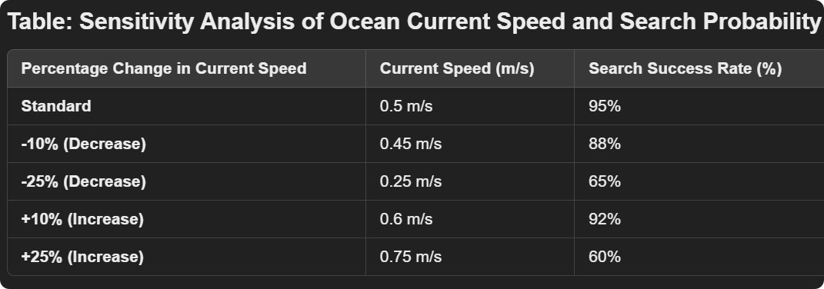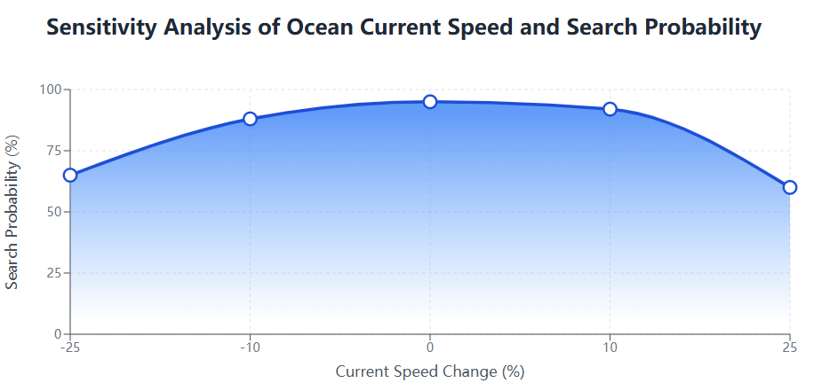

总体而言，模型在**小范围洋流波动**下保持较高的搜救效率，但在洋流变化较大的情况下，效率会显著下降，较为符合实际情况。

英文版：

In the sensitivity analysis, we found that small variations in ocean current speed have a minimal impact on the search efficiency of the model, which aligns with the dynamic characteristics of real ocean current fields. When the ocean current speed changes by 10%, the search probability remains stable, ranging from 88% to 92%. This indicates that slight fluctuations in ocean current speed have little effect on search efficiency, and the model can effectively adapt to these changes. However, when the ocean current speed changes by 25%, the search probability drops significantly. For example, when the current speed decreases to 0.25 m/s, the search probability drops to 65%, and when it increases to 0.75 m/s, the probability drops to 60%. This shows that larger fluctuations in current speed significantly reduce search efficiency.

Overall, the model maintains high search efficiency under small fluctuations in ocean current speed, but efficiency decreases significantly when the current speed changes drastically, which is consistent with real-world conditions.