Find an inverse problem in a publication in the field of environmental physics

Stohl, A., Seibert, P., Arduini, J., Eckhardt, S., Fraser, P., Greally, B. R., Lunder, C., Maione, M., Mühle, J., O’Doherty, S., Prinn, R. G., Reimann, S., Saito, T., Schmidbauer, N., Simmonds, P. G., Vollmer, M. K., Weiss, R. F., and Yokouchi, Y.: **An analytical inversion method 15 for determining regional and global emissions of greenhouse gases: Sensitivity studies and application to halocarbons**, Atmospheric Chemistry and Physics, 9, 1597–1620, doi:10.5194/acp-9-1597-2009, 200

1. Is the data continuous or discrete?

It exploits in situ measurement data from three global networks and builds on backward simulations with a Lagrangian particle dispersion model. The emission information is extracted from the observed concentration increases over a baseline that is itself objectively determined by the inversion algorithm

* Hence discrete; in-situ measurement data must be discrete data points

The HFC and HCFC data used in our inversions come from the three in situ atmospheric measurement networks listed in Table 1: Advanced Global Atmospheric Gases Experiment (AGAGE) (Prinn et al., 2000); System for Observation of Halogenated Greenhouse Gases in Europe (SOGE) (Greally et al., 2007); and Japanese National Institute for Environmental Studies (NIES) (Yokouchi et al., 2006). Each of these networks uses automated low-temperature preconcentration and re-focussing to measure HFCs and HCFCs with an automated gas chromatograph/mass spectrometer (GC/MS). All the modelled data were averaged over 3-hourly intervals and paired with the corresponding 3-hourly model results for the respective measurement station. We use data from January 2005 to March 2007.

* Discrete 3-hour average data points

1. Is the model continuous or discrete?

A special feature of FLEXPART is the possibility to run it backwards in time (Seibert and Frank, 2004). Such backward simulations from the measurement sites were made every 3 h. During every 3-h interval, 40 000 particles were released at the measurement point and followed backward in time for 20 d to calculate an emission sensitivity, called source-receptor-relationship (SRR) by Seibert and Frank (2004). The SRR value (in units of s kg−1 ) in a particular grid cell is proportional to the particle residence time in that cell and measures the simulated mixing ratio at the receptor that a source of unit strength (1 kg s−1 ) in the cell would produce.

* The model is continuous, but data is extracted from it and analysed for 3 hour chunks

1. Is the data noisy

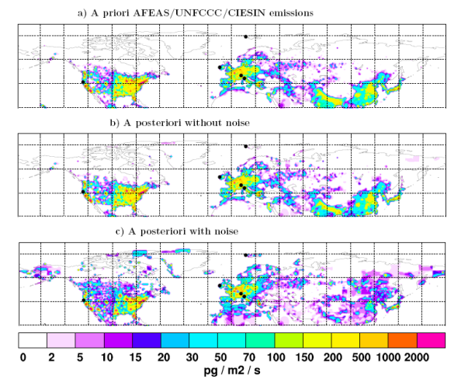

Significant noise, substantial variation between inclusion and no inclusion of noise

1. Is the forward model linear or nonlinear

Ein Bild, das Text enthält.

So the forward model used in this case is linear

Therefore we describe the baseline as a continuous, stepwise linear function with n2 segments of 31 d length.

1. Do the authors discuss whether the solution is existent, unique and/or instable?

Not existent; there is no unique solution that fits every data point.

Uniqueness: seemingly, as a final model is selected?

Instability; error handling comes up repeatedly as a major issue, so somewhat unstable

1. How could the solution be influenced if the data were noisier, sparser or biased?

Ein Bild, das Text enthält.

f error reduction that is achieved in the inversion (Table 2). We see that for the two mountain stations, Jungfraujoch and Monte Cimone, the errors are much larger both before and after the inversion than for other stations. This is quite understandable as in mountain areas, processes that are relevant for transport cannot be resolved well, or not at all, by a global meteorological model such as used at ECMWF (see Seibert and Skomoroski, 2008).

Such kind of transport events would be associated with underprediction by the model, and indeed as seen in Fig. 2 only the left tail is heavy at Jungfraujoch. These errors are “incurable” – the inversion cannot improve the agreement between the observations and the model results substantially. However, as the inversion minimizes quadratic errors, without additional measures taken they could have a disproportionately large influence on the inversion result. As the theoretical approach implies normally distributed errors, the solution obtained is no more the most likely one in a Bayesian sense.

Increased error leads to underprediction of greenhouse gas emissions

In the experiment without superimposed noise, the AFEAS/UNFCCC/CIESIN (AUC) emission field (Fig. 3a) is almost perfectly reconstructed by the inversion (Fig. 3b), with small differences occurring mostly in Asia where there is a poor constraint by the measurements. Consequently, the a posteriori modeled mixing ratios are virtually identical to the pseudo measurements, as shown for Mace Head (Fig. 4a), which features a Pearson correlation coefficient greater than 0.999. This shows that the inversion algorithm has been set up correctly. However, this experiment is not very realistic as the pseudo measurement data were constructed with the same transport model as was used for the inversion

Effect of increased noise is insignificant

In the second experiment we mimicked measurement and model errors by superimposing onto the pseudo measurements normally distributed random noise with stationspecific standard deviation σo (column E b in Table 2). Even for this case, the emission distribution in Europe – the continent best constrained by the measurement data (see Fig. 1) – is very well reconstructed (Fig. 3c) and the total European emission is only overestimated by 8%. Emissions in North America, still reasonably well constrained by the measurements, are also fairly well reproduced with a total overestimate of 17%. However, the emissions in Asia are not well determined, with clearly deficient emission patterns and an overall underestimate of 50% (a result of the regularization constraining the emissions towards zero).

Errors mostly impact predictions in Asia