Software Requirements Specification
for
Automatic management of faculty students - AMFS
Version 1.0 approved
Prepared by
Zane Livia
Simion Ramona
Stefan Ionut Valentin

University of Craiova
Faculty of Automation, Computers and Electronics
27.02.2023
Table of Contents
1. Introduction 1
1.1 Purpose 1
1.2 Document Conventions 1
1.3 Intended Audience and Reading Suggestions 1
1.4 Product Scope 1
1.5 References 1
2. Overall Description 2
2.1 Product Perspective 2
2.2 Product Functions 2
2.3 User Classes and Characteristics 3
2.4 Operating Environment 3
2.5 Design and Implementation Constraints 3
2.6 User Documentation 4
2.7 Assumptions and Dependencies 4
3. External Interface Requirements 4
3.1 User Interfaces 4
3.2 Hardware Interfaces 8
3.3 Software Interfaces 8
3.4 Communications Interfaces 9
4. System Features 9
4.1 Home page 9
4.2 Privacy page 9
4.3 Login 10
4.4 Logout 10
4.5 Add/edit/delete students 11
4.6 Add/edit/delete teachers 12
4.7 Add/edit/delete curricula 13
4.8 Add/edit/delete schedules 14
4.9 Add/edit/delete exams 15
4.10 Teacher’s catalog 17
4.11 Student’s request 17
5. Other Nonfunctional Requirements 18
5.1 Performance Requirements 18
5.2 Safety Requirements 18
5.3 Security Requirements 19
5.4 Software Quality Attributes 19
5.5 Business Rules 19
6. Other Requirements 20

Revision History
Name | Date | Reason For Changes | Version
Zane Livia | 09.03.2023 | Update introduction, overall description, external interfaces requirements, other nonfunctional requirements, other requirements, and system features 4.1 – 4.5 | 1.0
Simion Ramona | 14.03.2023 | Added system features: 4.6 – 4.8 | 1.1
Stefan Ionut Valentin | 19.03.2023 | Added system features: 4.9 – 4.11 | 1.2

Introduction

Purpose
This informatic system is designed to keep automatic management of the faculty’s students, their grades given by the teachers in exams, curricula, and exam planning.

Document Conventions
This document has the following format: 1-inch margins, 1 line spacing, size 11 Arial font italic. Important specification and titles are in bold format.
Abbreviations:
AMFS - Automatic Management of Faculty’s Students
SRS - Software Requirement Specification
DB - Database
HTML - Hypertext Markup Language
CSS - Cascading Style Sheets
IIS - Internet Information Service

Intended Audience and Reading Suggestions
This document is intended for the client, developers (which are testers also), and users (teachers, students, and secretaries). The rest of this SRS contains, in this order, the following sections:
- Overall description of the product (product perspectives and functions, users’ type, etc.)
- External interface requirements (user/software/hardware/communications interfaces)
- System features (including functional requirements)
- Other nonfunctional requirements
- Other requirements.
Our suggestion for audience is to read all the sections.

Product Scope
The scope of this informatic system is to automate the evidence of the students of the faculty, their grades given by the teachers in exams, curricula, and exam planning, having the following specific actions: add/edit/delete curricula/exam schedules/student grades, saves/retrieves information in/from database, data management, generating reports - through a web portal.
Main benefits of the project are increasing the information level of the students, avoiding the use of paper, an easier way for the teachers to grade the students, better evidence of the grades, which allow generating reports.

References
Support links:
- Curricula - http://www.ace.ucv.ro/invatamant/didactica/planuri.php
- Schedules - http://www.ace.ucv.ro/invatamant/utile/orar.php
- Evaluation methods - http://www.ace.ucv.ro/invatamant/calitate/evaluare.php
Useful links:
- https://learn.microsoft.com/en-us/aspnet/mvc
- https://www.w3schools.com/html/default.asp
- https://www.w3schools.com/css/default.asp
- https://www.tutorialspoint.com/javascript/index.htm
- https://www.sqlservertutorial.net/

Books:
- Ricardo Peres: Modern Web Development with ASP.NET Core 3. Packt, 2020.
- Michael Morrison: Head First JavaScript, O'Reilly Media, 2008
- Rob Larsen: Beginning HTML and CSS, Wrox, 2013

Overall Description

Product Perspective
This project will change the way that information about students, teachers, and curricula are now a days maintained in physical format, in an automated system through a web portal. The portal is a new, self-contained product.
A simple diagram that shows the major components of the overall system:
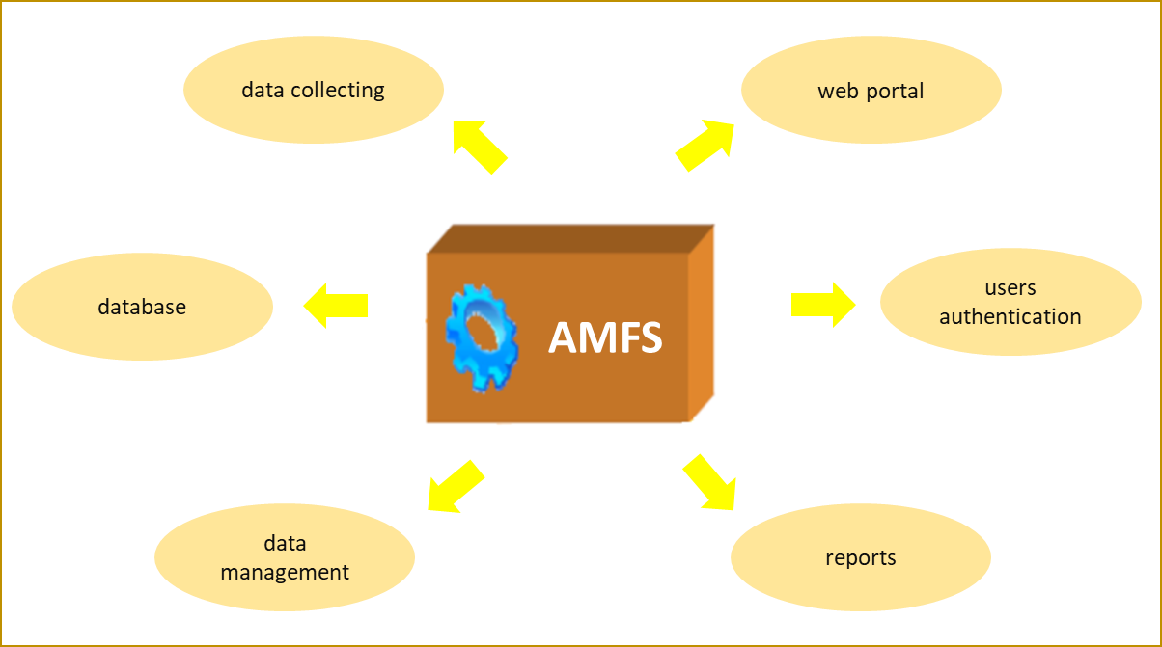

Product Functions
Major functions that the product must perform:
- User registration/authentication
- Adding/modify/removing secretaries (by Administrator user - just one this type account)
- Adding/modify/removing teachers (by secretary users)
- Adding/modify/removing students (by secretary users)
- Adding/modify/removing curricula (by secretary users)
- Adding/modify/removing schedules (by secretary users)
- Adding/modify/removing exams (by secretary users)
- Adding/modify/removing grades (by teacher users, just for their assigned catalog)
- Generating the reports regarding students, scholarships, catalog, personal data about students etc.

User Classes and Characteristics
The application will be accessed just by the authenticated users, which are:
- secretary user - grants to add/edit/delete students//exam schedules/curricula/catalog - view details about students but has no right to modify grades; one secretary will have a role of Administrator, with separate user and password, just to create new secretary users and save/restore the database.
- teacher user - view his catalogs, grading students - view all the public information on the site (curricula, schedules and exams planification);
- student user - view personal information, his grades, exams planification, schedules, curricula, but cannot make any changes.
In the implementing time of the application, the developers will access the system, but just on the test environment.

Operating Environment
The minimum characteristics of the server computer system on which the application will be installed are:
- Processor: 3.6 GHz or faster
- Memory: at least 32 GB
- Hard disk space: minimum 2 GB.
The application will be installed on Windows (version 10 minimum) operating system, with Internet Information Service (minimum IIS 10.0 version 1809) and Microsoft SQL Server (version 2019 minimum). The portal should be accessed, by the users, from Google Chrome (version 110.0.5481 or above), Microsoft Edge (110.0.1587.57 or above), Mozilla Firefox (version 110.0 or above), or Opera (version 95.0.4635.25 or above) web browsers.

Design and Implementation Constraints
The integrated development environment, frameworks and the technologies used to create this project are the following:
- Visual Studio IDE 2022 Community Edition with ASP.NET 6.0 and C# programming language version 11
- HTML version 5
- CSS version 3
- SQL Server 2019.
The application server should have access to Internet and the customer’s organization will be responsible for software licenses and maintaining the delivered application.

User Documentation
This document is the only user documentation that will be delivered along with the software application.

Assumptions and Dependencies
Not applicable.

External Interface Requirements

User Interfaces
First page displayed when the application is accessed:
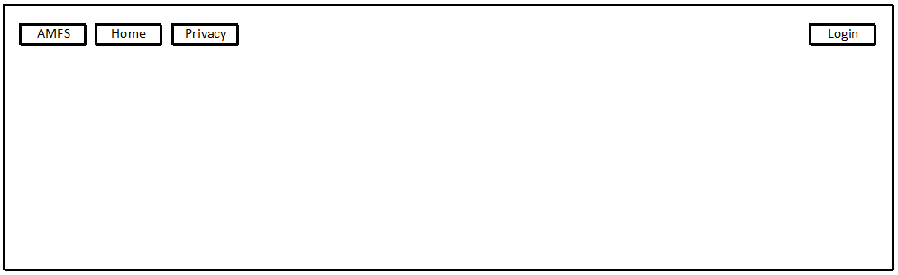

Next step, the user must enter his username (institutional email) and password that he received from the administrator (for secretary) or from the secretary (teachers and students).

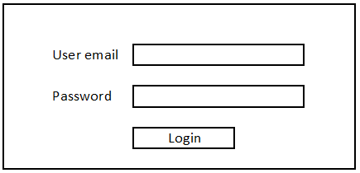

If the credentials are incorrect, the application will display an error message and will ask again the username and password.

3.1.1 – Administrator user graphic interface

If the credentials are correct filled in, and the user is Administrator, the application allows to create a new secretary user or save/restore the database, displaying the next screen:

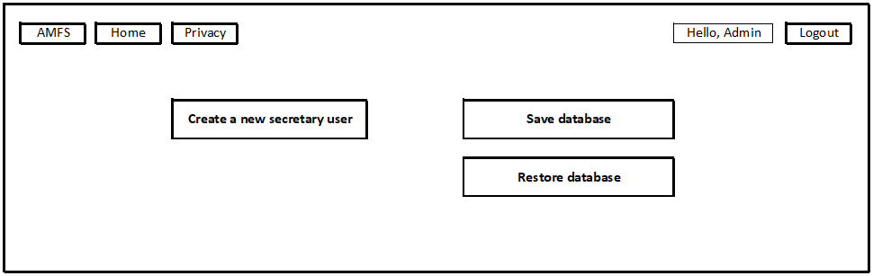

3.1.2 – Secretary user graphic interfaces

If the credentials are correct filled in, and the user has a secretary role, the application allows to create/edit/delete information regarding curricula, schedules, exams planification, teacher and students, displaying the next screen:

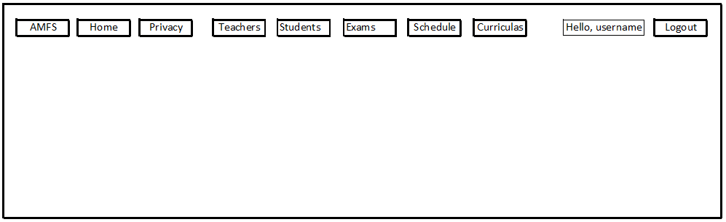

If [Student] button is pressed, will be displayed the next screen:
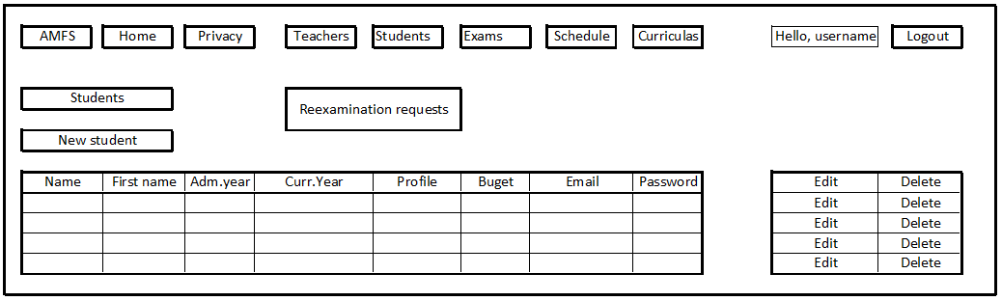

If secretary choose to press [Reexamination request] button, the next screen will be displayed, which allow to approve a reexamination request and the student is automatically included in the catalog for specified teacher, subject, date, hour.

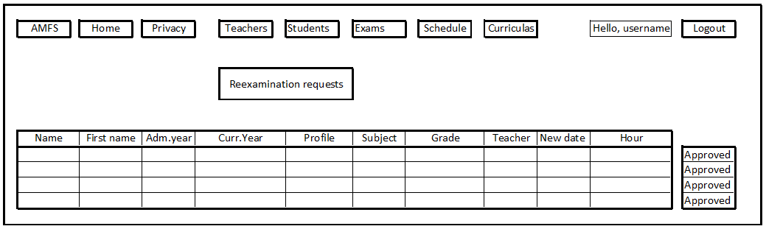

If [Teachers] button is pressed, will be displayed the next screen:

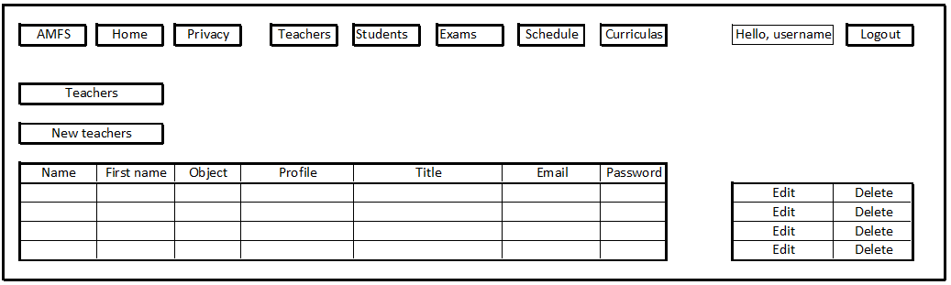

If [Exams] button is pressed, will be displayed the next screen:
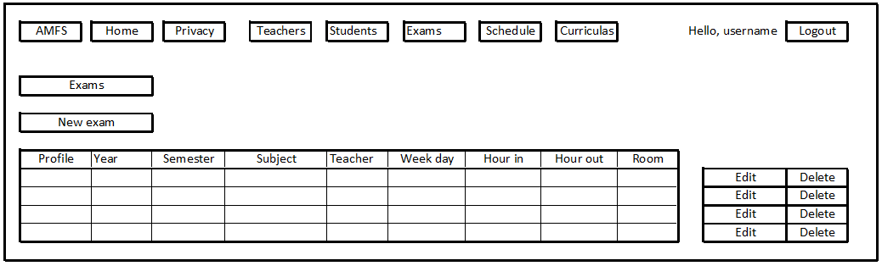

If [Schedules] button is pressed, will be displayed the next screen:

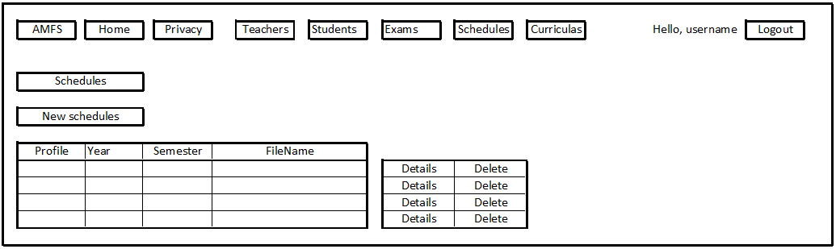

If [Curricula] button is pressed, will be displayed the next screen:

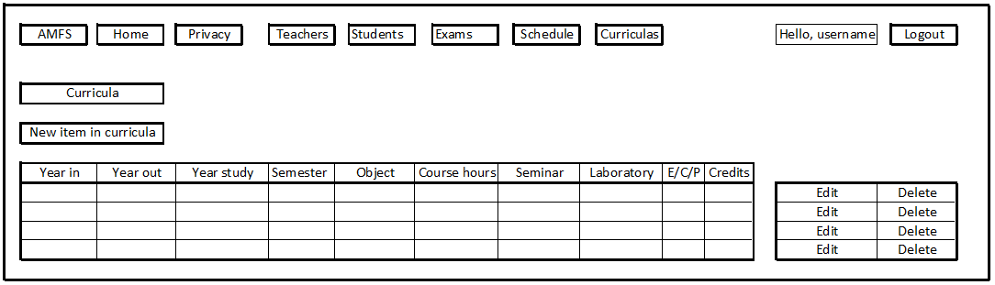

3.1.3 – Teacher user graphic interfaces

If the credentials are correct filled in, and the user has a teacher role, the application allows to display information regarding curricula, schedules, exams planification, and catalogs, displaying the next screen:

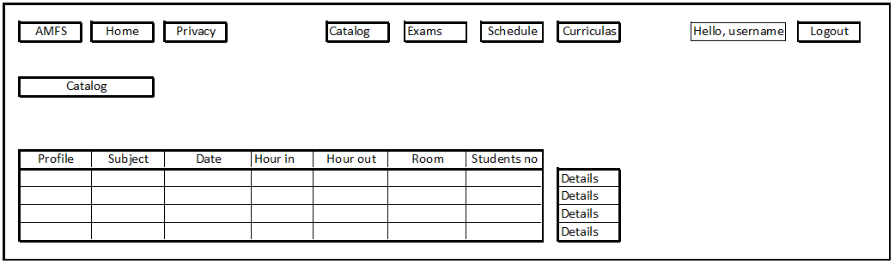
If teacher choose to press the [Details] button, will be displayed the next screen, which allow to grade each student, pressing [Edit grade] button:
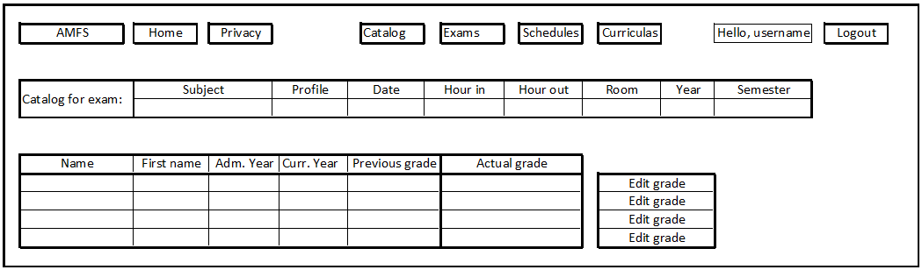

3.1.4 – Student user graphic interfaces

If the credentials are correct, and the user has a student role, the application allows to display information regarding curricula, schedules, exams planification, and grades, displaying the next screen:

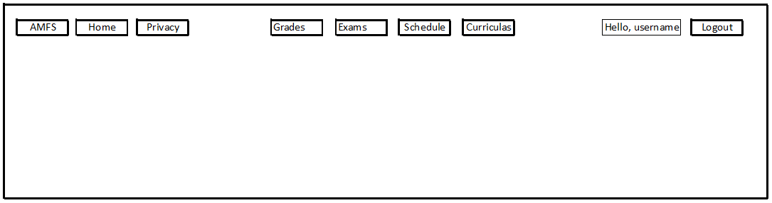

If student choose to press the [Grades] button, will be displayed the next screen, which allow the user to ask for a reexamination:

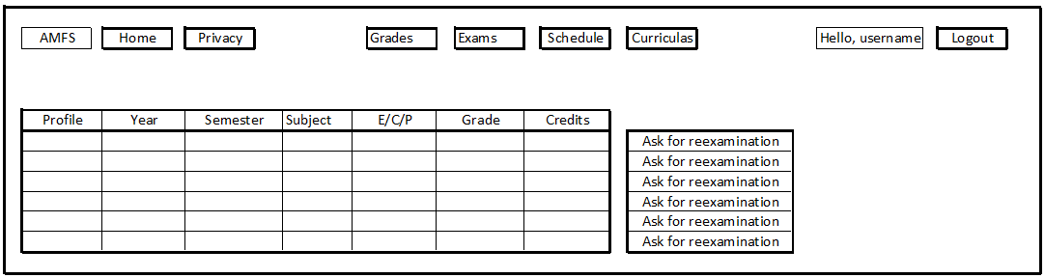

Hardware Interfaces
Not applicable.

Software Interfaces
Prototype read/write database functions.

Communications Interfaces
For communication, the application uses the HTTP protocol between web server (IIS) and users (web browsers). To provide a better communications security over Internet is used Transport Layer Security (TLS – former SSL) protocol.

System Features

The functional requirements for the application are described in this section as use cases pattern.

Home page
Home page is the first graphic interface displayed to the user when application is accessed.
4.1.1 Description and Priority
The home page will have three buttons (Home, Privacy and Login) within a nave-bar which will be available in all other pages, to redirect the user to desired feature.
Priority: High

4.1.2 Stimulus/Response Sequences
Input: On the home page, the user should press the button (Home, Privacy or Login) corresponding with desired feature.
Output: Selecting the respective button will redirect the user to the page of chosen feature.

4.1.3 Functional Requirements
REQ-1: The home page will have a nave-bar menu with buttons for Home, Privacy, and Login features, which redirect the user to chosen page (home.html, privacy.html and login.html).
REQ-2: The home page will have a background image and, in a footer, the contact details of the faculty.

Privacy page
4.2.1 Description and Priority
The privacy page will display information about the measures implemented in the application regarding the privacy of personal data.
Priority: Low
4.2.1 Stimulus/Response Sequences
Input: Pressing the Privacy button from nave-bar within any page.
Output: The Privacy page will display information about the measures implemented in the application regarding the privacy of personal data.

4.2.3 Functional Requirements
REQ-3: Access the Privacy page from the nave-bar within any page of the application.
REQ-4: Privacy page will display information about the measures implemented in the application regarding the privacy of personal data.
.

Login
4.3.1 Description and Priority
The visitor will be able to log in to the application using his username (institutional email address) and password provided by the secretariat of the faculty.
Priority: High

4.3.2 Stimulus/Response Sequences
Input: On the login page, the user should fill in the text field corresponding username (email address) and password, and then press the button “Login”.
Output: For correct credentials the application will redirect to Home page, then show and make available all feature buttons in nave-bar, corresponding to the user role. For wrong credentials will be displayed an error message and ask again the username and password.

4.3.3 Functional Requirements
REQ-5: The login page will have two text fields for username and password, and a button “Login” to commit the data imputed.
REQ-6 Commit button will query the table for users within the database and will verify if the credentials (username and password) exist or not in the table.
REQ-7: For correct credentials, corresponding to the user type, store the user information into session variables, redirect to the Home page, then change [Login] button into [Logout] button and make available all feature buttons in nave-bar.
REQ-8: For wrong credentials will be displayed an error message and asking again the username and password.

Logout

4.4.1 Description and Priority
The user should log out at any time, by clicking on the [Log out] button.
Priority: Medium
4.4.2 Stimulus/Response Sequences
Input: On each page should exist the [Logout] button, which log off the user.
Output: Pressing the [Logout] button the user will be redirect to the home page.
4.4.3 Functional Requirements
REQ-9: Should be a [Logout] button in nave-bar on each page, to be pressed by the users when they want to log out.
REQ-10: After pressing the button will be deleted all the variables which store the user credentials, and redirect to the home page.

Add/edit/delete students

4.5.1 Description and Priority
If the secretary presses the button [Student], a new page will open, which display in a table the information about the students. It is possible to edit the information about each student and delete records with students. Also, it is possible to add new student and fill in the requested information about the student, then press the [Save] button.
Priority: High
4.5.2 Stimulus/Response Sequences
Input1: Should be a [New student] button on the page Students for Secretary’s role, which allows adding the information about new students.
Output1: A page for fill in the information about the new student will appear.
Input2: In the New student page, the secretary will fill in the personal data about the new student (first name, last name, admission year, profile, budget/taxes) and, to save the data, should press [Save] button.
Output2: The data will be inserted into the database through a query, and then it will be redirect back to the page Student. In the table will be displayed all the students, including the new one.
Input3: In the Students page should be an [Edit] button, which allows modifying the information about each student/row in the table.
Output3: Open a new page for edit the information about the students.
Input4: In the Student Edit page will be displayed the information regarding the selected student.
Output4: After the secretary will modified the information, should press the [Save] button to save the information in database.
Input5: In page Student should be a [Delete] button to allow deleting a student.
Output5: A message with Success deleted will be displayed and the secretary will remain on Student page.
Input6: In page Student should be a [Approve student requests] button to allow granting the students to perform again an exam. The secretary should verify if the request is legal (reexam to increase the grade asked by an integral student, the reexam tax was paid, etc.) and every things are alright should press the [Approved] button.
Output6: The approved student will be inserted in the catalog for requested exam.

4.5.3 Functional Requirements
REQ-11: On the page Student, for the secretary role, will be a table that will be filled in automatically with information gathered from the student table within database through a query request.
-If the secretary presses the [New student] button:
REQ-12: On the page Student will be a [New student] button, which will redirect the secretary to the page (New student page) which allows implementing the information about the new student.
REQ-13: In the New student page will be some text boxes in which the secretary will insert the name, surname, admission year, section, budget, or taxes. Also, will be a [Save] button which send the data into database. After the [Save] button is pressed, the secretary will be redirect back on the page Student where the table will display the information about the students, including the new one.
-If the secretary presses the [Edit] button:
REQ-14: On the page Student will be one [Edit] button for each student in each row of the table, which will redirect the secretary to the page (Edit Student page) which allows modifying the information about the selected student.
REQ-15: In the Edit Student page will be some text boxes automatically filled in with information about the selected student from previous page, and allow the secretary to modify the name, surname, admission year, section, budget, or taxes. Also, will be a [Save] button which update the information into database. After the [Save] button is pressed, the secretary will be redirect back on the page Student where the table will display the information about the students, including the modified ones.
-If the secretary presses the [Delete] button:
REQ-16: On the page Student will be one [Delete] button for each student/row of the table, which will allow the secretary to delete the selected student.
REQ-17: After the [Delete] button is pressed, the information about selected student will be deleted from database, will be displayed a message to confirm the process and the secretary will be redirect back on the page Student where the table will display the information about the students again (without the information about the deleted student).
-If the secretary presses the [Approve student requests] button:
REQ-18: On the page Student will be one [Approve student requests] button, which will display in a table, the students which ask for reexamination. The information will be gathered from requests table within database.
REQ-19: For each student/row of the table will be a [Approved] button. If this button is pressed, the selected student will be adding in the table catalog for exam asked.

Add/edit/delete teachers
4.6.1 Description and Priority
If the secretary presses the button [Teachers], a new page will open, which display in a table the information about the teachers. It is possible to edit the information about each teacher and delete records with teachers. Also, it is possible to add new teacher and fill in the requested information about the teacher, then press the [Save] button.
Priority: High
4.6.2 Stimulus/Response Sequences
Input1: Should be a [New teacher] button on the page Teachers for Secretary’s role, which allows adding the information about new teachers.
Output1: A page for fill in the information about the new teacher will appear.
Input2: In the New teacher page, the secretary will fill in the personal data about the new teacher (first name, last name, title, profile, subject, email, password) and, to save the data, should press [Save] button.
Output2: The data will be inserted into the database through a query, and then it will be redirect back to the page Teachers.
Input3: Should be an [Edit] button in the page Teacher, which allows modifying the information about each teacher/row in the table.
Output3: Open a new page for edit the information about the teacher.
Input4: In the Teacher Edit page will be displayed the information regarding the selected teacher.
Output4: After the secretary will modified the information, should press the [Save] button to save the information in database.
Input5: In page Teacher should be a [Delete] button to allows the secretary to delete a teacher.
Output5: A message with Success deleted will be displayed and the secretary will remain on Teachers page.

4.6.3 Functional Requirements
REQ-20: On the page Teachers, for the secretary role, will be a table that will be filled in automatically with information gathered from the teacher table within database through a query request.
-If the secretary presses the [New teacher] button:
REQ-21: On the page Teachers will be a [New teacher] button, which will redirect the secretary to the page (New teacher page) which allows implementing the information about the new teacher.
REQ-22: In the New teacher page will be some text boxes in which the secretary will insert the name, surname, title, profile, subject, email and password. Also, will be a [Save] button which send the data into database. After the [Save] button is pressed, the secretary will be redirect back on the page Teachers where the table will display the information about all the teachers, including the new one.
-If the secretary presses the [Edit] button:
REQ-23: On the page Teachers will be one [Edit] button for each teacher in each row of the table, which will redirect the secretary to the page (Edit teacher page) which allows modifying the information about the selected teacher.
REQ-24: In the Edit teacher page will be some text boxes automatically filled in with information about the selected teacher from previous page, and allow the secretary to modify the name, surname, title, profile, subject, email and password. Also, will be a [Save] button which update the information into database. After the [Save] button is pressed, the secretary will be redirect back on the page Teachers where the table will display the information about all the teachers, including the modified one.
-If the secretary presses the [Delete] button:
REQ-25: On the page Teachers will be one [Delete] button for each teacher/row of the table, which will allow the secretary to delete the selected teacher.
REQ-26: After the [Delete] button is pressed, the information about selected teacher will be deleted from database, will be displayed a message to confirm the process and the secretary remain on the page Teacher where the table will display the information about the teachers again (without the information about the deleted teacher).

Add/edit/delete curricula
4.7.1 Description and Priority
If the secretary presses the button [Curricula], a new page will open, which display in a table the information about the curricula. It is possible to edit the information about each curriculum and delete records with curricula. Also, it is possible to add new curricula and fill in the requested information about the curricula, then press the [Save] button.
Priority: High
4.7.2 Stimulus/Response Sequences
Input1: Should be a [New curricula] button on the page Curricula for secretary’s role, which allows adding the information about new curricula.
Output1: A page for fill in the information about the new curricula will appear.
Input2: In the New curricula page, the secretary will fill in the information about the new curricula (profile, yearIn, yearOut, yearStudy, semester, subject, courseHour, seminarHour, laboratoryHour, e-c-p, creditsNumber) and, to save the data, should press [Save] button.
Output2: The data will be inserted into the database through a query, and then it will be redirect back to the page Curricula.
Input3: Should be an [Edit] button in the page Curricula, which allows modifying the information about each curricula/row in the table.
Output3: Open a new page for edit the information about the curricula.
Input4: In the Curricula Edit page will be displayed the information regarding the selected curricula.
Output4: After the secretary will modified the information, should press the [Save] button to save the information in database.
Input5: In page Curricula should be a [Delete] button to allow the secretary to delete a curriculum.
Output5: A message with Success deleted will be displayed and the secretary will remain on Curricula page.

4.7.3 Functional Requirements
REQ-27: On the page Curricula, for the secretary role, will be a table that will be filled in automatically with information gathered from the curricula table within database through a query request.
-If the secretary presses the [New curricula] button:
REQ-28: On the page Curricula will be a [New curricula] button, which will redirect the secretary to the page (New curricula page) which allows implementing the information about the new curricula.
REQ-29: In the New curricula page will be some text boxes in which the secretary will insert the profile, yearIn, yearOut, yearStudy, semester, subject, courseHour, seminarHour, laboratoryHour, e-c-p, credits. Also, will be a [Save] button which send the data into database. After the [Save] button is pressed, the secretary will be redirect back on the page Curricula where the table will display the information about all the Curricula, including the new one.
-If the secretary presses the [Edit] button:
REQ-30: On the page Curricula will be one [Edit] button for each curriculum in each row of the table, which will redirect the secretary to the page (Edit curricula page) which allows modifying the information about the selected curriculum.
REQ-31: In the Edit curricula page will be some text boxes automatically filled in with information about the selected curricula from previous page, and allow the secretary to modify the profile, yearIn, yearOut, yearStudy, semester, subject, courseHour, seminarHour, laboratoryHour, e-c-p, credits. Also, will be a [Save] button which update the information into database. After the [Save] button is pressed, the secretary will be redirect back on the page Curricula where the table will display the information about all the curricula, including the modified one.
-If the secretary presses the [Delete] button:
REQ-32: On the page Curricula will be one [Delete] button for each curriculum/row of the table, which will allow the secretary to delete the selected curriculum.
REQ-33: After the [Delete] button is pressed, the information about selected curriculum will be deleted from database, will be displayed a message to confirm the process and the secretary remain on the page Curricula where the table will display the information about the curricula again (without the information about the deleted curriculum).

Add/edit/delete schedules
4.8.1 Description and Priority
If the secretary presses the button [Schedules], a new page will open, which display in a table the information about the schedules. It is possible to edit the information about each schedule and delete records with schedule. Also, it is possible to add new schedule and fill in the requested information about the schedule, then press the [Save] button.
Priority: Medium
4.8.2 Stimulus/Response Sequences
Input1: Should be a [New schedule] button on the page Schedules for secretary’s role, which allows adding the information about new schedule.
Output1: A page for fill in the information about the new schedule will appear.
Input2: In the New schedule page, the secretary will fill in the information about the new schedule (profile, yearStudy, semester, fileName) and, to save the data, should press [Save] button. The file (fileName) with schedule can be pdf, jpg or png type.
Output2: The data will be inserted into the database through a query, and then it will be redirect back to the page Schedules.
Input3: Should be an [Edit] button in the page Schedules, which allows modifying the information about each schedule/row in the table.
Output3: Open a new page for edit the information about the schedule.
Input4: In the Schedule Edit page will be displayed the information regarding the selected schedule.
Output4: After the secretary will modified the information, should press the [Save] button to save the information in database.
Input5: In page Schedules should be a [Delete] button to allow the secretary to delete a schedule.
Output5: A message with Success deleted will be displayed and the secretary will remain on Schedules page.

4.8.3 Functional Requirements
REQ-34: On the page Schedules, for the secretary role, will be a table that will be filled in automatically with information gathered from the schedule table within database through a query request.
-If the secretary presses the [New schedule] button:
REQ-35: On the page Schedules will be a [New schedule] button, which will redirect the secretary to the page (New schedule page) which allows implementing the information about the new schedule (profile, yearStudy, semester, fileName).
REQ-36: In the New schedule page will be some text boxes in which the secretary will insert the profile, yearStudy, semester, fileName. The file (fileName) with schedule can be pdf, jpg or png type. Also, will be a [Save] button which send the data into database. After the [Save] button is pressed, the secretary will be redirect back on the page Schedules where the table will display the information about all the Schedules, including the new one.
-If the secretary presses the [Edit] button:
REQ-37: On the page Schedules will be one [Edit] button for each schedule in each row of the table, which will redirect the secretary to the page (Edit Schedule page) which allows modifying the information about the selected schedule.
REQ-38: In the Edit schedule page will be some text boxes automatically filled in with information about the selected schedule from previous page, and allow the secretary to modify the profile, yearStudy, semester, fileName. Also, will be a [Save] button which update the information into database. After the [Save] button is pressed, the secretary will be redirect back on the page Schedules where the table will display the information about all the Schedules, including the modified one.
-If the secretary presses the [Delete] button:
REQ-39: On the page Schedules will be one [Delete] button for each schedules/row of the table, which will allow the secretary to delete the selected schedule.
REQ-40: After the [Delete] button is pressed, the information about selected schedule will be deleted from database, will be displayed a message to confirm the process and the secretary remain on the page Schedules where the table will display the information about the schedules again (without the information about the deleted schedule).

Add/edit/delete exams
4.9.1 Description and Priority
If the secretary presses the button [Exams], a new page will open, which display in a table the information about the exams. It is possible to edit the information about each exam and delete records with exams. Also, it is possible to add new exams and fill in the requested information about the exam, then press the [Save] button.
Priority: High
4.9.2 Stimulus/Response Sequences
Input1: Should be a [New exam] button on the page Exams for secretary’s role, which allows adding the information about new exam.
Output1: A page for fill in the information about the new exam will appear.
Input2: In the New exam page, the secretary will fill in the information about the new exam (profile, yearStudy, semester, subject, teacher, date, hourIn, hourOut, room) and, to save the data, should press [Save] button.
Output2: The data will be inserted into the database through a query, and then it will be redirect back to the page Exams.
Input3: Should be an [Edit] button in the page Exams, which allows modifying the information about each exam/row in the table.
Output3: Open a new page for edit the information about the exam.
Input4: In the Exam Edit page will be displayed the information regarding the selected exam.
Output4: After the secretary will modified the information, should press the [Save] button to save the information in database.
Input5: In page Exams should be a [Delete] button to allow the secretary to delete a exam.
Output5: A message with Success deleted will be displayed and the secretary will remain on Exams page.

4.9.3 Functional Requirements
REQ-41: On the page Exams, for the secretary role, will be a table that will be filled in automatically with information gathered from the exam table within database through a query request.
-If the secretary presses the [New exam] button:
REQ-42: On the page Exams will be a [New Exam] button, which will redirect the secretary to the page (New exam page) which allows implementing the information about the new exam.
REQ-43: In the New exam page will be some text boxes in which the secretary will insert the profile, yearStudy, semester, subject, teacher, date, hourIn, hourOut, room. Also, will be a [Save] button which send the data into database. After the [Save] button is pressed, the secretary will be redirect back on the page Exams where the table will display the information about all the exams, including the new one.
-If the secretary presses the [Edit] button:
REQ-44: On the page Exams will be one [Edit] button for each exam in each row of the table, which will redirect the secretary to the page (Edit exam page) which allows modifying the information about the selected exam.
REQ-45: In the Edit exam page will be some text boxes automatically filled in with information about the selected exam from previous page, and allow the secretary to modify the profile, yearStudy, semester, subject, teacher, date, hourIn, hourOut, room. Also, will be a [Save] button which update the information into database. After the [Save] button is pressed, the secretary will be redirect back on the page Exams where the table will display the information about all the exams, including the modified one.
-If the secretary presses the [Delete] button:
REQ-46: On the page Exams will be one [Delete] button for each exam/row of the table, which will allow the secretary to delete the selected exam.
REQ-47: After the [Delete] button is pressed, the information about selected exam will be deleted from database, will be displayed a message to confirm the process and the secretary remain on the page Exams where the table will display the information about the exams again (without the information about the deleted exam).

Teacher’s catalog
4.10.1 Description and Priority
This page is available just for teacher’s role. This page display in a table the information about the catalogs of the teacher logged in (profile, subject, date, hourIn, hourOut, room, studentsNumber). It is possible to open each catalog pressing the [Details] button. After selecting a catalog, it is possible to display all the students which belong to that catalog and grade them, pressing the [Edit grade] button.
Priority: High
4.10.2 Stimulus/Response Sequences
Input1: Should be some [Details] buttons in the page Teacher’s catalog, which allows opening the information about each exam/row in the table.
Output1: Open a new page which will display the information regarding all the students within the selected catalog and the teacher has an [Edit grade] button available for each student. Also, will be displayed a table with information about that exam (subject, profile, year, semester, date, hourIn, hourOut, room), just to inform the teacher what exam is in progress.
Input2: Pressing the [Edit grade] button, the teacher is allowed to modify the student’s grade (from empty to a grade between 1 and 10; empty or zero means the student was not present to that exam).
Output2: After the modified the grade, should press the [Save] button to save the information in studentGrades within database.

4.10.3 Functional Requirements
REQ-48: On the page Teacher’s catalog, for the teacher’s role, will be a table that will be filled in automatically with information gathered from the exam table within database through a query request, which will display the exams for the teacher logged in. These information are: profile, subject, date, hourIn, hourOut, room and studentsNumber.
REQ-49: On the page Teacher’s catalog will be a one [Details] button for each catalog in each row of the table, which will redirect the teacher to the page Details catalog page which allow modifying the student’s grade for the selected student.
REQ-50: In the Details catalog page will be a table automatically filled in with information about the selected catalog from previous page, with following information regarding the students: name, firstName, admYear, currentYear, previousGrade and actualGrade. Also, will be one [Edit grade] button for each student/row in the table
REQ-50: Pressing the [Edit grade] button, the field [Actual Grade] will be editable and [Edit grade] button will become [Save] button.
REQ-51: After the [Save] button is pressed, the information will be saved in database, will be displayed a message to confirm the process and the teacher remain on the same page.

Student’s request
4.11.1 Description and Priority
This page is available just for student’s role. This page display in a table the information about the grades of the student logged in (profile, year, semester, subject, e-c-p, grade and creditsNumber), ordered by year then by semester. After each year will be display the grade’s media. For each grade/row in the table will be one [Ask for reexamination] button, which be available just for September exams and just for that grade which are allowed to be reexamined (grade bellow 5, or above but just for the current year and if student passed all the exams).
Priority: High
4.11.2 Stimulus/Response Sequences
Input1: Should be some [Ask for reexamination] buttons on the Student’s page, which allows asking for a reexamination.
Output1: Pressing an available button, will send a request to secretary page. These information will be saved in the requests table within database.

4.11.3 Functional Requirements
REQ-52: On the Student’s page, for the student’s role, will be a table that will be filled in automatically with information gathered from the student and studentGrades tables within database through a query request, which will display the exams and corresponding grades for the student logged in.
REQ-53: These information are: profile, year, semester, subject, e-c-p, grade and creditsNumber, ordered by year then by semester. After each year will be display the grade’s media.
REQ-54: On the Student’s page will be a one [Ask for reexamination] button for each exam in each row of the table, which will available (can be pressed) just for September exams and just for that grade bellow 5, or above but just for the current year and if the student passed all the exams (all the grades are strictly above 4).
REQ-55: Pressing the [Ask for reexamination] button, information about the student and exam will be inserted into studentRequests table within database, will be displayed a message to confirm the process, the student remains on the same page but the [Ask for reexamination] button became unavailable (cannot be pressed).

Other Nonfunctional Requirements

Performance Requirements
REQ-56: The web application will be able to manage a large amount of information in database and any query for data should be displayed in the web browser in less than 3 seconds from the request.
REQ-57: Each page of the site should load in less than 1 second.
REQ-58: The web application should be able to handle up to 100 users at any time if the connection to Internet is available.
REQ-59: The server computer should be started, connected to the Internet, and IIS and SQL Server services must be running.

Safety Requirements
Not applicable.

Security Requirements
REQ-60: Connection between web server and clients (internet browsers) should be made through Hypertext Transfer Protocol Secure (HTTPS) protocol, which means that the communications are encrypted.
REQ-61: The information will be safely stored in the Microsoft SQL Server database.
REQ-62: To access the web application and information is required a valid user and a password.
REQ-63: Students can see just their personal information (personal identification data and their grades) and public information (curricula, schedules, exam planification).
REQ-64: The teachers can access their personal information, all the public information (curricula, schedules, and exams) and just their catalog, being allowed to modify just the grade for the students from their catalog.
REQ-65: The secretaries can access the students’ personal data and have granted the right to modify this information, except the grades.
REQ-66: Just one Administrator user (from secretaries, with a separate Administrator account) can add other secretaries.
REQ-67: To avoid creation of users by intruders, the users and passwords will be created by the secretaries.
REQ-68: Database should be saved at list one time per month, by Administrator user (secretary with this account type), to be possible to back up the database after a disaster.

Software Quality Attributes
To ensure adaptability, availability, correctness, flexibility, interoperability, maintainability, portability, reliability, reusability, robustness, testability, and usability of the application, the
final product has the following characteristics:
1. All classes, methods and variables will have a name with a certain meaning to avoid the ambiguity.
2. To maintain clean and easy to understand the source code will be commented just in case of ambiguous definition.
3. The class name will be written in upper camel case (e.g.: ClassName)
4. The methods, variables and parameters will be written in lower camel case (e.g.: functionName, variableName and parameterName)
5. The multi-line comments will be in format /* comment */
6. The comments for variables and one-line comments will be in format //
7. The variables are declared just before being used.
8. The statements have open and close accolades. Each accolade is on a separate line, without any other character on that line.
9. The application will be extensive tests to ensure a good quality, correctness, and bugs free.
10. All the software used to develop this application will be the last version of the products at the implementation time.

Business Rules
The application must have just one Administrator user (one from secretaries, with a separate account).
The user is not allowed to reveal the password or use other people accounts.
The customer will ensure the maintenance of the system after the guaranty period – 1 year.

Other Requirements
Not applicable.

Appendix A: Glossary
SRS - Software Requirement Specification
IDE - Integrated Development Environment
SQL - Structured Query Language
DB - Database
HTML - Hypertext Markup Language
CSS - Cascading Style Sheets
HTTP - Hypertext Transport Protocol
HTTPS - Hypertext Transfer Protocol Secure
TSL - Transport Layer Security (former SSL - Secure Sockets Layer)
Appendix B: Analysis Models
<Optionally, include any pertinent analysis models, such as data flow diagrams, class diagrams, state-transition diagrams, or entity-relationship diagrams.>
Appendix C: To Be Determined List
- 3.3 Software Interfaces
- Appendix B.

