Documentation - Button Usage
by Eric LIU

Objective: Create a toggleable button to light up LED.
Components:
- 10kΩ Resistor x1
- 300Ω Resistor x1
- Pull up button x1
- LED x1
- Jump wires x 6
- Arduino Setup

Basic Schematic:

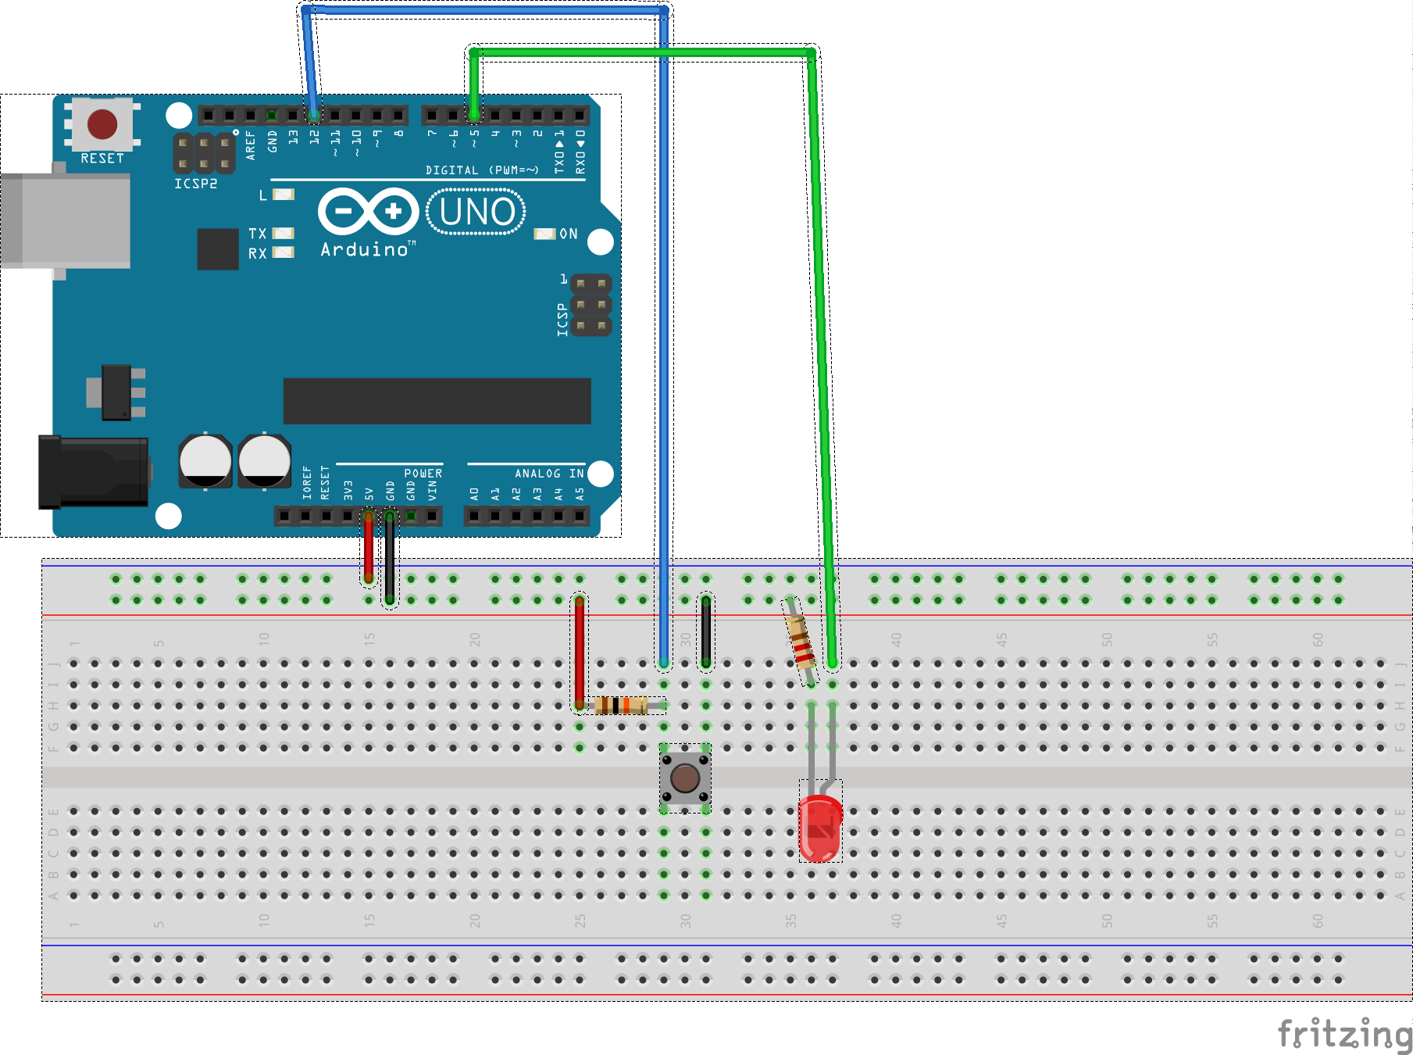

Code:
//Create a toggable button to turn on light
int readPin = 12;
int ledInput = 5;
int dt = 200;
int buttonRead;
int ledState=1;
void setup() {
Serial.begin(9600);
pinMode(readPin, INPUT);
pinMode(ledInput, OUTPUT);

}

void loop() {
buttonRead = digitalRead(readPin);
Serial.println(buttonRead);
delay(dt);
//toggle led state
if(buttonRead==0){
if(ledState==0){
ledState=1;
}
else if(ledState==1){
ledState=0;
};
};
while(buttonRead==0){
buttonRead = digitalRead(readPin);
};

if(ledState==0){
digitalWrite(ledInput,HIGH);
}
else if(ledState==1){
digitalWrite(ledInput,LOW);
};
}

