Change the variable in the config can change the model:  
**size:** size of input, please do size = [224, 300, 348].

**Type:** corresponding to different model of clip type = [“base”, “large”]

**Trans:** corresponding to the way of downsampling trans=[“resize”,“crop”]

#please try all the combination of the above variable

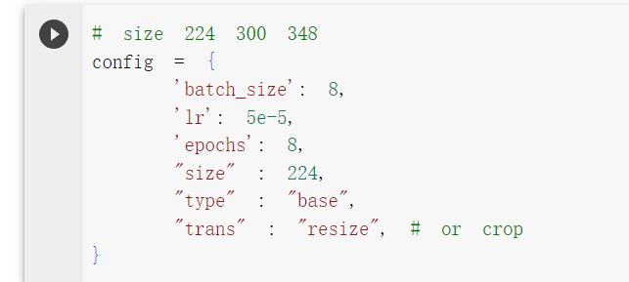

Run this cell to check if the image is reasonable and the size of image

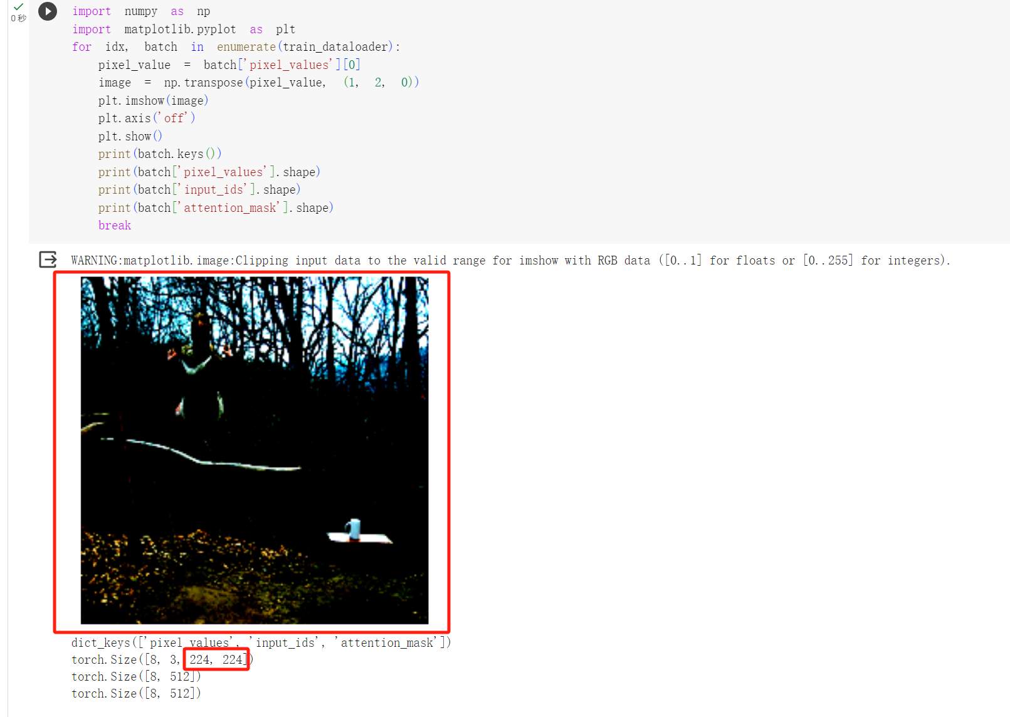

Please recorde # of parameters and flops in the spread sheet:  
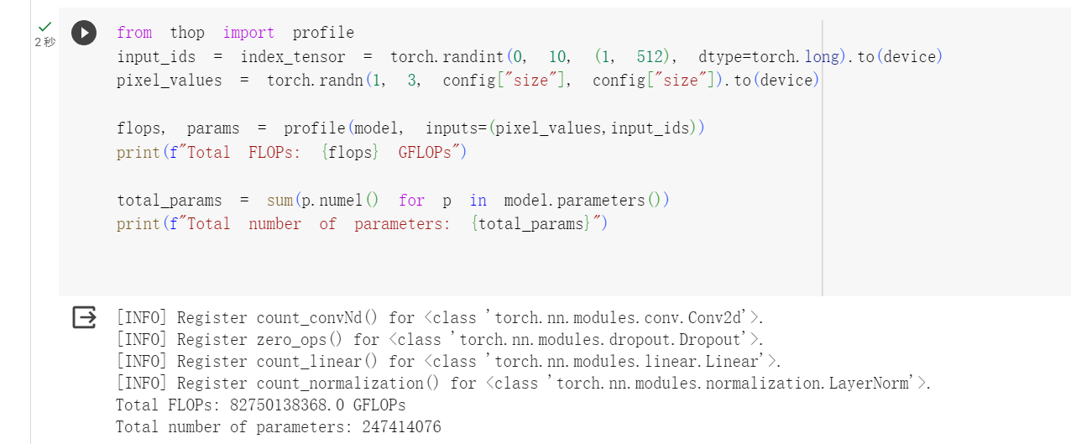

After finish training ignore the rest of the cell directly go to end to run the huggingface one

Check the model name  
