Stanford AI for Burgers Study – Part 2

Guidelines for Recipe Development
This document is intended to be used by the executive Chefs hired by Palate Insights. It presents the ingredient lists and their corresponding quantities, and describes how the lists should be interpreted.

Recipes
This study includes 6 burgers. The ingredients and their quantities for the 6 burgers are given below. Guidelines for the Chefs follow in the next section.
1. The bean burger
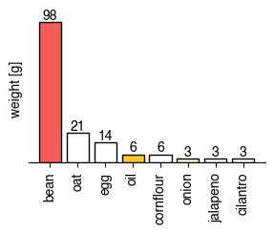

2. The mushroom burger
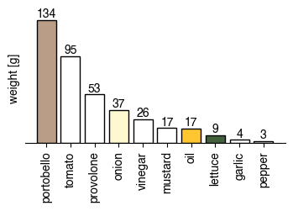

3. The chickpea burger
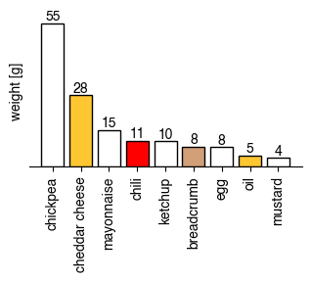

4. The lentil burger
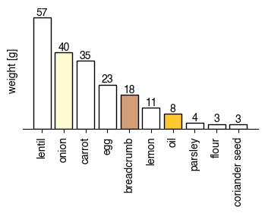

5. The oat burger
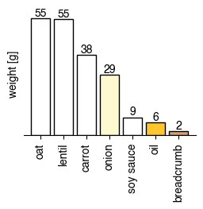
6. The oat and fruit burger
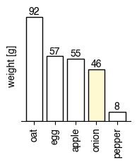
Figure 1: Option 1

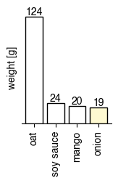
Figure 2: Option 2

Guidelines
- Each one of the listed recipes amounts to 350 calories exactly. The chefs should use the given weights of the ingredients without any changes.
- The recipes don’t list buns. The chefs should choose 1 standard sesame seed bun for all 6 burgers.
- There are two separate recipes given under “oat and fruit burger”, one uses apples and the other uses mangoes. The chefs are asked to choose one that they think will be most preferred by consumers.
- The ingredient lists only show the ingredients, but all processing steps are to be decided by the chefs.
- The bean burger is a repeat of the bean burger from the previous study. The chefs are asked to design an alternative way of preparing this burger.
- The previous study also contained a mushroom burger, where the chefs decided to slice the mushroom into pieces. We ask that the chefs grind/chop the mushroom into a patty this time.
- The chefs should decide which parts of the ingredient lists should be used in the patty, and which parts should be layered on top. This even includes dividing some ingredients into two or more parts. For example, if the recipe mentions “onions”, the chef could decide to mince some of it and add to the patty, and slice some for layering on top of the patty. In such cases, we ask the chefs to record the weights of the parts.
- The weights are generally meant to be dry and uncooked weights. If the chef believes that the weight listed for an ingredient is too high/low for it to be the dry/uncooked weight (e.g. beans), please let us know for further consideration.
- Salt: The ingredient lists don’t show salt. The chefs should adjust salt to taste (and record the amount they used).
- All of the listed ingredients are meant to be used in preparing the burgers, but not all of them have to stay on the burger. Examples:
  - Vegetables and fruits have peels and stems that can be removed after weighing.
  - If the recipe lists “oil”, and if the chef decides that the oil is best used for frying/sauteing, then the oil may remain in the pan after sauteing.
  - Some herbs like rosemary may be used to add aroma to the rest of the ingredients and disposed afterwards.
- Some of the recipes may result in “overflowing” burgers, this is acceptable but the chefs are still kindly asked to try their best in preparing/cooking the burgers in a way that is presentable, and that the burger has a structural integrity.
- The ingredient lists do not mention specific details like variety of the ingredients. The chefs are free to make their own decisions about this. Examples:
  - “beef” may be interpreted as intact meat or ground beef, depending on what the chef believes is the best choice for that particular recipe.
  - Vegetables can be any variety that the chef prefers (e.g. red onions, white onions, etc (but not green onions, which are a different product)).
- “Other cheese” includes any cheese that is not one of these: blue cheese, cheddar cheese, cottage cheese, cream cheese, feta, goat cheese, gouda, monterey, monterey jack, mozzarella, parmesan, provolone. We ask the chef to select a cheese that they think best fits the rest of the ingredients.
- “Other sauce” includes any sauce that is not one of these: barbecue sauce, buffalo sauce, cream, curry sauce, hoisin sauce, honey, hot pepper sauces, ketchup, mustard, pesto, ranch, relish, salsa, soy sauce, steak sauce, teriyaki sauce, vinegar, wasabi, Worcestershire sauce. We ask the chef to select a sauce that they think best fits the rest of the ingredients.
- In Sustainable Burger 2, we ask that the chef combine the meat and mushrooms together to make the patty. This way the burger is more aligned with the Cardinal Burger that Stanford serves in its cafeterias.
- We kindly ask the chefs to put their best creativity and artistic skills to work to turn these ingredient lists to the best burgers possible, and wholeheartedly thank them for their help in this study!

