
Department of Computer Science

Lab Manual

of

DEEP LEARNING

MAI417-3

Class Name: III MScAIML

Master of Science Artifitial Intelligence and Machine Learning

2025-26

Prepared by: Meet Virani Verified by: Faculty name:
Department Overview
Department of Computer Science of CHRIST (Deemed to be University) strives to shape outstanding computer professionals with ethical and human values to reshape nation’s destiny. The training imparted aims to prepare young minds for the challenging opportunities in the IT industry with a global awareness rooted in the Indian soil, nourished and supported by experts in the field.

Vision
The Department of Computer Science endeavours to imbibe the vision of the University “Excellence and Service”. The department is committed to this philosophy which pervades every aspect and functioning of the department.

Mission
“To develop IT professionals with ethical and human values”. To accomplish our mission, the department encourages students to apply their acquired knowledge and skills towards professional achievements in their career. The department also moulds the students to be socially responsible and ethically sound.

Introduction to the Programme
Machines are gaining more intelligence to perform human like tasks. Artificial Intelligence has spanned across the world irrespective of domains. MSc (Artificial Intelligence and Machine Learning) will enable to capitalize this wide spectrum of opportunities to the candidates who aspire to master the skill sets with a research bent. The curriculum supports the students to obtain adequate knowledge in the theory of artificial intelligence with hands-on experience in relevant domains with tools and techniques to address the latest demands from the industry. Also, c andidates gain exposure to research models and industry standard application development in specialized domains through guest lectures, seminars, industry offered electives, projects, internships, etc.

Programme Objective
● To acquire in-depth understanding of the theoretical concepts in Artificial Intelligence and Machine Learning
● To gain practical experience in programming tools for Data Engineering, Knowledge Representation, Artificial intelligence, Machine learning, Natural Language Processing and Computer Vision.
● To strengthen the research and development of intelligent applications skills through specialization based real time projects.
● To imbibe quality research and develop solutions to the social issues.

Programme Outcomes:
PO1 : Conduct investigation and develop innovative solutions for real world problems in industry and research establishments related to Artificial Intelligence and Machine Learning PO2 : Apply programming principles and practices for developing automation solutions to meet future business and society needs.
PO3 : Ability to use or develop the right tools to develop high end intelligent systems
PO4 : Adopt professional and ethical practices in Artificial Intelligence application development
PO5 : Understand the importance and the judicious use of technology for the sustainability of the environment.

MAI417-3– Deep Learning
Total Teaching Hours for Trimester: 75
Max Marks: 100 Credits: 4
Course Description
The course introduces deep learning techniques, focusing on feedforward networks, CNNs, RNNs, and autoencoders. Students will learn regularization methods, optimization for long-term dependencies, and advanced model implementations. Lab exercises provide hands-on experience with Keras and TensorFlow. By the end, students will apply these techniques to real-world problems in computer vision and sequence processing.

Course Objectives
The main objective of this course is to make students comfortable with the tools and techniques required to handle large datasets. Several libraries and datasets publicly available will be used to illustrate the application of these algorithms. This will help students develop the skills required to gain experience in doing independent research and study.

Course Outcomes
Upon successful completion of the course, the student will be able to
CO1: Implement deep feedforward and backpropagation networks for classification.
CO2: Analyze regularization techniques for optimizing deep learning models.
CO3: Apply convolutional and recurrent neural networks for vision and sequence processing tasks.
CO4: Evaluate autoencoders for feature extraction and data compression.
CO5: Compare different deep learning architectures for performance improvement.

Unit-1 Teaching Hours: 15
DEEP FEEDFORWARD NETWORKS
An overview of ANN, Back Propagation Neural Networks, Deep Feedforward Networks: Deep network for Universal Boolean function representation, Classification and Approximation, Perceptron Learning.
Lab Exercises:
1. Demonstrate MLP in Keras/TensorFlow
2. Demonstrate Deep Feedforward Network

Unit-2 Teaching Hours: 15
REGULARIZATION FOR DEEP MODELS
Regularization for Deep models: L2 and L1 Regularization, Constrained Optimization and Under- Constrained Early Stopping, Parameter Tying and Parameter Sharing, Sparse representations, Dropout
Lab Exercises:
3. Demonstrate Regularization L1 and L2 for Deep learning model

Unit-3 Teaching Hours: 15
CONVOLUTIONAL NEURAL NETWORK
Introduction to convolution neural networks: stacking, striding and pooling, Applications in Computer Vision
Lab Exercises:
4. Demonstrate Convolution Neural Network

Unit-4 Teaching Hours: 15
RECURRENT NEURAL NETWORKS
Sequence Processing, Unfolding Computational Graphs, Training recurrent networks
The Long Short-Term Memory (LSTM), Optimization for Long- Term Dependencies, Encoder-Decoder Sequence-to-Sequence processing
Lab Exercises:
5. Demonstrate Short-Term Long Memory (LSTM)

Unit-5 Teaching Hours: 15
AUTOENCODERS
The architecture of autoencoders - the relationship between the Encoder, Bottleneck, and Decoder, how to train autoencoders? Types of autoencoders: Undercomplete autoencoders, Sparse autoencoders, Contractive autoencoders, Denoising autoencoders, Variational Autoencoders
Lab Exercises:
6. Demonstrate Sparse Autoencoders
7. Demonstrate Contractive Autoencoders

Text Books and Reference Books
[1] Deep Learning by Ian Goodfellow, Yoshua Bengio, Aaron Courville. MIT Press 2016.
[2] Simon J.D. Prince, Understanding Deep Learning: The Simple Math of Deep Learning, MIT
Press 2024.

Essential Reading / Recommended Reading
[1] Deep Learning with Python by Francois Chollet. 2nd Edition, Manning Publications Co.,
2020
[2] Introduction to Deep Learning by Eugene Charniak. The MIT Press 2019
[3] Dive into Deep Learning by Aston Zhang, Zack C. Lipton, Mu Li, Alex J. Smola. 2019
[4] AurélienGéron, “Hands-On Machine Learning with Scikit- Learn and TensorFlow”, O’Reilly,
2022.

Web Resources:
[1] https://www.deeplearningbook.org/
[2] https://archive.ics.uci.edu/ml/datasets.php

CO – PO Mapping

 | PO1 | PO2 | PO3 | PO4 | PO5 | PO6 | PO7
CO1 | 3 | 3 | 2 | 2 | 2 | 1 | 2
CO2 | 2 | 2 | 1 | 1 | 1 | 1 | 2
CO3 | 3 | 3 | 2 | 1 | 2 | 1 | 2
CO4 | 2 | 2 | 1 | 1 | 1 | 1 | 2
CO5 | 3 | 3 | 2 | 2 | 2 | 2 | 3

LIST OF PROGRAMS

MSCAIML
Sl.no | Title of lab Experiment | Page number | RBT | CO
1 | Learning the XOR Boolean Function Using an MLP | 8 | L3 | CO1,3
2 | Deep Feedforward Neural Network for Fashion MNIST Classification | 26 | L3 | CO2,3
3 | Effect of L1, L2, and Elastic Net Regularization on Model Training |  | L3 | CO3
4 | Implement CNN from scratch and train YOLO on signature data | 59 | L3 | CO3
5 |  |  | L3 | CO3
6 |  |  | L3 | CO3,4
7 |  |  | L4 | CO3
8 |  |  | L3 | CO3
9 |  |  | L3 | CO4
10 |  |  | L5 | CO4

Evaluation Rubrics:
Evaluation Rubrics for each program would be
Correctness and Demonstration and timely submission (5 =3+2marks)
Concept Clarity and modeling (3 marks)
Initiative & Effort ( (2 marks)
Submission Guidelines:
- Make a copy of the lab manual template with your <name_reg:no_subject name >,

- Copy the given question and the answer (lab code) with results, followed by the conclusion of that lab. Title the lab as lab number.
- Keep updating your lab manual and show the lab manual of that particular lab for evaluation.
- Create a Git Repository in your profile <SPR lab-reg no> . Follow a different branch for each lab <Lab 1, Lab 2…>, and push the code to Git. The link should be provided in Google Classroom along with the PDF of the lab manual.
- Upload the PDF to Google Classroom before the deadline.

Lab 1

Lab Exercise I: Learning the XOR Boolean Function Using an MLP

Aim
- To understand how to implement neural networks using different deep learning libraries (Keras, PyTorch, and TensorFlow).
- To solve the non-linear XOR problem using an MLP and study the effect of hyperparameters such as learning rate, activation functions, number of neurons, and epochs on model performance.

Question
Implement an MLP to learn the XOR Boolean function
The XOR function takes two binary inputs (0 or 1) and produces a binary output (0 or 1) based on the following rule:
Input 1 | Input 2 | XOR Output
0 | 0 | 0
0 | 1 | 1
1 | 0 | 1
1 | 1 | 0
Steps:
- Create the Dataset
  - Define input (X) and output (y) arrays for all 4 XOR combinations.
- Build an MLP
  - Input layer: size 2 (for the two inputs).
  - Hidden layer: at least 2 neurons with ReLU or Tanh activation.
  - Output layer: 1 neuron with sigmoid activation for binary classification.
- Compile the Model / Define Loss and Optimizer
  - Use Binary Cross-Entropy loss.
  - Use an optimizer of your choice (e.g., Adam or SGD).
- Train the Model
  - Train the model on the XOR dataset.
  - Experiment with epochs, learning rate, and number of neurons to improve performance.
- Evaluate the Model
  - Predict outputs for all 4 input combinations.
  - Check if the network correctly learns the XOR function.
- Implement Using Three Libraries
  - Repeat the above steps using:
    - Keras (TensorFlow high-level API)
    - PyTorch
    - TensorFlow low-level API

Additional Exercises (Optional):
- Plot the decision boundary for each implementation.
- Compare training curves and final accuracy between libraries.
- Discuss how changes in learning rate, activation function, hidden layers, or epochs affect learning.

Evaluation Rubrics
- Implementation – 5 marks
- Complexity and Validation – 3 marks
- Documentation & Writing the inference – 2 marks

Submission Guidelines
- Make a copy of the lab manual template with your <name_reg:no_subject name>
- Copy the given question and the answer (lab code) with results, followed by the conclusion of that lab. Title the lab as Lab 1.
- Keep updating your lab manual and show the lab manual of that particular lab for evaluation.
- Create a Git repository in your profile <SPR lab-reg no>. Follow a different branch for each lab <Lab 1, Lab 2 …> and push the code to Git.
- Provide the Git link in Google Classroom along with the PDF of the lab manual.
- Upload the PDF to Google Classroom before the deadline.

Code with Results
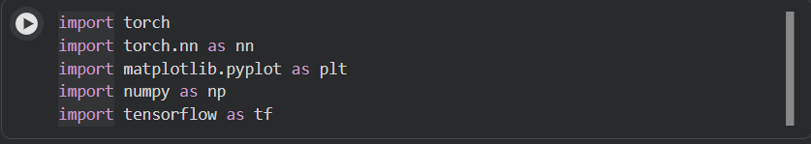
Imports of the program
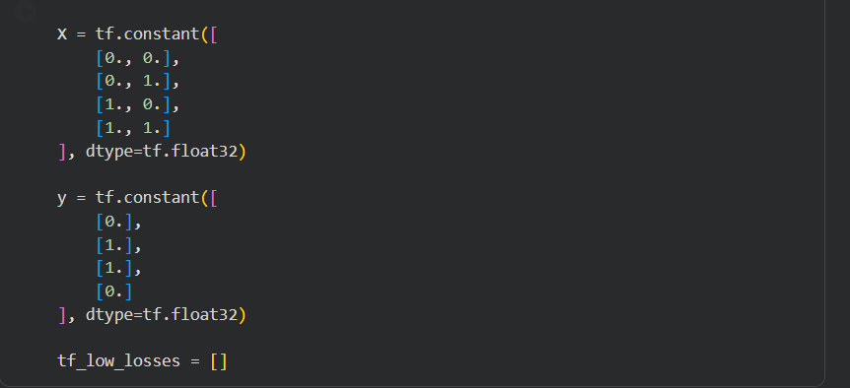
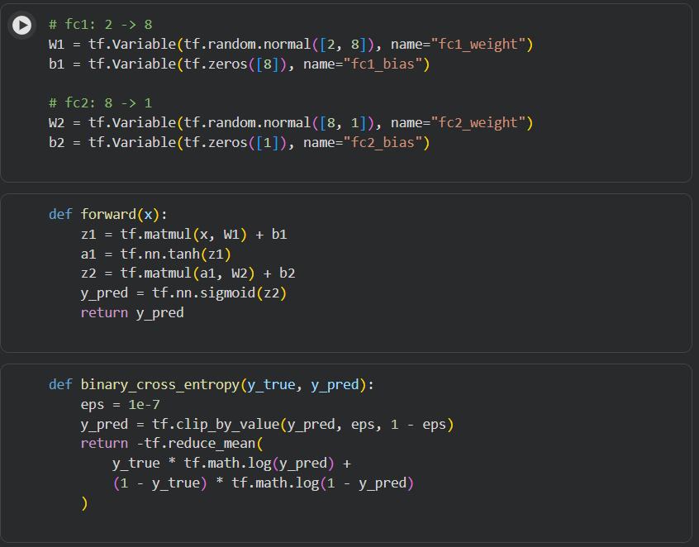

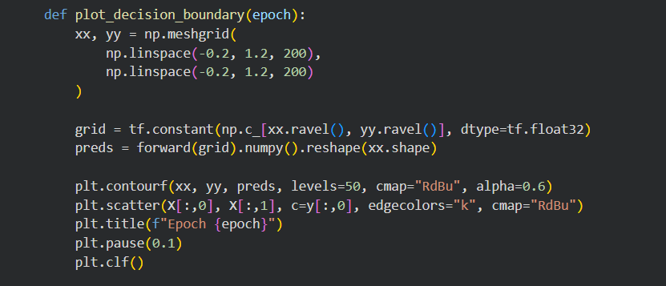
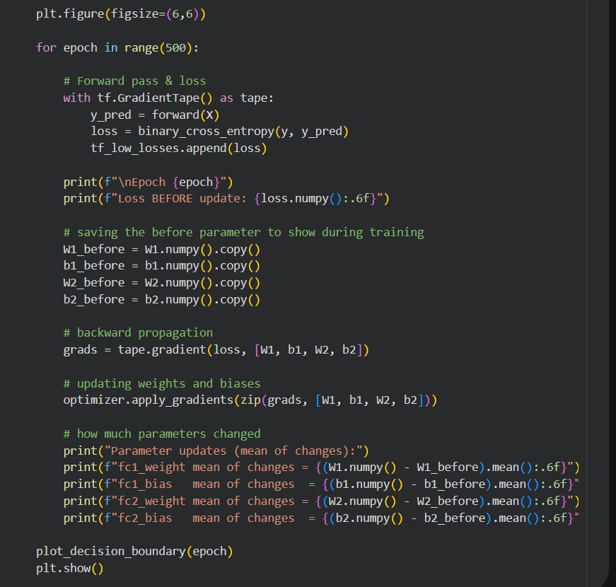
Output :- 200 epochs with graphs and other information
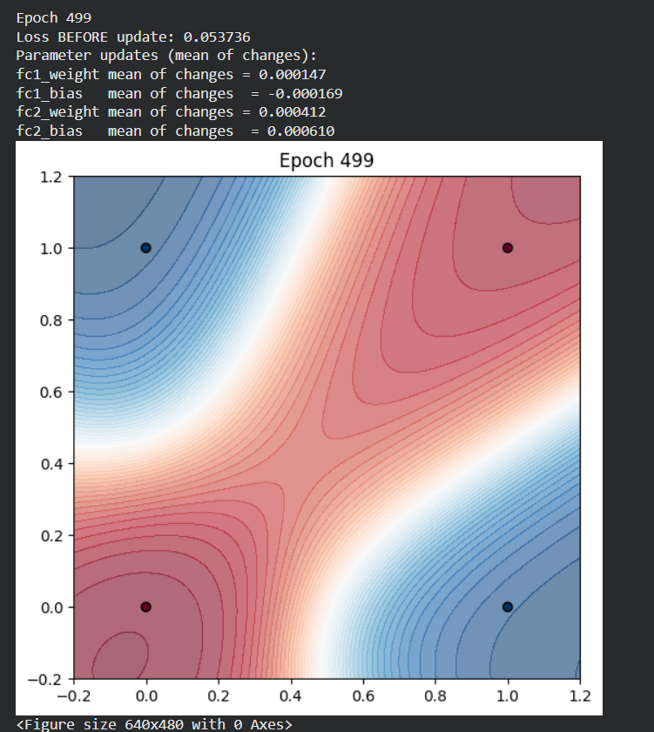
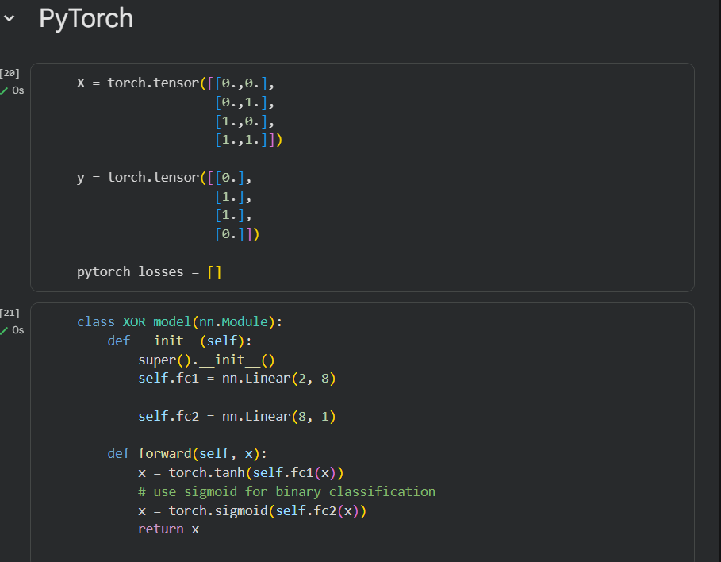
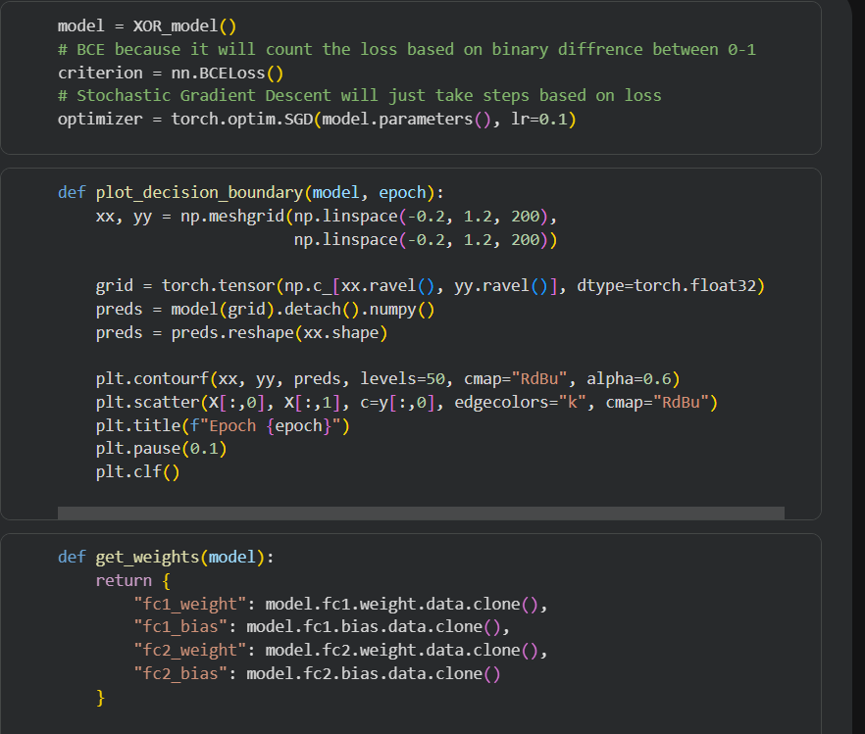
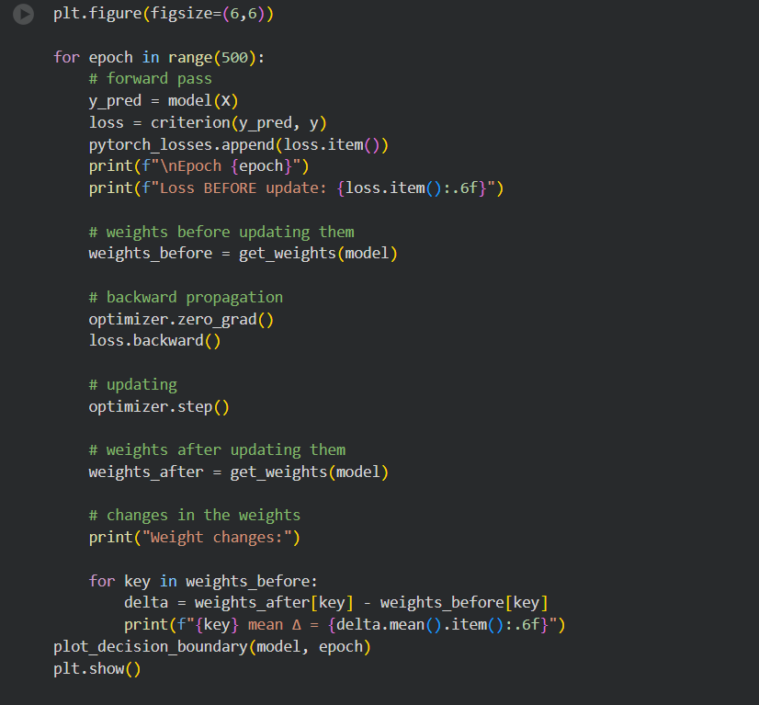
Output :- 200 epochs with graphs and other information
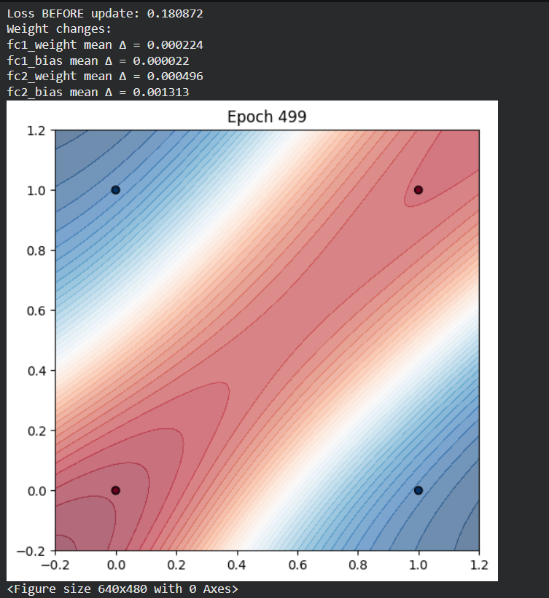

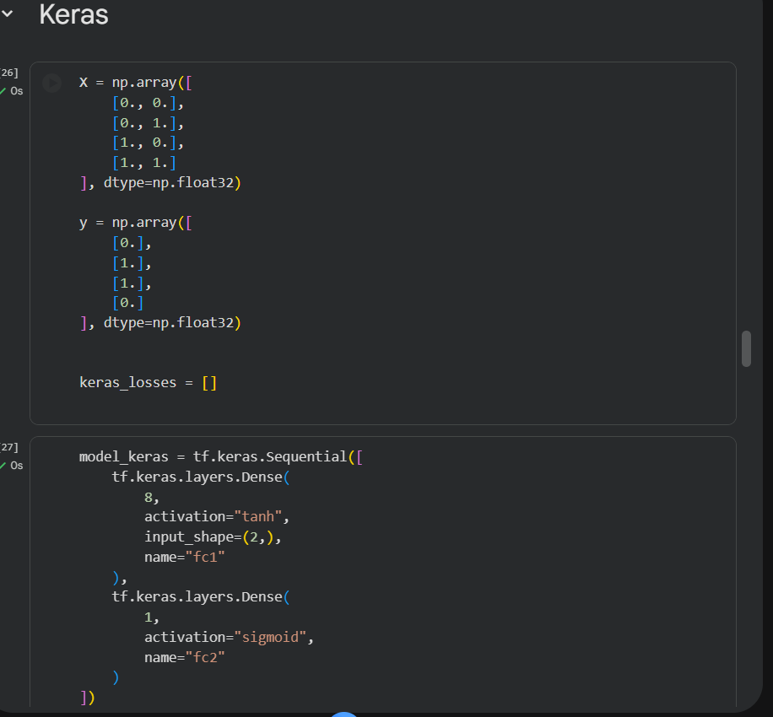
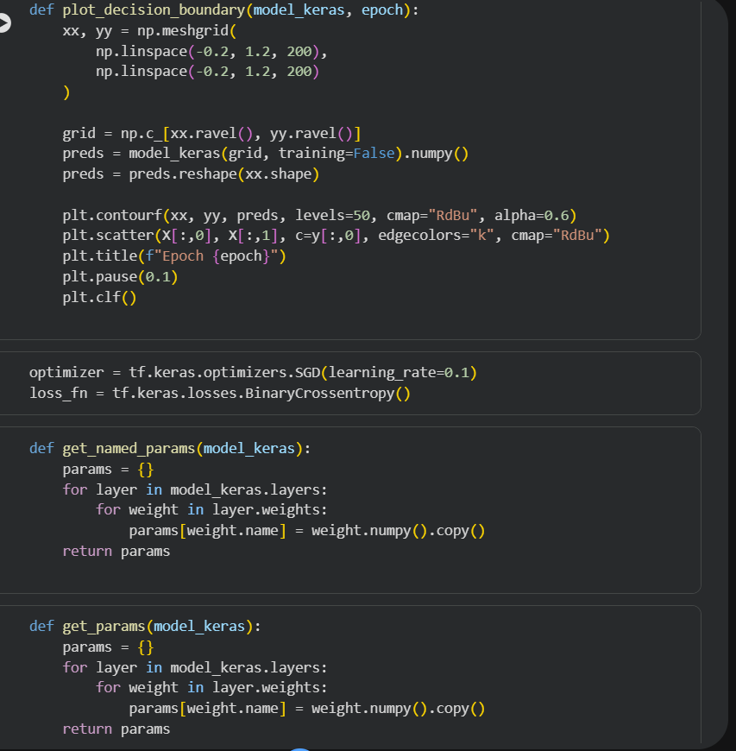
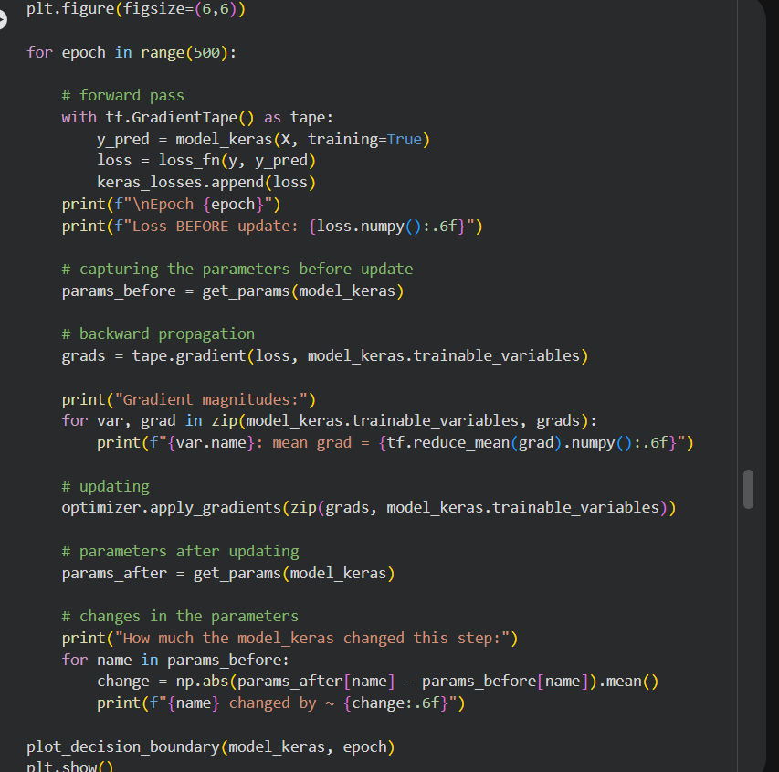
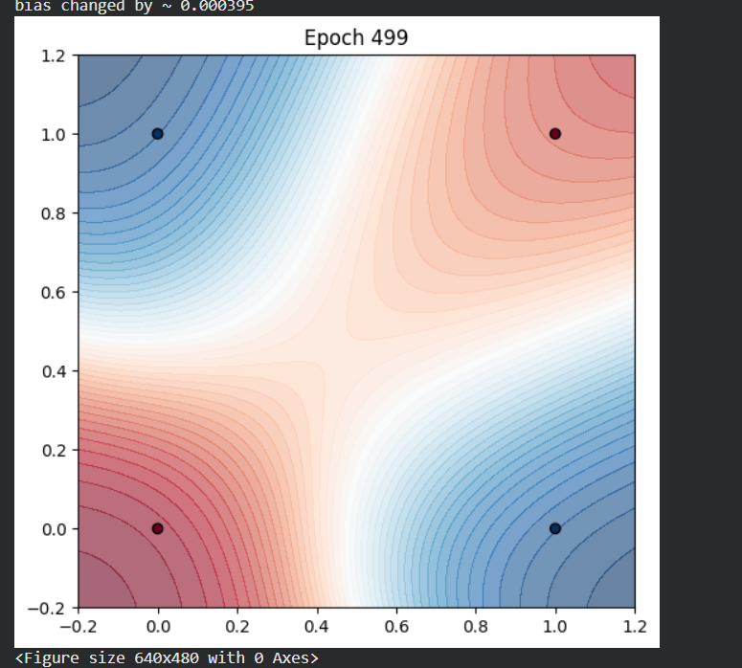

Now, I am comparing the outputs of every model to write the final interpretation

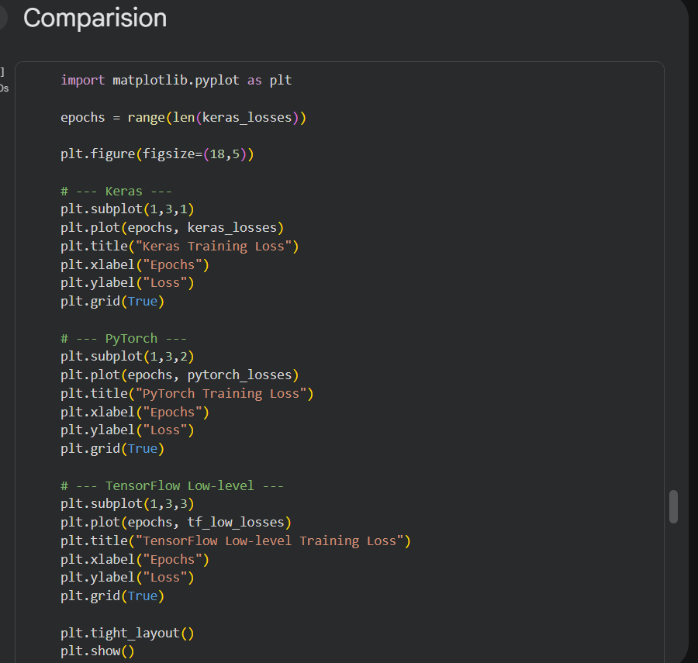
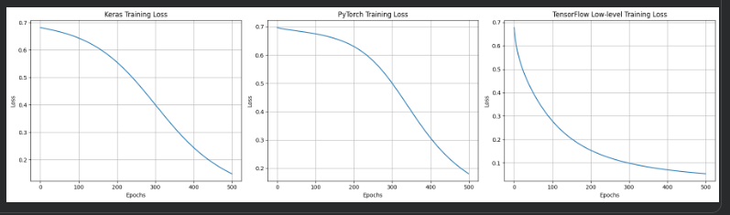

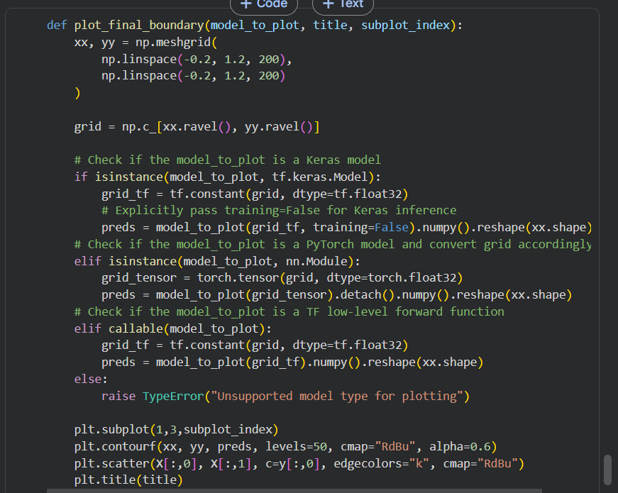
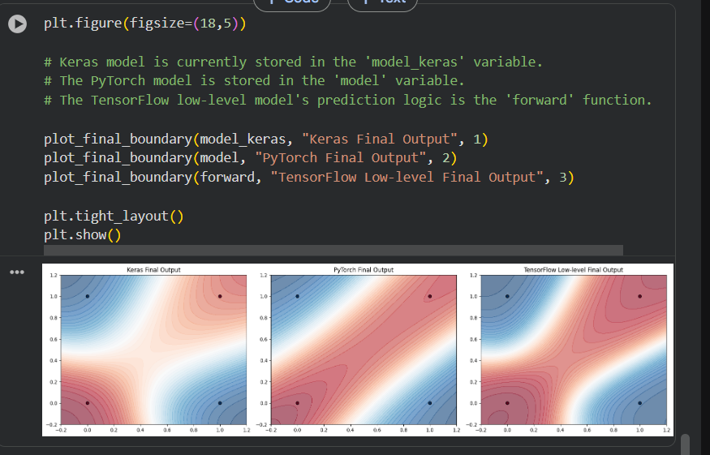

Conclusion /inference
Effect of learning rate
The learning rate decides how fast the model updates itself.
If learning rate is too small:
- Learning is slow
- Loss decreases very gradually
If learning rate is too large:
- Loss can jump up and down
- Model can become unstable
In these results, the learning rate is balanced:
- Loss decreases smoothly
- No sudden jumps
Final output is clean and correct
Final Region Graph
All three models (Keras, PyTorch, TensorFlow low-level) learned the XOR pattern correctly.
The color regions show that:
- The model separates diagonal points correctly
- A non-straight (non-linear) boundary is learned
- Final outputs are almost the same for all three methods
Small differences in shape happen because each framework starts with slightly different initial values, but the final understanding is the same.
Training loss graphs
In all three graphs:
- Loss starts high, meaning the model is guessing
- Loss goes down steadily, meaning learning is happening
- Loss becomes very small, meaning the model learned XOR well
PyTorch and TensorFlow low-level reduce loss a bit faster at the start, while Keras is slightly smoother. This difference is normal and not a problem.

Lab 2
Lab Exercise: Deep Feedforward Neural Network for Fashion MNIST Classification
Aim
To design, implement and evaluate a deep feedforward neural network for classifying Fashion MNIST images using PyTorch, and to understand the role of depth, nonlinear activation, loss computation and gradient based learning in a supervised classification task.
Task
- Load and preprocess Fashion MNIST data using PyTorch data loaders.
- Construct a multilayer feedforward neural network with at least three hidden layers.
- Use ReLU activation in hidden layers and linear outputs for classification.
- Train the network using cross entropy loss and an optimizer such as Adam or SGD.
- Monitor training loss and accuracy across epochs.
- Evaluate the model on unseen test data and compute accuracy.
- Explain the role of forward pass, backward pass and gradient updates.
- Interpret the impact of hyperparameters such as learning rate, batch size and number of epochs.

Advanced Task 1: Experiment with Network Depth and Width(optional)
- Train models with different numbers of hidden layers (e.g., 1, 3, 5) and different neurons per layer.
- Compare training loss, test accuracy, and convergence speed.
- Discuss the trade-off between depth and overfitting.
Advanced Task 2: Activation Function Study
- Replace ReLU with Sigmoid, Tanh, and Leaky ReLU.
- Compare training time, convergence, and test accuracy.
- Explain why some activations perform better than others for deep networks.
Advanced Task 3: Visualization of Hidden Layers
- Visualize activations of hidden layers for a few sample images.
- Explain how features are transformed at each layer.
Evaluation Rubrics

Rubrics | Marks
Correctness and Demonstration | 5 marks
Concept Clarity (Viva) | 3 marks
Initiative & Effort (self-learning) | 2 marks

Submission Guidelines
- Make a copy of the lab manual template with your <name_reg:no_subject name>
- Copy the given question and the answer (lab code) with results, followed by the conclusion of that lab. Title the lab as Lab 1.
- Keep updating your lab manual and show the lab manual of that particular lab for evaluation.
- Create a Git repository in your profile <C lab-reg no>. Follow a different branch for each lab <Lab 1, Lab 2 …> and push the code to Git.
- Provide the Git link in Google Classroom along with the PDF of the lab manual.
- Upload the PDF to Google Classroom before the deadline.

Code:
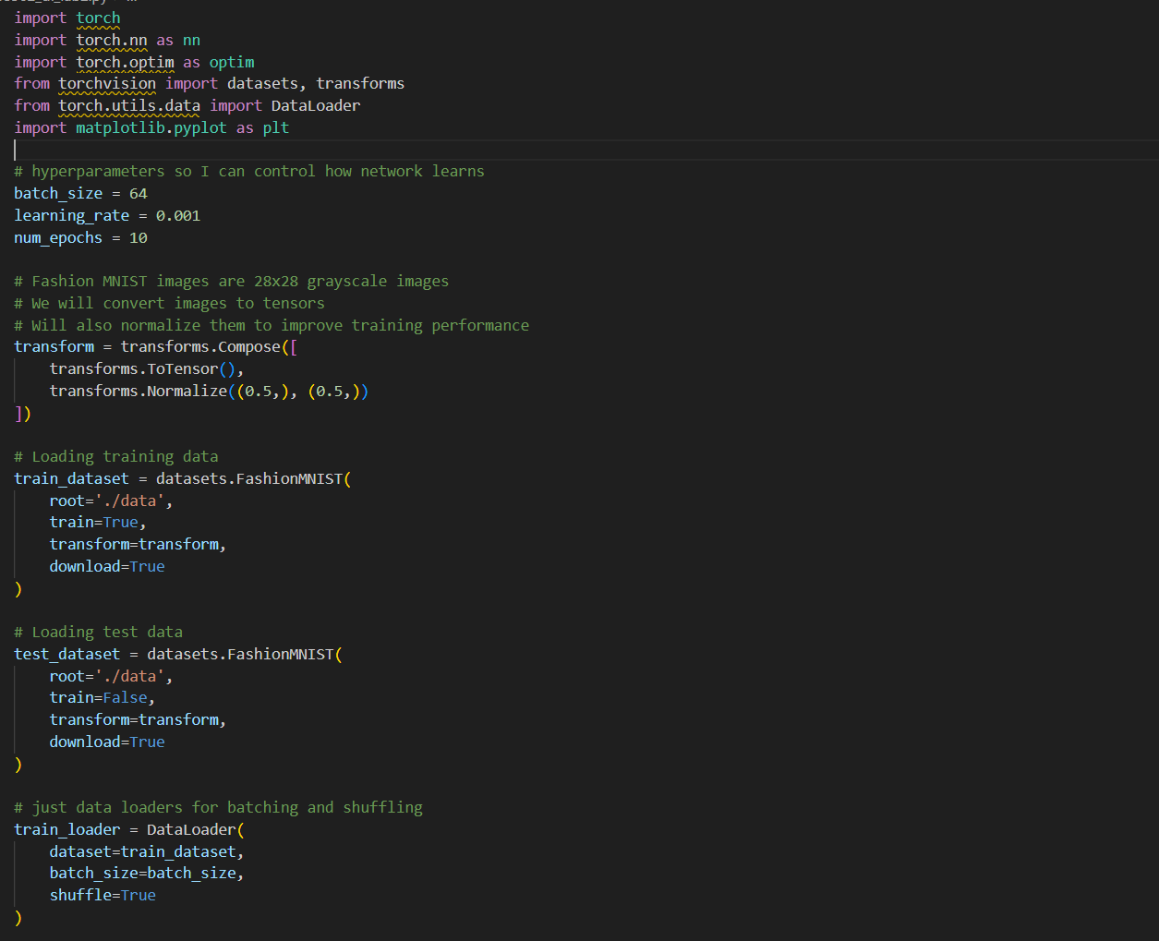
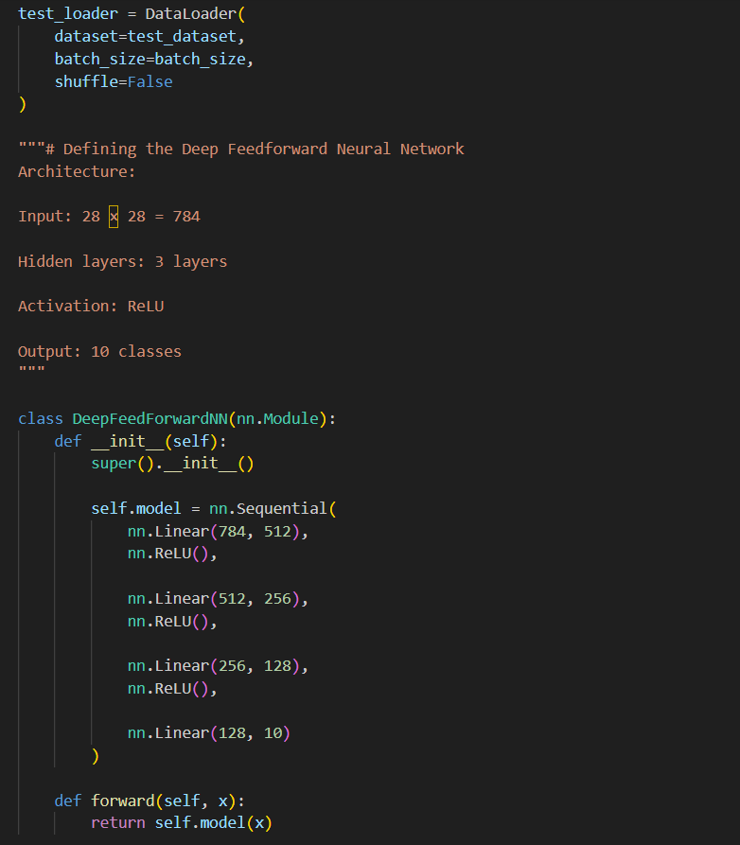
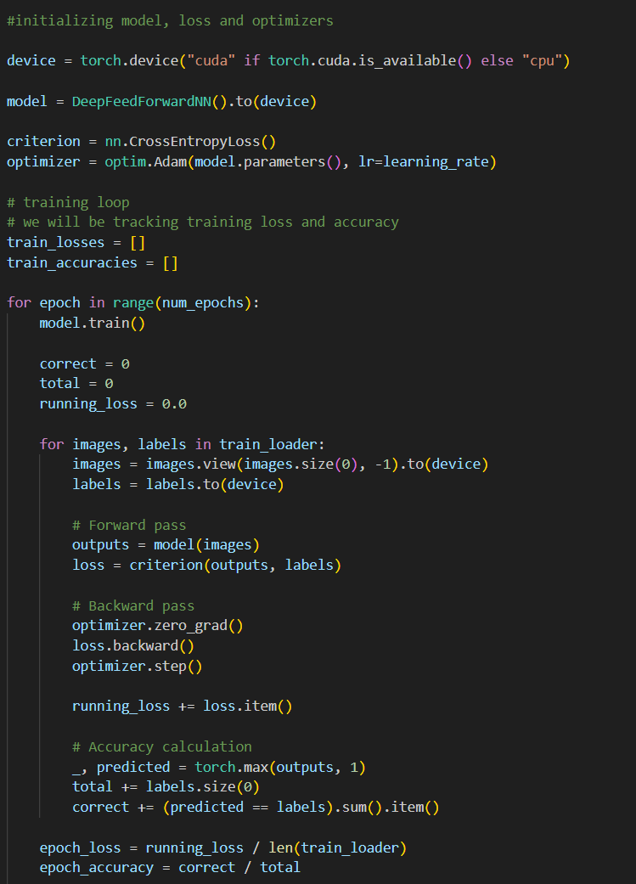

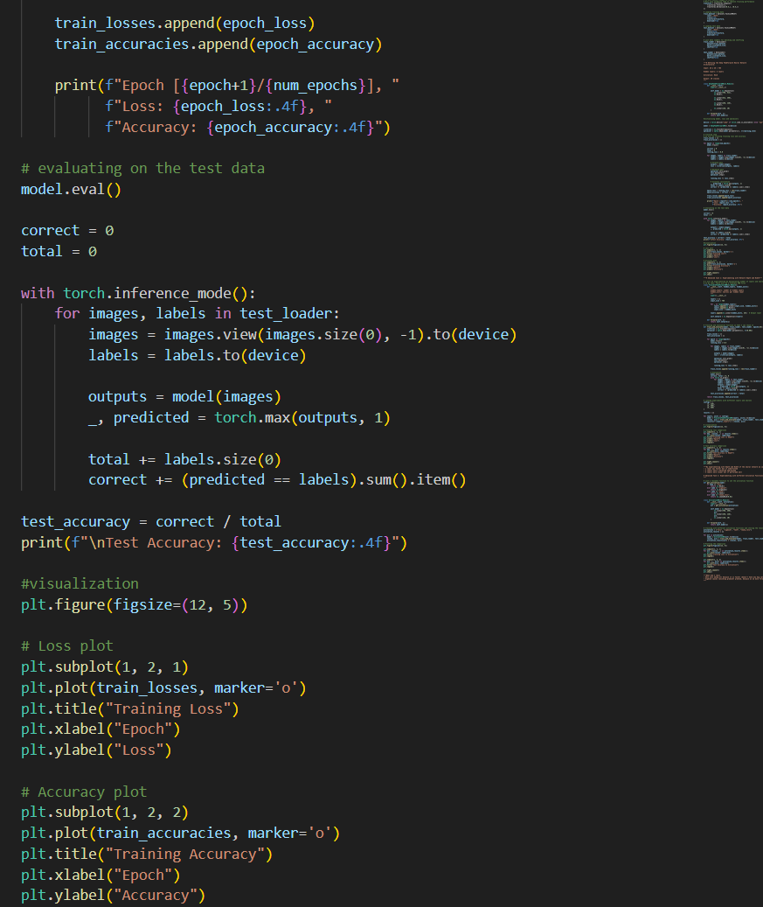
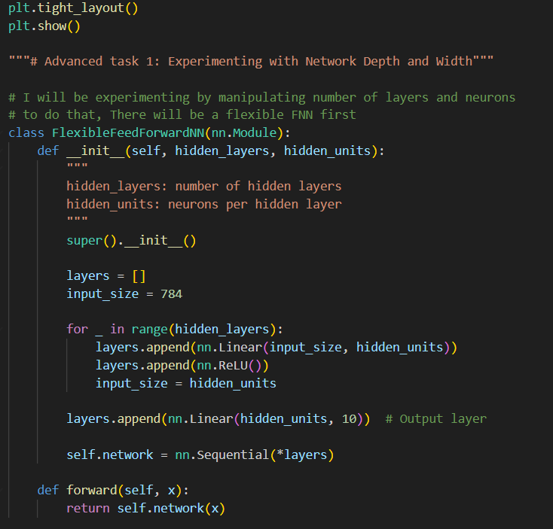
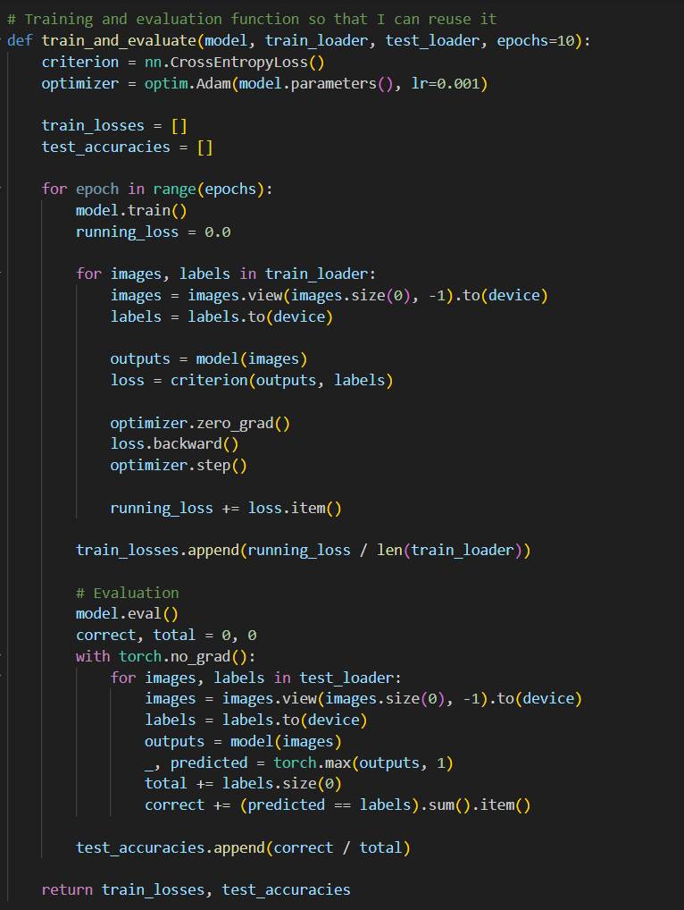
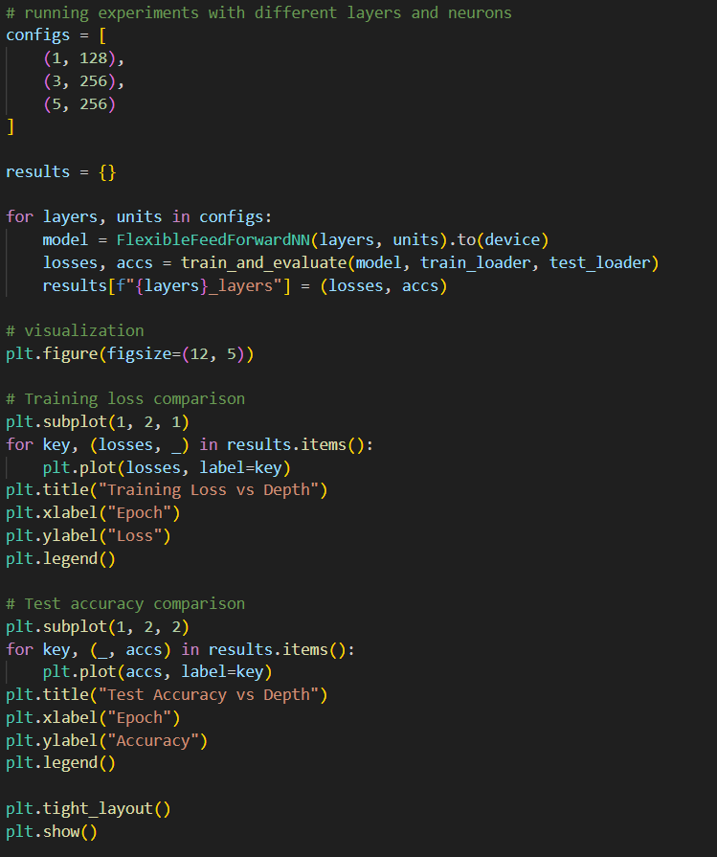
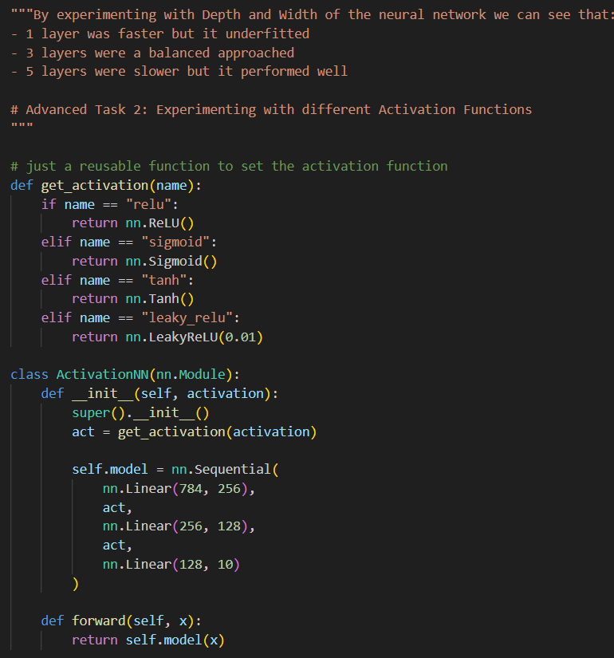
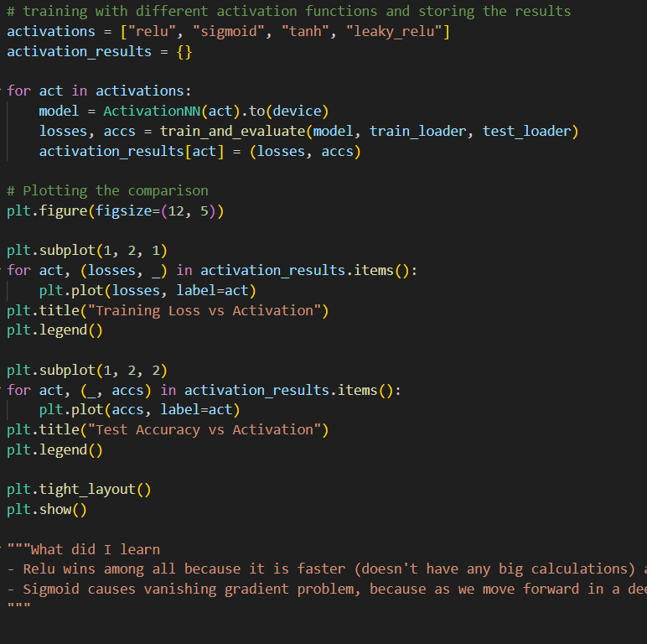

Interpretations:
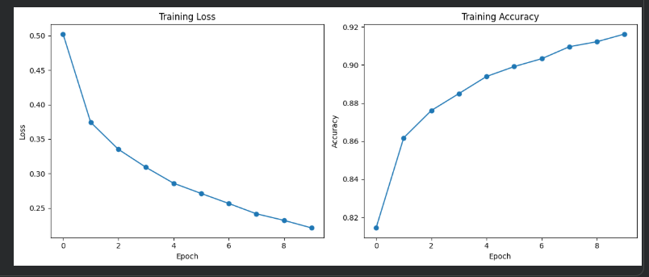
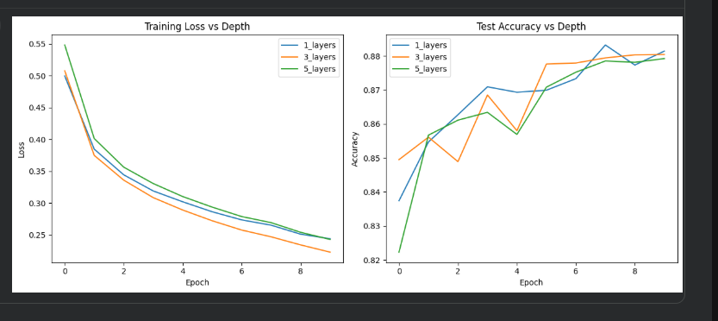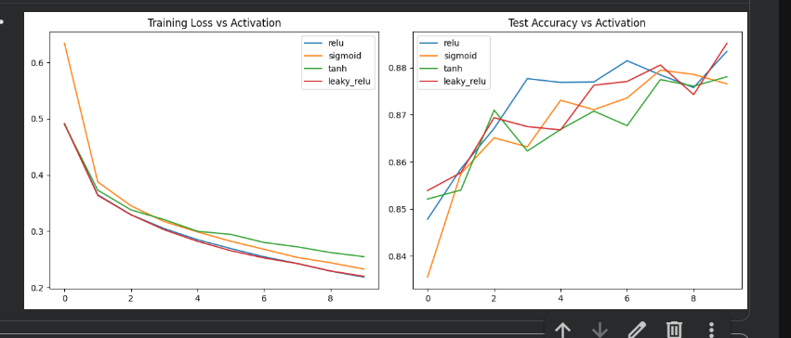
By experimenting with Depth and Width of the neural network we can see that:
- 1 layer was faster but it underfitted
- 3 layers were a balanced approached
- 5 layers were slower but it performed well

By experimenting on Activation functions, we can say that:
- Relu wins among all because it is faster (doesn't have any big calculations) and also it doesn't have the vanishing gradient problem.
- Sigmoid causes vanishing gradient problem, because as we move forward in a deep neural network, it will make the value of neurons' output smaller and smaller. At one point, we won't be able to extract any information.
How does Learning rate, batch size and epochs affect it:
- Learning rate determines the step size, if it is too high, neural network will take large steps and might overshoot & if it is too low then the training will be slow.
- Batch size affects update frequency and memory. Smaller batch size means there will be more frequent updates and slower per epoch. If the batch size is large, it might give bad generalization but training will be faster.
- Number of epochs defines how many times the model sees the entire training dataset, it is low then the model would underfit and if it is too high then model would overfit.

Lab 3: Effect of L1, L2, and Elastic Net Regularization on Model Training
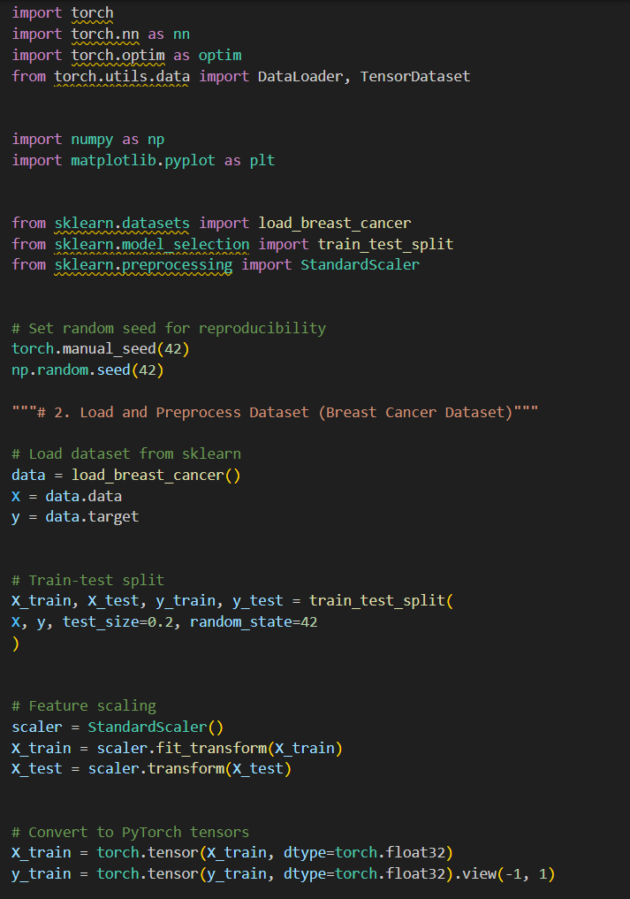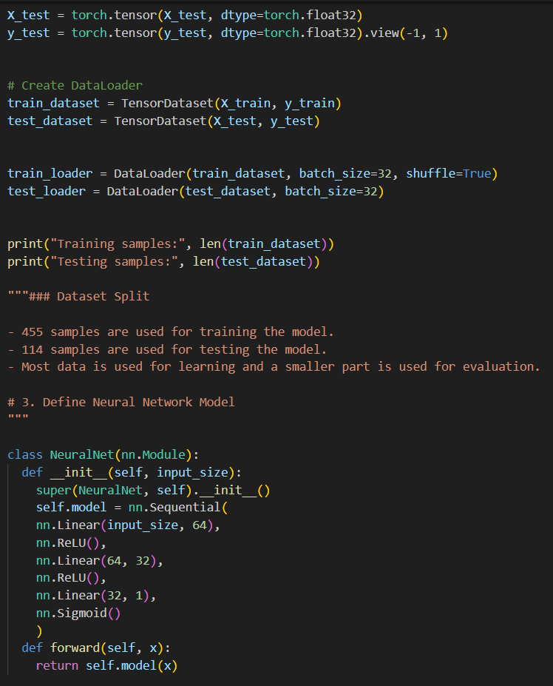
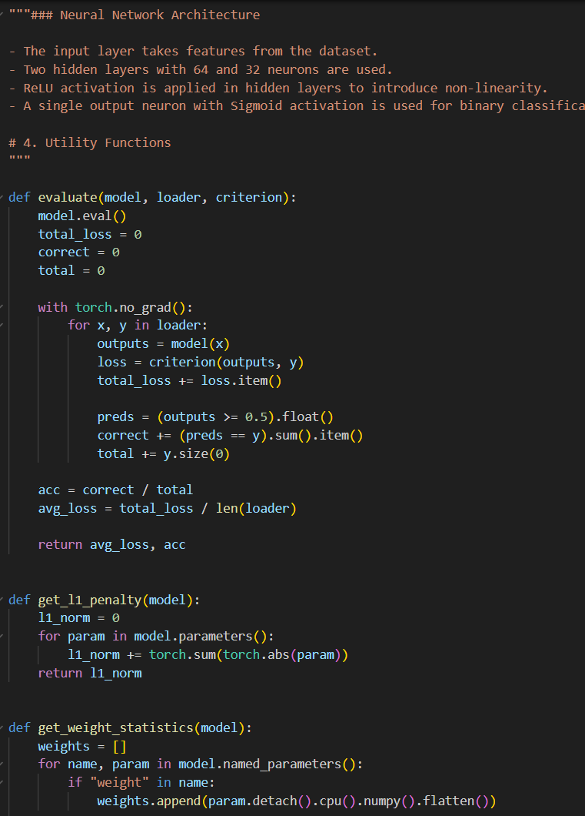
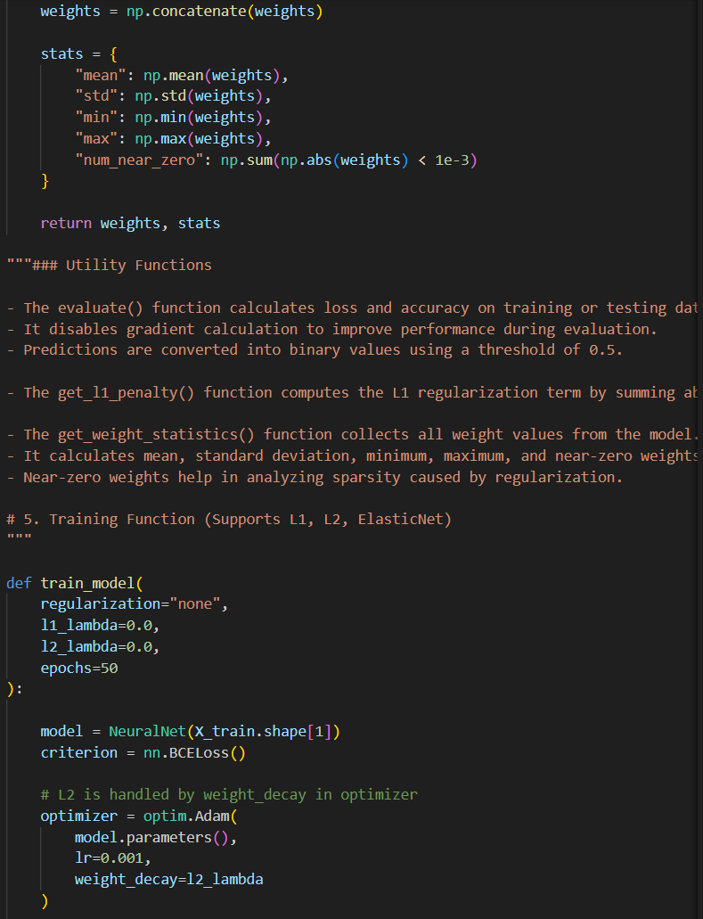
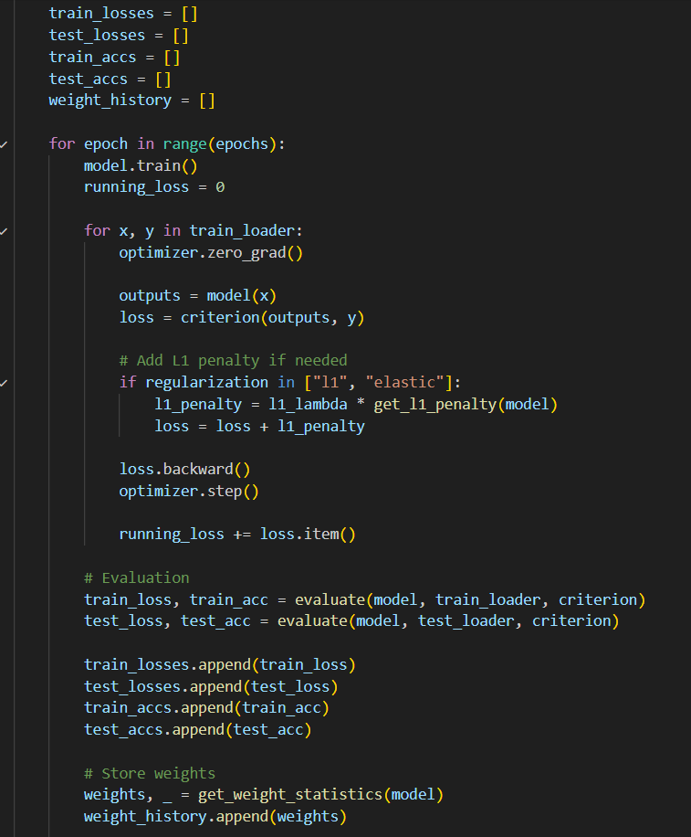
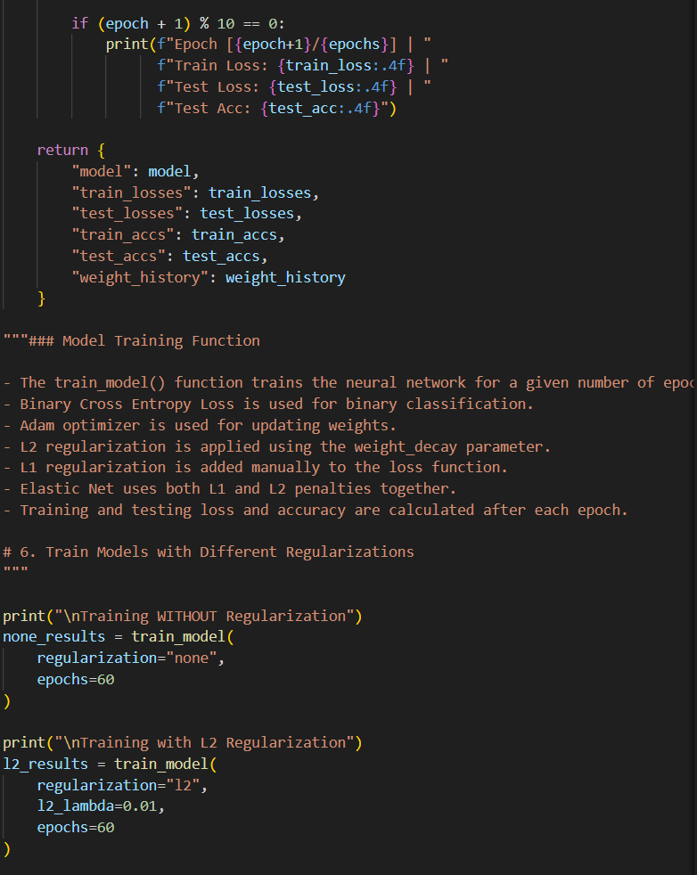
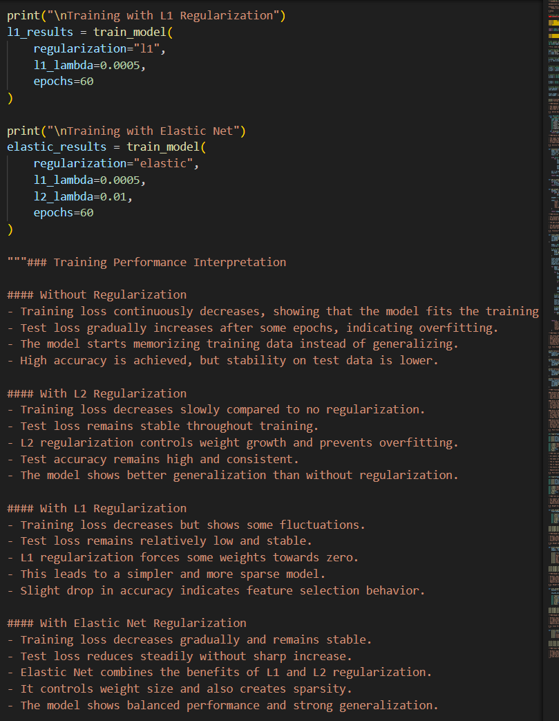
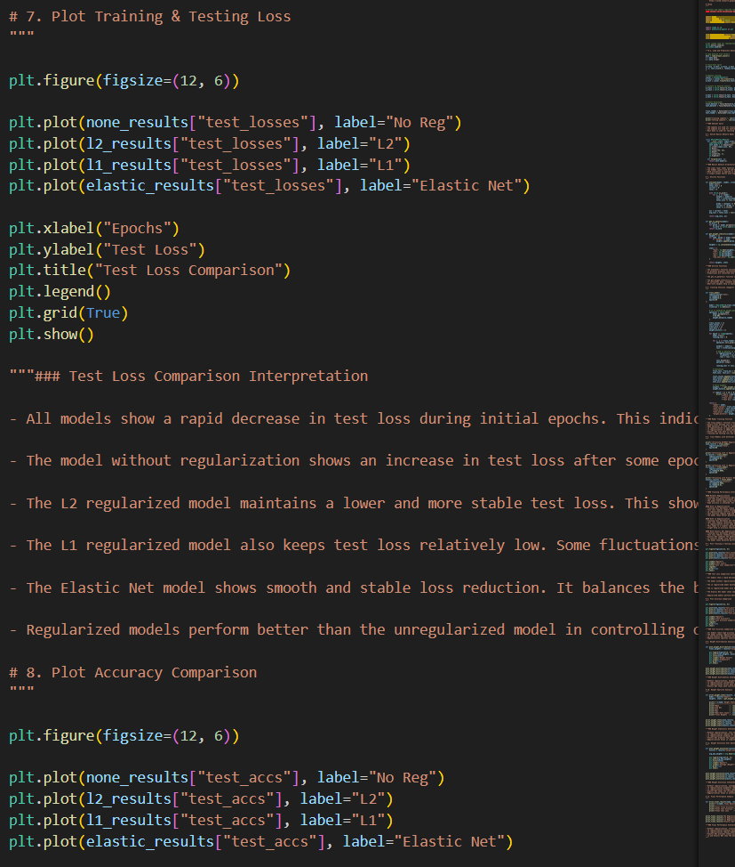
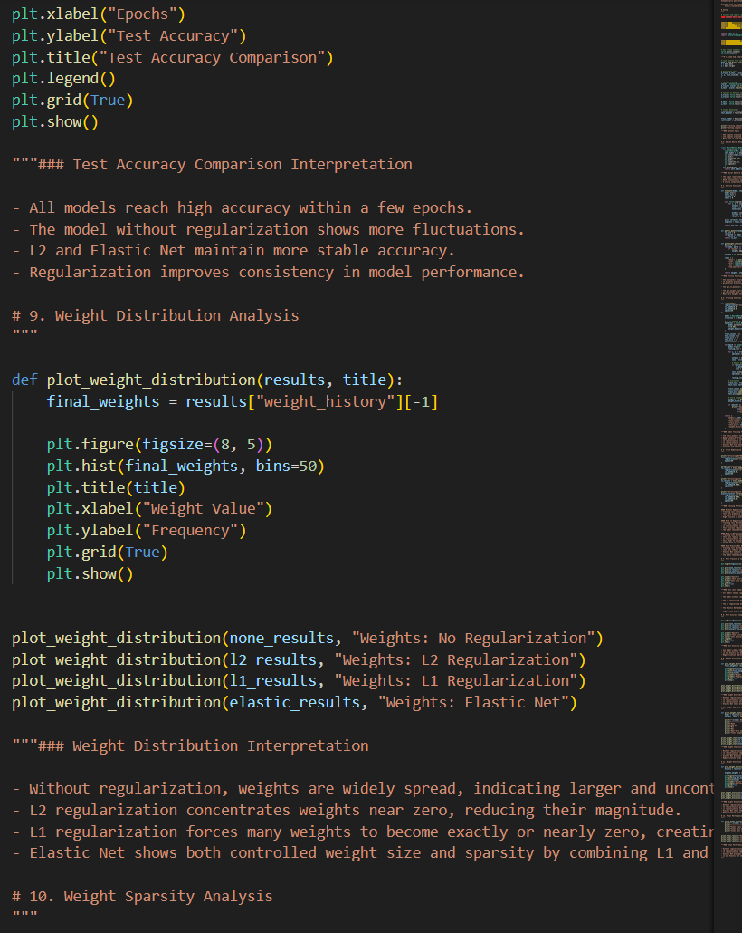
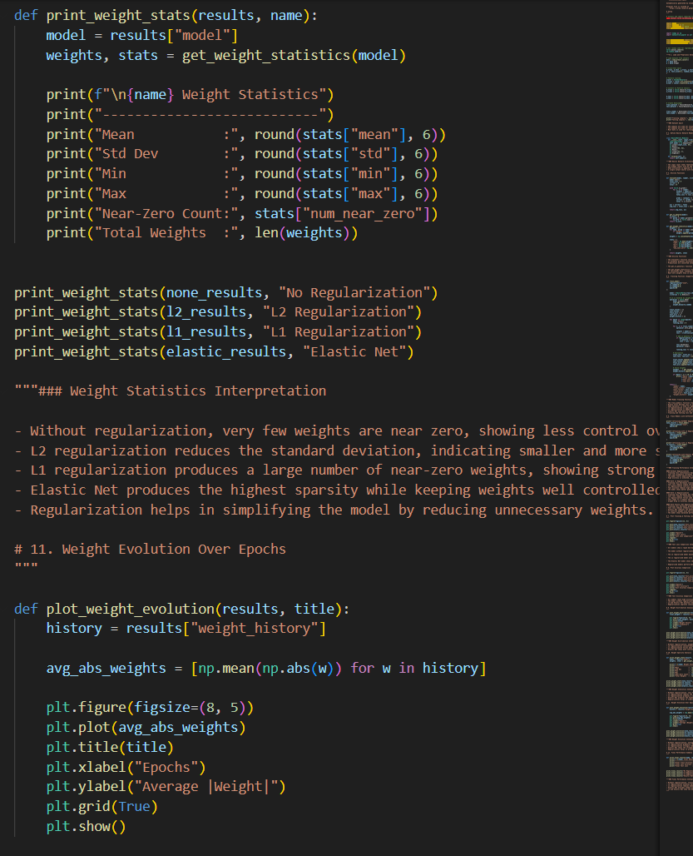
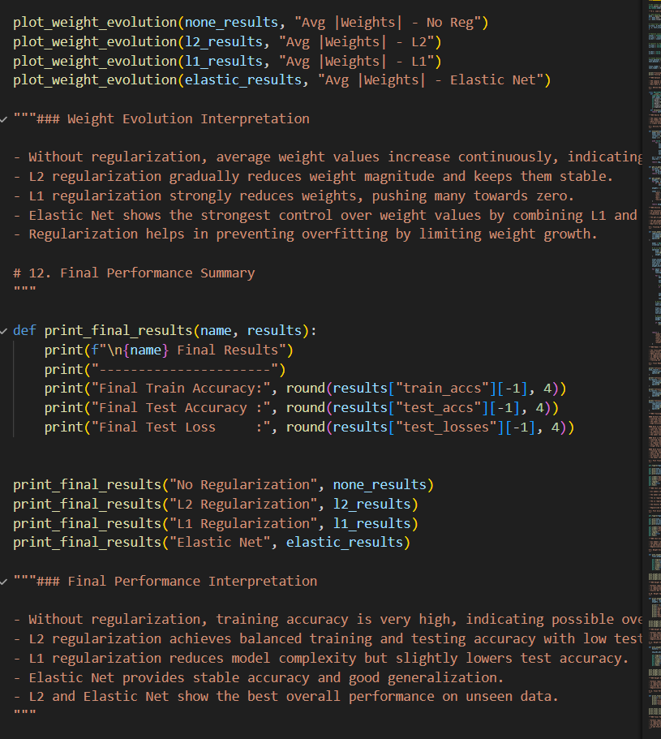

Visualization:
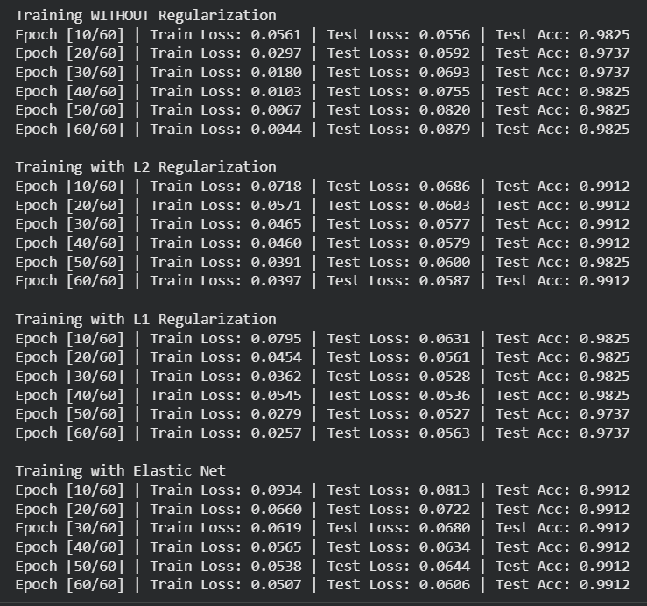
Training Performance Interpretation
Without Regularization
- Training loss continuously decreases, showing that the model fits the training data very well.
- Test loss gradually increases after some epochs, indicating overfitting.
- The model starts memorizing training data instead of generalizing.
- High accuracy is achieved, but stability on test data is lower.

With L2 Regularization
- Training loss decreases slowly compared to no regularization.
- Test loss remains stable throughout training.
- L2 regularization controls weight growth and prevents overfitting.
- Test accuracy remains high and consistent.
- The model shows better generalization than without regularization.

With L1 Regularization
- Training loss decreases but shows some fluctuations.
- Test loss remains relatively low and stable.
- L1 regularization forces some weights towards zero.
- This leads to a simpler and more sparse model.
- Slight drop in accuracy indicates feature selection behavior.
With Elastic Net Regularization
- Training loss decreases gradually and remains stable.
- Test loss reduces steadily without sharp increase.
- Elastic Net combines the benefits of L1 and L2 regularization.
- It controls weight size and also creates sparsity.
- The model shows balanced performance and strong generalization.

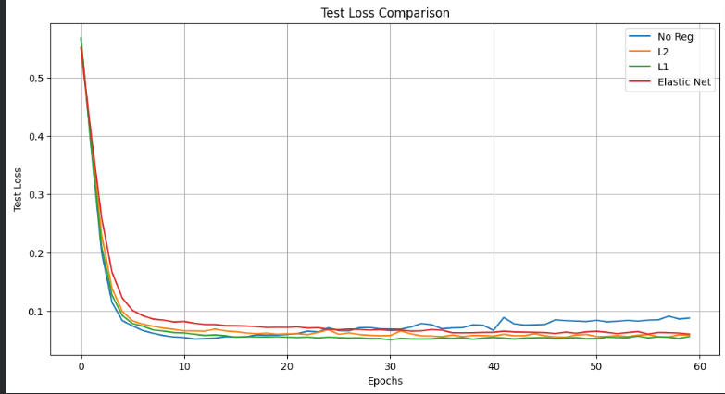
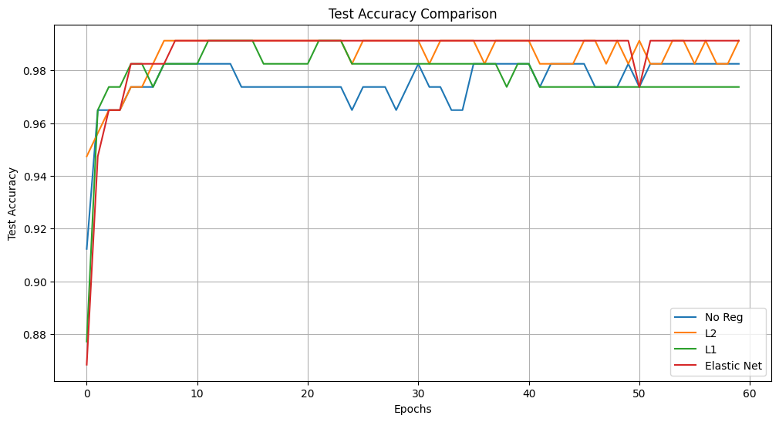
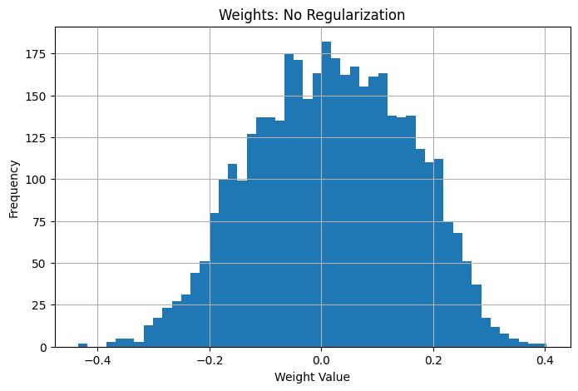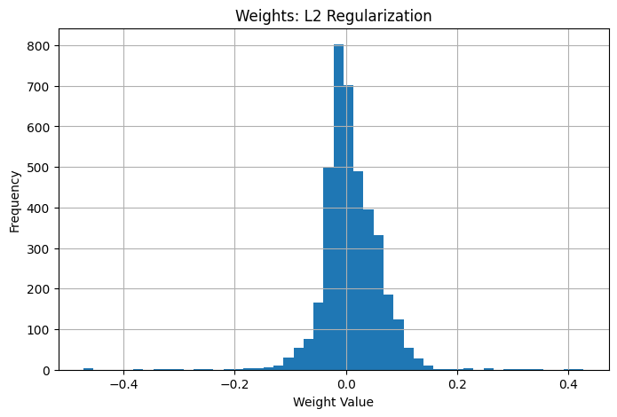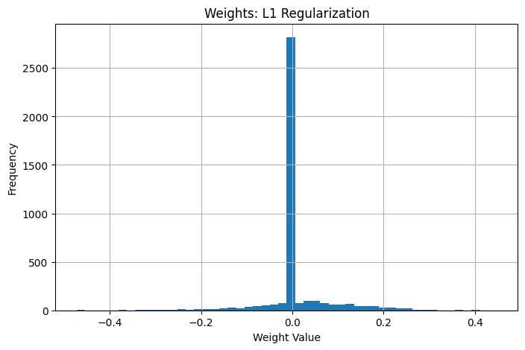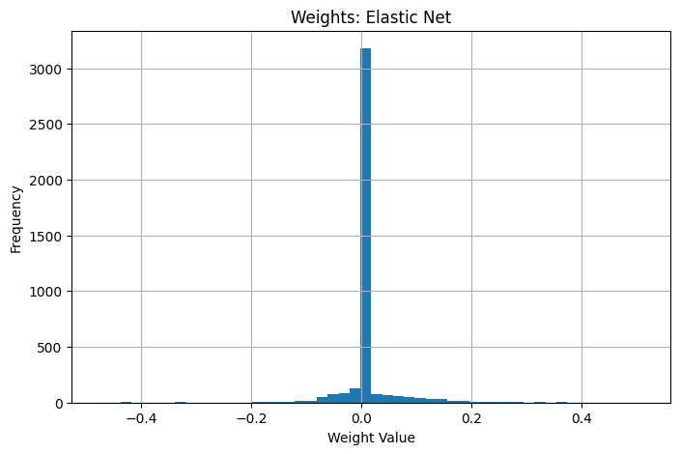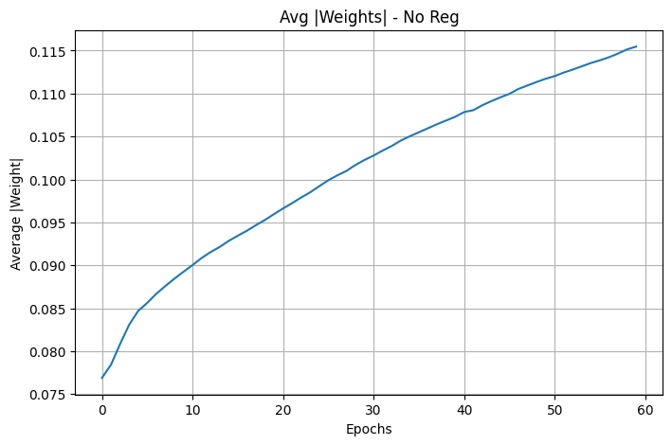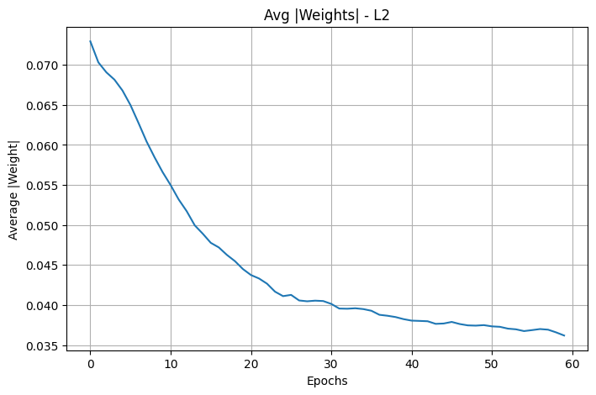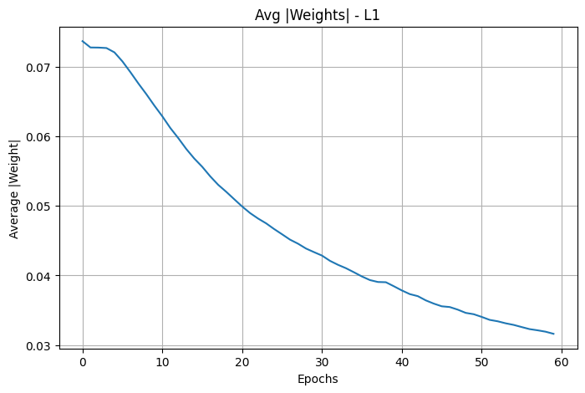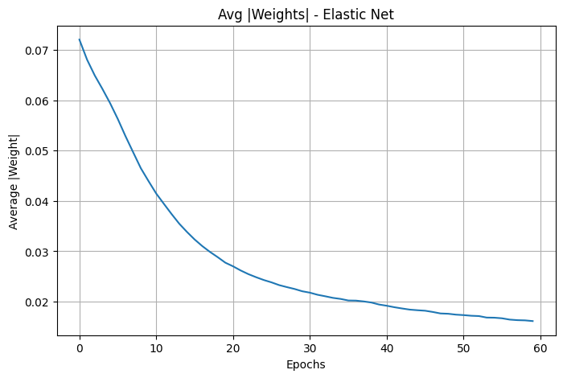

Final Performance Interpretation

- Without regularization, training accuracy is very high, indicating possible overfitting.
- L2 regularization achieves balanced training and testing accuracy with low test loss.
- L1 regularization reduces model complexity but slightly lowers test accuracy.
- Elastic Net provides stable accuracy and good generalization.
- L2 and Elastic Net show the best overall performance on unseen data.

Lab 4
4.1 Implementation of CNN from scratch on your choice of dataset. Share the link of dataset while submitting.
4.2 Implementation of YoloV5 and YoloV8 Model on the Dataset link attached here . Also try to incorporate ensemble learning here too and show how the predictions has improved using ensemble learning.
Datasets for the Roll numbers
1. VisDrone Dataset :- Task 1 Object detection in Images . Roll no ( 2 to 16)
2. Brain Tumour Dataset : Roll no (17-32)
3. African Wildlife Dataset : Roll no (33-48)
4. Signature Detection Dataset: Roll no (49-63)
For both 4.1 and 4.2 Please consider training your model only up to 500 images if the dataset is too large. Also, attach the PDF and .py file.
1 week of time is given for performing both the experiments.

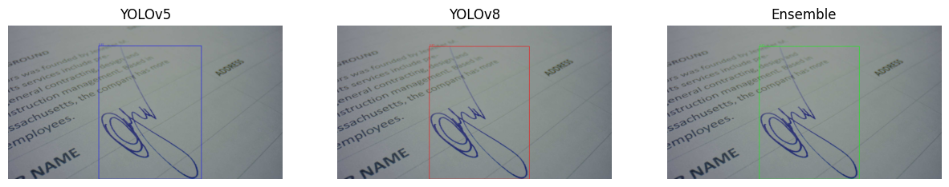
# -*- coding: utf-8 -*-
"""2548562_DL_Lab4.ipynb
Automatically generated by Colab.
Original file is located at
https://colab.research.google.com/drive/1TXqoxlNZEvTQ13ViUPQMYX5hzMQbVbNe
# Building CNN from scratch
## Setup
"""
import numpy as np
import matplotlib.pyplot as plt
from keras.datasets import mnist
"""## Load Dataset"""
(x_train, y_train), (x_test, y_test) = mnist.load_data()
# normalize
x_train = x_train / 255.0
x_test = x_test / 255.0
# reshape to (samples, channels, height, width)
x_train = x_train.reshape(-1,1,28,28)
x_test = x_test.reshape(-1,1,28,28)
"""## Implementing Convolution Layer"""
def conv_forward(image, filt, bias, stride=1):
# extracting filter dimensions
n_filters, n_c, f, _ = filt.shape
# extracting image dimensions
n_c, in_dim, _ = image.shape
# calculating output dimension according to image and filter
out_dim = int((in_dim - f)/stride) + 1
# initializing output feature maps
out = np.zeros((n_filters, out_dim, out_dim))
# loop through each filter
for curr_f in range(n_filters):
curr_y = out_y = 0
# this for moving filter vertically
while curr_y + f <= in_dim:
curr_x = out_x = 0
# this for moving filter horizontally
while curr_x + f <= in_dim:
# the convolution operation
out[curr_f, out_y, out_x] = np.sum(
filt[curr_f] * image[:, curr_y:curr_y+f, curr_x:curr_x+f]
) + bias[curr_f]
# move filter position to right
curr_x += stride
out_x += 1
# this for moving filter position to down
curr_y += stride
out_y += 1
# returns extracted features
return out
"""- this function will apply convolution filters to an input image to extract features
- it takes image, filt(kernel), bias (added after convolution) and stride (step size of filter movement) as input
- Extracting filter dimensions: n_filters is number of filters, n_c is channer (for RGB there are 3 and for our grayscale, there is only one), and f is the filter size.
- Extracting image dimensions: n_c is again channel, and in_dim is height and width
- applies multiple filters across the input image to extract important visual features
- Each filter slides across the image and computes element-wise multiplication followed by summation and bias addition
- This process generates feature maps that highlight patterns such as edges and curves, enabling the CNN to learn meaningful representations from the input
## ReLU function
"""
def relu(x):
return np.maximum(0, x)
"""## Max Pooling"""
# function takes image, size of pooling window and
# stride of pooling window as input
def maxpool(image, size=2, stride=2):
# getting dimension of the feature mape (we get it from conv_forward functoin)
# channer, height, weight
n_c, h_prev, w_prev = image.shape
# calculates the heights and weights after max pooling
h = int((h_prev - size)/stride) + 1
w = int((w_prev - size)/stride) + 1
# initializing output with zeroes
downsampled = np.zeros((n_c, h, w))
# looping through each feature map
for i in range(n_c):
curr_y = out_y = 0
# while loop to move window veritcally
while curr_y + size <= h_prev:
curr_x = out_x = 0
# while loop to move window horizontally
while curr_x + size <= w_prev:
# select maximum value from the window
downsampled[i, out_y, out_x] = np.max(
image[i, curr_y:curr_y+size, curr_x:curr_x+size]
)
# move window to right
curr_x += stride
out_x += 1
# move window to left
curr_y += stride
out_y += 1
return downsampled
"""- Max pooling performs downsampling by selecting the maximum value from small regions of the feature map that we will get from the conv_forward funtion
- it helps reduce computation, reduce overfitting, retain strongest features and make model robust to small shifts.
- we take max value because we want to extract strongest edge, strongest curve or most important feature
## Softmax and Loss
"""
def softmax(x):
e = np.exp(x - np.max(x))
return e / e.sum()
def cross_entropy(pred, label):
return -np.log(pred[label])
"""- softmax converts raw output scores into probabilities
- we subtract by np.max(x) to prevent numerical overflow when exponent value become very large
- cross_entropy measures how wrong the prediction is
- if predicted probability is too far from true probability, it will assing bigger loss
- otherewise, it will assign a smaller loss
## Fully Connected layer
"""
# takes flattened features as input and gives output
def dense(x, W, b):
return np.dot(W, x) + b
"""## Pipeline"""
np.random.seed(0)
# 8 filters of 3x3 size
# dividing by 9 keeps values small and maintains stable learning
filt = np.random.randn(8,1,3,3) / 9
# to shift activation values
bias = np.zeros((8,1))
# 10 weights for 10 output classes
W = np.random.randn(10, 1352) * 0.01
# 10 biase
b = np.zeros((10,1))
"""## Forward Pass Example"""
# process 10 first images
for i in range(10):
# input image
img = x_train[i]
# label
label = y_train[i]
# convolution layer
conv = conv_forward(img, filt, bias)
# relu activation function to remove negative values
relu_out = relu(conv)
# max pooling
pool = maxpool(relu_out)
# falttening the output
fc_input = pool.flatten().reshape(-1,1)
# sending it to dense layer
out = dense(fc_input, W, b)
# softmax activation function to count probabilities
probs = softmax(out)
print("Predicted:", np.argmax(probs))
print("Actual:", label)
"""# YOLO
## YOLO V8
### Setup
"""
!pwd
# Commented out IPython magic to ensure Python compatibility.
# %cd "/content/drive/MyDrive/DL datasets"
!ls
!pip install ultralytics -q
# download dataset
!wget -q https://github.com/ultralytics/assets/releases/download/v0.0.0/signature.zip
# unzip dataset
!unzip -q signature.zip
!ls
!unzip -q signature.zip
!ls signature
!ls
!ls signature/images/train | head
"""### YOLOv8 Training"""
data = "/content/drive/MyDrive/DL datasets/signature.yaml"
"""- the above yaml file has information about dataset structure, including training and validation images paths and class labels"""
from ultralytics import YOLO
# loading pre-trained YOLO model
model_v8 = YOLO('yolov8n.pt')
# training the model on signature dataset
model_v8.train(
data=data,
epochs=50,
# resizing image to 640x640 for better standarization
imgsz=640,
batch=8,
project="/content/drive/MyDrive/DL datasets",
name='signature_training_v8'
)
"""- The YOLOv8 model was trained for 50 epochs using 640 x 640 images.
### Model Inference
"""
from ultralytics import YOLO
model_v8 = YOLO("/content/drive/MyDrive/DL datasets/signature_training_v8/weights/best.pt")
model_v8.predict(
source="/content/drive/MyDrive/DL datasets/signature/images/val",
save=True,
save_txt=True,
save_conf=True
)
model_v8.predict(
source="/content/drive/MyDrive/DL datasets/signature/images/val",
save=True,
# if confidence is < 0.25 then it will be removed
conf=0.25
)
"""#### Now we can see the output in runs/detect/predict
### Validation and Visualization
"""
from ultralytics import YOLO
model_v8 = YOLO("/content/drive/MyDrive/DL datasets/signature_training_v8/weights/best.pt")
metrics_v8 = model_v8.val()
metrics_v8
"""- The trained YOLO v8 model was evaluated on 35 validation images
- model achieved a precision of 0.997 and recall of 1.0
- we can tell that it is highly accurate detection with no missed signatures
- The mAP@0.5 score of 0.995 also demonstrates excellent detection performance
- the mAP@0.5-0.95 score of 0.969 indicates strong bounding box localizatoin acccuracy
"""
from IPython.display import Image
Image(filename="/content/drive/MyDrive/DL datasets/signature_training_v8/results.png")
"""- The training and validation loss curves show a steady decrease
- the model successfully learned meaningful features without overfitting
- Precision and recall rapidly improved and stabilized near 1.0, demonstrating reliable detection performance
- The mAP curves show continuous improvement, reaching values close to 1.0
"""
from IPython.display import Image, display
import glob
results = glob.glob("/content/drive/MyDrive/DL datasets/runs/detect/predict/*.jpg")
for img in results[:5]:
display(Image(filename=img))
"""## YOLO v5
### Setup
"""
!pwd
# Commented out IPython magic to ensure Python compatibility.
!git clone https://github.com/ultralytics/yolov5
# %cd yolov5
!pip install -r requirements.txt
"""
### Training the model"""
# Commented out IPython magic to ensure Python compatibility.
import os
# Ensure the current directory is where yolov5 is cloned
# %cd /content/drive/MyDrive/DL datasets/yolov5
# Construct the command with quoted paths
!python train.py \
--img 640 \
--batch 8 \
--epochs 50 \
--data "/content/drive/MyDrive/DL datasets/signature.yaml" \
--weights yolov5s.pt \
--project signature_training_v5 \
--name yolov5
!pwd
"""### validation and visualization"""
!python val.py \
--weights signature_training_v5/yolov54/weights/best.pt \
--data "/content/drive/MyDrive/DL datasets/signature.yaml" \
--img 640
"""- the model was validated using 35 images, it shows the precision of 0.99 and recall of 1 just like before in YOLO v8.
- it learned patterns meaningfully, and scores demonstrates that
"""
!python detect.py \
--weights signature_training_v5/yolov54/weights/best.pt \
--source "/content/drive/MyDrive/DL datasets/yolov5/signature/images/val" \
--conf 0.25 \
--save-txt \
--save-conf
from IPython.display import Image
Image(filename='/content/drive/MyDrive/DL datasets/yolov5/signature_training_v5/yolov54/results.png')
from IPython.display import Image, display
import glob
v5_results = glob.glob("/content/drive/MyDrive/DL datasets/yolov5/runs/detect/exp/*.jpg")
for img in v5_results[:5]:
display(Image(filename=img))
"""# Ensemble implementation
## Setup
"""
import os
import glob
v5_labels_path = "/content/drive/MyDrive/DL datasets/yolov5/runs/detect/exp/labels"
v8_labels_path = "/content/drive/MyDrive/DL datasets/runs/detect/predict/labels"
# folder to save ensemble predictions
ensemble_output = "/content/drive/MyDrive/DL datasets/ensemble_labels"
os.makedirs(ensemble_output, exist_ok=True)
"""## Generating labels using ensemble learning"""
# Convert YOLO format to box corners
# YOLO format: class x_center y_center width height confidence
def yolo_to_corners(box):
_, x, y, w, h, conf = box
x1 = x - w/2
y1 = y - h/2
x2 = x + w/2
y2 = y + h/2
return [x1, y1, x2, y2, conf]
# Intersection over Union (IoU)
# measures overlap between two boxes
def iou(boxA, boxB):
xA = max(boxA[0], boxB[0])
yA = max(boxA[1], boxB[1])
xB = min(boxA[2], boxB[2])
yB = min(boxA[3], boxB[3])
interArea = max(0, xB - xA) * max(0, yB - yA)
boxAArea = (boxA[2]-boxA[0]) * (boxA[3]-boxA[1])
boxBArea = (boxB[2]-boxB[0]) * (boxB[3]-boxB[1])
union = boxAArea + boxBArea - interArea
return interArea / union if union != 0 else 0
# Read YOLO label file
def read_labels(path):
boxes = []
if not os.path.exists(path):
return boxes
with open(path, "r") as f:
for line in f.readlines():
parts = list(map(float, line.strip().split()))
boxes.append(parts)
return boxes
# Ensemble process for each image
label_files = glob.glob(v5_labels_path + "/*.txt")
for file in label_files:
filename = os.path.basename(file)
v5_file = os.path.join(v5_labels_path, filename)
v8_file = os.path.join(v8_labels_path, filename)
v5_boxes = read_labels(v5_file)
v8_boxes = read_labels(v8_file)
combined = v5_boxes + v8_boxes
final_boxes = []
# Remove duplicate boxes using IoU
while combined:
chosen = combined.pop(0)
chosen_corner = yolo_to_corners(chosen)
keep = True
for fb in final_boxes:
fb_corner = yolo_to_corners(fb)
# if boxes overlap heavily then duplicate
if iou(chosen_corner, fb_corner) > 0.5:
# keep box with higher confidence
if chosen[5] > fb[5]:
final_boxes.remove(fb)
final_boxes.append(chosen)
keep = False
break
if keep:
final_boxes.append(chosen)
# Save ensemble results
out_path = os.path.join(ensemble_output, filename)
with open(out_path, "w") as f:
for box in final_boxes:
f.write(" ".join(map(str, box)) + "\n")
print("Ensemble predictions saved to:", ensemble_output)
"""## Generating output images"""
import cv2
import os
import glob
from matplotlib import pyplot as plt
# Paths
image_folder = "/content/drive/MyDrive/DL datasets/signature/images/val"
label_folder = "/content/drive/MyDrive/DL datasets/ensemble_labels"
output_folder = "/content/drive/MyDrive/DL datasets/ensemble_visuals"
os.makedirs(output_folder, exist_ok=True)
# Function to draw bounding boxes
def draw_boxes(image_path, label_path):
img = cv2.imread(image_path)
h, w, _ = img.shape
if os.path.exists(label_path):
with open(label_path, "r") as f:
for line in f.readlines():
cls, x, y, bw, bh, conf = map(float, line.split())
# Convert YOLO format → pixel coordinates
x1 = int((x - bw/2) * w)
y1 = int((y - bh/2) * h)
x2 = int((x + bw/2) * w)
y2 = int((y + bh/2) * h)
# Draw rectangle
cv2.rectangle(img, (x1, y1), (x2, y2), (0,255,0), 2)
# Label text
label = f"Signature {conf:.2f}"
cv2.putText(img, label, (x1, y1-5),
cv2.FONT_HERSHEY_SIMPLEX,
0.5, (0,255,0), 1)
return img
# Draw ensemble detections
image_paths = glob.glob(image_folder + "/*.jpg")
for img_path in image_paths[:5]: # show first 5 images
filename = os.path.basename(img_path)
label_path = os.path.join(label_folder, filename.replace(".jpg",".txt"))
result_img = draw_boxes(img_path, label_path)
# Save output
save_path = os.path.join(output_folder, filename)
cv2.imwrite(save_path, result_img)
# VVisualization
plt.figure(figsize=(6,6))
plt.imshow(cv2.cvtColor(result_img, cv2.COLOR_BGR2RGB))
plt.axis("off")
plt.title("Ensemble Detection Result")
plt.show()
print("✅ Ensemble visual results saved in:", output_folder)
"""## Comparison and visualization"""
import cv2
import os
import glob
from matplotlib import pyplot as plt
# paths
image_folder = "/content/drive/MyDrive/DL datasets/signature/images/val"
v5_labels = "/content/drive/MyDrive/DL datasets/yolov5/runs/detect/exp/labels"
v8_labels = "/content/drive/MyDrive/DL datasets/runs/detect/predict/labels"
ens_labels = "/content/drive/MyDrive/DL datasets/ensemble_labels"
# Function to draw bounding boxes
def draw_boxes(image_path, label_path, color):
img = cv2.imread(image_path)
h, w, _ = img.shape
if os.path.exists(label_path):
with open(label_path, "r") as f:
for line in f.readlines():
parts = list(map(float, line.split()))
cls, x, y, bw, bh, conf = parts
x1 = int((x - bw/2) * w)
y1 = int((y - bh/2) * h)
x2 = int((x + bw/2) * w)
y2 = int((y + bh/2) * h)
cv2.rectangle(img, (x1, y1), (x2, y2), color, 2)
cv2.putText(img, f"{conf:.2f}", (x1, y1-5),
cv2.FONT_HERSHEY_SIMPLEX, 0.5, color, 1)
return img
# Compare detections
image_paths = glob.glob(image_folder + "/*.jpg")
for img_path in image_paths[:5]: # show 5 samples
filename = os.path.basename(img_path)
v5_path = os.path.join(v5_labels, filename.replace(".jpg",".txt"))
v8_path = os.path.join(v8_labels, filename.replace(".jpg",".txt"))
ens_path = os.path.join(ens_labels, filename.replace(".jpg",".txt"))
img_v5 = draw_boxes(img_path, v5_path, (255,0,0)) # Blue
img_v8 = draw_boxes(img_path, v8_path, (0,0,255)) # Red
img_ens = draw_boxes(img_path, ens_path, (0,255,0)) # Green
plt.figure(figsize=(15,5))
plt.subplot(1,3,1)
plt.imshow(cv2.cvtColor(img_v5, cv2.COLOR_BGR2RGB))
plt.title("YOLOv5")
plt.axis("off")
plt.subplot(1,3,2)
plt.imshow(cv2.cvtColor(img_v8, cv2.COLOR_BGR2RGB))
plt.title("YOLOv8")
plt.axis("off")
plt.subplot(1,3,3)
plt.imshow(cv2.cvtColor(img_ens, cv2.COLOR_BGR2RGB))
plt.title("Ensemble")
plt.axis("off")
plt.show()
"""- As we can see, ensemble learning does not improve results much
- because the two models that we used for ensemble learning, were already powerful enought with good precision and recall
- ensemble learning is helpful when we have more than one weak models, in this scenerio, it won't benefit us.
"""
# -*- coding: utf-8 -*-
"""2548562_DL_Lab4.ipynb
Automatically generated by Colab.
Original file is located at
https://colab.research.google.com/drive/1TXqoxlNZEvTQ13ViUPQMYX5hzMQbVbNe
# Building CNN from scratch
## Setup
"""
import numpy as np
import matplotlib.pyplot as plt
from keras.datasets import mnist
"""## Load Dataset"""
(x_train, y_train), (x_test, y_test) = mnist.load_data()
# normalize
x_train = x_train / 255.0
x_test = x_test / 255.0
# reshape to (samples, channels, height, width)
x_train = x_train.reshape(-1,1,28,28)
x_test = x_test.reshape(-1,1,28,28)
"""## Implementing Convolution Layer"""
def conv_forward(image, filt, bias, stride=1):
# extracting filter dimensions
n_filters, n_c, f, _ = filt.shape
# extracting image dimensions
n_c, in_dim, _ = image.shape
# calculating output dimension according to image and filter
out_dim = int((in_dim - f)/stride) + 1
# initializing output feature maps
out = np.zeros((n_filters, out_dim, out_dim))
# loop through each filter
for curr_f in range(n_filters):
curr_y = out_y = 0
# this for moving filter vertically
while curr_y + f <= in_dim:
curr_x = out_x = 0
# this for moving filter horizontally
while curr_x + f <= in_dim:
# the convolution operation
out[curr_f, out_y, out_x] = np.sum(
filt[curr_f] * image[:, curr_y:curr_y+f, curr_x:curr_x+f]
) + bias[curr_f]
# move filter position to right
curr_x += stride
out_x += 1
# this for moving filter position to down
curr_y += stride
out_y += 1
# returns extracted features
return out
"""- this function will apply convolution filters to an input image to extract features
- it takes image, filt(kernel), bias (added after convolution) and stride (step size of filter movement) as input
- Extracting filter dimensions: n_filters is number of filters, n_c is channer (for RGB there are 3 and for our grayscale, there is only one), and f is the filter size.
- Extracting image dimensions: n_c is again channel, and in_dim is height and width
- applies multiple filters across the input image to extract important visual features
- Each filter slides across the image and computes element-wise multiplication followed by summation and bias addition
- This process generates feature maps that highlight patterns such as edges and curves, enabling the CNN to learn meaningful representations from the input
## ReLU function
"""
def relu(x):
return np.maximum(0, x)
"""## Max Pooling"""
# function takes image, size of pooling window and
# stride of pooling window as input
def maxpool(image, size=2, stride=2):
# getting dimension of the feature mape (we get it from conv_forward functoin)
# channer, height, weight
n_c, h_prev, w_prev = image.shape
# calculates the heights and weights after max pooling
h = int((h_prev - size)/stride) + 1
w = int((w_prev - size)/stride) + 1
# initializing output with zeroes
downsampled = np.zeros((n_c, h, w))
# looping through each feature map
for i in range(n_c):
curr_y = out_y = 0
# while loop to move window veritcally
while curr_y + size <= h_prev:
curr_x = out_x = 0
# while loop to move window horizontally
while curr_x + size <= w_prev:
# select maximum value from the window
downsampled[i, out_y, out_x] = np.max(
image[i, curr_y:curr_y+size, curr_x:curr_x+size]
)
# move window to right
curr_x += stride
out_x += 1
# move window to left
curr_y += stride
out_y += 1
return downsampled
"""- Max pooling performs downsampling by selecting the maximum value from small regions of the feature map that we will get from the conv_forward funtion
- it helps reduce computation, reduce overfitting, retain strongest features and make model robust to small shifts.
- we take max value because we want to extract strongest edge, strongest curve or most important feature
## Softmax and Loss
"""
def softmax(x):
e = np.exp(x - np.max(x))
return e / e.sum()
def cross_entropy(pred, label):
return -np.log(pred[label])
"""- softmax converts raw output scores into probabilities
- we subtract by np.max(x) to prevent numerical overflow when exponent value become very large
- cross_entropy measures how wrong the prediction is
- if predicted probability is too far from true probability, it will assing bigger loss
- otherewise, it will assign a smaller loss
## Fully Connected layer
"""
# takes flattened features as input and gives output
def dense(x, W, b):
return np.dot(W, x) + b
"""## Pipeline"""
np.random.seed(0)
# 8 filters of 3x3 size
# dividing by 9 keeps values small and maintains stable learning
filt = np.random.randn(8,1,3,3) / 9
# to shift activation values
bias = np.zeros((8,1))
# 10 weights for 10 output classes
W = np.random.randn(10, 1352) * 0.01
# 10 biase
b = np.zeros((10,1))
"""## Forward Pass Example"""
# process 10 first images
for i in range(10):
# input image
img = x_train[i]
# label
label = y_train[i]
# convolution layer
conv = conv_forward(img, filt, bias)
# relu activation function to remove negative values
relu_out = relu(conv)
# max pooling
pool = maxpool(relu_out)
# falttening the output
fc_input = pool.flatten().reshape(-1,1)
# sending it to dense layer
out = dense(fc_input, W, b)
# softmax activation function to count probabilities
probs = softmax(out)
print("Predicted:", np.argmax(probs))
print("Actual:", label)
"""# YOLO
## YOLO V8
### Setup
"""
!pwd
# Commented out IPython magic to ensure Python compatibility.
# %cd "/content/drive/MyDrive/DL datasets"
!ls
!pip install ultralytics -q
# download dataset
!wget -q https://github.com/ultralytics/assets/releases/download/v0.0.0/signature.zip
# unzip dataset
!unzip -q signature.zip
!ls
!unzip -q signature.zip
!ls signature
!ls
!ls signature/images/train | head
"""### YOLOv8 Training"""
data = "/content/drive/MyDrive/DL datasets/signature.yaml"
"""- the above yaml file has information about dataset structure, including training and validation images paths and class labels"""
from ultralytics import YOLO
# loading pre-trained YOLO model
model_v8 = YOLO('yolov8n.pt')
# training the model on signature dataset
model_v8.train(
data=data,
epochs=50,
# resizing image to 640x640 for better standarization
imgsz=640,
batch=8,
project="/content/drive/MyDrive/DL datasets",
name='signature_training_v8'
)
"""- The YOLOv8 model was trained for 50 epochs using 640 x 640 images.
### Model Inference
"""
from ultralytics import YOLO
model_v8 = YOLO("/content/drive/MyDrive/DL datasets/signature_training_v8/weights/best.pt")
model_v8.predict(
source="/content/drive/MyDrive/DL datasets/signature/images/val",
save=True,
save_txt=True,
save_conf=True
)
model_v8.predict(
source="/content/drive/MyDrive/DL datasets/signature/images/val",
save=True,
# if confidence is < 0.25 then it will be removed
conf=0.25
)
"""#### Now we can see the output in runs/detect/predict
### Validation and Visualization
"""
from ultralytics import YOLO
model_v8 = YOLO("/content/drive/MyDrive/DL datasets/signature_training_v8/weights/best.pt")
metrics_v8 = model_v8.val()
metrics_v8
"""- The trained YOLO v8 model was evaluated on 35 validation images
- model achieved a precision of 0.997 and recall of 1.0
- we can tell that it is highly accurate detection with no missed signatures
- The mAP@0.5 score of 0.995 also demonstrates excellent detection performance
- the mAP@0.5-0.95 score of 0.969 indicates strong bounding box localizatoin acccuracy
"""
from IPython.display import Image
Image(filename="/content/drive/MyDrive/DL datasets/signature_training_v8/results.png")
"""- The training and validation loss curves show a steady decrease
- the model successfully learned meaningful features without overfitting
- Precision and recall rapidly improved and stabilized near 1.0, demonstrating reliable detection performance
- The mAP curves show continuous improvement, reaching values close to 1.0
"""
from IPython.display import Image, display
import glob
results = glob.glob("/content/drive/MyDrive/DL datasets/runs/detect/predict/*.jpg")
for img in results[:5]:
display(Image(filename=img))
"""## YOLO v5
### Setup
"""
!pwd
# Commented out IPython magic to ensure Python compatibility.
!git clone https://github.com/ultralytics/yolov5
# %cd yolov5
!pip install -r requirements.txt
"""
### Training the model"""
# Commented out IPython magic to ensure Python compatibility.
import os
# Ensure the current directory is where yolov5 is cloned
# %cd /content/drive/MyDrive/DL datasets/yolov5
# Construct the command with quoted paths
!python train.py \
--img 640 \
--batch 8 \
--epochs 50 \
--data "/content/drive/MyDrive/DL datasets/signature.yaml" \
--weights yolov5s.pt \
--project signature_training_v5 \
--name yolov5
!pwd
"""### validation and visualization"""
!python val.py \
--weights signature_training_v5/yolov54/weights/best.pt \
--data "/content/drive/MyDrive/DL datasets/signature.yaml" \
--img 640
"""- the model was validated using 35 images, it shows the precision of 0.99 and recall of 1 just like before in YOLO v8.
- it learned patterns meaningfully, and scores demonstrates that
"""
!python detect.py \
--weights signature_training_v5/yolov54/weights/best.pt \
--source "/content/drive/MyDrive/DL datasets/yolov5/signature/images/val" \
--conf 0.25 \
--save-txt \
--save-conf
from IPython.display import Image
Image(filename='/content/drive/MyDrive/DL datasets/yolov5/signature_training_v5/yolov54/results.png')
from IPython.display import Image, display
import glob
v5_results = glob.glob("/content/drive/MyDrive/DL datasets/yolov5/runs/detect/exp/*.jpg")
for img in v5_results[:5]:
display(Image(filename=img))
"""# Ensemble implementation
## Setup
"""
import os
import glob
v5_labels_path = "/content/drive/MyDrive/DL datasets/yolov5/runs/detect/exp/labels"
v8_labels_path = "/content/drive/MyDrive/DL datasets/runs/detect/predict/labels"
# folder to save ensemble predictions
ensemble_output = "/content/drive/MyDrive/DL datasets/ensemble_labels"
os.makedirs(ensemble_output, exist_ok=True)
"""## Generating labels using ensemble learning"""
# Convert YOLO format to box corners
# YOLO format: class x_center y_center width height confidence
def yolo_to_corners(box):
_, x, y, w, h, conf = box
x1 = x - w/2
y1 = y - h/2
x2 = x + w/2
y2 = y + h/2
return [x1, y1, x2, y2, conf]
# Intersection over Union (IoU)
# measures overlap between two boxes
def iou(boxA, boxB):
xA = max(boxA[0], boxB[0])
yA = max(boxA[1], boxB[1])
xB = min(boxA[2], boxB[2])
yB = min(boxA[3], boxB[3])
interArea = max(0, xB - xA) * max(0, yB - yA)
boxAArea = (boxA[2]-boxA[0]) * (boxA[3]-boxA[1])
boxBArea = (boxB[2]-boxB[0]) * (boxB[3]-boxB[1])
union = boxAArea + boxBArea - interArea
return interArea / union if union != 0 else 0
# Read YOLO label file
def read_labels(path):
boxes = []
if not os.path.exists(path):
return boxes
with open(path, "r") as f:
for line in f.readlines():
parts = list(map(float, line.strip().split()))
boxes.append(parts)
return boxes
# Ensemble process for each image
label_files = glob.glob(v5_labels_path + "/*.txt")
for file in label_files:
filename = os.path.basename(file)
v5_file = os.path.join(v5_labels_path, filename)
v8_file = os.path.join(v8_labels_path, filename)
v5_boxes = read_labels(v5_file)
v8_boxes = read_labels(v8_file)
combined = v5_boxes + v8_boxes
final_boxes = []
# Remove duplicate boxes using IoU
while combined:
chosen = combined.pop(0)
chosen_corner = yolo_to_corners(chosen)
keep = True
for fb in final_boxes:
fb_corner = yolo_to_corners(fb)
# if boxes overlap heavily then duplicate
if iou(chosen_corner, fb_corner) > 0.5:
# keep box with higher confidence
if chosen[5] > fb[5]:
final_boxes.remove(fb)
final_boxes.append(chosen)
keep = False
break
if keep:
final_boxes.append(chosen)
# Save ensemble results
out_path = os.path.join(ensemble_output, filename)
with open(out_path, "w") as f:
for box in final_boxes:
f.write(" ".join(map(str, box)) + "\n")
print("Ensemble predictions saved to:", ensemble_output)
"""## Generating output images"""
import cv2
import os
import glob
from matplotlib import pyplot as plt
# Paths
image_folder = "/content/drive/MyDrive/DL datasets/signature/images/val"
label_folder = "/content/drive/MyDrive/DL datasets/ensemble_labels"
output_folder = "/content/drive/MyDrive/DL datasets/ensemble_visuals"
os.makedirs(output_folder, exist_ok=True)
# Function to draw bounding boxes
def draw_boxes(image_path, label_path):
img = cv2.imread(image_path)
h, w, _ = img.shape
if os.path.exists(label_path):
with open(label_path, "r") as f:
for line in f.readlines():
cls, x, y, bw, bh, conf = map(float, line.split())
# Convert YOLO format → pixel coordinates
x1 = int((x - bw/2) * w)
y1 = int((y - bh/2) * h)
x2 = int((x + bw/2) * w)
y2 = int((y + bh/2) * h)
# Draw rectangle
cv2.rectangle(img, (x1, y1), (x2, y2), (0,255,0), 2)
# Label text
label = f"Signature {conf:.2f}"
cv2.putText(img, label, (x1, y1-5),
cv2.FONT_HERSHEY_SIMPLEX,
0.5, (0,255,0), 1)
return img
# Draw ensemble detections
image_paths = glob.glob(image_folder + "/*.jpg")
for img_path in image_paths[:5]: # show first 5 images
filename = os.path.basename(img_path)
label_path = os.path.join(label_folder, filename.replace(".jpg",".txt"))
result_img = draw_boxes(img_path, label_path)
# Save output
save_path = os.path.join(output_folder, filename)
cv2.imwrite(save_path, result_img)
# VVisualization
plt.figure(figsize=(6,6))
plt.imshow(cv2.cvtColor(result_img, cv2.COLOR_BGR2RGB))
plt.axis("off")
plt.title("Ensemble Detection Result")
plt.show()
print("✅ Ensemble visual results saved in:", output_folder)
"""## Comparison and visualization"""
import cv2
import os
import glob
from matplotlib import pyplot as plt
# paths
image_folder = "/content/drive/MyDrive/DL datasets/signature/images/val"
v5_labels = "/content/drive/MyDrive/DL datasets/yolov5/runs/detect/exp/labels"
v8_labels = "/content/drive/MyDrive/DL datasets/runs/detect/predict/labels"
ens_labels = "/content/drive/MyDrive/DL datasets/ensemble_labels"
# Function to draw bounding boxes
def draw_boxes(image_path, label_path, color):
img = cv2.imread(image_path)
h, w, _ = img.shape
if os.path.exists(label_path):
with open(label_path, "r") as f:
for line in f.readlines():
parts = list(map(float, line.split()))
cls, x, y, bw, bh, conf = parts
x1 = int((x - bw/2) * w)
y1 = int((y - bh/2) * h)
x2 = int((x + bw/2) * w)
y2 = int((y + bh/2) * h)
cv2.rectangle(img, (x1, y1), (x2, y2), color, 2)
cv2.putText(img, f"{conf:.2f}", (x1, y1-5),
cv2.FONT_HERSHEY_SIMPLEX, 0.5, color, 1)
return img
# Compare detections
image_paths = glob.glob(image_folder + "/*.jpg")
for img_path in image_paths[:5]: # show 5 samples
filename = os.path.basename(img_path)
v5_path = os.path.join(v5_labels, filename.replace(".jpg",".txt"))
v8_path = os.path.join(v8_labels, filename.replace(".jpg",".txt"))
ens_path = os.path.join(ens_labels, filename.replace(".jpg",".txt"))
img_v5 = draw_boxes(img_path, v5_path, (255,0,0)) # Blue
img_v8 = draw_boxes(img_path, v8_path, (0,0,255)) # Red
img_ens = draw_boxes(img_path, ens_path, (0,255,0)) # Green
plt.figure(figsize=(15,5))
plt.subplot(1,3,1)
plt.imshow(cv2.cvtColor(img_v5, cv2.COLOR_BGR2RGB))
plt.title("YOLOv5")
plt.axis("off")
plt.subplot(1,3,2)
plt.imshow(cv2.cvtColor(img_v8, cv2.COLOR_BGR2RGB))
plt.title("YOLOv8")
plt.axis("off")
plt.subplot(1,3,3)
plt.imshow(cv2.cvtColor(img_ens, cv2.COLOR_BGR2RGB))
plt.title("Ensemble")
plt.axis("off")
plt.show()
"""- As we can see, ensemble learning does not improve results much
- because the two models that we used for ensemble learning, were already powerful enought with good precision and recall
- ensemble learning is helpful when we have more than one weak models, in this scenerio, it won't benefit us.
"""
# -*- coding: utf-8 -*-
"""2548562_DL_Lab4.ipynb
Automatically generated by Colab.
Original file is located at
https://colab.research.google.com/drive/1TXqoxlNZEvTQ13ViUPQMYX5hzMQbVbNe
# Building CNN from scratch
## Setup
"""
import numpy as np
import matplotlib.pyplot as plt
from keras.datasets import mnist
"""## Load Dataset"""
(x_train, y_train), (x_test, y_test) = mnist.load_data()
# normalize
x_train = x_train / 255.0
x_test = x_test / 255.0
# reshape to (samples, channels, height, width)
x_train = x_train.reshape(-1,1,28,28)
x_test = x_test.reshape(-1,1,28,28)
"""## Implementing Convolution Layer"""
def conv_forward(image, filt, bias, stride=1):
# extracting filter dimensions
n_filters, n_c, f, _ = filt.shape
# extracting image dimensions
n_c, in_dim, _ = image.shape
# calculating output dimension according to image and filter
out_dim = int((in_dim - f)/stride) + 1
# initializing output feature maps
out = np.zeros((n_filters, out_dim, out_dim))
# loop through each filter
for curr_f in range(n_filters):
curr_y = out_y = 0
# this for moving filter vertically
while curr_y + f <= in_dim:
curr_x = out_x = 0
# this for moving filter horizontally
while curr_x + f <= in_dim:
# the convolution operation
out[curr_f, out_y, out_x] = np.sum(
filt[curr_f] * image[:, curr_y:curr_y+f, curr_x:curr_x+f]
) + bias[curr_f]
# move filter position to right
curr_x += stride
out_x += 1
# this for moving filter position to down
curr_y += stride
out_y += 1
# returns extracted features
return out
"""- this function will apply convolution filters to an input image to extract features
- it takes image, filt(kernel), bias (added after convolution) and stride (step size of filter movement) as input
- Extracting filter dimensions: n_filters is number of filters, n_c is channer (for RGB there are 3 and for our grayscale, there is only one), and f is the filter size.
- Extracting image dimensions: n_c is again channel, and in_dim is height and width
- applies multiple filters across the input image to extract important visual features
- Each filter slides across the image and computes element-wise multiplication followed by summation and bias addition
- This process generates feature maps that highlight patterns such as edges and curves, enabling the CNN to learn meaningful representations from the input
## ReLU function
"""
def relu(x):
return np.maximum(0, x)
"""## Max Pooling"""
# function takes image, size of pooling window and
# stride of pooling window as input
def maxpool(image, size=2, stride=2):
# getting dimension of the feature mape (we get it from conv_forward functoin)
# channer, height, weight
n_c, h_prev, w_prev = image.shape
# calculates the heights and weights after max pooling
h = int((h_prev - size)/stride) + 1
w = int((w_prev - size)/stride) + 1
# initializing output with zeroes
downsampled = np.zeros((n_c, h, w))
# looping through each feature map
for i in range(n_c):
curr_y = out_y = 0
# while loop to move window veritcally
while curr_y + size <= h_prev:
curr_x = out_x = 0
# while loop to move window horizontally
while curr_x + size <= w_prev:
# select maximum value from the window
downsampled[i, out_y, out_x] = np.max(
image[i, curr_y:curr_y+size, curr_x:curr_x+size]
)
# move window to right
curr_x += stride
out_x += 1
# move window to left
curr_y += stride
out_y += 1
return downsampled
"""- Max pooling performs downsampling by selecting the maximum value from small regions of the feature map that we will get from the conv_forward funtion
- it helps reduce computation, reduce overfitting, retain strongest features and make model robust to small shifts.
- we take max value because we want to extract strongest edge, strongest curve or most important feature
## Softmax and Loss
"""
def softmax(x):
e = np.exp(x - np.max(x))
return e / e.sum()
def cross_entropy(pred, label):
return -np.log(pred[label])
"""- softmax converts raw output scores into probabilities
- we subtract by np.max(x) to prevent numerical overflow when exponent value become very large
- cross_entropy measures how wrong the prediction is
- if predicted probability is too far from true probability, it will assing bigger loss
- otherewise, it will assign a smaller loss
## Fully Connected layer
"""
# takes flattened features as input and gives output
def dense(x, W, b):
return np.dot(W, x) + b
"""## Pipeline"""
np.random.seed(0)
# 8 filters of 3x3 size
# dividing by 9 keeps values small and maintains stable learning
filt = np.random.randn(8,1,3,3) / 9
# to shift activation values
bias = np.zeros((8,1))
# 10 weights for 10 output classes
W = np.random.randn(10, 1352) * 0.01
# 10 biase
b = np.zeros((10,1))
"""## Forward Pass Example"""
# process 10 first images
for i in range(10):
# input image
img = x_train[i]
# label
label = y_train[i]
# convolution layer
conv = conv_forward(img, filt, bias)
# relu activation function to remove negative values
relu_out = relu(conv)
# max pooling
pool = maxpool(relu_out)
# falttening the output
fc_input = pool.flatten().reshape(-1,1)
# sending it to dense layer
out = dense(fc_input, W, b)
# softmax activation function to count probabilities
probs = softmax(out)
print("Predicted:", np.argmax(probs))
print("Actual:", label)
"""# YOLO
## YOLO V8
### Setup
"""
!pwd
# Commented out IPython magic to ensure Python compatibility.
# %cd "/content/drive/MyDrive/DL datasets"
!ls
!pip install ultralytics -q
# download dataset
!wget -q https://github.com/ultralytics/assets/releases/download/v0.0.0/signature.zip
# unzip dataset
!unzip -q signature.zip
!ls
!unzip -q signature.zip
!ls signature
!ls
!ls signature/images/train | head
"""### YOLOv8 Training"""
data = "/content/drive/MyDrive/DL datasets/signature.yaml"
"""- the above yaml file has information about dataset structure, including training and validation images paths and class labels"""
from ultralytics import YOLO
# loading pre-trained YOLO model
model_v8 = YOLO('yolov8n.pt')
# training the model on signature dataset
model_v8.train(
data=data,
epochs=50,
# resizing image to 640x640 for better standarization
imgsz=640,
batch=8,
project="/content/drive/MyDrive/DL datasets",
name='signature_training_v8'
)
"""- The YOLOv8 model was trained for 50 epochs using 640 x 640 images.
### Model Inference
"""
from ultralytics import YOLO
model_v8 = YOLO("/content/drive/MyDrive/DL datasets/signature_training_v8/weights/best.pt")
model_v8.predict(
source="/content/drive/MyDrive/DL datasets/signature/images/val",
save=True,
save_txt=True,
save_conf=True
)
model_v8.predict(
source="/content/drive/MyDrive/DL datasets/signature/images/val",
save=True,
# if confidence is < 0.25 then it will be removed
conf=0.25
)
"""#### Now we can see the output in runs/detect/predict
### Validation and Visualization
"""
from ultralytics import YOLO
model_v8 = YOLO("/content/drive/MyDrive/DL datasets/signature_training_v8/weights/best.pt")
metrics_v8 = model_v8.val()
metrics_v8
"""- The trained YOLO v8 model was evaluated on 35 validation images
- model achieved a precision of 0.997 and recall of 1.0
- we can tell that it is highly accurate detection with no missed signatures
- The mAP@0.5 score of 0.995 also demonstrates excellent detection performance
- the mAP@0.5-0.95 score of 0.969 indicates strong bounding box localizatoin acccuracy
"""
from IPython.display import Image
Image(filename="/content/drive/MyDrive/DL datasets/signature_training_v8/results.png")
"""- The training and validation loss curves show a steady decrease
- the model successfully learned meaningful features without overfitting
- Precision and recall rapidly improved and stabilized near 1.0, demonstrating reliable detection performance
- The mAP curves show continuous improvement, reaching values close to 1.0
"""
from IPython.display import Image, display
import glob
results = glob.glob("/content/drive/MyDrive/DL datasets/runs/detect/predict/*.jpg")
for img in results[:5]:
display(Image(filename=img))
"""## YOLO v5
### Setup
"""
!pwd
# Commented out IPython magic to ensure Python compatibility.
!git clone https://github.com/ultralytics/yolov5
# %cd yolov5
!pip install -r requirements.txt
"""
### Training the model"""
# Commented out IPython magic to ensure Python compatibility.
import os
# Ensure the current directory is where yolov5 is cloned
# %cd /content/drive/MyDrive/DL datasets/yolov5
# Construct the command with quoted paths
!python train.py \
--img 640 \
--batch 8 \
--epochs 50 \
--data "/content/drive/MyDrive/DL datasets/signature.yaml" \
--weights yolov5s.pt \
--project signature_training_v5 \
--name yolov5
!pwd
"""### validation and visualization"""
!python val.py \
--weights signature_training_v5/yolov54/weights/best.pt \
--data "/content/drive/MyDrive/DL datasets/signature.yaml" \
--img 640
"""- the model was validated using 35 images, it shows the precision of 0.99 and recall of 1 just like before in YOLO v8.
- it learned patterns meaningfully, and scores demonstrates that
"""
!python detect.py \
--weights signature_training_v5/yolov54/weights/best.pt \
--source "/content/drive/MyDrive/DL datasets/yolov5/signature/images/val" \
--conf 0.25 \
--save-txt \
--save-conf
from IPython.display import Image
Image(filename='/content/drive/MyDrive/DL datasets/yolov5/signature_training_v5/yolov54/results.png')
from IPython.display import Image, display
import glob
v5_results = glob.glob("/content/drive/MyDrive/DL datasets/yolov5/runs/detect/exp/*.jpg")
for img in v5_results[:5]:
display(Image(filename=img))
"""# Ensemble implementation
## Setup
"""
import os
import glob
v5_labels_path = "/content/drive/MyDrive/DL datasets/yolov5/runs/detect/exp/labels"
v8_labels_path = "/content/drive/MyDrive/DL datasets/runs/detect/predict/labels"
# folder to save ensemble predictions
ensemble_output = "/content/drive/MyDrive/DL datasets/ensemble_labels"
os.makedirs(ensemble_output, exist_ok=True)
"""## Generating labels using ensemble learning"""
# Convert YOLO format to box corners
# YOLO format: class x_center y_center width height confidence
def yolo_to_corners(box):
_, x, y, w, h, conf = box
x1 = x - w/2
y1 = y - h/2
x2 = x + w/2
y2 = y + h/2
return [x1, y1, x2, y2, conf]
# Intersection over Union (IoU)
# measures overlap between two boxes
def iou(boxA, boxB):
xA = max(boxA[0], boxB[0])
yA = max(boxA[1], boxB[1])
xB = min(boxA[2], boxB[2])
yB = min(boxA[3], boxB[3])
interArea = max(0, xB - xA) * max(0, yB - yA)
boxAArea = (boxA[2]-boxA[0]) * (boxA[3]-boxA[1])
boxBArea = (boxB[2]-boxB[0]) * (boxB[3]-boxB[1])
union = boxAArea + boxBArea - interArea
return interArea / union if union != 0 else 0
# Read YOLO label file
def read_labels(path):
boxes = []
if not os.path.exists(path):
return boxes
with open(path, "r") as f:
for line in f.readlines():
parts = list(map(float, line.strip().split()))
boxes.append(parts)
return boxes
# Ensemble process for each image
label_files = glob.glob(v5_labels_path + "/*.txt")
for file in label_files:
filename = os.path.basename(file)
v5_file = os.path.join(v5_labels_path, filename)
v8_file = os.path.join(v8_labels_path, filename)
v5_boxes = read_labels(v5_file)
v8_boxes = read_labels(v8_file)
combined = v5_boxes + v8_boxes
final_boxes = []
# Remove duplicate boxes using IoU
while combined:
chosen = combined.pop(0)
chosen_corner = yolo_to_corners(chosen)
keep = True
for fb in final_boxes:
fb_corner = yolo_to_corners(fb)
# if boxes overlap heavily then duplicate
if iou(chosen_corner, fb_corner) > 0.5:
# keep box with higher confidence
if chosen[5] > fb[5]:
final_boxes.remove(fb)
final_boxes.append(chosen)
keep = False
break
if keep:
final_boxes.append(chosen)
# Save ensemble results
out_path = os.path.join(ensemble_output, filename)
with open(out_path, "w") as f:
for box in final_boxes:
f.write(" ".join(map(str, box)) + "\n")
print("Ensemble predictions saved to:", ensemble_output)
"""## Generating output images"""
import cv2
import os
import glob
from matplotlib import pyplot as plt
# Paths
image_folder = "/content/drive/MyDrive/DL datasets/signature/images/val"
label_folder = "/content/drive/MyDrive/DL datasets/ensemble_labels"
output_folder = "/content/drive/MyDrive/DL datasets/ensemble_visuals"
os.makedirs(output_folder, exist_ok=True)
# Function to draw bounding boxes
def draw_boxes(image_path, label_path):
img = cv2.imread(image_path)
h, w, _ = img.shape
if os.path.exists(label_path):
with open(label_path, "r") as f:
for line in f.readlines():
cls, x, y, bw, bh, conf = map(float, line.split())
# Convert YOLO format → pixel coordinates
x1 = int((x - bw/2) * w)
y1 = int((y - bh/2) * h)
x2 = int((x + bw/2) * w)
y2 = int((y + bh/2) * h)
# Draw rectangle
cv2.rectangle(img, (x1, y1), (x2, y2), (0,255,0), 2)
# Label text
label = f"Signature {conf:.2f}"
cv2.putText(img, label, (x1, y1-5),
cv2.FONT_HERSHEY_SIMPLEX,
0.5, (0,255,0), 1)
return img
# Draw ensemble detections
image_paths = glob.glob(image_folder + "/*.jpg")
for img_path in image_paths[:5]: # show first 5 images
filename = os.path.basename(img_path)
label_path = os.path.join(label_folder, filename.replace(".jpg",".txt"))
result_img = draw_boxes(img_path, label_path)
# Save output
save_path = os.path.join(output_folder, filename)
cv2.imwrite(save_path, result_img)
# VVisualization
plt.figure(figsize=(6,6))
plt.imshow(cv2.cvtColor(result_img, cv2.COLOR_BGR2RGB))
plt.axis("off")
plt.title("Ensemble Detection Result")
plt.show()
print("✅ Ensemble visual results saved in:", output_folder)
"""## Comparison and visualization"""
import cv2
import os
import glob
from matplotlib import pyplot as plt
# paths
image_folder = "/content/drive/MyDrive/DL datasets/signature/images/val"
v5_labels = "/content/drive/MyDrive/DL datasets/yolov5/runs/detect/exp/labels"
v8_labels = "/content/drive/MyDrive/DL datasets/runs/detect/predict/labels"
ens_labels = "/content/drive/MyDrive/DL datasets/ensemble_labels"
# Function to draw bounding boxes
def draw_boxes(image_path, label_path, color):
img = cv2.imread(image_path)
h, w, _ = img.shape
if os.path.exists(label_path):
with open(label_path, "r") as f:
for line in f.readlines():
parts = list(map(float, line.split()))
cls, x, y, bw, bh, conf = parts
x1 = int((x - bw/2) * w)
y1 = int((y - bh/2) * h)
x2 = int((x + bw/2) * w)
y2 = int((y + bh/2) * h)
cv2.rectangle(img, (x1, y1), (x2, y2), color, 2)
cv2.putText(img, f"{conf:.2f}", (x1, y1-5),
cv2.FONT_HERSHEY_SIMPLEX, 0.5, color, 1)
return img
# Compare detections
image_paths = glob.glob(image_folder + "/*.jpg")
for img_path in image_paths[:5]: # show 5 samples
filename = os.path.basename(img_path)
v5_path = os.path.join(v5_labels, filename.replace(".jpg",".txt"))
v8_path = os.path.join(v8_labels, filename.replace(".jpg",".txt"))
ens_path = os.path.join(ens_labels, filename.replace(".jpg",".txt"))
img_v5 = draw_boxes(img_path, v5_path, (255,0,0)) # Blue
img_v8 = draw_boxes(img_path, v8_path, (0,0,255)) # Red
img_ens = draw_boxes(img_path, ens_path, (0,255,0)) # Green
plt.figure(figsize=(15,5))
plt.subplot(1,3,1)
plt.imshow(cv2.cvtColor(img_v5, cv2.COLOR_BGR2RGB))
plt.title("YOLOv5")
plt.axis("off")
plt.subplot(1,3,2)
plt.imshow(cv2.cvtColor(img_v8, cv2.COLOR_BGR2RGB))
plt.title("YOLOv8")
plt.axis("off")
plt.subplot(1,3,3)
plt.imshow(cv2.cvtColor(img_ens, cv2.COLOR_BGR2RGB))
plt.title("Ensemble")
plt.axis("off")
plt.show()
"""- As we can see, ensemble learning does not improve results much
- because the two models that we used for ensemble learning, were already powerful enought with good precision and recall
- ensemble learning is helpful when we have more than one weak models, in this scenerio, it won't benefit us.
"""
# -*- coding: utf-8 -*-
"""2548562_DL_Lab4.ipynb
Automatically generated by Colab.
Original file is located at
https://colab.research.google.com/drive/1TXqoxlNZEvTQ13ViUPQMYX5hzMQbVbNe
# Building CNN from scratch
## Setup
"""
import numpy as np
import matplotlib.pyplot as plt
from keras.datasets import mnist
"""## Load Dataset"""
(x_train, y_train), (x_test, y_test) = mnist.load_data()
# normalize
x_train = x_train / 255.0
x_test = x_test / 255.0
# reshape to (samples, channels, height, width)
x_train = x_train.reshape(-1,1,28,28)
x_test = x_test.reshape(-1,1,28,28)
"""## Implementing Convolution Layer"""
def conv_forward(image, filt, bias, stride=1):
# extracting filter dimensions
n_filters, n_c, f, _ = filt.shape
# extracting image dimensions
n_c, in_dim, _ = image.shape
# calculating output dimension according to image and filter
out_dim = int((in_dim - f)/stride) + 1
# initializing output feature maps
out = np.zeros((n_filters, out_dim, out_dim))
# loop through each filter
for curr_f in range(n_filters):
curr_y = out_y = 0
# this for moving filter vertically
while curr_y + f <= in_dim:
curr_x = out_x = 0
# this for moving filter horizontally
while curr_x + f <= in_dim:
# the convolution operation
out[curr_f, out_y, out_x] = np.sum(
filt[curr_f] * image[:, curr_y:curr_y+f, curr_x:curr_x+f]
) + bias[curr_f]
# move filter position to right
curr_x += stride
out_x += 1
# this for moving filter position to down
curr_y += stride
out_y += 1
# returns extracted features
return out
"""- this function will apply convolution filters to an input image to extract features
- it takes image, filt(kernel), bias (added after convolution) and stride (step size of filter movement) as input
- Extracting filter dimensions: n_filters is number of filters, n_c is channer (for RGB there are 3 and for our grayscale, there is only one), and f is the filter size.
- Extracting image dimensions: n_c is again channel, and in_dim is height and width
- applies multiple filters across the input image to extract important visual features
- Each filter slides across the image and computes element-wise multiplication followed by summation and bias addition
- This process generates feature maps that highlight patterns such as edges and curves, enabling the CNN to learn meaningful representations from the input
## ReLU function
"""
def relu(x):
return np.maximum(0, x)
"""## Max Pooling"""
# function takes image, size of pooling window and
# stride of pooling window as input
def maxpool(image, size=2, stride=2):
# getting dimension of the feature mape (we get it from conv_forward functoin)
# channer, height, weight
n_c, h_prev, w_prev = image.shape
# calculates the heights and weights after max pooling
h = int((h_prev - size)/stride) + 1
w = int((w_prev - size)/stride) + 1
# initializing output with zeroes
downsampled = np.zeros((n_c, h, w))
# looping through each feature map
for i in range(n_c):
curr_y = out_y = 0
# while loop to move window veritcally
while curr_y + size <= h_prev:
curr_x = out_x = 0
# while loop to move window horizontally
while curr_x + size <= w_prev:
# select maximum value from the window
downsampled[i, out_y, out_x] = np.max(
image[i, curr_y:curr_y+size, curr_x:curr_x+size]
)
# move window to right
curr_x += stride
out_x += 1
# move window to left
curr_y += stride
out_y += 1
return downsampled
"""- Max pooling performs downsampling by selecting the maximum value from small regions of the feature map that we will get from the conv_forward funtion
- it helps reduce computation, reduce overfitting, retain strongest features and make model robust to small shifts.
- we take max value because we want to extract strongest edge, strongest curve or most important feature
## Softmax and Loss
"""
def softmax(x):
e = np.exp(x - np.max(x))
return e / e.sum()
def cross_entropy(pred, label):
return -np.log(pred[label])
"""- softmax converts raw output scores into probabilities
- we subtract by np.max(x) to prevent numerical overflow when exponent value become very large
- cross_entropy measures how wrong the prediction is
- if predicted probability is too far from true probability, it will assing bigger loss
- otherewise, it will assign a smaller loss
## Fully Connected layer
"""
# takes flattened features as input and gives output
def dense(x, W, b):
return np.dot(W, x) + b
"""## Pipeline"""
np.random.seed(0)
# 8 filters of 3x3 size
# dividing by 9 keeps values small and maintains stable learning
filt = np.random.randn(8,1,3,3) / 9
# to shift activation values
bias = np.zeros((8,1))
# 10 weights for 10 output classes
W = np.random.randn(10, 1352) * 0.01
# 10 biase
b = np.zeros((10,1))
"""## Forward Pass Example"""
# process 10 first images
for i in range(10):
# input image
img = x_train[i]
# label
label = y_train[i]
# convolution layer
conv = conv_forward(img, filt, bias)
# relu activation function to remove negative values
relu_out = relu(conv)
# max pooling
pool = maxpool(relu_out)
# falttening the output
fc_input = pool.flatten().reshape(-1,1)
# sending it to dense layer
out = dense(fc_input, W, b)
# softmax activation function to count probabilities
probs = softmax(out)
print("Predicted:", np.argmax(probs))
print("Actual:", label)
"""# YOLO
## YOLO V8
### Setup
"""
!pwd
# Commented out IPython magic to ensure Python compatibility.
# %cd "/content/drive/MyDrive/DL datasets"
!ls
!pip install ultralytics -q
# download dataset
!wget -q https://github.com/ultralytics/assets/releases/download/v0.0.0/signature.zip
# unzip dataset
!unzip -q signature.zip
!ls
!unzip -q signature.zip
!ls signature
!ls
!ls signature/images/train | head
"""### YOLOv8 Training"""
data = "/content/drive/MyDrive/DL datasets/signature.yaml"
"""- the above yaml file has information about dataset structure, including training and validation images paths and class labels"""
from ultralytics import YOLO
# loading pre-trained YOLO model
model_v8 = YOLO('yolov8n.pt')
# training the model on signature dataset
model_v8.train(
data=data,
epochs=50,
# resizing image to 640x640 for better standarization
imgsz=640,
batch=8,
project="/content/drive/MyDrive/DL datasets",
name='signature_training_v8'
)
"""- The YOLOv8 model was trained for 50 epochs using 640 x 640 images.
### Model Inference
"""
from ultralytics import YOLO
model_v8 = YOLO("/content/drive/MyDrive/DL datasets/signature_training_v8/weights/best.pt")
model_v8.predict(
source="/content/drive/MyDrive/DL datasets/signature/images/val",
save=True,
save_txt=True,
save_conf=True
)
model_v8.predict(
source="/content/drive/MyDrive/DL datasets/signature/images/val",
save=True,
# if confidence is < 0.25 then it will be removed
conf=0.25
)
"""#### Now we can see the output in runs/detect/predict
### Validation and Visualization
"""
from ultralytics import YOLO
model_v8 = YOLO("/content/drive/MyDrive/DL datasets/signature_training_v8/weights/best.pt")
metrics_v8 = model_v8.val()
metrics_v8
"""- The trained YOLO v8 model was evaluated on 35 validation images
- model achieved a precision of 0.997 and recall of 1.0
- we can tell that it is highly accurate detection with no missed signatures
- The mAP@0.5 score of 0.995 also demonstrates excellent detection performance
- the mAP@0.5-0.95 score of 0.969 indicates strong bounding box localizatoin acccuracy
"""
from IPython.display import Image
Image(filename="/content/drive/MyDrive/DL datasets/signature_training_v8/results.png")
"""- The training and validation loss curves show a steady decrease
- the model successfully learned meaningful features without overfitting
- Precision and recall rapidly improved and stabilized near 1.0, demonstrating reliable detection performance
- The mAP curves show continuous improvement, reaching values close to 1.0
"""
from IPython.display import Image, display
import glob
results = glob.glob("/content/drive/MyDrive/DL datasets/runs/detect/predict/*.jpg")
for img in results[:5]:
display(Image(filename=img))
"""## YOLO v5
### Setup
"""
!pwd
# Commented out IPython magic to ensure Python compatibility.
!git clone https://github.com/ultralytics/yolov5
# %cd yolov5
!pip install -r requirements.txt
"""
### Training the model"""
# Commented out IPython magic to ensure Python compatibility.
import os
# Ensure the current directory is where yolov5 is cloned
# %cd /content/drive/MyDrive/DL datasets/yolov5
# Construct the command with quoted paths
!python train.py \
--img 640 \
--batch 8 \
--epochs 50 \
--data "/content/drive/MyDrive/DL datasets/signature.yaml" \
--weights yolov5s.pt \
--project signature_training_v5 \
--name yolov5
!pwd
"""### validation and visualization"""
!python val.py \
--weights signature_training_v5/yolov54/weights/best.pt \
--data "/content/drive/MyDrive/DL datasets/signature.yaml" \
--img 640
"""- the model was validated using 35 images, it shows the precision of 0.99 and recall of 1 just like before in YOLO v8.
- it learned patterns meaningfully, and scores demonstrates that
"""
!python detect.py \
--weights signature_training_v5/yolov54/weights/best.pt \
--source "/content/drive/MyDrive/DL datasets/yolov5/signature/images/val" \
--conf 0.25 \
--save-txt \
--save-conf
from IPython.display import Image
Image(filename='/content/drive/MyDrive/DL datasets/yolov5/signature_training_v5/yolov54/results.png')
from IPython.display import Image, display
import glob
v5_results = glob.glob("/content/drive/MyDrive/DL datasets/yolov5/runs/detect/exp/*.jpg")
for img in v5_results[:5]:
display(Image(filename=img))
"""# Ensemble implementation
## Setup
"""
import os
import glob
v5_labels_path = "/content/drive/MyDrive/DL datasets/yolov5/runs/detect/exp/labels"
v8_labels_path = "/content/drive/MyDrive/DL datasets/runs/detect/predict/labels"
# folder to save ensemble predictions
ensemble_output = "/content/drive/MyDrive/DL datasets/ensemble_labels"
os.makedirs(ensemble_output, exist_ok=True)
"""## Generating labels using ensemble learning"""
# Convert YOLO format to box corners
# YOLO format: class x_center y_center width height confidence
def yolo_to_corners(box):
_, x, y, w, h, conf = box
x1 = x - w/2
y1 = y - h/2
x2 = x + w/2
y2 = y + h/2
return [x1, y1, x2, y2, conf]
# Intersection over Union (IoU)
# measures overlap between two boxes
def iou(boxA, boxB):
xA = max(boxA[0], boxB[0])
yA = max(boxA[1], boxB[1])
xB = min(boxA[2], boxB[2])
yB = min(boxA[3], boxB[3])
interArea = max(0, xB - xA) * max(0, yB - yA)
boxAArea = (boxA[2]-boxA[0]) * (boxA[3]-boxA[1])
boxBArea = (boxB[2]-boxB[0]) * (boxB[3]-boxB[1])
union = boxAArea + boxBArea - interArea
return interArea / union if union != 0 else 0
# Read YOLO label file
def read_labels(path):
boxes = []
if not os.path.exists(path):
return boxes
with open(path, "r") as f:
for line in f.readlines():
parts = list(map(float, line.strip().split()))
boxes.append(parts)
return boxes
# Ensemble process for each image
label_files = glob.glob(v5_labels_path + "/*.txt")
for file in label_files:
filename = os.path.basename(file)
v5_file = os.path.join(v5_labels_path, filename)
v8_file = os.path.join(v8_labels_path, filename)
v5_boxes = read_labels(v5_file)
v8_boxes = read_labels(v8_file)
combined = v5_boxes + v8_boxes
final_boxes = []
# Remove duplicate boxes using IoU
while combined:
chosen = combined.pop(0)
chosen_corner = yolo_to_corners(chosen)
keep = True
for fb in final_boxes:
fb_corner = yolo_to_corners(fb)
# if boxes overlap heavily then duplicate
if iou(chosen_corner, fb_corner) > 0.5:
# keep box with higher confidence
if chosen[5] > fb[5]:
final_boxes.remove(fb)
final_boxes.append(chosen)
keep = False
break
if keep:
final_boxes.append(chosen)
# Save ensemble results
out_path = os.path.join(ensemble_output, filename)
with open(out_path, "w") as f:
for box in final_boxes:
f.write(" ".join(map(str, box)) + "\n")
print("Ensemble predictions saved to:", ensemble_output)
"""## Generating output images"""
import cv2
import os
import glob
from matplotlib import pyplot as plt
# Paths
image_folder = "/content/drive/MyDrive/DL datasets/signature/images/val"
label_folder = "/content/drive/MyDrive/DL datasets/ensemble_labels"
output_folder = "/content/drive/MyDrive/DL datasets/ensemble_visuals"
os.makedirs(output_folder, exist_ok=True)
# Function to draw bounding boxes
def draw_boxes(image_path, label_path):
img = cv2.imread(image_path)
h, w, _ = img.shape
if os.path.exists(label_path):
with open(label_path, "r") as f:
for line in f.readlines():
cls, x, y, bw, bh, conf = map(float, line.split())
# Convert YOLO format → pixel coordinates
x1 = int((x - bw/2) * w)
y1 = int((y - bh/2) * h)
x2 = int((x + bw/2) * w)
y2 = int((y + bh/2) * h)
# Draw rectangle
cv2.rectangle(img, (x1, y1), (x2, y2), (0,255,0), 2)
# Label text
label = f"Signature {conf:.2f}"
cv2.putText(img, label, (x1, y1-5),
cv2.FONT_HERSHEY_SIMPLEX,
0.5, (0,255,0), 1)
return img
# Draw ensemble detections
image_paths = glob.glob(image_folder + "/*.jpg")
for img_path in image_paths[:5]: # show first 5 images
filename = os.path.basename(img_path)
label_path = os.path.join(label_folder, filename.replace(".jpg",".txt"))
result_img = draw_boxes(img_path, label_path)
# Save output
save_path = os.path.join(output_folder, filename)
cv2.imwrite(save_path, result_img)
# VVisualization
plt.figure(figsize=(6,6))
plt.imshow(cv2.cvtColor(result_img, cv2.COLOR_BGR2RGB))
plt.axis("off")
plt.title("Ensemble Detection Result")
plt.show()
print("✅ Ensemble visual results saved in:", output_folder)
"""## Comparison and visualization"""
import cv2
import os
import glob
from matplotlib import pyplot as plt
# paths
image_folder = "/content/drive/MyDrive/DL datasets/signature/images/val"
v5_labels = "/content/drive/MyDrive/DL datasets/yolov5/runs/detect/exp/labels"
v8_labels = "/content/drive/MyDrive/DL datasets/runs/detect/predict/labels"
ens_labels = "/content/drive/MyDrive/DL datasets/ensemble_labels"
# Function to draw bounding boxes
def draw_boxes(image_path, label_path, color):
img = cv2.imread(image_path)
h, w, _ = img.shape
if os.path.exists(label_path):
with open(label_path, "r") as f:
for line in f.readlines():
parts = list(map(float, line.split()))
cls, x, y, bw, bh, conf = parts
x1 = int((x - bw/2) * w)
y1 = int((y - bh/2) * h)
x2 = int((x + bw/2) * w)
y2 = int((y + bh/2) * h)
cv2.rectangle(img, (x1, y1), (x2, y2), color, 2)
cv2.putText(img, f"{conf:.2f}", (x1, y1-5),
cv2.FONT_HERSHEY_SIMPLEX, 0.5, color, 1)
return img
# Compare detections
image_paths = glob.glob(image_folder + "/*.jpg")
for img_path in image_paths[:5]: # show 5 samples
filename = os.path.basename(img_path)
v5_path = os.path.join(v5_labels, filename.replace(".jpg",".txt"))
v8_path = os.path.join(v8_labels, filename.replace(".jpg",".txt"))
ens_path = os.path.join(ens_labels, filename.replace(".jpg",".txt"))
img_v5 = draw_boxes(img_path, v5_path, (255,0,0)) # Blue
img_v8 = draw_boxes(img_path, v8_path, (0,0,255)) # Red
img_ens = draw_boxes(img_path, ens_path, (0,255,0)) # Green
plt.figure(figsize=(15,5))
plt.subplot(1,3,1)
plt.imshow(cv2.cvtColor(img_v5, cv2.COLOR_BGR2RGB))
plt.title("YOLOv5")
plt.axis("off")
plt.subplot(1,3,2)
plt.imshow(cv2.cvtColor(img_v8, cv2.COLOR_BGR2RGB))
plt.title("YOLOv8")
plt.axis("off")
plt.subplot(1,3,3)
plt.imshow(cv2.cvtColor(img_ens, cv2.COLOR_BGR2RGB))
plt.title("Ensemble")
plt.axis("off")
plt.show()
"""- As we can see, ensemble learning does not improve results much
- because the two models that we used for ensemble learning, were already powerful enought with good precision and recall
- ensemble learning is helpful when we have more than one weak models, in this scenerio, it won't benefit us.
"""

https://drive.google.com/drive/folders/1VY8GcA5DavZFBEjPm5WC2XHIzWmU-6Ah?usp=sharing

Program 5: Implementation of RNN and LSTM
Write a program to train a Next word predictor using RNN and LSTM.
Input: Any small text file (More than 150 lines).
Perform the following Tasks:
1. Load text
2. Create input sequences. Create character vocabulary and vectorize text.
3. Create training sequence
4. Build RNN model and LSTM Model
5. Train the model
6. Write text generation function
7. Generate the new text and validate.
Output Expected: Generated model produces text similar in style to training data.

Loading Data….
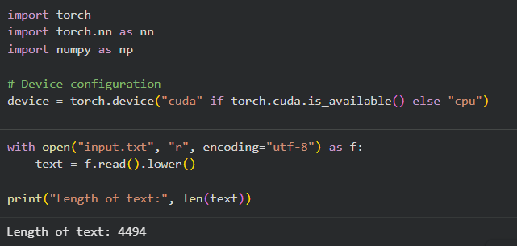
Creating Character Vocabulary and then Vectorizing Text
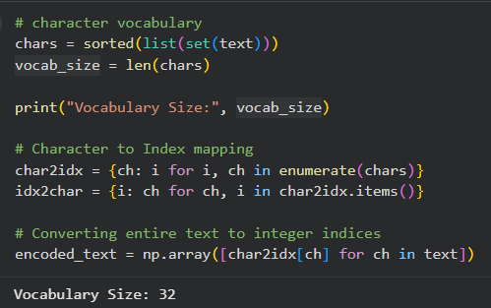
Creating Sequences
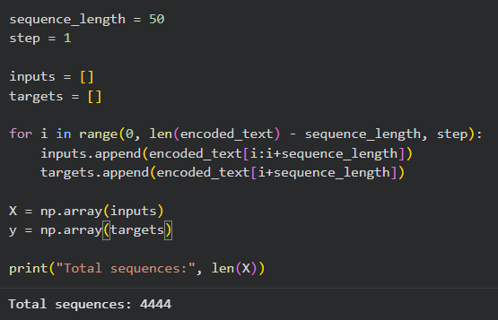

Converting to Tensors
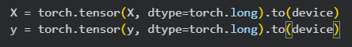
RNN
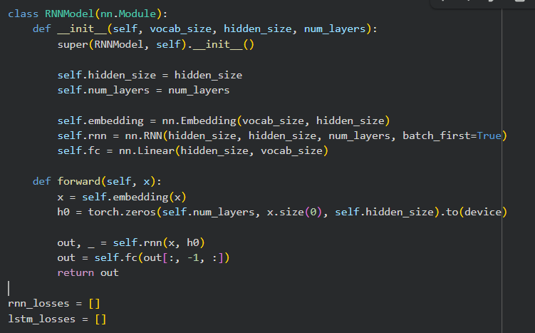
Train RNN
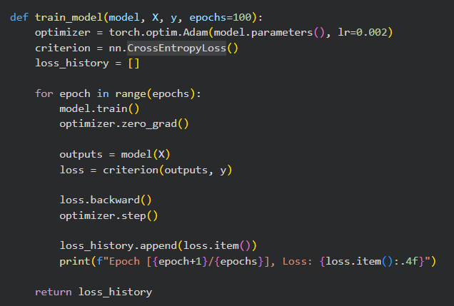
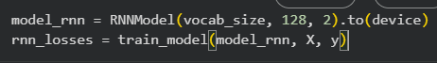
Output :-
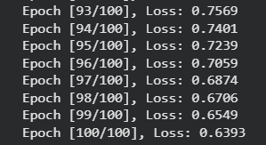
LSTM
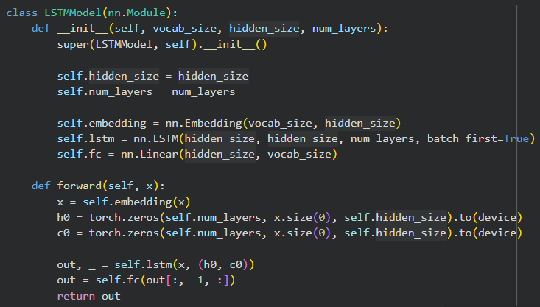
Train LSTM
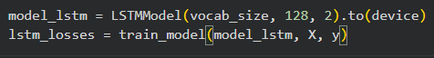
Output :-
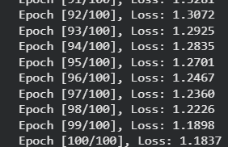
Text Generation
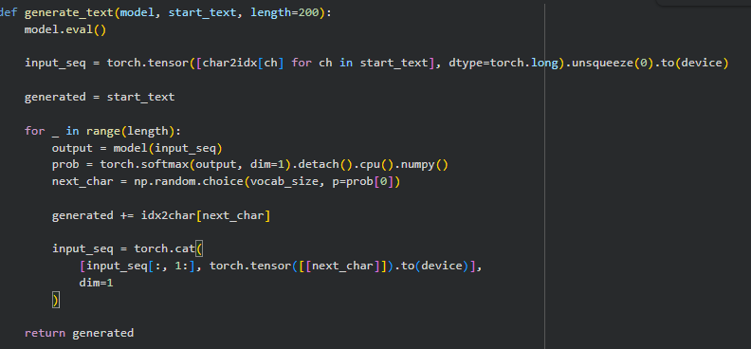

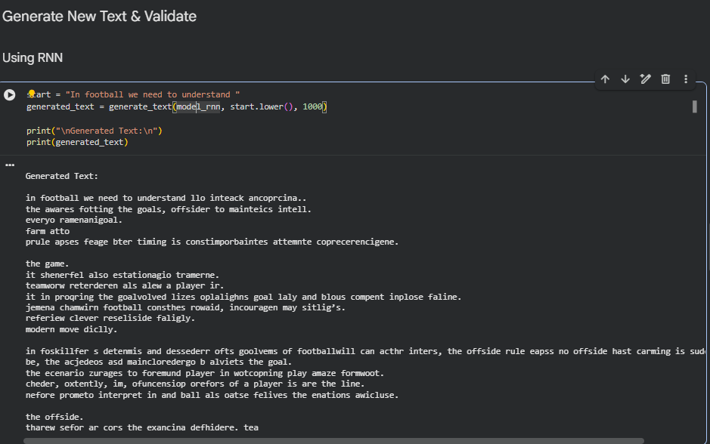
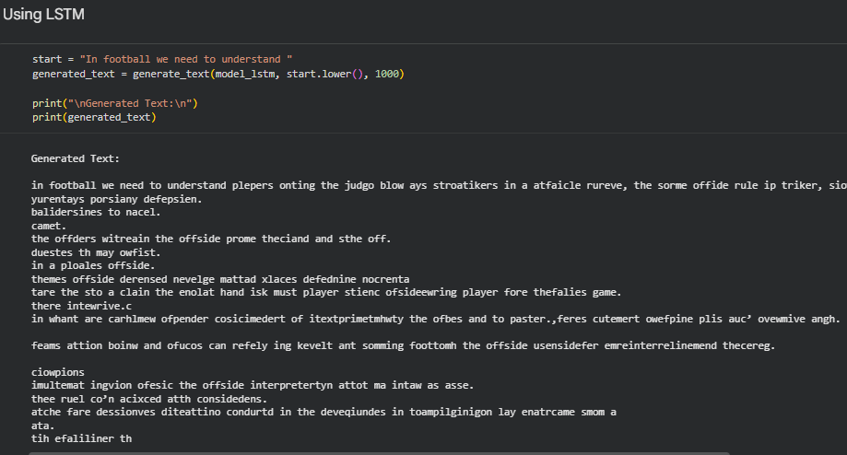
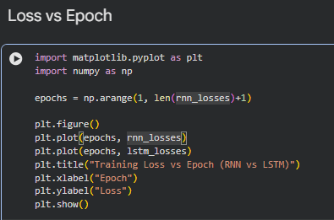
Output :-
