Taylor

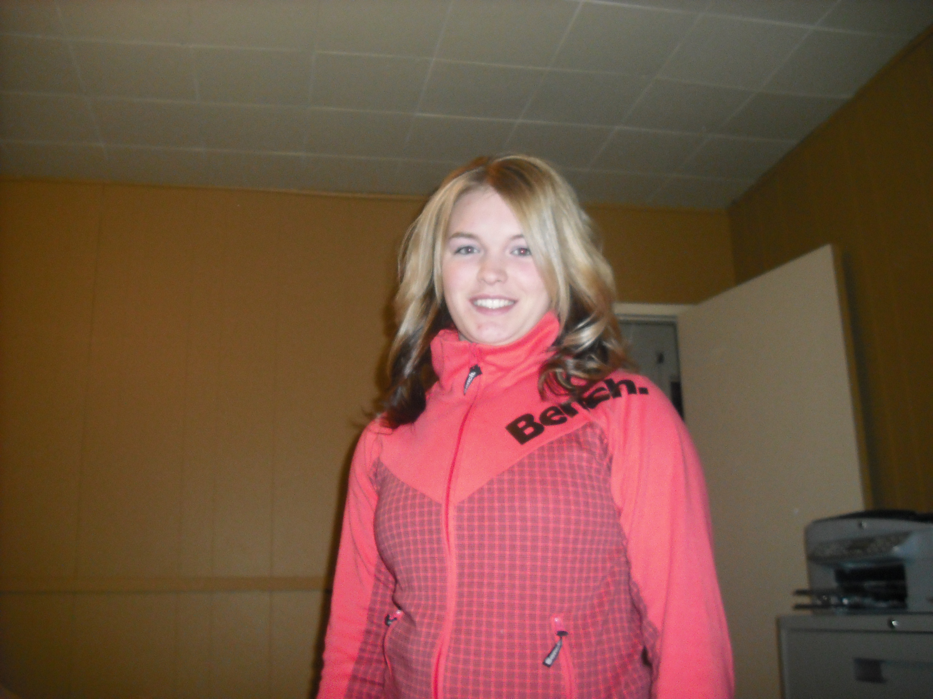

- I am currently attending the Cut Knife High School
- I like to play sports and my favorite sport is volleyball. I also enjoy playing hockey fastball and badminton. I love hanging out with my friends!
- I chose to work on this journalism project because I was curious to know what it would be like to be a reporter.
- Oh and I can’t forget, I’m very excited to go water sliding!
- I hope to learn more about journalism and all the different ways of technology you can use to share events.

