**Pre-K: Creative Dance & Music**

Music is used in a number of different ways in early years dance and music classes:

* to help transition from one activity to the next
* set the mood
* bring the energy up or to calm down

Students can be taught a number of different skills using different selections such as:

* walking/playing in time to the beat
* using music as background to other activity
* expressing how a selection makes them feel

**Music:**

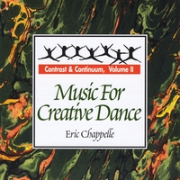Consult the insert with the CD for more ideas on how to use music from Contrast and Continuum Volume II

1. **Potpourri IV (track 21)** – Selection of music that stops and starts, going from longer intervals to shorter ones. Use for the spot/instrument dance. Have students alternate between dancing on the spots in different levels, speeds, body parts, etc. when the music stops have them freeze and when it starts again the dance around the spots moving through general space. Repeat.
2. **Caribbean Leaps (track 11)** – Selection of music with a nice tempo for jumping of all kinds. Use for obstacle course or other hopping, leaping skills that move through space.

1. **Pastorale and Whales (track 10 and 1)** – Calming, slow selection. Use at the end of class to relax students and prepare them for transitioning from dance to something else.
2. **Ski Reel (track 9) –** Use for circle dancing.
3. **Bee Beat and American Fiddler (track 2 and 13)** – Songs with strong beats, use for teaching moving skills or rhythm. Have students play along with instruments of clapping and stamping.

**Ashley Johnson**

Living Sky School Division

ArtsSmart 2015