[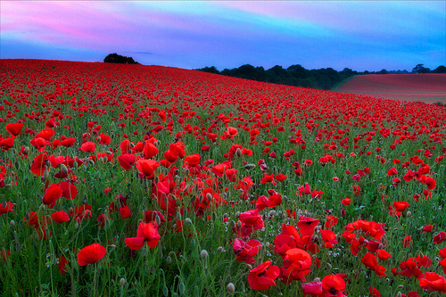](http://www.flickr.com/photos/richjjones/7370242980/)***Flanders* yikwahaskānihk**

“In Flanders Fields”

– Plains Cree translation, by Jean Okimāsis and Arok Wolvengrey,

– based on an original Woods Cree translation by Minnie Mckenzie.

*Flanders* yikwahaskānihk wāh-wēpāstanwa wāpikwaniya

In Flanders fields the poppies blow

tastawāyihk pimitāskwahikana kā-nāh-nīpitēstēki

Between the crosses, row on row,  
ta-kiskinawācihtāhk ita kā-pimisiniyāhk; māka kīsikohk

That mark our place; but in the sky

aniki ē-sōhkē-nikamocik piyēsīsak ē-pimihācik

The larks, still bravely singing, fly  
akāwāc pēhtākosiwak iyikohk ē-māh-matwēwēhk askīhk.

Scarce heard amid the guns below.

onakataskēwak niyanān. namōya māka kayās

We are the Dead. Short days ago  
nikī-pimātisinān, nikī-mōsihtānān kā-sākāstēk, nikī-wāpahtēnān kā-pahkisimok.

We lived, felt dawn, saw sunset glow,  
nikī-sākihiwānān mīna nikī-sākihikawinān, māka ēkwa nipimisininān

Loved and were loved, and now we lie  
ōta *Flanders* yikwahaskānihk.

In Flanders fields.

kiyawāw ēkwa naskwāhihkok kinōtinākaniminawak

Take up our quarrel with the foe:  
ē-kī-sākōcihikoyāhkik, kitāsōnamātinān

To you from failing hands we throw  
iskotēw; ohpinamok ēkwa kiyawāw.

The torch; be yours to hold it high.  
kīspin ānwēhtawiyāhki niyanān kā-nakataskēyāhk,

If ye break faith with us who die  
namwāc nika-aywēpinān, āta ē-ohpikiki wāpikwaniya

We shall not sleep, though poppies grow  
ōta *Flanders* yikwahaskānihk.

In Flanders Field