**Application form for admission to a Hampshire school outside the main admission round**

* **Please read the attached notes before completing this form.**
* **The pupil’s parent/guardian should fill in the form in BLOCK CAPITALS, using black ink, and then sign it.**
* **Please return this form to: County Admissions Team, Children’s Services Department, The Castle, Winchester, SO23 8UG. You may do this via a school.**

|  |  |  |  |
| --- | --- | --- | --- |
| Child’s Surname: ____________________________________________________ Forenames: ____________________________________________________________________  Any previous Surname: ____________________________________________________  Male:  Female:  Date of birth: ___________________________________________________________ Current Year Group: ____________________  Child’s permanent address*: ____________________________________________________________________________________________________________________________  _______________________________________________________________________________________________________________________________ Postcode: _____________________  Current or previous school: _______________________________________________________________________________________________________________________________  Catchment school: _________________________________________________________________________________________________________________________________________  Is child in the care of the local authority? YES / NO  Does the child have a statement of Special Educational Needs? YES / NO  *\*If you give false information the offer of a school place may be withdrawn*  **Please state your preferred schools and tick any box(es) which apply.** | | | |
|  | **First preference school** | **Second preference school** | **Third preference school** |
| **School name** |  |  |  |
| **Child or a family member with a significant medical,physical or psychological condition which makes it essential to attend the indicated school.** Evidence **must** be attached (see Note 1 below). |  |  |  |
| **hurch criterion** Supplementary information form **must** be sent to the school (see Note 2 below). |  |  |  |
| **Brother or sister currently on roll at the school or for whom an application to the school has been made\***  *For application to an infant or junior school, include any brother or sister on roll at the linked junior or infant school. | Full name of brother/sister: Date of birth: Current year group: | Full name of brother/sister: Date of birth: Current year group: | Full name of brother/sister: Date of birth: Current year group: |

**Notes:**

1. **Medical, physical or psychological criterion:** To be considered under this criterion, you **must** attach appropriate written evidence of your child’s (or a family member’s) significant medical, physical or psychological condition from, for example, a doctor or psychologist, which explains why it is **essential** that your child attends the indicated school. ***If you do not attach this evidence your application will not be considered under this criterion.*** Some Foundation and Aided schools do not use the County’s medical criterion. You should refer to the individual school’s admission criteria as listed in their admission policy.
2. **Church criterion:** To be considered under this criterion, you **must** complete the school’s supplementary information form, obtainable from the school. ***If you do not complete the supplementary information form and return it to the school your application will not be considered under this criterion.***

*CONTINUE OVERLEAF*



Form OOR01

**Applying for admission to secondary school outside the main admissions round – information for parents**

**Please read these notes before you complete your application.**

If you are a Hampshire resident applying for a place in secondary school, you must:

* apply online at www.hants.gov.uk/admissions ; or
* use the form *Application form for admission to a Hampshire school outside the main*

*admission round*, available from schools or from the County Admissions Team on 0845 603 5623.

Full information and guidance about admissions to Hampshire schools is given on Hampshire’s website, at www.hants.gov.uk/admissions

You may also refer to Hampshire County Council’s admissions brochure, which contains the same information. You are advised to visit your preferred school(s) and obtain a copy of the prospectus for each school. These contain further important information about admissions.

**Voluntary aided (VA) and foundation schools** may also

require a supplementary information form. Please check in the school’s prospectus. Supplementary information forms must be returned directly to the school.

**Entitlement to assistance with transport**

The eligibility criteria for assistance with transport are set out in detail on the Hampshire website and in the County admissions brochure. Please read this carefully before choosing your preferred schools. If you do not name your catchment school in your application it may affect your transport entitlement.

**Completing your application**

You can list up to three preferred schools in priority order. Please consider your preferences carefully; naming the same school more than once does not increase your chances of being offered a place.

**What will happen to my application?**

Your application to each school named on this form will be considered using that school’s admission policy. Where more

than one of your preferred schools can offer a place, the

higher preference school where you are successful will be allocated. If none of your preferred schools can offer a place, your child will be allocated a place in the catchment school or the school nearest to your home which can offer a place. Your child’s name will automatically be added to the waiting list of any schools where you were not successful, unless you were successful at a higher preference school. Details of your right of appeal will be provided in any refusal letter.

**Address**

If you are moving house, evidence of your new address should be attached to your application form. Proof of exchange of contracts or a signed tenancy agreement will normally be accepted. Contact the Admissions Team if you need help with this.

If the address on your form is not your child’s permanent

address, a Residence Order may be required for that address to

be considered. The County Council may monitor the residence details you provide, particularly if validity of a permanent address causes concern. An offer of a place may be withdrawn if you provide false information.

**When will I be told the outcome of my application?**

The County Admissions Team will send you a decision letter by first class post within 5 days of receipt of your application.

**How soon will I have to take up any place offered?**

You are expected to take up the place within four school weeks of the offer. Failure to do so will result in the offer being withdrawn. (There are exceptions for forces families and Crown servants -please contact the Admissions Team for details.)

**If you wish to apply for a place in a school outside Hampshire you must obtain an application form from the relevant authority.**

**If you need the information in this document in large print, translated, on audio cassette or in Braille, contact The County Admissions Team on 0845 603 5623.**



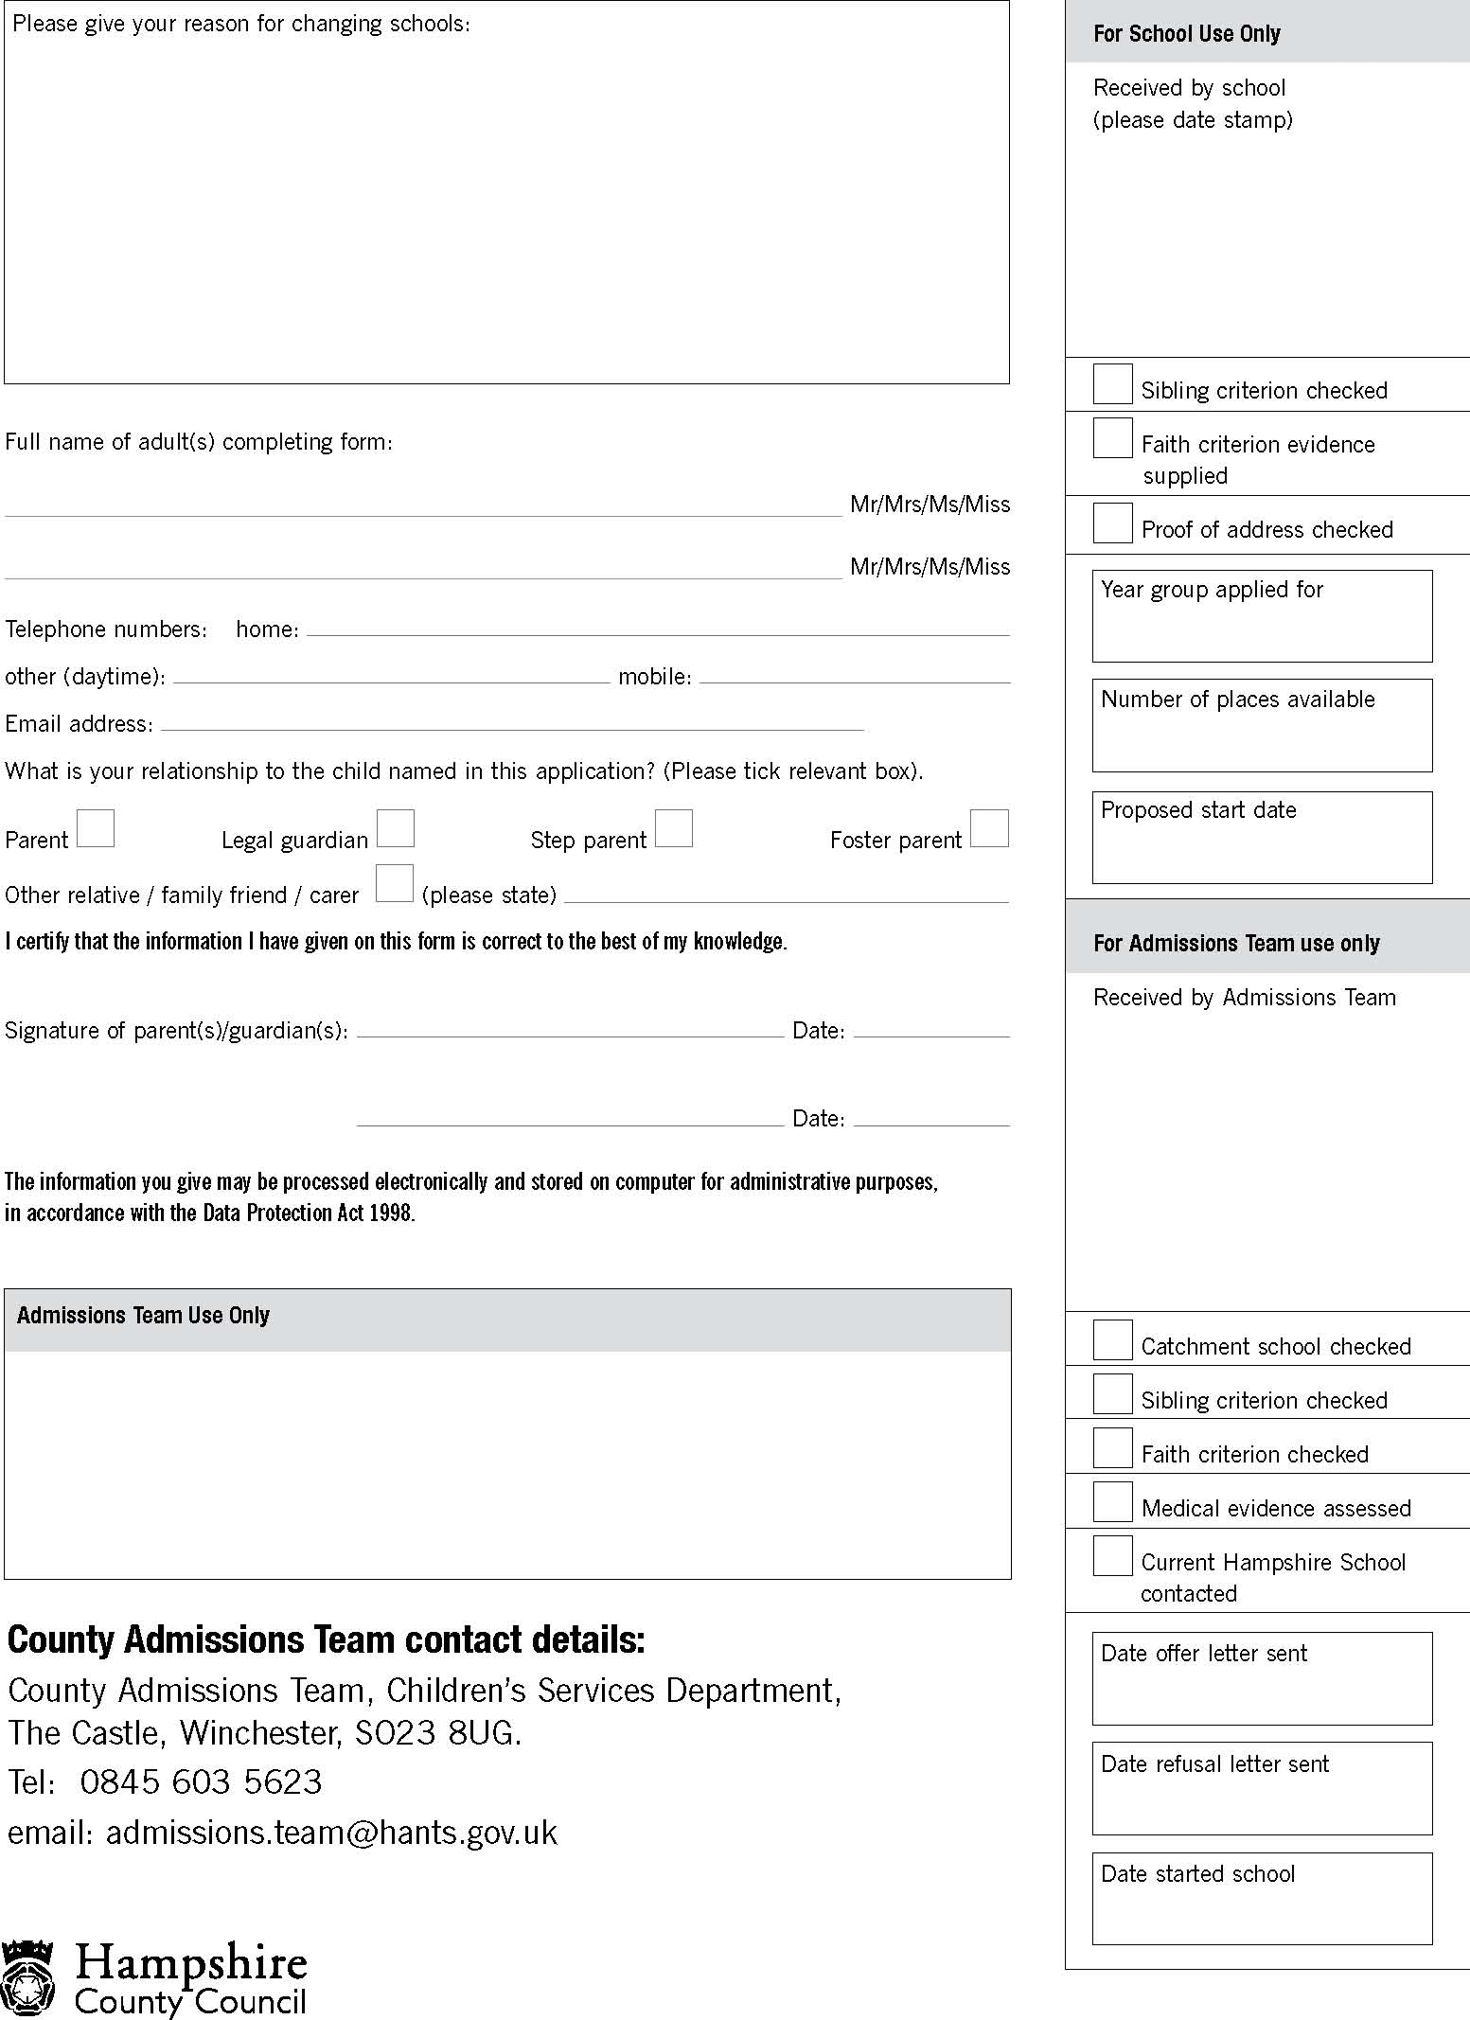

Please give your reason for changing schools: