**SCREENSHOTS**

**FRONT END:**

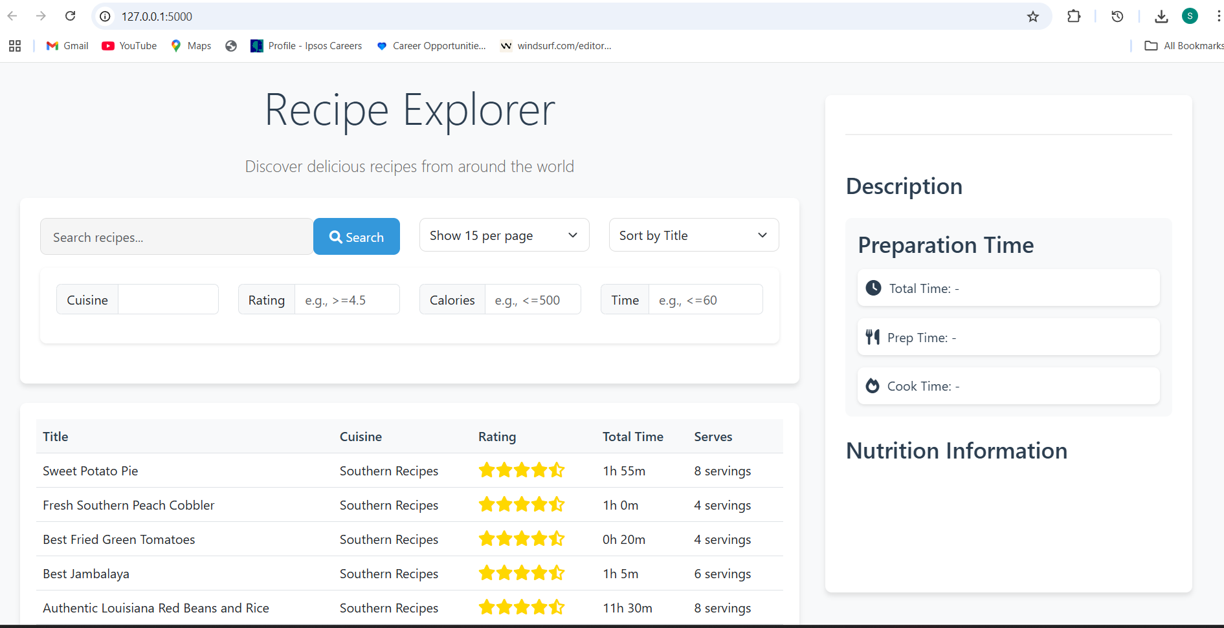

**INTERFACE:**

-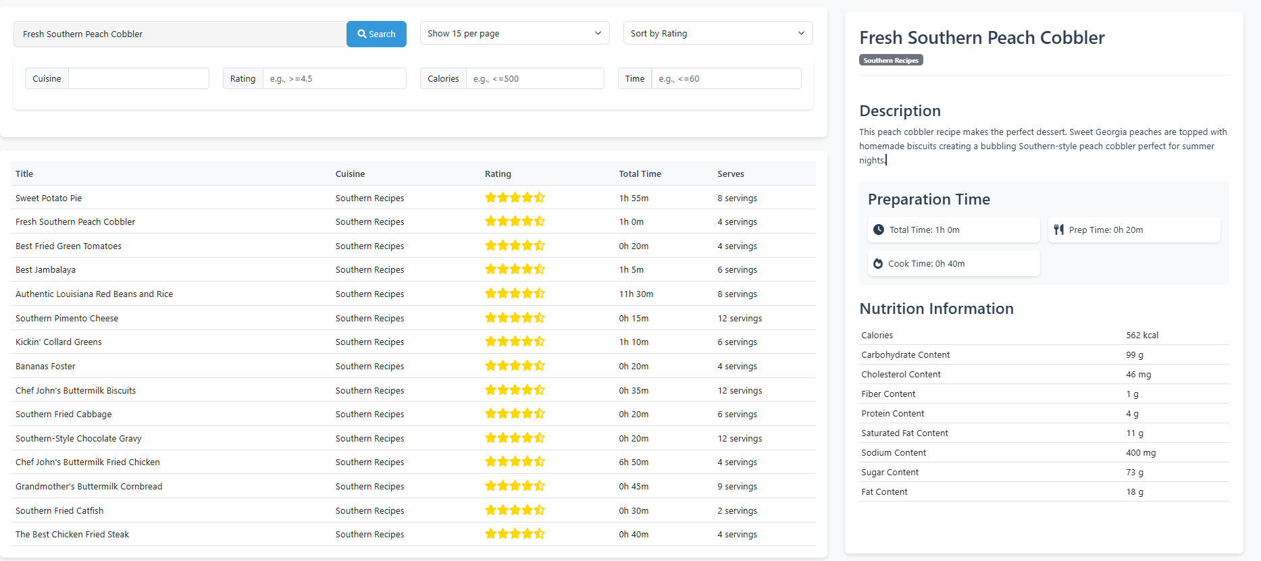

1. <http://127.0.0.1:5000/api/recipes?page=2&limit=10>

**The above link will give the recipes present in the page number mentioned there**.

For Example: if we edit 500 instead of 2 this link will take us to recipes in 500th page.

1. [http://127.0.0.1:5000/api/recipes/search?calories=<500](http://127.0.0.1:5000/api/recipes/search?calories=%3c500)

**The above link will give the recipes for calories less than or equal to 500.**

1. [http://127.0.0.1:5000/api/recipes/search?calories=>300](http://127.0.0.1:5000/api/recipes/search?calories=%3e300)

**The above link will give the recipes for calories greater than or equal to 300.**