InvoiceIQ
Automated Invoice Processing Agent

Solution demo overview — Copilot Studio, Azure AI Document Intelligence, Microsoft Fabric and Power BI
Source: Invoice_IQ.mp4 demo recording (3 min 24 s)
Prepared: 26 October 2026

Contents

1. Executive summary
InvoiceIQ is an autonomous invoice processing agent built in Microsoft Copilot Studio. When an invoice is uploaded to an Azure Blob Storage container, the agent is triggered automatically. It extracts key fields using Azure AI Document Intelligence (exposed to the agent as an MCP tool), and writes the structured result to an Excel table through a Power Automate flow.
The extracted data is then ingested into Microsoft Fabric with a Dataflow Gen2, stored as a Lakehouse table, modelled as a semantic model, and visualised in a Power BI report generated with Copilot. The result turns a manual, error-prone data-entry task into a hands-off pipeline that ends in a live finance dashboard.

2. Business problem
Finance and operations teams process large volumes of invoices. Today this typically means opening each invoice and manually capturing:
- Vendor details, invoice number and invoice date
- Line items and tax amounts
- Currency and total invoice value
As volumes grow, this manual process becomes time-consuming, introduces data-entry errors, and delays downstream processing such as approvals and payments.

3. Solution overview

3.1 End-to-end flow
- Upload — a user (or upstream system) drops an invoice PDF into the automated-invoice-processing-agent Blob container.
- Trigger — the Copilot Studio trigger "When a blob is added or modified (properties only) (V2)" fires and starts the agent.
- Extract — the agent calls the extract_invoice tool on the Invoice Extraction MCP server, which uses Azure AI Document Intelligence on the document's SAS URL.
- Save — the agent calls the Save Automated Invoice Output flow, which appends a row to the Invoice Output table in Excel (SharePoint / OneDrive).
- Ingest — a Fabric Dataflow Gen2 reads the Excel file, transforms it and loads it into a Lakehouse table.
- Model and report — a semantic model is built on the table, and Power BI Copilot generates the invoice dashboard.

3.2 Solution components
Layer | Component | Role in the solution
Intake | Azure Blob Storage — container automated-invoice-processing-agent | Landing zone for invoice PDFs; source of the event trigger
Orchestration | Copilot Studio — Automated Invoice Processing Agent (GPT-5.5 Chat model) | Autonomous agent that reacts to the trigger and decides which tools to call
Extraction | Invoice Extraction MCP (Model Context Protocol) — tool extract_invoice | Wraps Azure AI Document Intelligence; extracts data from invoices, bills, sales orders, purchase orders and utility bills
Persistence | Power Automate flow — Save Automated Invoice Output | Writes extracted fields to the Excel Invoice Output table
Data platform | Microsoft Fabric — Dataflow Gen2, Lakehouse, SQL analytics endpoint | Ingests and transforms Excel data into a governed Lakehouse table
Analytics | Semantic model + Power BI report with Copilot | Self-service dashboard instead of scrolling through spreadsheets

4. Demo walkthrough

4.1 Agent configuration in Copilot Studio
The agent is described as: "Automatically processes invoice documents uploaded to Azure Blob Storage, extracts invoice information using Azure Document Intelligence, and stores the extracted data in Excel." Its configuration has one trigger and two tools, with no knowledge sources:
- Trigger: When a blob is added or modified (properties only) (V2)
- Tool 1: Invoice Extraction MCP (Model Context Protocol connector)
- Tool 2: Save Automated Invoice Output (Power Automate flow)
- Topics: Greeting and Goodbye (defaults; not used in the autonomous path)
The agent's instructions start with "You are an autonomous invoice processing agent. A document will be received from an Azure Blob Storage event trigger." The rules visible in the demo include:
- If any required value is not available, use NA.
- Ignore information that is not required by the Save Automated Invoice Output tool.
- Do not search knowledge sources.
- Do not ask the user for additional information.
- Complete the processing autonomously.
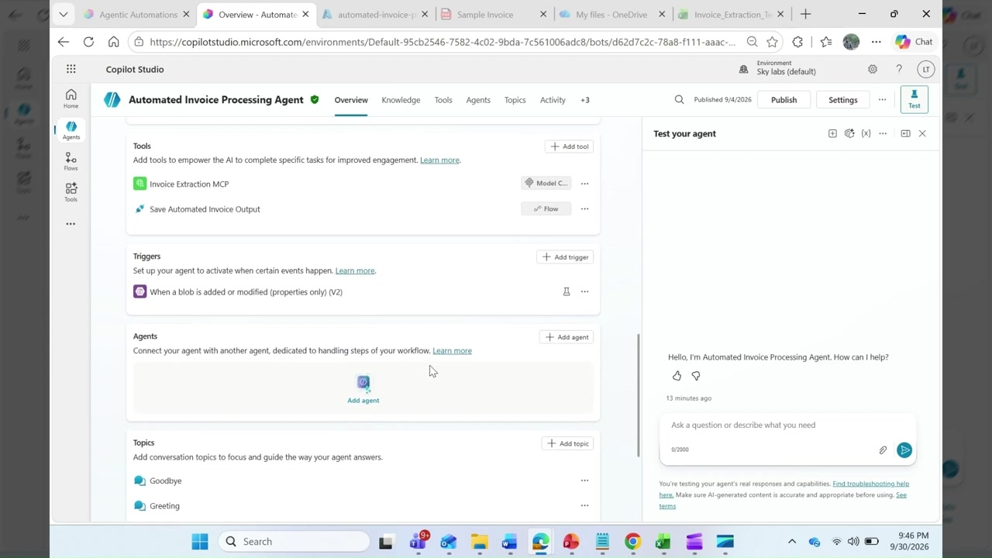
Figure 1 — Agent tools, trigger and topics in Copilot Studio

4.2 Uploading an invoice to Blob Storage
In the Azure portal, the presenter opens the automated-invoice-processing-agent container (storage account documenttranslation7217). It already holds sample invoices across industries — enterprise cloud services, SAP manufacturing, logistics, telecom, healthcare GST, ERP professional services, retail procurement, utilities and industrial equipment. A new file, Sample_Invoice (3).pdf, is uploaded through the Upload blob pane.
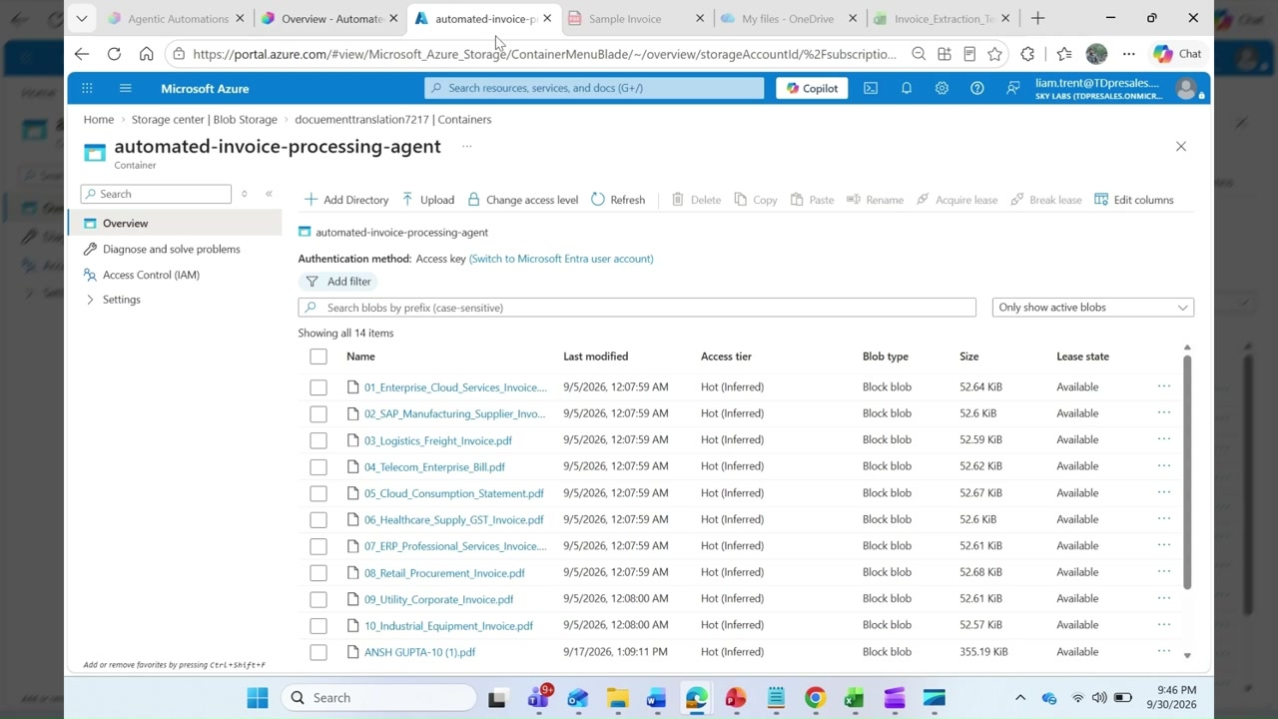
Figure 2 — Uploading a sample invoice to the Blob container

4.3 Agent run and extraction
The upload fires the trigger. The Activity view in Copilot Studio shows the run:
Step | Type | Duration
Trigger detected | Blob event | —
extract_invoice | Model Context Protocol tool | 8.99 s
Save Automated Invoice Output | Power Automate flow | 4.99 s
Result | "Invoice processed successfully. The invoice information was extracted and saved to Excel." | ≈ 14 s total

The MCP server's tool description says extract_invoice will "extract invoice information from invoice, bill, sales order, purchase order, or utility bill. Input must be a document URL, preferably Azure Blob SAS URL." The MCP server also advertises government identity document extraction.
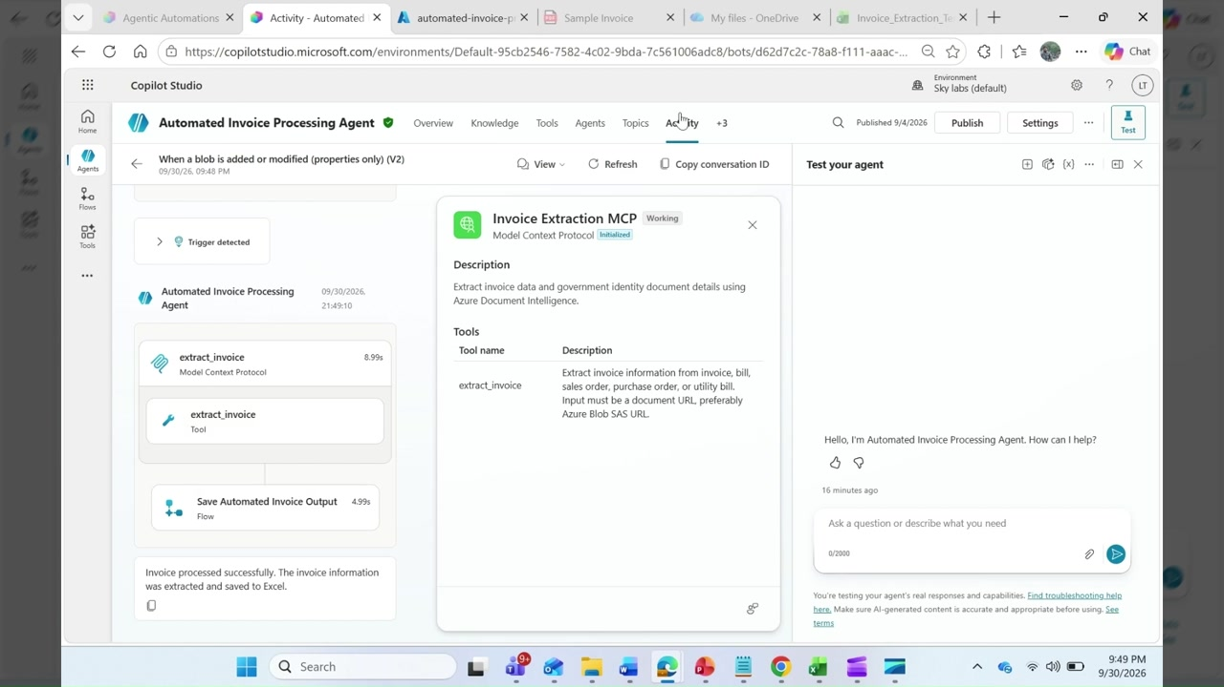
Figure 3 — Activity trace showing the MCP extraction and the Excel flow

4.4 Structured output in Excel
Each processed invoice becomes one row in the Invoice Output table of the "Automated Invoice Processing Agent Output" workbook. The columns are:
Column | Description | Example from demo
VendorName | Supplier issuing the invoice | APC
InvoiceNumber | Invoice identifier | APC/INV/26-27/77821
InvoiceDate | Date of issue | 29-Aug-26
CustomerName | Bill-to party | Contoso Automotive India Ltd. Accounts Payable Department
TotalTax | Tax amount with currency | NA / CHF 96.00
InvoiceTotal | Total payable with currency | INR 48,250.00
Currency | ISO currency code | INR, USD, CHF
ConfidenceScore | Extraction confidence (0–1) | 1
DocumentURL | SAS link to the source PDF in Blob | https://documenttranslation7217.blob.core.windows.net/…

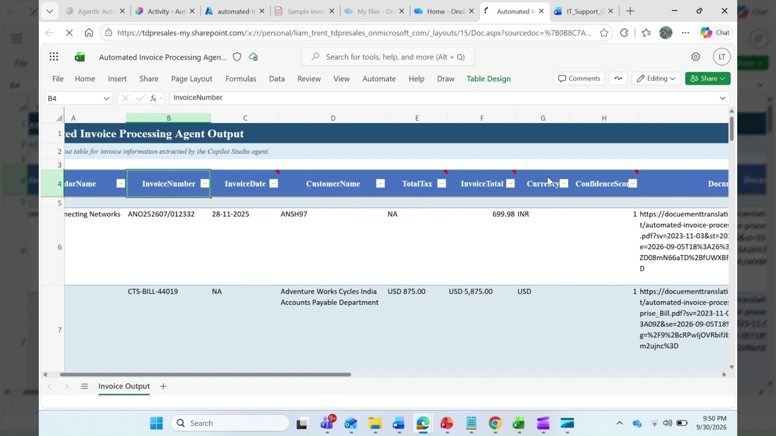
Figure 4 — Extracted invoice rows in the Excel Invoice Output table

4.5 Ingestion into Microsoft Fabric
In the Fabric workspace ("Test"), a Dataflow Gen2 reads the Excel file and transforms the data. The output is stored as a table in a Lakehouse (StagingLakehouseForDataflows, with its SQL analytics endpoint). A semantic model is then created on that table to serve as the reporting layer.

4.6 Power BI dashboard generated by Copilot
A new Power BI report is created from the semantic model. Measures and visuals can be built by hand with DAX, but the demo uses Power BI Copilot. The prompt asks for:
- Top row: KPI cards for Total Invoice Value (sum of InvoiceTotal), Total Tax (sum of TotalTax), Invoice Count (distinct count of InvoiceNumber), Average Invoice Value, and Average ConfidenceScore as a percentage.
- Middle row: clustered bar charts of InvoiceTotal by VendorName and by CustomerName, sorted descending.
- Conditional formatting that highlights ConfidenceScore below 0.92 in red.
- Slicers for Currency, VendorName and InvoiceDate, with Currency defaulting to INR so mixed currencies aren't summed together, in a clean, consistent colour theme.
Copilot produced an "Invoice Processing Overview" page with KPI cards, two vendor bar charts and a trend line chart.
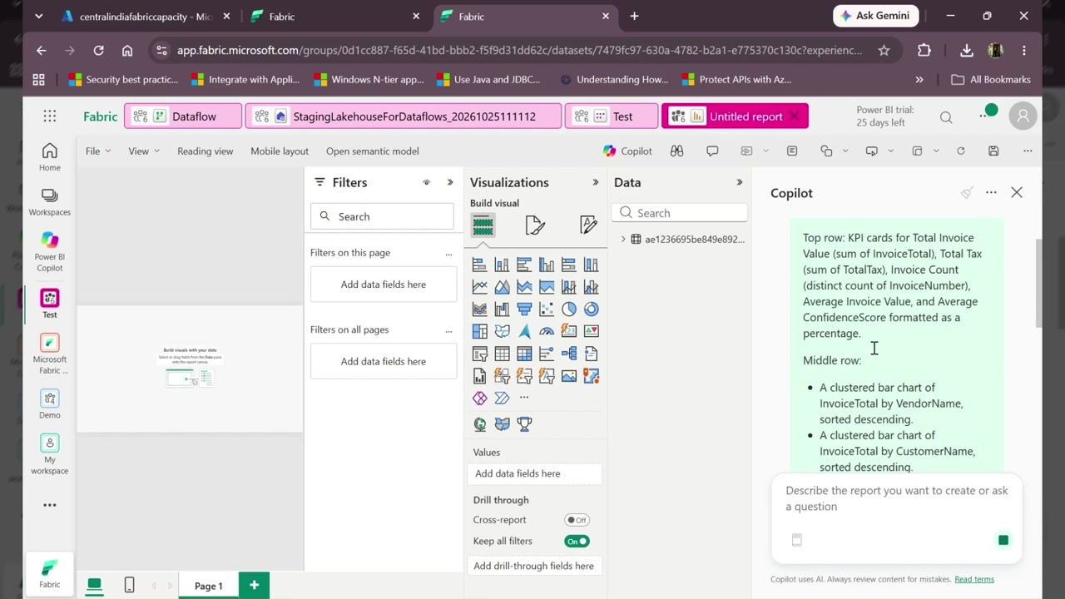
Figure 5 — Copilot prompt for the invoice dashboard
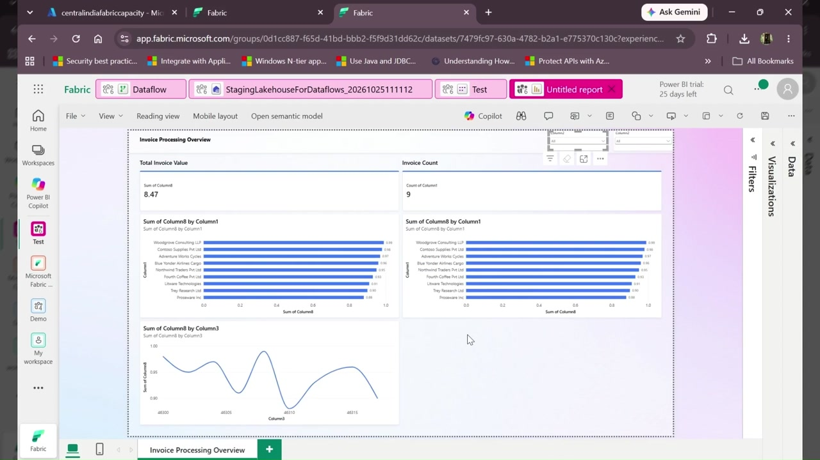
Figure 6 — Copilot-generated Invoice Processing Overview report

5. Business benefits
- Speed: invoices are processed end-to-end in about 14 seconds with no human input.
- Accuracy: Document Intelligence extraction with a confidence score replaces manual keying.
- Coverage: works across invoice formats, industries and currencies (INR, USD, CHF in the demo).
- Traceability: every row links back to its source document.
- Visibility: finance teams monitor a dashboard instead of scrolling through spreadsheets.
- Platform fit: built on Copilot Studio, Power Automate and Fabric, so it is extensible and low-code.

6. Observations and recommendations
These points were noticed while reviewing the recording. Address them before showing this to a customer or moving to production.
Area | Observation in the demo | Recommendation
Report data model | Visuals show generic field names (Column1, Column3, Column8). The "Total Invoice Value" card reads 8.47 — the sum of ConfidenceScore, not invoice totals. | Promote headers in the Dataflow and set data types so the semantic model exposes VendorName, InvoiceTotal and so on; regenerate the report.
Numeric fields | InvoiceTotal and TotalTax are stored as text with a currency prefix (e.g. "USD 5,875.00"). | Store amounts as decimals, with currency in its own column. Add FX conversion to a reporting currency.
Missing values | "NA" is written into numeric and date columns. | Write blanks or nulls for numeric and date fields, or handle NA in the Dataflow.
Security — SAS URLs | DocumentURL stores full SAS tokens in Excel; these expire and grant access if shared. | Store the blob path only, and generate short-lived SAS on demand. Use managed identity where possible.
Security — storage auth | The container uses access-key authentication. | Switch to Microsoft Entra ID / managed identity with RBAC, and disable shared key access.
Agent settings | Web Search is enabled even though the instructions forbid knowledge use. The agent shows 3 warnings. | Disable Web Search, resolve the warnings, and limit the agent to its two tools.
Scale and ops | Excel is the system of record between agent and Fabric. | For volume, write directly to a Fabric Lakehouse, Dataverse or SQL. Add error handling, retries and a low-confidence review queue.

Appendix A — Demo timeline
Time | Segment
0:00 – 0:45 | Introduction and business problem; agent overview in Copilot Studio
0:45 – 1:10 | Azure Blob Storage trigger explained; sample invoice uploaded
1:10 – 1:30 | Agent tools and instructions reviewed; Document Intelligence MCP extraction
1:30 – 2:00 | Activity trace; extracted results reviewed in Excel
2:00 – 2:40 | Microsoft Fabric: Dataflow Gen2 ingestion, Lakehouse table, semantic model
2:40 – 3:24 | Power BI report; Copilot generates the invoice dashboard

Note: this document was produced from the screen recording and its narration. The narration was transcribed automatically, and the first part of the agent's numbered instructions was not visible on screen, so it is not reproduced here.

