

Antonino Palumeri

<https://www.linkedin.com/in/antonino-palumeri-0048bb247/>

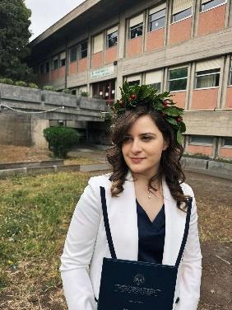

Eleonora Giuffrida

<https://www.linkedin.com/in/eleonora-giuffrida-7795a130b/>



Livio Mattia Lipani

<https://www.linkedin.com/in/livio-mattia-lipani/>