Creating a pipeline to quantify rDNA copies using Fob1 binding events using Super-Resolution Microscopy.

  - Introduction
The yeast ribosomal DNA (rDNA) locus has about 150 tandem repeats of identical sequences. Each repeat contains an RFB site2 that allows binding of a protein called Fob1 once per individual rDNA repeat. The number of rDNA repeats is linked with fitness with higher number of repeats indicative of higher fitness while lower number of repeats indicate lower fitness. As part of previous projects, several strains with estimated reduced rDNA repeats were engineered, with the corresponding number of rDNA repeats shown below in Table 1:
Strain | Est. Repeats
YBW-03 | 20
YBW-05 | 40
YBW-07 | 80
YBW-09 | 110
Table 1. Strain table
It is the goal of this experiment was to begin to develop a pipeline to use these strains to come up with a method to quantify the number of rDNA repeats using super-resolution microscopic techniques.
  - Aims
As part of previous experiments, the aforementioned strains were engineered to express a tagged fluorescent protein known as GFP (Green Fluorescent Protein) on each Fob1 molecule, which allowed the application of single molecule localisation techniques. In cell cultures grown in a media with a limited number of nutrients, the following ‘growth cycle’ is observed, with the associated stages:
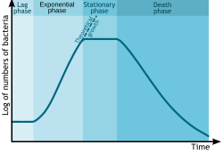
Fig 1. Cellular Growth Cycle
- Lag phase: Cells are adapting themselves to growth conditions. It is the period where the individual bacteria are maturing and not yet able to divide.
- Exponential phase: is a period characterized by cell doubling.
- Stationary phase: is often due to a growth-limiting factor such as the depletion of an essential nutrient, and/or the formation of an inhibitory product.
- Death phase: bacteria die. This could be caused by lack of nutrients, environmental temperature, etc. ^{[1]}
When yeast cultures are grown in liquid media overnight, they reach stationary phase. As part of preliminary experiments, it was noted that GFP activity in these cultures was much higher in the few budding cells that were present. Hence, the experiment consisted of two portions. The first aim was to create growth curves to reliably grow the cultures to exponential phase, and the second was to create an imaging pipeline that allowed us to estimate the number of rDNA repeats reliably using single-molecule localisation techniques.

  - Experiment 1: Growth Curves
  - Methods
In order to determine the correct growth time to grow the overnight cultures to get them to exponential phase, the following procedure was developed:
- Strains YBW-03, YBW-05, YBW-07, and YBW-09 were grown up in YNB-URA into overnight cultures, and then diluted in a serial dilution to produce 10x, 100x and 1000x dilutions, for two types of liquid media: YPD and YNB-URA.
- The 100x and 1000x dilutions were aliquoted into three separate wells and placed into a Microplate: COSTAR 96 reader, where they were ran on the AS Growth Curves program for 24 hours.
- OD₆₀₀ (optical density at 600nm) was obtained against time every 10 minutes. This result was then copied into an excel file, GrowthCurves.xslx, which subtracted the background and calculated the average, a well as standard error, in a transposed table.
- This transposed table was then pasted into a .txt file, where it could be read into the FittingCurve.py python programme. This python program plotted a graph of ln(OD₆₀₀) against time and estimated the doubling time for each strain.
Often doubling time is measured by a simple linear fit to the ‘exponential section’ of the logged growth curve, however, this could be subject to error due to the human judgement. To avoid this, the FittingCurve.py programme uses a standard non-linear least squares regression in Python (SciPy.Optimize) to fit to a growth model from which the doubling time can be extracted. The model eventually chosen was the ‘Modified Gompertz model’:
$$y=y_{0}+A\exp\left\{-\exp\left[\frac{μ_{max}⋅e}{A}\left(λ-t\right)+1\right]\right\}$$
$$where A = y_{max} - y_{0}$$
Eq 1. Modified Gompertz Model
Such that:
- $y_{0}$ $⇒$ baseline optical density (in natural log)
- $y_{max}$ $⇒$ Maximum optical density at stationary phase (in natural log)
- $μ_{max}$ $⇒$Maximum specific growth rate (hrs⁻¹)
- $λ$ $⇒$ Lag time (hrs)
The addition of a baseline optical density as required as the original model ^{[1]} was for relative growth.
Once fit, the doubling time could then be found from the fitted value of $μ_{max}$, as:
$$t_{d} = \frac{ln(2)}{μ_{max}}$$
The standard error in the original OD600 values was propagated to the final doubling time using the following scheme:
- Using the covariance matrix which is automatically generated by SciPy’s curve fit, the allowed the standard error of the maximum growth rate, $\text{SE}\left(μ_{max}\right)$ can be calculated from the square root of the diagonal entry corresponding to $μ_{max}$:
$$pcov= \left[\begin{matrix}σ_{y_{0}}^{2} & ⋯ & ⋯ & ⋯ \\ ⋯ & σ_{y_{max}}^{2} & ⋯ & ⋯ \\ ⋯ & ⋯ & σ_{μ_{max}}^{2} & ⋯ \\ ⋯ & ⋯ & ⋯ & σ_{λ}^{2}\end{matrix}\right]$$

$$⇒\text{SE}\left(μ_{max}\right)=\sqrt{{pcov}_{μ_{max},μ_{max}}}$$

- $\text{SE}\left(μ_{max}\right)$ was then propagated to the doubling time in a standard calculus-based error propagation:
$$\text{SE}\left(t_{d}\right)≈\left|\frac{dt_{d}}{dμ_{max}}\right|⋅\text{SE}\left(μ_{max}\right)=-\frac{\ln\left(2\right)}{μ_{max}^{2}}\text{SE}\left(μ_{max}\right)$$

For all strains, media and concentration, the fit showed a good visual correspondence. Shown here are two examples of the YBW-03 stain in YNB-URA and YPD with their fits added:
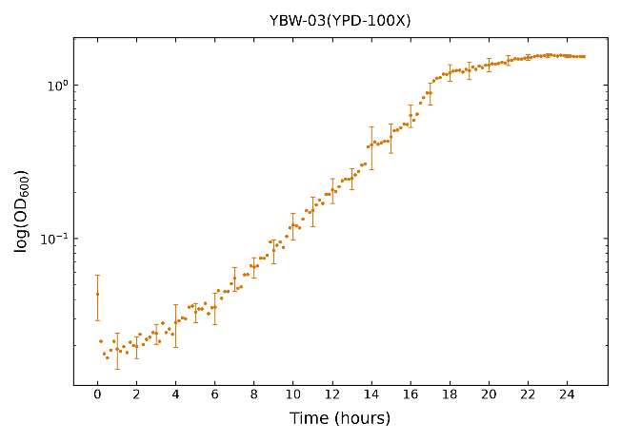
Fig 2.1 Growth curve of YBW-03 in YPD Media under 100X dilution
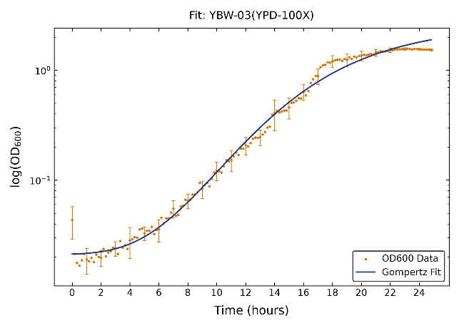
Fig 2.2 Growth curve of YBW-03 in YPD Media under 100X dilution, with fit.
The doubling times for YPD are shown below, for 100X and 1000X concentration:
Strain | Doubling Time (mins)
YBW-03(100X) | 128.5 ± 2.4
YBW-05(100X) | 140.6 ± 2.8
YBW-07(100X) | 129.9 ± 2.2
YBW-09(100X) | 75.5 ± 2.4

Table 2. Doubling Times in 100X

Strain | Doubling Time (mins)
YBW-03(1000X) | 126.2 ± 2.5
YBW-05(1000X) | 113.8 ± 1.5
YBW-07(1000X) | 110.2 ± 1.3
YBW-09(1000X) | 100.4 ± 1.5

Table 3. Doubling Times in 1000X
  - Analysis:
The experimental doubling times obtained in this study align well with established literature values for Saccharomyces cerevisiae, which typically fall within the range of 75 to 140 minutes depending on strain and growth conditions. Most interestingly, they match the general trend, with doubling time decreasing with increasing copy number.^{[2]}
This is often explained as strains with higher rDNA gene copy numbers or enhanced transcription efficiency produce greater quantities of rRNA, allowing for faster ribosome biogenesis and higher rates of protein synthesis. This increased cellular machinery supports rapid growth and cell division, resulting in shorter doubling times.^{[2]}
With the doubling-times clearly established, we could now calculate the optimal starting concentration required to grow the cells to exponential phase overnight. From this, these cells could be prepared for imaging.
  - Experiment 2: Imaging
  - Introduction
Conventional optical microscopy is limited by diffraction, as described by Abbe's principle:
$$d=\frac{λ}{2\text{NA}}$$
where $d$ is the minimal resolved distance, $λ$ is the wavelength of light, and $\text{NA}=n\sin{θ}$ is the numerical aperture of the objective lens. Light emitted from a point source spreads out into an Airy pattern characterized by a Point Spread Function (PSF):

Fig 3. Airy Disk
When features are closer together than distance $d$, their PSFs overlap and cannot be visually resolved.
Single-molecule super-resolution techniques overcome this barrier by controlling the temporal activation of fluorophores, such as GFP in this case. By stochastically switching only a small subset of molecules into an emitting state at any given frame, individual molecules become spatially isolated. Because the emitter is isolated, its central position can be calculated by fitting its intensity profile to a 2D Gaussian function, which acts as a good approximation of the PSF. These molecules, using software such as PySTACHIO, could then be tracked. Our goal here, was to create an image preparation pipeline for further analysis.
  - Methods
Cultures first had to be prepared into slides for imaging. The procedure followed here was simple:
- Overnight cell cultures were diluted to 5000X and 10,000X and allowed to grow to mid-exponential phase (${\text{OD}}_{600}≈0.5$, corresponding to a $10X$ diluted ${\text{OD}}_{600}$ of $0.04\text{–}0.05$).
- Culture was diluted 1:1 ($50\%$) using $\text{YNB-ura+gluc}$ medium, and ${\text{CuCl}}_{2}$ or ${\text{CuSO}}_{4}$ was added to reach a final concentration of $100 μ\text{M}$.
- Mixture was incubated at $30 ^{∘}\text{C}$ with continuous shaking for 1 hour.
- A $1\text{ mL}$ aliquot was transferred into a microcentrifuge tube and centrifuged at $3000g$ ($5000\text{ rpm}$) using a small benchtop centrifuge.
- The supernatant was decanted, and the cell pellet was resuspended in $500 μ\text{L}$ of growth medium
- A custom tunnel slide was prepared by introducing $20 μ\text{L}$ of concanavalin A ($\text{ConA}$, $1\text{ mg/mL}$) into the chamber, which was allowed to incubate for 5 minutes before flushing with imaging medium.
- $20 μ\text{L}$ of the resuspended cell suspension was loaded into the functionalized tunnel slide and incubated for 5 minutes to facilitate cell adhesion.
- Unattached cells were washed away by gently flushing the chamber with $100\text{–}200 μ\text{L}$ of imaging medium.
- Both ends of the tunnel slide were sealed with clear nail polish to prevent evaporation.
With these slides prepared, it was simply a matter of imaging these slides using the M1 microscope, which can take both fluorescent and bright-field acquisitions.
  - Results:
Once acquisitions were taken, clear foci which denote areas of high concentration of FOB1 were able to be observed in certain fields, with candidates for single molecules also spotted:
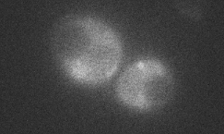
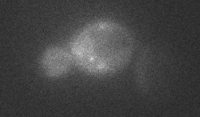
Fig 4: Fluorescent Acquisitions

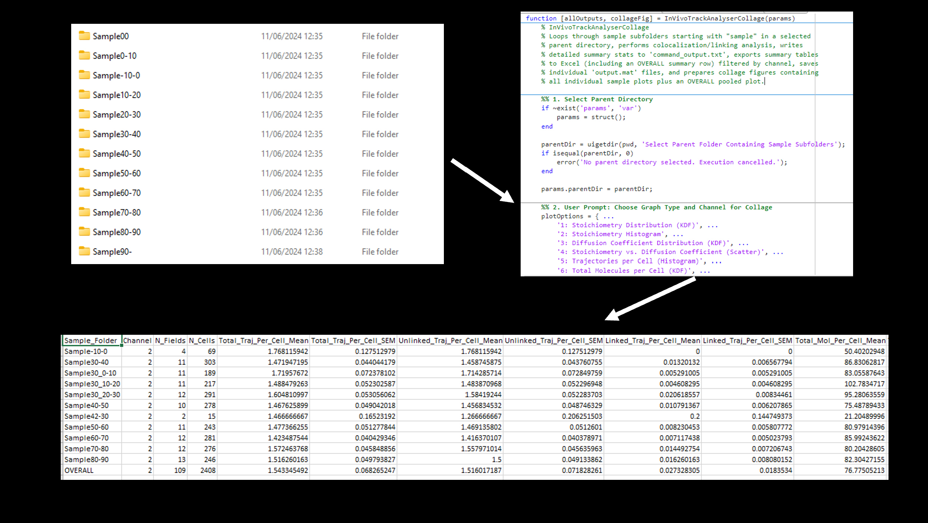
Fig 4. InVivoTrackAnalyserCollage Pipeline

However, the crescent-like structure of the nucleolus is still hard to make out for some form of masking.
  - Further Steps:
In order to quantify the number of rDNA copies, a masking technique for the nucleolus most likely needs to be developed. Possible techniques for going in direction could be the addition of a stain that stains nuclear material. Once the nucleolus is easily identifiable in an
image, it is likely that a simple multi-Otsu thresholding technique will be adequate for making it and working out the I-single value.
  - Bonus Experiment: LacO34
  - Introduction
As part of my internship at York, I also helped to streamline the code of other experiments, one being an investigation of LacO34 in E-Coli. The previous experimental workflow relied on two main software tools: InVivoTrackAnalyser, which constructs individual single-molecule tracks from microscopy images, and CoPro, which links those tracks across two colour channels to determine whether target molecules are interacting.

Originally, both programs operated as standalone scripts designed to process a single folder of data at a time. To support time-course experiments, both tools were upgraded into automated batch pipelines capable of analysing a sequence of time points while keeping their underlying math and tracking algorithms identical to the original single-sample versions.
  - Results
‘InVivoTrackAnalyser’ serves as the initial feature-extraction stage. It takes in raw image data containing candidate single-molecule spots, cell segmentation masks (*segmentation.mat) that define cell boundaries, single-molecule brightness reference values (Isingle), and user-defined thresholds for signal-to-noise ratios and image edge exclusions. Using these inputs, the program outputs multi-frame particle trajectories, track arrays (trackArrayCh1 and trackArrayCh2) containing molecule counts and calculated stoichiometries, and Mean Square Displacement data used to derive single-molecule diffusion coefficients ($D$). To adapt this tool for time-course studies, the manual setup step was replaced by a centralized parameters structure (params) that

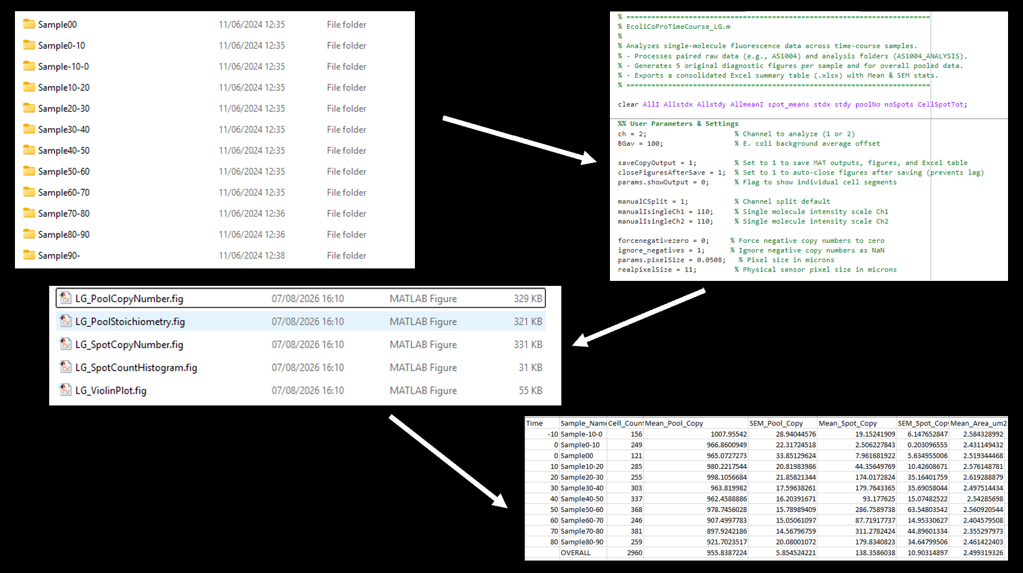
Fig 5. EcoliCoProTimeCourse Pipeline

distributes the exact same tracking, calibration, and cell-masking rules across every time point. Additionally, automated error handling was implemented so that if a specific time point suffers from poor imaging or missing spots, the program logs a warning and automatically advances to the next time step without interrupting the broader time-course run, as shown in Fig 4.
The other piece of code developed was ‘EcoliCoProTimeCourse’ program. It takes in raw fluorescence image sequences in TIF format, saved alongside pre-calculated tracking files (*TRACKS.mat) and cell segmentation masks (*segmentation.mat). These input files are gathered directly from structured experiment folders containing individual sample time points and cell or field subdirectories. Along with these data files, the script relies on a few key user inputs specified at launch, including the target image channel (Channel 1 or Channel 2), the parent directory path, and the specific strain datasets chosen through interactive selection dialogues.
Once these inputs are loaded, the script processes the images by applying point spread function models, background offsets, single-

molecule intensity scales, and spatial channel-splitting parameters to evaluate single-molecule features across each segmented cell.
Upon completion, the pipeline outputs structured results at both the individual sample level and overall experiment level. It saves processed MATLAB data files (.mat) containing all calculated single-cell metrics, such as diffuse pool copy numbers, pool stoichiometry, cell volumes, surface areas, spot counts, and spot-bound molecule totals. Additionally, it outputs a set of five diagnostic MATLAB figure files (.fig) per dataset, displaying kernel density estimation plots, spot count histograms, and violin plots of copy number distributions. Finally, the script generates a consolidated Excel summary table (Summary_CopyNumbers_chX.xlsx) containing overall cell counts alongside calculated means and standard errors of the mean (SEM) for pool copy numbers, spot copy numbers, and cell areas. If duplicate strains are analyzed, it also outputs a dedicated merged analysis folder with combined dataset tables and figures.
By the collated data that these programs allow, graphs can be plotted which show trends in copy numbers and other characteristics over the course of the experiment:
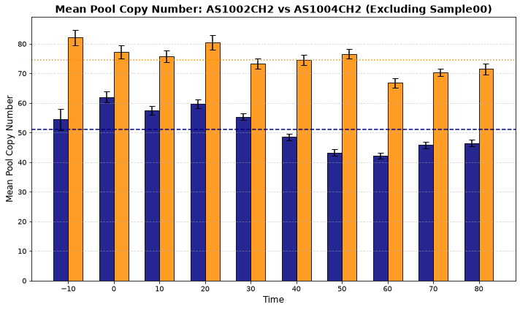
Fig 6. Copy Number Comparison

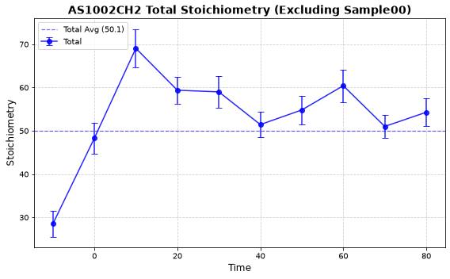
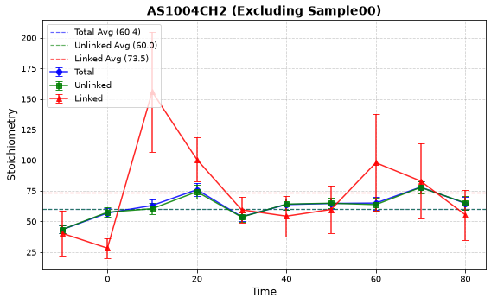
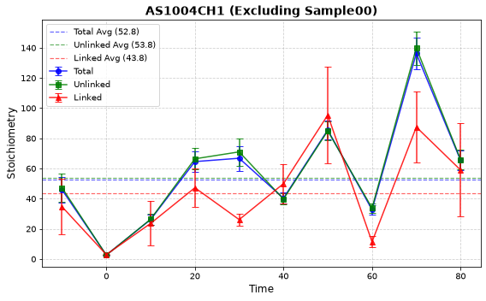
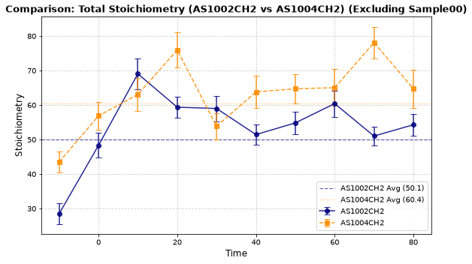
Fig 7. Comparison of assorted stoichiometries
  - Supplementary Material:
[Available from author.]
  - References:
- Zwietering MH, Jongenburger I, Rombouts FM, van 't Riet K. Modeling of the bacterial growth curve. Applied and Environmental Microbiology [Internet]. 1990 [cited 2026 Sept 10];56(6):1875–81. Available from: https://journals.asm.org/doi/epdf/10.1128/aem.56.6.1875-1881.1990

- Ide S, Miyazaki T, Maki H, Kobayashi T. Abundance of ribosomal RNA gene copies maintains genome integrity. Science. 2010 Feb 5;327(5966):693–6.

