 | UNIVERSITATEA DIN CRAIOVA  FACULTATEA DE AUTOMATICĂ, CALCULATOARE ȘI ELECTRONICĂ  DEPARTMENT OF COMPUTERS AND INFORMATION TECHNOLOGY | 

DEGREE PROJECT
EDUARD-LIVIU BANA

COORDONATOR ȘTIINȚIFIC
Sef lucr. dr. ing. , CERBULESCU CATALIN

Septembrie 2023
CRAIOVA
UNIVERSITATEA DIN CRAIOVA
FACULTATEA DE AUTOMATICĂ, CALCULATOARE ȘI ELECTRONICĂ

DEPARTMENT OF COMPUTERS AND INFORMATION TECHNOLOGY

APPLICATION FOR FINDING
THE LOWEST PRICE OF A PRODUCT

EDUARD-LIVIU BANA

COORDONATOR ȘTIINȚIFIC
Sef lucr. dr. ing. , CERBULESCU CATALIN

Septembrie 2023
CRAIOVA
„Învățătura este o comoară care își urmează stăpânul pretutindeni.”
Proverb popular

DECLARAȚIE DE ORIGINALITATE

Subsemnatul EDUARD-LIVIU BANA student la CALCULATOARE CU PREDARE IN LIMBA ENGLEZA din cadrul Facultății de Automatică, Calculatoare și Electronică a Universității din Craiova, certific prin prezenta că am luat la cunoştinţă de cele prezentate mai jos şi că îmi asum, în acest context, originalitatea proiectului meu de licenţă:
- cu titlul APPLICATION FOR FINDING THE LOWEST PRICE OF A PRODUCT,
- coordonată de SEF LUCR. DR. ING. , CERBULESCU CATALIN,
- prezentată în sesiunea SEPTEMBRIE 2023.
La elaborarea proiectului de licenţă, se consideră plagiat una dintre următoarele acţiuni:
- reproducerea exactă a cuvintelor unui alt autor, dintr-o altă lucrare, în limba română sau prin traducere dintr-o altă limbă, dacă se omit ghilimele şi referinţa precisă,
- redarea cu alte cuvinte, reformularea prin cuvinte proprii sau rezumarea ideilor din alte lucrări, dacă nu se indică sursa bibliografică,
- prezentarea unor date experimentale obţinute sau a unor aplicaţii realizate de alţi autori fără menţionarea corectă a acestor surse,
- însuşirea totală sau parţială a unei lucrări în care regulile de mai sus sunt respectate, dar care are alt autor.
Pentru evitarea acestor situaţii neplăcute se recomandă:
- plasarea între ghilimele a citatelor directe şi indicarea referinţei într-o listă corespunzătoare la sfărşitul lucrării,
- indicarea în text a reformulării unei idei, opinii sau teorii şi corespunzător în lista de referinţe a sursei originale de la care s-a făcut preluarea,
- precizarea sursei de la care s-au preluat date experimentale, descrieri tehnice, figuri, imagini, statistici, tabele et caetera,
- precizarea referinţelor poate fi omisă dacă se folosesc informaţii sau teorii arhicunoscute, a căror paternitate este unanim cunoscută și acceptată.
Data, Semnătura candidatului,
02.09.2023

 | UNIVERSITATEA DIN CRAIOVA  Facultatea de Automatică, Calculatoare şi Electronică  Departamentul de Calculatoare si Tehnologia Informatiei | Aprobat la data de  …………………  Şef de departament,  Prof. dr. ing.

PROIECTUL DE DIPLOMĂ

Numele și prenumele studentului/-ei: | BANA EDUARD-LIVIU
Enunțul temei: | APPLICATION FOR FINDING THE LOWEST PRICE OF A PRODUCT
Datele de pornire: | Descriere:aplicatie web ce gaseste cel mai mic pret al unui produs prin folosirea tehnicilor de web-mining
Conținutul proiectului: | 1.Introduction: a short description of what is the purpose of  my project and what research I had to do before  implementation  2.Used tools and frameworks: what i used in the project and  what helped me learn more about the subject  3.Application Design and Implementation: detailed  description of the solution architecture and its  implementation  4.Conclusions: final thoughts about the project  5.References: references made during the documentation  phase
Material grafic obligatoriu: | Prezentare PowerPoint
Consultații: | Periodice
Conducătorul științific  (titlul, nume și prenume, semnătura): | Sef lucr. Dr. Ing., Cerbulescu Catalin
Data eliberării temei: | 20.10.2022
Termenul estimat de predare a proiectului: | 28.08.2023
Data predării proiectului de către student și semnătura acestuia:

UNIVERSITATEA DIN CRAIOVA
Facultatea de Automatică, Calculatoare şi Electronică

Departamentul de Departamentul de Calculatoare și Tehnologia Informației

REFERATUL CONDUCĂTORULUI ȘTIINȚIFIC

Numele și prenumele candidatului/-ei:
Specializarea: | Calculatoare cu predare in limba Engleza
Titlul proiectului: | Aplicatie pentru gasirea celui mai mic pret al unui produs
Locația în care s-a realizat practica de documentare (se bifează una sau mai multe din opțiunile din dreapta): | În facultate □X
 | În producție □
 | În cercetare □
 | Altă locație: [se detaliază]

În urma analizei lucrării candidatului au fost constatate următoarele:
Nivelul documentării |  | Insuficient  □ | Satisfăcător □ | Bine  □ | Foarte bine  □
Tipul proiectului |  | Cercetare  □ | Proiectare  □ | Realizare practică □ | Altul  [se detaliază]
Aparatul matematic utilizat |  | Simplu  □ | Mediu  □ | Complex □ | Absent  □
Utilitate |  | Contract de cercetare □ | Cercetare internă □ | Utilare  □ | Altul  [se detaliază]
Redactarea lucrării |  | Insuficient  □ | Satisfăcător □ | Bine  □ | Foarte bine  □
Partea grafică, desene |  | Insuficientă  □ | Satisfăcătoare □ | Bună  □ | Foarte bună  □
Realizarea practică | Contribuția autorului | Insuficientă  □ | Satisfăcătoare □ | Mare  □ | Foarte mare  □
Realizarea practică | Complexitatea  temei | Simplă  □ | Medie  □ | Mare  □ | Complexă  □
Realizarea practică | Analiza cerințelor | Insuficient  □ | Satisfăcător □ | Bine  □ | Foarte bine  □
Realizarea practică | Arhitectura | Simplă  □ | Medie  □ | Mare  □ | Complexă  □
Realizarea practică | Întocmirea specificațiilor funcționale | Insuficientă  □ | Satisfăcătoare □ | Bună  □ | Foarte bună  □
Realizarea practică | Implementarea | Insuficientă  □ | Satisfăcătoare □ | Bună  □ | Foarte bună  □
Realizarea practică | Testarea | Insuficientă  □ | Satisfăcătoare □ | Bună  □ | Foarte bună  □
Realizarea practică | Funcționarea | Da  □ | Parțială  □ | Nu  □
Rezultate experimentale |  | Experiment propriu  □ |  | Preluare din bibliografie  □
Bibliografie |  | Cărți | Reviste | Articole | Referințe web
Comentarii
și
observații

În concluzie, se propune:

ADMITEREA PROIECTULUI  □ | RESPINGEREA PROIECTULUI  □

Data, Semnătura conducătorului științific,

PROJECT SUMMARY
Web Application for finding the lowest price of a product

The project consists of 3 interconnected applications: the web crawler, the web API app used for the manipulation of the data extracted, and the user interface developed using Angular.
The role of the web crawler is to collect data from various online sources and, using automated scripts, navigate through web pages, extract relevant information about products, and store it in a structured format. The collected data then serves as a valuable resource for further analysis or use. These data were stored in a database.
ASP.NET Core Web API was used to build web services that enable communication between my applications by providing a structured and standardized way to expose data and functionalities over the web.
The Angular web app is the user interface for accessing and visualizing the collected data. It provides a user-friendly platform where users can search, filter, and explore the gathered information on the products.
Together, the three applications form a comprehensive system for data collection, organization, and exploration, enabling users to stay up-to-date with the latest information on the Internet about the prices of products in order to buy them at a more advantageous price.

Keywords: Python, Scrapy, Web Crawler,MySQL,C#,ASP.NET Core Web API, Angular,Typescript.

GRATITUDE
I want to thank Sef lucr. Dr. Ing. Cerbulescu Catalin for his help and guidance in completing my Degree project. The online meetings and discussions with Him helped me to understand the proposed theme and how to achieve it.

CUPRINSUL
1 INTRODUCTION 1
1.1 PURPOSE 1
1.2 MOTIVATION 2
1.3 RESEARCH 3
2 USED TOOLS AND FRAMEWORKS 5
2.1 Python 5
2.2 PyCharm 7
2.3 C sharp (C#) 9
2.4 Visual Studio 11
2.5 Visual Studio Code 13
2.6 Typescript 15
2.7 My SQL 16
2.8 Git 17
2.9 Github 17
2.10 Necessary frameworks and other packages 19
2.10.1 Scrapy 19
2.10.2 ASP.NET Web API 20
2.10.3 Angular 21
3 APPLICATION DESIGN AND IMPLEMENTATION 23
3.1 APPLICATION DESIGN 23
3.1.1. 23
3.1.2. 26
3.1.3. 27
3.2 APPLICATION IMPLEMENTATION 31
3.2.1 PROJECTS SETUP 31
3.2.2 WEB CRAWLER IMPLEMENTATION 36
3.2.3 ASP.NET WEB API implementation 44
3.2.4 Angular application implementation: 50
4 CONCLUSIONS 55
5 REFERENCES 56
6 SOURCE CODE 59

LISTA FIGURILOR
Figure 1 -Python logo 5
Figure 2 - PyCharm logo 7
Figure 3 - C# logo 9
Figure 4 - Visual Studio logo 11
Figure 5 - VisualStudioCode logo 13
Figure 6 - Typescript logo 15
Figure 7 - MySQL logo 16
Figure 8 - Git logo 17
Figure 9 - Github logo 17
Figure 10 - Scrapy logo 19
Figure 11 - ASP.NET WEB API logo 20
Figure 12 - Angular logo 21
Figure 13 - Solution architecture 23
Figure 14 - Web Crawler Architecture 24
Figure 15 - Web API Architecture 26
Figure 16 - Angular Architecture 27
Figure 17 - Search by title page 30
Figure 18 - Products ordered by site entry 31
Figure 19 - Crawler folder structure 32
Figure 20 - Python create connection to db 33
Figure 21 - My SQL Table structure 33
Figure 22 - ConnectionStrings of wep API app 34
Figure 23 - Entrypoint for web crawler 36
Figure 24 DwynCrawler class 37
Figure 25 DwynCrawler parse func 37
Figure 26 - get_details() func 38
Figure 27 - RombizCrawler class 39
Figure 28 - RombizCrawler parse function 39
Figure 29 -VexioCrawler class 40
Figure 30 - VexioCrawler parse function 41
Figure 31 - items.py 41
Figure 32 - NeuralcrawlingPipeline class 42
Figure 33 - create_table function 43
Figure 34 - other functions used in pipelines.py 43
Figure 35 -API project setup 44
Figure 36 - Itemstable class 44
Figure 37 - generated ProductsContextClass 45
Figure 38 -method for ProductsContext class 46
Figure 39 - ProductsControllers class 46
Figure 40 - GetAllProducers() function 47
Figure 41 - GetProducerModels() function 47
Figure 42 - getProductsByModel() function 48
Figure 43 - getProductsByTitle() function 48
Figure 44 Swagger UI method tested 49
Figure 45 - Angular project structure 50
Figure 46 - Root module of Angular app 51
Figure 47 Main component of Angular app 52
Figure 48 –Html page of main component 53
Figure 49 -CSS page of main component 54

INTRODUCTION

PURPOSE
The purpose of this project is to address and tackle the challenges and opportunities posed by the rapidly evolving digital world, especially the increasing availability of data and the advancement of technology, which in turn lead to the growing need to harness the power of data and develop efficient systems for data acquisition, management and analysis of large volumes of data from diverse online sources, with a focus on relevant information about products and identifying the sites that have the best offers of them.
My project aims to provide a comprehensive solution by developing three interconnected applications: a web crawler[1], a web API and an Angular app. The web crawler[1] serves as a data gathering tool, extracting information from a list of given online sources. The collected data will be processed, organized, and stored in a structured format to facilitate easy retrieval and analysis.
ASP.NET Core Web API was used to build web services that enable communication between my applications by providing a structured and standardized way to expose data and functionalities over the web.
The Angular web app was utilized for human-computer interaction in order to view the extracted information about products, search and filter them, in a user-friendly manner.
The ultimate goal of my application is to bring together and facilitate the comparison of prices and products. Thus, the potential buyer can easily and quickly find the desired product and the ideal price.

MOTIVATION
A combination of personal interest, professional goals, and the growing significance of data-driven approaches in today's digital age led me to select this topic for my degree project.
The most important, the chosen topic perfectly corresponds to my everyday work experience. As an aspect of my responsibilities, I as often as possible experience circumstances where different manual undertakings are demonstrated to be drawn-out and mistake inclined.
I seek to create a tool that will make it easy for people who want to make the best deal by buying a product to easily access information gathered from multiple sources about various products that may cover these points of interest, by combining web crawling methods with a web application. Users of my application can see the best offers of the products they are interested in by comparing prices from several sites.
Throughout my professional career, I have worked with Python and witnessed firsthand its adaptability, efficiency in automating tasks, and productivity-enhancing capabilities. Python is an excellent choice for creating effective solutions, particularly in the field of data collection and management, due to its extensive ecosystem of libraries and frameworks. We free up valuable time and resources to focus on higher-value activities by automating manual and error-prone tasks. As part of my degree project, I want to highlight the immense value of automation in the context of data collection and management. I want to show how it can help us make better decisions or better organize our time.
Furthermore, I am expanding my knowledge of web crawling techniques, data processing, and web application development by working on this project. These are skills that are extremely valuable and provide a crucial foundation for pursuing a career in data science or other technology-driven fields.
Despite the fact that I do not work in the area of ​​web application development, it is a branch of programming that I want to learn and that I am passionate about. That's why I chose ASP.NET Core Web API and Angular.

RESEARCH
Before really beginning to deal with my project, I previously needed to learn about a progression of concepts which I didn't experience previously, for example, what is a Web Crawler[1], what is the process of web scraping[2],what is the process of web crawling[3], the contrast between these, what websites to consider and how to approach scraping data from them.
Then I had to figure out how to store this information in a helpful manner for me, how to manipulate this data and how to display them on the web.
„A Web crawler[1], sometimes called a spider or spiderbot and often shortened to crawler, is an Internet bot that systematically browses the World Wide Web and that is typically operated by search engines for the purpose of Web indexing (web spidering).[1]
Web search engines and some other websites use Web crawling or spidering software to update their web content or indices of other sites' web content. Web crawlers copy pages for processing by a search engine, which indexes the downloaded pages so that users can search more efficiently.
Crawlers can validate hyperlinks and HTML code. They can also be used for web scraping and data-driven programming.” [1]
Web crawling[3] and web scraping[2] are two concepts that are interconnected and often used interchangeably, even though they are ultimately different and have different use cases. Because of this, I will try to provide a short description for each.
Web scraping [2] is a technique whose main goal is to extract data from a given list of websites, whereas the main goal of web crawling [3] is to read the given web pages and find all the links, URLs from those given websites. The crawler then follows these links in order to find even more links, thus indexing web pages. From these short definitions, we can deduce that web crawling is an essential part of web scraping, since after fetching these pages, the data from them can be extracted, processed and loaded in a database for further use.
One key aspect of web scraping is that it follows a focused approach, meaning that the web scraping project seeks to extract specific data from a website for further use. On the other hand, a web crawler[1] will go through every single page on a website that respects the given rules for the crawler.
“XPath stands for XML Path Language and uses "path like" syntax to identify and navigate nodes in an XML document.” [4] XML documents have a tree structure, due to the "father-son" relationship of the nodes in that document, which allows the XPath language to be able to access different elements within xml documents.
After cementing these principles, I had to document and decide about what websites would be a good starting point for my spiders, which was a tricky task because the big websites that sell phones periodically change their html structure. Taking into account the fact that my degree focuses on extracting data about comparing phone prices, I chose three websites that seemed handy from one of the most popular comparing prices website, ’compari.ro’ . The full list of scraped websites will be presented in the section dedicated to the application implementation. Given the flexible and extensible manner of the used framework, Scrapy [5], there can always be added new URLs to this list without affecting the overall functionality of the project.

USED TOOLS AND FRAMEWORKS
While developing the application representing my degree project, I had to first document about a set of programming languages,frameworks, concepts, libraries, platforms or other technologies some of which I used for the first time.

Python
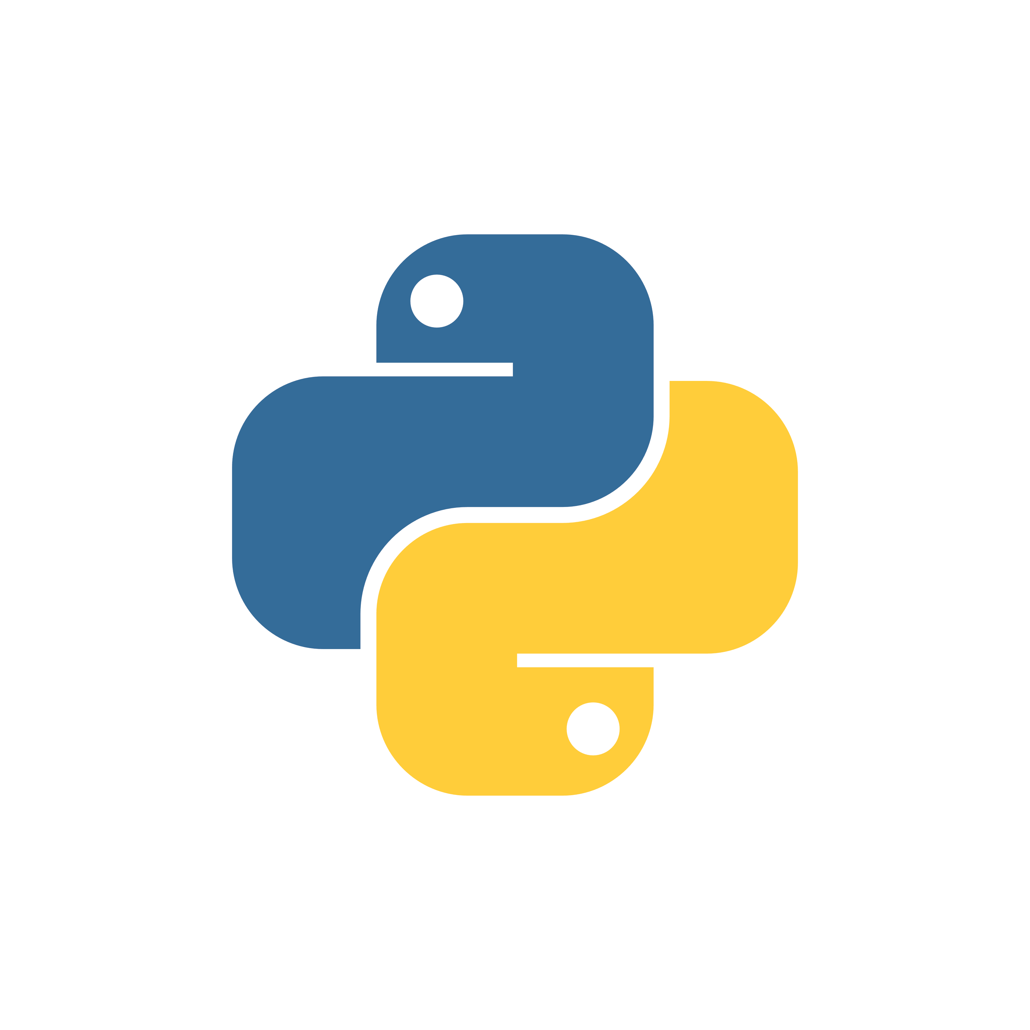
Figure 1 -Python logo

I used python for the first application, that of extracting data from websites. Python’s rich ecosystem allowed me to implement complex functionalities, interact with databases and handle web scraping [2] tasks with ease. I am using Python version ‚3.8’ for developing my project.
„Python is an interpreted, object-oriented, high-level programming language with dynamic semantics. Its high-level built in data structures, combined with dynamic typing and dynamic binding, make it very attractive for Rapid Application Development, as well as for use as a scripting or glue language to connect existing components together. Python's simple, easy to learn syntax emphasizes readability and therefore reduces the cost of program maintenance. Python supports modules and packages, which encourages program modularity and code reuse. The Python interpreter and the extensive standard library are available in source or binary form without charge for all major platforms and can be freely distributed. Often, programmers fall in love with Python because of the increased productivity it provides. Since there is no compilation step, the edit-test-debug cycle is incredibly fast. Debugging Python programs is easy: a bug or bad input will never cause a segmentation fault. Instead, when the interpreter 6 discovers an error, it raises an exception. When the program doesn't catch the exception, the interpreter prints a stack trace. A source level debugger allows inspection of local and global variables, evaluation of arbitrary expressions, setting breakpoints, stepping through the code a line at a time, and so on. The debugger is written in Python itself, testifying to Python's introspective power. On the other hand, often the quickest way to debug a program is to add a few print statements to the source: the fast edit-test-debug cycle makes this simple approach very effective.” [6]
WHY PYTHON?
There are several motives why I chose Python as the programming language for my project. Here are some key arguments supporting my decision:
Pros:
- Readability and Simplicity: Python’s clean and readable syntax makes it easier to write and understand the implementation, leading to improved development productivity and reduced debugging time.
- Extensive Libraries and Frameworks: Python provides a rich ecosystem of libraries and frameworks for various purposes, such as data analysis, web scraping[2] and more. These pre-existing packages helped me save time and effort by providing ready-to-use solutions for complex tasks.
- Automation and Scripting: Python excels at automating repetitive tasks and scripting, making it suitable for my topic which entails interacting with numerous APIs, automating processes and performing system administration tasks.
- Cross-Platform Compatibility: Python is a highly portable language, enabling any project to run on different operating systems without significant preparations. This compatibility increases the accessibility and potential user base for my application.
Cons:
- Memory Consumption: Python can consume more memory compared to other programming languages. This can be a concern in resource-constrained environments or when dealing with large-scale web scraping[2] and data processing.
- Performance: While Python is known for its simplicity, it is not as fast as some lower-level languages like C or C++. Python’s interpreted nature and dynamic typing can result in slower execution speed for certain computationally intensive tasks.

PyCharm
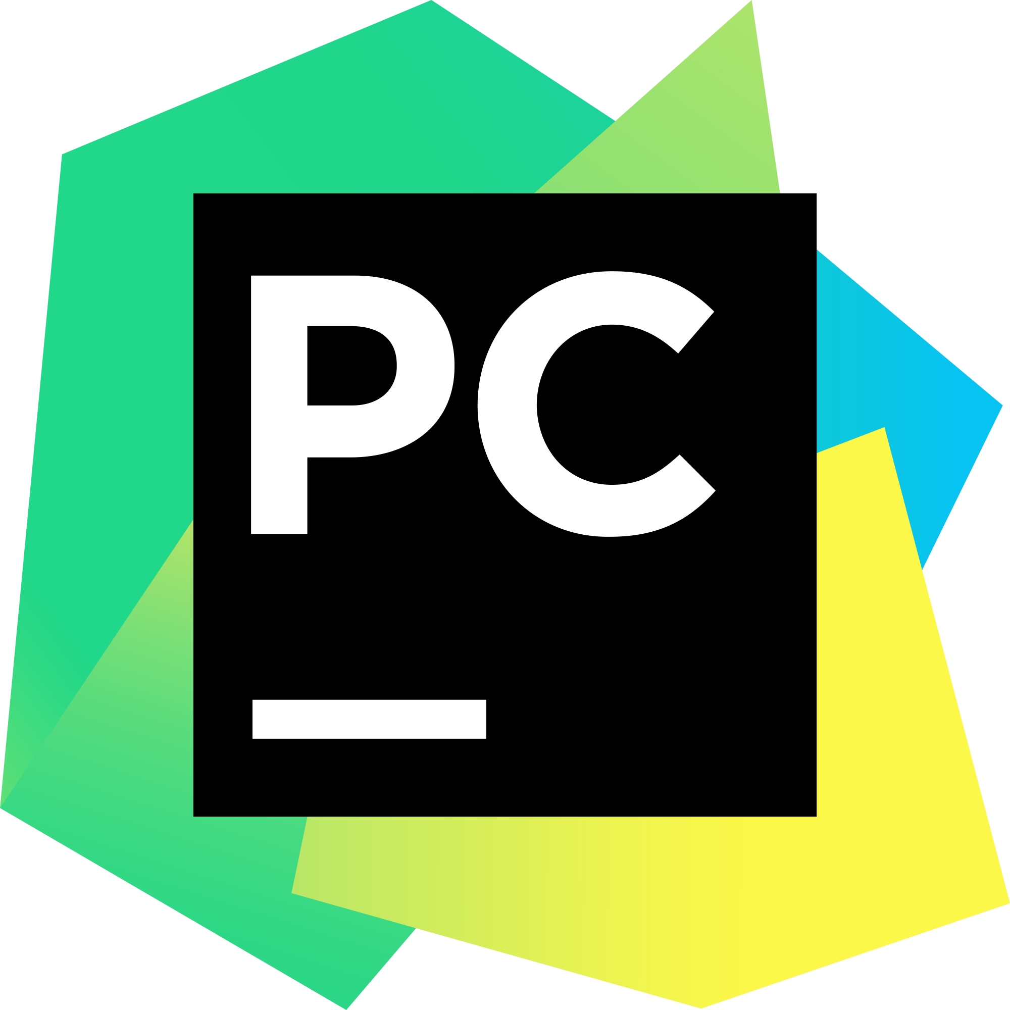
Figure 2 - PyCharm logo
„PyCharm is an integrated development environment [11](IDE) used for programming in Python[12]. It provides code analysis, a graphical debugger, an integrated unit tester, integration with version control[13] systems, and supports web development with Django. PyCharm is developed by the Czech company JetBrains.[37]
It is cross-platform[35], working on Microsoft Windows[32], macOS[33] and Linux[34]. PyCharm has a Professional Edition, released under a proprietary license and a Community Edition released under the Apache License.[36] PyCharm Community Edition is less extensive than the Professional Edition.”[10]
Here is a list of reasons why I chose PyCharm[10] Community Edition as my working IDE for my project:
- Rich Feature Set: PyCharm offers a comprehensive set of features that enhance the development experience. It provides intelligent code completion, syntax highlighting, code navigation, and refactoring tools, making it easier to write, read, and maintain Python code.
- Code Analysis and Error Checking: PyCharm incorporates advanced code analysis and error-checking capabilities. It helps identify potential issues, offers suggestions for improvements, and highlights errors in real time. This feature greatly improves code quality and reduces debugging time.
- Debugging and Testing Support: PyCharm provides robust debugging and testing tools. It allows setting breakpoints, stepping through code, inspecting variables, and evaluating expressions, aiding in the process of identifying and fixing issues during development.
- Virtual Environments and Package Management: PyCharm simplifies the management of virtual environments, allowing the isolation of project dependencies. It also integrates with package managers like Pip and Anaconda, facilitating package installation and management within the IDE.
- Extensibility and Customization: PyCharm supports a wide range of plugins and extensions, allowing customization and tailoring the IDE to individual preferences and project requirements. This flexibility enhances productivity by providing additional tools and integrations.
- Cross-Platform Support: PyCharm is available for Windows, macOS, and Linux, ensuring a consistent development experience across different operating systems.
- User-Friendly Interface: PyCharm has an intuitive and user-friendly interface that makes it easy to navigate and use. Its well-organized layout, customizable themes, and helpful documentation contribute to an enjoyable development experience.
- Community and Support: PyCharm has a large and active community of developers who actively contribute to its improvement and share knowledge. There are ample resources, tutorials, and forums available to seek help, making it easier to overcome challenges during development.
In conclusion, I chose PyCharm as my working IDE for both personal reasons, being my preferred IDE while coding in Python and the IDE that I mainly use at my job, and also for the objective reasons presented above, which constitute features that contribute to a more efficient and productive development experience.

C sharp (C#)
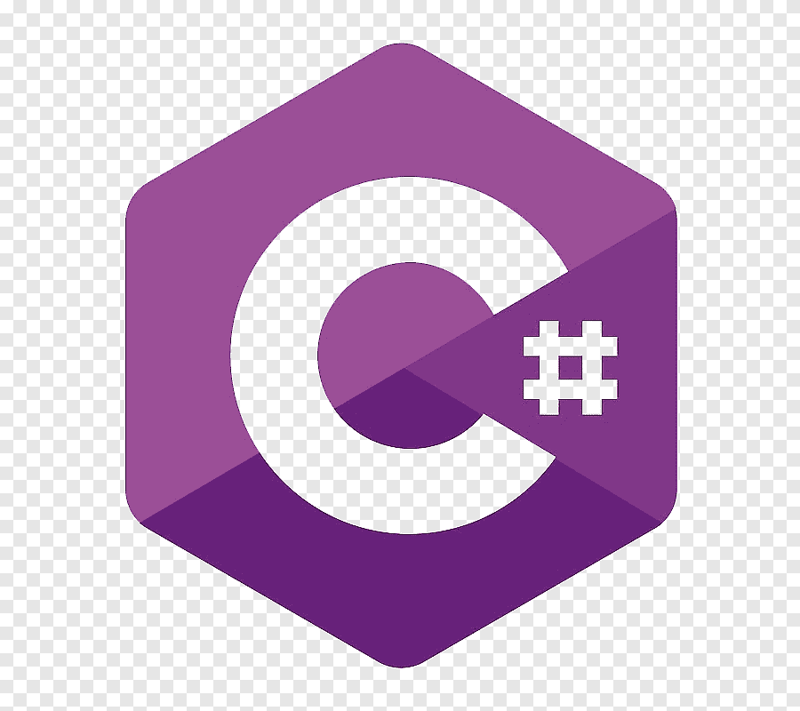
Figure 3 - C# logo
“C# (pronounced See sharp)[b] is a general-purpose high-level programming language supporting multiple paradigms. C# encompasses static typing,[18]: 4 strong typing, lexically scoped, imperative, declarative, functional, generic,[16]: 22 object-oriented (class-based), and component-oriented programming disciplines
The C# programming language was designed by Anders Hejlsberg from Microsoft in 2000 and was later approved as an international standard by Ecma (ECMA-334) in 2002 and ISO/IEC (ISO/IEC 23270) in 2003. Microsoft introduced C# along with .NET Framework and Visual Studio, both of which were closed-source. At the time, Microsoft had no open-source products. Four years later, in 2004, a free and open-source project called Mono began, providing a cross-platform compiler and runtime environment for the C# programming language. A decade later, Microsoft released Visual Studio Code (code editor), Roslyn (compiler), and the unified .NET platform (software framework), all of which support C# and are free, open-source, and cross-platform. Mono also joined Microsoft but was not merged into .NET.”[18]
Why did I choose C#[18] ?
- Versatility: C# can be used for a wide range of applications, from building desktop applications to web development, mobile apps, game development, cloud services, and more. It's a language that can be applied in various domains, making it suitable for different types of projects.

- Integration with the Microsoft Ecosystem: If you're developing applications within the Microsoft ecosystem, such as Windows desktop applications, Azure cloud services, or integration with Microsoft Office, C#[18] is a natural choice. It's well-integrated with Microsoft technologies, libraries, and development tools.
- Strongly Typed Language: C# is a statically typed language, which means that you declare the data types of your variables at compile time. This leads to fewer runtime errors and makes the code more readable and maintainable.
- Object-Oriented Programming (OOP): C# is designed around object-oriented principles, making it well-suited for building complex and organized software systems. OOP promotes modularity, reusability, and easier maintenance.
- .NET Framework and .NET Core/.NET 5+: C# is primarily used with the .NET framework, which provides a rich set of libraries and tools for building various types of applications. With the introduction of .NET Core and later .NET 5+, cross-platform development became more feasible, allowing you to develop applications that can run on Windows, macOS, and Linux.
- Memory Management: C#[18] includes automatic memory management through a process known as garbage collection. This simplifies memory management tasks, reducing the likelihood of memory leaks and other memory-related issues.
- Security: C# offers features that help improve security in applications, such as strong typing, automatic bounds checking, and robust exception handling.
- Development Tools: Microsoft offers powerful integrated development environments (IDEs) for C# development, such as Visual Studio. These IDEs provide tools for code analysis, debugging, and project management, enhancing developer productivity.
- Community and Resources: C# has a large and active developer community. This means you can find plenty of tutorials, documentation, forums, and libraries to help you solve problems and learn more about the language.
- Performance: While C# is not as low-level as languages like C or C++, it still offers good performance, especially when using features like just-in-time compilation. For most applications, the performance is more than sufficient.
- Language Features: C# has evolved over the years, incorporating modern language features such as asynchronous programming with async/await, LINQ (Language Integrated Query), and more. These features make development more efficient and the code more expressive.

Here are some cons of C#[18] that I noticed:
- Windows-Centric: While efforts have been made to make C# cross-platform with the introduction of .NET Core and .NET 5+, historically, it has been closely tied to the Windows platform. This could be a limitation if you're targeting non-Windows environments.
- Lack of Certain Language Features: While C# has many modern language features, it might lack some features that are present in other modern programming languages. This could affect the expressiveness and flexibility of your code in certain cases.
- Community and Libraries: While C# has a strong community and many libraries available, it might not have as extensive a selection as languages like Python or JavaScript, especially in certain specialized domains.
- License Considerations: Depending on your project and its licensing requirements, you might need to consider the licensing terms of the .NET runtime and associated libraries.

Visual Studio

Figure 4 - Visual Studio logo
“Visual Studio is an integrated development environment (IDE) from Microsoft. It is used to develop computer programs including websites, web apps, web services and mobile apps. Visual Studio uses Microsoft software development platforms such as Windows API, Windows Forms, Windows Presentation Foundation, Windows Store and Microsoft Silverlight. It can produce both native code and managed code.”[16]

Advantages that I considered using Visual Studio[16] as IDE:
- Rich Feature Set: Visual Studio offers a comprehensive set of features that cover the entire software development lifecycle. It includes advanced code editing, debugging, testing, profiling, version control integration, and more. This can significantly improve your productivity by having all these tools integrated into a single environment.
- Intuitive User Interface: Visual Studio provides a user-friendly interface with well-organized menus, toolbars, and panels. This helps you navigate through your projects and access the features you need more easily.
- Code Productivity Features: Visual Studio includes intelligent code completion, real-time error checking, code refactoring tools, and code snippets. These features help you write code faster, reduce errors, and adhere to best practices.
- Debugging Tools: Visual Studio offers powerful debugging tools, such as interactive debugging, call stack inspection, variable tracking, and breakpoints. It supports both local debugging and remote debugging for applications running on different environments.
- Cross-Platform Development: While Visual Studio has historically been associated with Windows development, it now supports cross-platform development through tools like Visual Studio Code and .NET Core/.NET 5+. This allows you to create applications that can run on Windows, macOS, and Linux.

Visual Studio Code

Figure 5 - VisualStudioCode logo
“Visual Studio Code, also commonly referred to as VS Code,^{[12]} is a source-code editor made by Microsoft with the Electron Framework, for Windows, Linux and macOS.^{[13]} Features include support for debugging, syntax highlighting, intelligent code completion, snippets, code refactoring, and embedded Git. Users can change the theme, keyboard shortcuts, preferences, and install extensions that add functionality.”[17]
Using Visual Studio Code (VS Code)[17] as an IDE for Angular development comes with several advantages due to its lightweight, extensible nature and excellent support for web development. Here are some pros of using Visual Studio Code with Angular:
- Lightweight and Fast: Visual Studio Code[17] is known for its lightweight and fast performance. It launches quickly and consumes fewer system resources compared to more feature-rich IDEs, making it suitable for developers who want a responsive development environment.
- Built-in Terminal: VS Code comes with an integrated terminal, allowing me to execute command-line operations directly within the IDE. This is particularly handy for running Angular CLI commands and managing my project without switching between different tools.
- Angular Language Service: VS Code has excellent support for Angular development through the Angular Language Service[21] extension. This extension provides features like intelligent code completion, type checking, and error highlighting specific to Angular projects.
- IntelliSense: VS Code offers powerful IntelliSense capabilities that provide context-aware suggestions for HTML, TypeScript, and CSS code. This help me write code faster and reduces the chances of errors.
- Extensions and Plugins: VS Code's vast ecosystem of extensions allows you to tailor the IDE to your specific needs. There are numerous extensions available for Angular[21] development, including extensions for linting, formatting, debugging, and more.
- Integrated Git: VS Code has built-in Git integration that simplifies version control tasks. I can manage branches, commits, and even resolve merge conflicts directly within the IDE.
- Debugger: VS Code includes a debugger that works seamlessly with Angular applications. I can set breakpoints, inspect variables, and step through my code to identify and fix issues.
- Live Server: The Live Server extension lets you launch a local development server directly from VS Code. This is useful for previewing my Angular[21] application as I make changes, without needing to manually refresh the browser.
- Task Automation: I can define and run tasks using the built-in Task Runner, which is especially useful for automating common development tasks or integrating with build tools like Gulp or Webpack.
- Integrated Terminal: VS Code features a terminal integrated within the IDE, allowing meto run commands and scripts directly. This is useful for tasks such as running the Angular[21] CLI, npm scripts, or other command-line tools.
- Customizable Themes and Layout: VS Code offers a wide range of themes and customization options for its appearance and layout, allowing you to create a development environment that suits your preferences.
- Frequent Updates and Community Support: VS Code is actively maintained and updated by Microsoft, and it has a vibrant developer community. This means you can expect regular feature updates and bug fixes, along with ample online resources and community support.

Typescript

Figure 6 - Typescript logo
„TypeScript is a free and open-source high-level programming language developed by Microsoft that adds static typing with optional type annotations to JavaScript. It is designed for the development of large applications and transpiles to JavaScript.^{[5]} Because TypeScript is a superset of JavaScript, all JavaScript programs are syntactically valid TypeScript, but they can fail to type-check for safety reasons.”[20]
Because Angular[21] is a modern framework build entirely in TypeScript, and because it is recommended to use TypeScript in Angular, I had to learn how to use it.
Some major benefits that set TypeScript[20] apart from other options are :
- Static Typing: TypeScript is a statically typed superset of JavaScript. This means you can define types for variables, function parameters, and return values. This helps catch type-related errors during development, making your code more robust and easier to maintain.
- Code Quality: With its static typing, TypeScript improves code quality by providing better tooling and IDE support, which can catch mistakes early and provide auto-completion and code navigation features.
- Readability and Maintainability: Type annotations make your code more self-documenting, making it easier for developers to understand and maintain the codebase.
- Ecosystem and Compatibility: TypeScript is developed by Microsoft and has gained widespread adoption. It's compatible with existing JavaScript libraries and tools.

My SQL
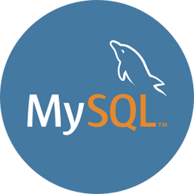
Figure 7 - MySQL logo
MySQL is a popular open-source relational database management system (RDBMS) that is widely used for storing and managing structured data. It offers a robust set of features and capabilities that make it suitable for a wide range of applications, including web development, data analytics, and business applications.
I used MySQL database in the first application : The python app where I put the data extracted from websites into the database through some incorporated pipelines of the Scrapy framework .Then I ‘scaffolded’ the database in my C# ,ASP.NET Core Web API app in order to manipulate and manage the data stored.
In order to administrate and handle the data from my database, I used MySQL Workbench 8.0 CE.
“MySQL Workbench is a unified visual tool for database architects, developers, and DBAs. MySQL Workbench provides data modeling, SQL development, and comprehensive administration tools for server configuration, user administration, backup, and much more. MySQL Workbench is available on Windows, Linux and Mac OS X. MySQL Workbench enables a DBA, developer, or data architect to visually design, model, generate, and manage databases. It includes everything a data modeler needs for creating complex ER models, forward and reverse engineering, and also delivers key features for performing difficult change management and documentation tasks that normally require much time and effort.
MySQL Workbench delivers visual tools for creating, executing, and optimizing SQL queries. The SQL Editor provides color syntax highlighting, auto-complete, reuse of SQL snippets, and execution history of SQL. The Database Connections Panel enables developers to easily manage standard database connections, including MySQL Fabric. The Object Browser provides instant access to database schema and objects.” [9]

Git

Figure 8 - Git logo
„Git is a free and open source distributed version control system designed to handle everything from small to very large projects with speed and efficiency.
Git is easy to learn and has a tiny footprint with lightning fast performance. It outclasses SCM tools like Subversion, CVS, Perforce, and ClearCase with features like cheap local branching, convenient staging areas, and multiple workflows.”[7]

Github

Figure 9 - Github logo

“GitHub, Inc. (/ˈɡɪthʌb/^{[a]}) is a platform and cloud-based service for software development and version control using Git, allowing developers to store and manage their code. It provides the distributed version control of Git plus access control, bug tracking, software feature requests, task management, continuous integration, and wikis for every project.^{[6]} Headquartered in California, it has been a subsidiary of Microsoft since 2018.^{[7]}
It is commonly used to host open source software development projects.^{[8]} As of January 2023, GitHub reported having over 100 million developers^{[9]} and more than 372 million repositories,^{[10]} including at least 28 million public repositories.^{[11]} It is the largest source code host as of June 2023.

The primary purpose of GitHub.com is to facilitate the version control and issue tracking aspects of software development. Labels, milestones, responsibility assignment, and a search engine are available for issue tracking. For version control, Git (and, by extension, GitHub.com) allows pull requests to propose changes to the source code. Users who can review the proposed changes can see a diff between the requested changes and approve them. In Git terminology, this action is called "committing" and one instance of it is a "commit." A history of all commits is kept and can be viewed at a later time.”[8]

Here is why I chose to use Git, GitHub and all in all version control in my project:

- Code Backup and Disaster Recovery: By using Git and hosting the project on GitHub, I ensured that my codebase is securely backed up and protected from accidental loss. Git keeps a complete history of changes, allowing me to roll back to any previous version if needed. Additionally, GitHub provides an extra layer of redundancy by storing the code on remote servers, reducing the risk of data loss.
- Version Management: Git makes it easy to manage different versions of my project. I can create branches for new features or bug fixes, experiment with different ideas, and revert changes if necessary. This version control capability allows for greater flexibility and reduces the risk of introducing errors into the main codebase.
- Code Review and Quality Assurance: GitHub provides a platform for code review, where team members can review each other's code, provide feedback, and suggest improvements. This code review process enhances code quality, helps catch bugs early, and promotes best practices. It also fosters knowledge sharing and continuous learning among team members.
- Open-Source Community: GitHub hosts a vast open-source community, making it easier to share my project, contribute to other projects, and leverage existing libraries and frameworks. This vibrant community provides opportunities for collaboration, feedback, and exposure to a wide range of coding styles and best practices.
- Traceability and Accountability: Git's commit history provides a detailed record of all changes made to the codebase. This traceability allows for accountability, as it's possible to identify who made specific changes and when. It helps in tracking issues, understanding the evolution of the project, and maintaining a clear audit trail.

Necessary frameworks and other packages

Scrapy

Figure 10 - Scrapy logo
„Scrapy (/ˈskreɪpaɪ/) is an application framework for crawling websites and extracting structured data which can be used for a wide range of useful applications, like data mining, information processing or historical archival.” [5]
Scrapy provides a set of features specifically designed for web crawling and it simplified a lot the process of building my web crawler[1] application by abstracting away many low-level details.
Modules used in the web crawler[1] application:
- scrapy.spiders.CrawlSpider
This is the most used spider for crawling regular websites, as it provides a convenient mechanism for following links by defining a set of rules. [25]
- scrapy.crawler.CrawlerRunner
This is a convenient helper class that keeps track of, manages and runs crawlers inside an already setup reactor.[29]
- scrapy.Field
The Field class is just an alias to the built-in ‘dict’ class and doesn’t provide any extra functionality or attributes. In other words, Field objects are plain-old Python dicts.[31]
- scrapy.Request
In Scrapy, scrapy.Request is a class that represents an HTTP request to be made while crawling a website. It's a fundamental component of the Scrapy[5] framework.
- scrapy.Response
Is a class that represents an HTTP response received after making a request during the crawling process. It encapsulates the data and metadata associated with the response, allowing you to extract information from the web page, such as HTML content, headers, status codes, and more.

ASP.NET Web API
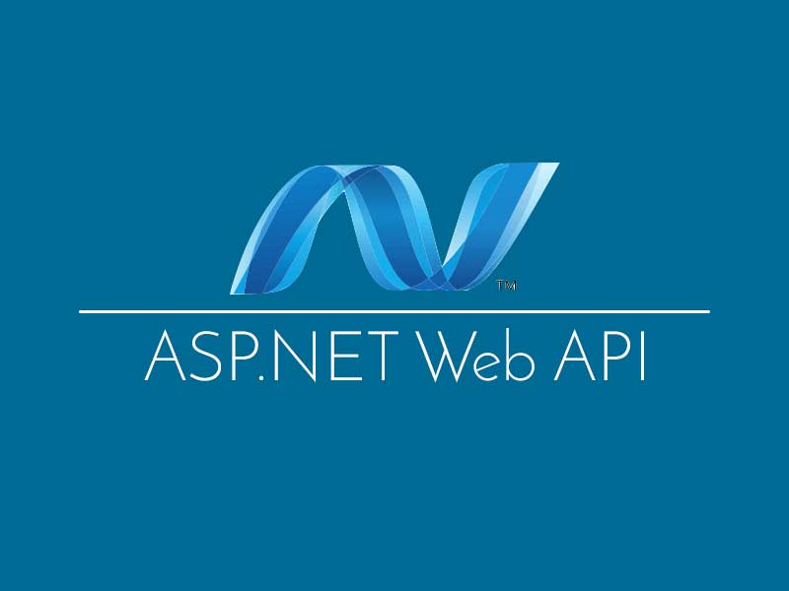
Figure 11 - ASP.NET WEB API logo
“ASP.NET Web API is a framework developed by Microsoft that allows you to build and expose HTTP services or APIs (Application Programming Interfaces) that can be consumed by various clients, such as web browsers, mobile devices, and other applications. It's a part of the larger ASP.NET ecosystem and provides a way to create RESTful APIs using the .NET framework.”[14]
In my C# ASP.NET Web API application, I scaffolded the MySQL database and created web services which I later used in the Angular app.
In order to realize the scaffolding process I used EntityFramework.
“Entity Framework (EF) is an object-relational mapper that enables .NET developers to work with relational data using domain-specific objects. It eliminates the need for most of the data-access code that developers usually need to write.”[24]
“Scaffolding a database produces an Entity Framework model from an existing database. The resulting entities are created and mapped to the tables in the specified database.”[24]

Angular
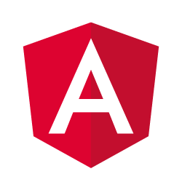
Figure 12 - Angular logo
“Angular is an open-source front-end web application framework developed and maintained by Google. It's designed to help developers build dynamic, single-page web applications (SPAs) with a rich user interface. Angular provides a set of tools, libraries, and best practices for building modern, responsive web applications.”[21]
„Key features and concepts of Angular[21] include:
- Component-Based Architecture: Angular applications are built using a component-based architecture. Components are self-contained, reusable building blocks that encapsulate a part of the user interface and its behavior.
- Templates and Data Binding: Angular offers powerful data binding mechanisms that allow you to connect data from your application's model to the view. This enables automatic synchronization of data between the model and the view, reducing the need for manual DOM manipulation.
- Directives: Directives are markers in the DOM that tell Angular to attach certain behavior to elements or components. Built-in directives like ngFor and ngIf help you manipulate the DOM dynamically based on your application's state.
- Dependency Injection: Angular has a built-in dependency injection system that helps manage the dependencies of your application. This promotes modularity and testability by allowing you to inject dependencies into components rather than creating them directly within the component.
- Services: Services in Angular are used to provide common functionality that can be shared across different components. They can handle data fetching, business logic, and more, promoting separation of concerns.
- Routing: Angular's router allows you to create navigation paths and views for different parts of your application. It supports features like lazy loading, route guards for authentication, and more.
- Forms: Angular provides robust support for creating both template-driven and reactive forms. These forms can include validation, custom validators, and two-way data binding.
- HTTP Client: Angular's built-in HTTP client module makes it easy to communicate with back-end servers using HTTP requests. It supports handling different types of data and making asynchronous requests.
- Internationalization (i18n): Angular offers tools for internationalizing your application, allowing you to create multilingual apps.
- Testing: Angular applications are highly testable, and the framework provides utilities for writing unit tests, integration tests, and end-to-end tests.
- CLI (Command Line Interface): Angular CLI is a command-line tool that makes it easier to create, build, test, and deploy Angular applications. It generates boilerplate code and handles many development tasks.”

APPLICATION DESIGN AND IMPLEMENTATION

APPLICATION DESIGN
The project consists of three projects,the web crawler[1],the web API and the Angular front-end web application.
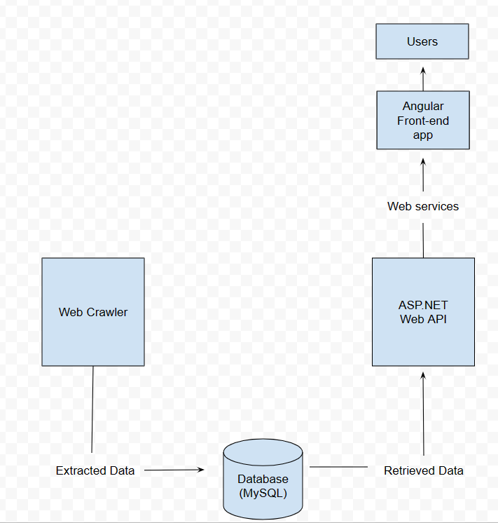
Figure 13 - Solution architecture
3.1.1.The web crawler[1] project is responsible for scraping and extracting data from three websites where many types of tech products are sold. Furthermore, the crawler leverages the scrapy[5] pipeline and item processing to clean and transform the extracted data before storing it, processes which will be described in further detail in the next chapters.
Due to the long time of extracting data,I limited the crawlers to only extracting information about phones.This long time is due to the fact that these sites have many products for sale . Another fact is that on one of the 3 sites (vexio.ro) I received a ban on a webcrawler robot and I had to find a method to bypass the site's proxy.
I managed to solve this problem, but the time of extracting data from this site has increased.I will talk more about this impediment in the implementation section.
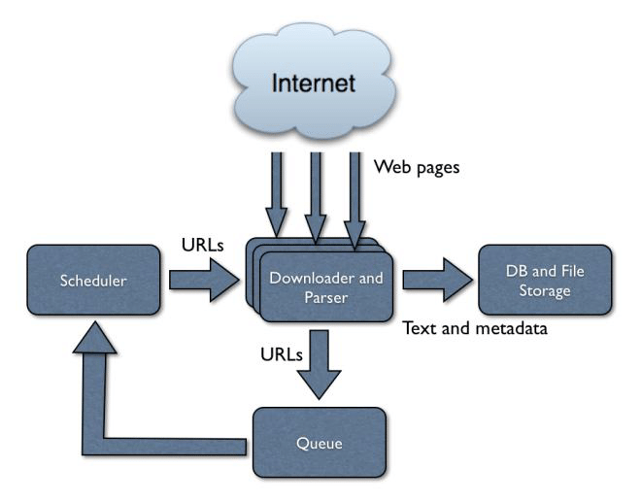
Figure 14 - Web Crawler Architecture
The Web Crawler[1] consists of three spider classes : VexioCrawler , RombizCrawler and DwynCrawler. Each spider class is responsible for crawling a specific web page and extracting relevant data. It manages the flow of URLs to be crawled and coordinates the other components.
The Downloader component is responsible for retrieving web pages by making HTTP requests. It handles downloading the HTML content and other associated resources. It also interacts with the network layer to send HTTP requests and receive the web page responses. It handles headers, cookies, redirects, and other aspects of the HTTP protocol.
The Queue manages the list of URLs to be crawled. It maintains a queue or priority queue of URLs and provides new URLs to the Fetcher component.
The Parser component processes the downloaded web pages. It extracts relevant data, such as links, text, images, and other metadata, from the HTML content. The Database component is responsible for storing the crawled data after it has been processed. The architecture allows for parallel processing, where multiple instances of the Downloader, Parser, and Data Store components can work simultaneously to increase the crawling speed.
Scrapy Framework [5]: The web crawler[1] is built using the Scrapy framework [5], which provides a high-level framework for writing and running spiders [25]. Scrapy handles crawling logic, request 17 management, and response processing. It provides a set of built-in functionalities and extension points for customization.
CrawlerRunner [36]: The CrawlerRunner [36] is a utility class provided by Scrapy that manages the execution of multiple spiders simultaneously. It allows you to run and control the spiders programmatically. I created an instance of CrawlerRunner [36] and used it to run my spider classes.
Settings: Scrapy [5] uses a settings module to configure various aspects of the crawler, such as the user-agent, download delays, pipelines, and more. The settings are defined in a settings.py file. I retrieve the project settings using the get_project_settings() function.
Logging: Scrapy [5] provides a logging mechanism to capture and manage log messages generated during the crawling process. It allows you to configure the log levels, log formats, and destinations. I used the configure_logging() function to set up the logging configuration.
Reactor: The reactor is a core component of the Twisted networking framework, which is used by Scrapy. It provides an event-driven programming model and handles the scheduling and coordination of network operations. The reactor is responsible for managing the asynchronous nature of the crawler and ensuring proper execution.
Item Pipelines: Item pipelines are used to process the extracted data from spiders. They enable you to perform tasks such as data validation, transformation, and storage. In your case, no item pipelines are currently enabled, but you can define and activate pipelines to process the scraped data as needed.
Twisted Framework: Scrapy is built on top of the Twisted framework, which is an asynchronous networking library. Twisted provides the underlying infrastructure for handling network operations, such as making HTTP requests, managing connections, and handling callbacks.
Scheduler and Downloader: Scrapy uses a scheduler to manage the queue of URLs to be crawled and a downloader to handle the actual HTTP requests and responses. These components work together to efficiently schedule and retrieve web pages during the crawling process.
Overall, the architecture of your web crawler[1] leverages the Scrapy framework and its components to perform web scraping[2] and data extraction. It utilizes spider classes, the CrawlerRunner, settings, logging, and the Twisted framework to manage the crawling process. Understanding this architecture will help you navigate and customize the web crawler[1] according to your specific requirements.

3.1.2.The ASP.NET[14] Web API app serves to retrieve the data stored in the MySQL database,to manipulate and to manage these data . I used it to create backend services that allow my Angular application to communicate with them through HTTP requests.
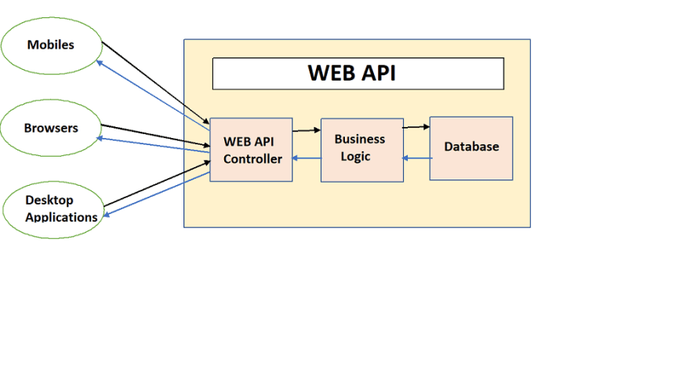
Figure 15 - Web API Architecture
Some key features of Entity Framework[24] that I used in my ASP.NET [14] Web API[15] app :
- Object-Relational Mapping (ORM): Entity Framework maps database tables to .NET classes and database columns to class properties. This enables developers to work with database records using familiar object-oriented concepts.
- LINQ Integration: Entity Framework integrates with Language Integrated Query (LINQ), allowing you to write expressive queries using C# or VB.NET syntax. These queries are then translated into SQL by Entity Framework.
- Database Providers: Entity Framework supports various database providers, including SQL Server, MySQL, PostgreSQL, SQLite, and more, allowing you to work with different types of databases using a consistent API.

Entity Framework aims to increase developer productivity by reducing the need to write repetitive data access code and manual SQL queries. It abstracts many complexities of working with databases, making it a popular choice for developers building .NET applications that interact with relational databases.

3.1.3. I used angular to display, search and filter this data in a user-friendly way using those HTTP requests and Typescript.Thus,I used html and css to structure and beauty the web page created.

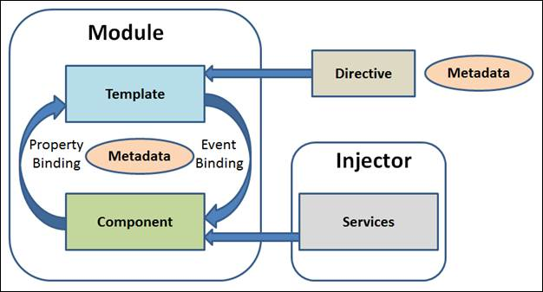
Figure 16 - Angular Architecture

Components play a central role in Angular's component-based architecture and follow a well-defined structure and lifecycle. Here's an overview of key concepts related to components in Angular[21]:

Component Structure:
- A component is defined using a TypeScript[20] class.
- The class is typically decorated with the @Component decorator, which provides metadata about the component.
- The metadata includes properties like selector, template (or templateUrl), styles (or styleUrls), and more.
Selector:
- The selector is a CSS selector that specifies how the component is identified within the HTML templates. It's used like a custom HTML tag.
- For example, if the selector is app-header, you can use <app-header></app-header> in your templates to include the component.
Template and Styles:
- The template property contains the component's HTML template. This is the markup that defines the component's structure and content.
- The styles property holds the component's CSS styles as an array of strings.
- Alternatively, you can use templateUrl and styleUrls to reference external template and style files.
Data Binding:
- Components can interact with the template by using data binding mechanisms.
- Data binding includes one-way binding (from component to template) and two-way binding (both directions).
- Interpolation ({{ }}), property binding ([ ]), event binding (( )), and two-way binding ([( )]) are common data binding techniques.
Input Properties:
- Components can accept input from their parent components using input properties.
- Input properties are decorated with @Input() and allow data to flow from the parent to the child component.

Output Properties and Event Emitters:
- Components can emit events to notify their parent components about certain actions or changes.
- Output properties are decorated with @Output() and use EventEmitter to emit custom events.
Component Lifecycle:
- Components have a lifecycle that consists of different phases, such as creation, rendering, updates, and destruction.
- Angular provides lifecycle hooks like ngOnInit, ngOnChanges, ngAfterViewInit, and more, which allow you to perform actions at specific stages of a component's lifecycle.
Dependency Injection:
- Components can have dependencies injected into them using Angular's dependency injection system.
- Dependencies, such as services, can be injected into a component's constructor, making them available for use within the component.
Component Communication:
- Components can communicate with each other using services, shared data via parent-child relationships, or a state management solution.
Encapsulation:
- Angular provides encapsulation of component styles to prevent styles from leaking into other components.
- Component styles are scoped to the component's template and do not affect other parts of the application.
Components form the core of Angular applications, enabling you to create reusable and maintainable user interface elements. They allow you to separate concerns, making it easier to develop, test, and manage different parts of your application's UI independently.

The Angular front-end application has 2 search functionalities :

You can search for a phone by writing its title in the search bar.If the searched phone exists on at least one of the three websites, the details of the phone will apear on the page.
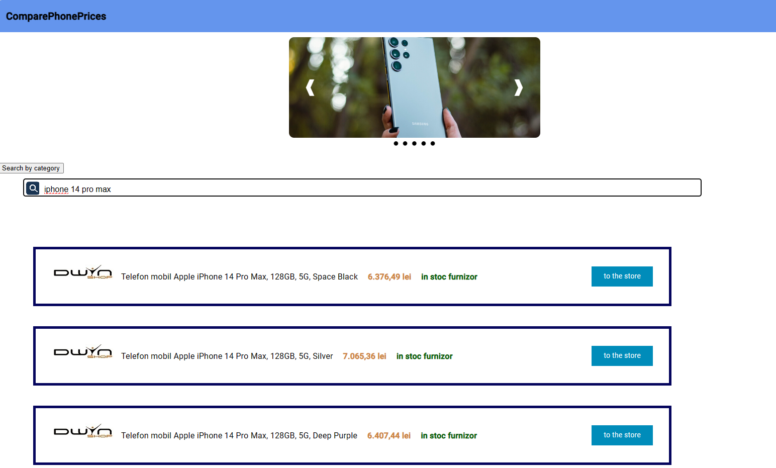
Figure 17 - Search by title page

If the phone with the specified title is found on all 3 sites, the offers will appear in the following order: Dwyn.ro, Vexio.ro, Rombiz.ro

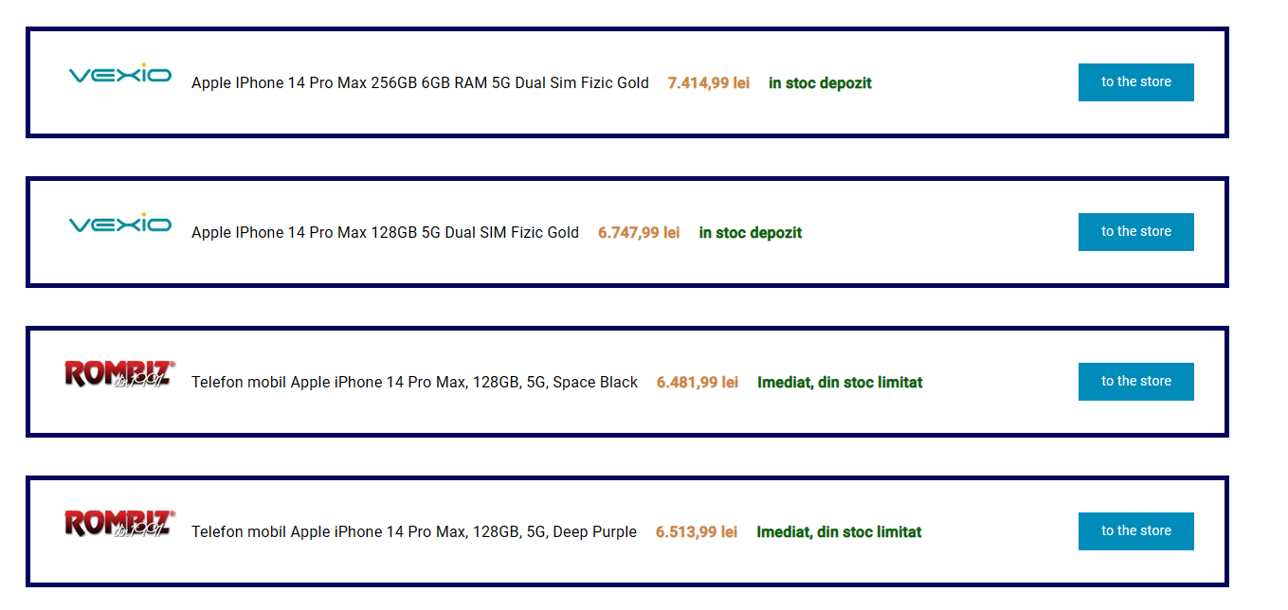
Figure 18 - Products ordered by site entry
The user can check the site in order to buy the phone or see more details of it by clicking on the title,price or the ‚go to store’ button.If the user will click on the logo of a website,he will be redirected to the main page of that site.

APPLICATION IMPLEMENTATION

PROJECTS SETUP

- Python application(Web crawler)
After I installed Scrapy [5] and other necessary packages, I needed to create a project using this framework. In order to set up the project I ran from the terminal the command: “scrapy startproject ProductsCrawler”. By running this command, I created the following folder structure:
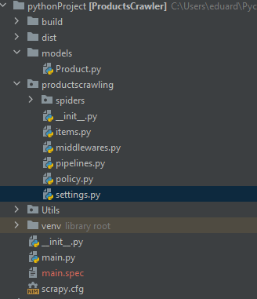
Figure 19 - Crawler folder structure
In the ‚spiders’ directory, I then created my spider classes:DwynCrawler,VexioCrawler and RombizCrawler which inherit the CrawlSpider class from scrapy.
For the first few tries I had to run my spiders from the terminal using the command: ‘scrapy crawl mycrawler -o output.json’. By using this argument, I also wrote the output collected by the crawler in a readable format represented by a json file.
To store the data, in my case in the MySQL database, I had to create the connection and build the table.
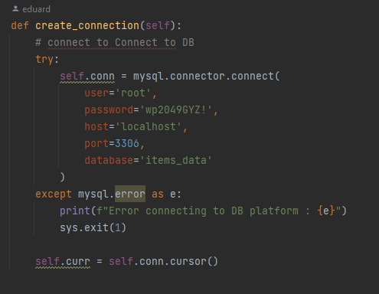
Figure 20 - Python create connection to db

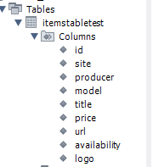
Figure 21 - My SQL Table structure

- For the second app, ASP.NET Web API, I also had to install neccesary frameworks and packages.
In order to scaffold the database into my web API[15] application I had to run some commands and follow some steps :
Add Connection String =>
Figure 22 - ConnectionStrings of wep API app
Packages to install =>
dotnet add package Microsoft.EntityFrameworkCore.Design
dotnet add package Pomelo.EntityFrameworkCore.MySql

Install & Update dotnet EF tool =>
dotnet tool install --global dotnet-ef
dotnet tool update --global dotnet-ef

Scaffold MySQL Database =>
dotnet ef dbcontext scaffold Name=ProductsDB Pomelo.EntityFrameworkCore.MySql --output-dir Models --context-dir Data --namespace Products.Models --context-namespace Products.Data --context ProductsContext -f --no-onconfiguring

dotnet add package Microsoft.AspNetCore.Mvc.NewtonsoftJson

- Setting up the Angular project involed several steps,including Angular CLI,creating a new project,and configuring project settings.The steps I followed to set up my Angular project are:
  - Install Node.js and npm
  - Install Angular CLI using the command on VS Code terminal :
    - „npm install -g @angular/cli”
  - Create a new Angular Project.Command used:
    - „ng new project-name”
  - Serve the Application :
    - ng serve
  - Generate Components and other Artifacts:
    - ng generate component component-name

WEB CRAWLER IMPLEMENTATION

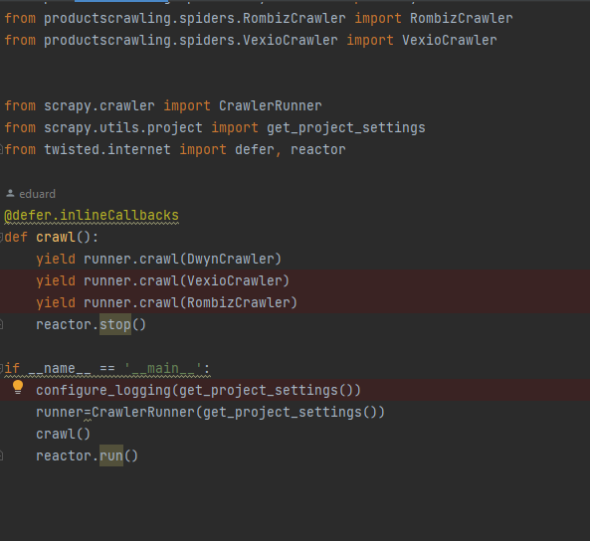
Figure 23 - Entrypoint for web crawler

This code from main.py is responsible for running the Scrapy spiders DwynCrawler,VexioCrawler and RombizCrawler using CrawlerRunner ‚inlineCallbacks’ method.I used this aproach to have my data ordered by site entry position in pipeline. I configure logging for Scrapy using configure_logging() function, create an instance of CrawlerRunner with the project settings obtained from get_project_settings() and start crawling all three spiders by calling the crawl() method of the runner instance.

Code of Spider extracting phones details from Dwyn.ro :
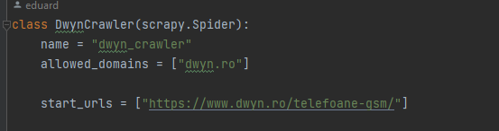
Figure 24 DwynCrawler class
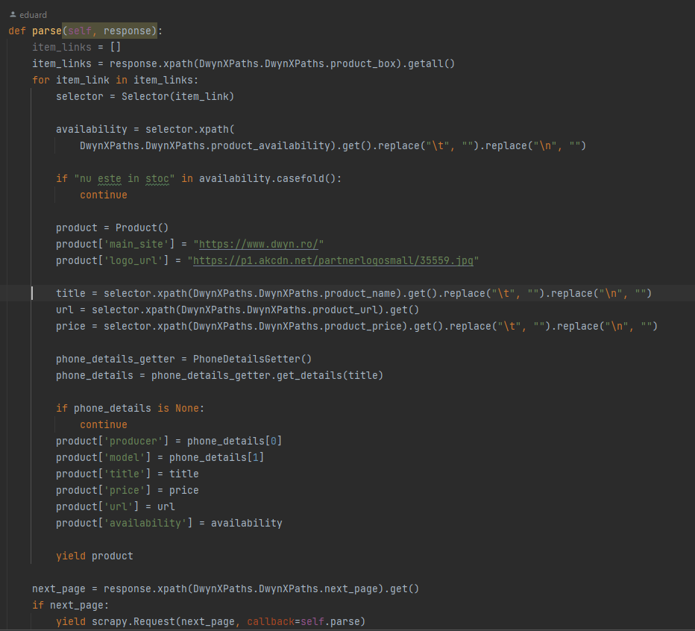
Figure 25 DwynCrawler parse func

In this figure 2we can see the implementation of parsing phone information from www.dwyn.ro website.If an item is not available to buy ,we will pass over it and won’t put it into the database .The information we extract about a phone is:
- main site of the item
- image url of the website
- the producer of the phone(brand)
- the model of the phone(Eg. S22,Iphone 14)
- A short description of the phone
- The price of the item
- The url of the phone page on the specific website
- Availability
In order to get the brand of the phone and the model,I used a method called ‚get_details(title)’ from class ‚ PhoneDetailsGetter()’.
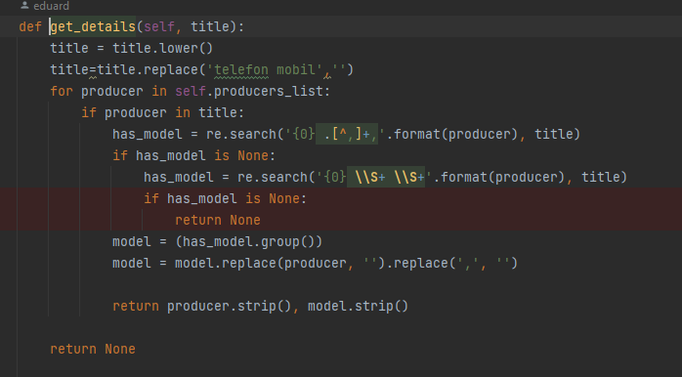
Figure 26 - get_details() func
As we can see, the function uses some regex to identify the producer and the model of the respective phone. Also , some deletions of whitespaces and characters are used.
The data parsing implementations on www.rombiz.ro and www.vexio.ro crawlers are similar with DwynCrawler class implementation.
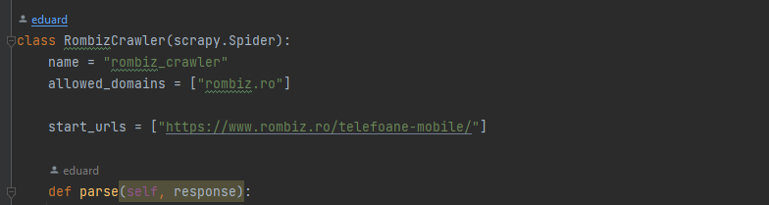
Figure 27 - RombizCrawler class
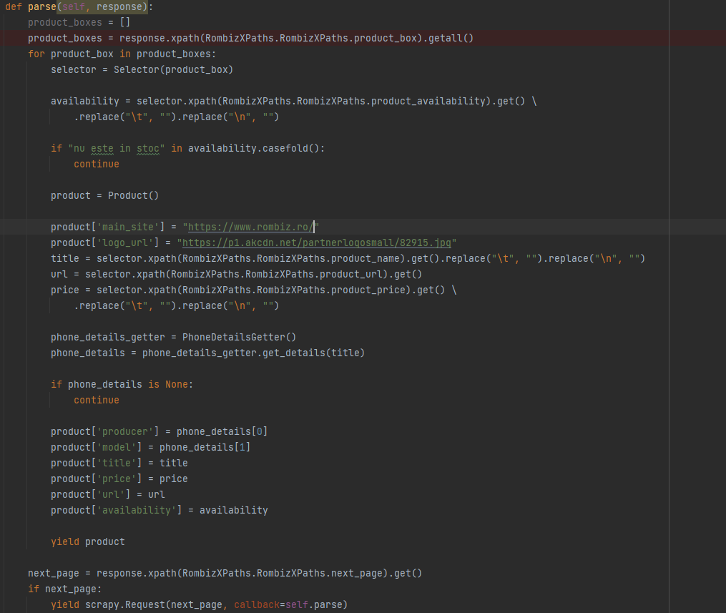
Figure 28 - RombizCrawler parse function
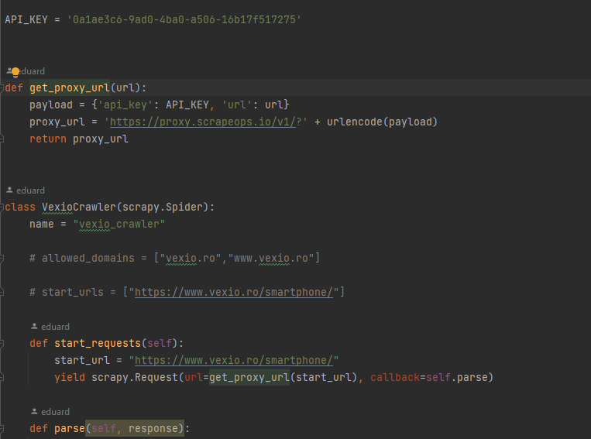
Figure 29 -VexioCrawler class

As I said above, after several runs of the Spider which extracts information from the website www.vexio.ro , I received a ban on the web spider 'robot'. In order to continue parsing the data about phones on this site ,I had to pass the site’s proxy. For that , for every request on this site ,I used an API_KEY that has the role of changing the IP frequently so that the website’s proxy can’t identify that it is accessed by a robot.

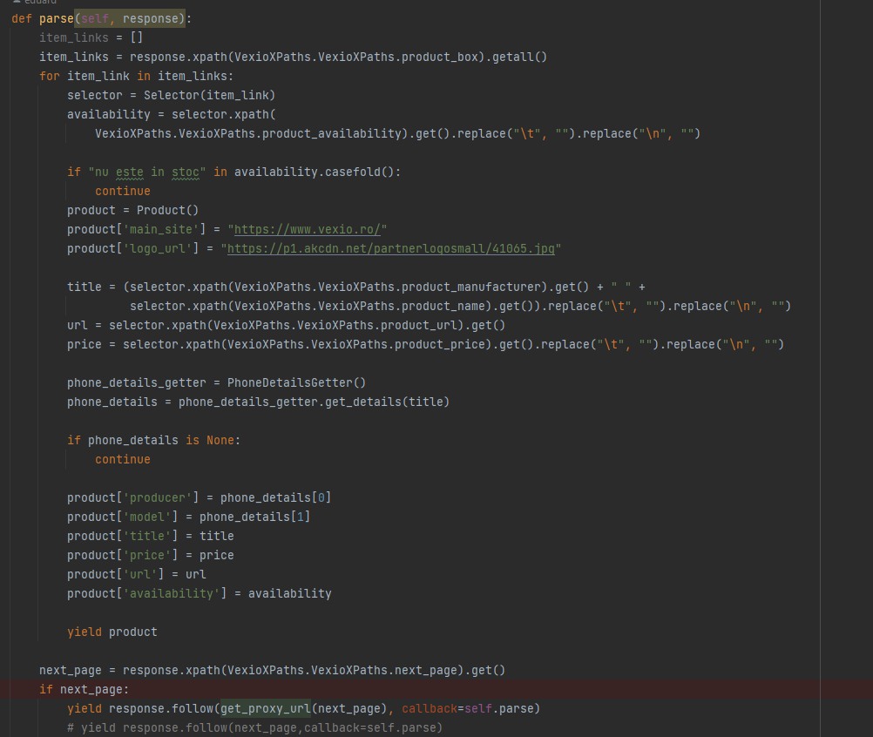
Figure 30 - VexioCrawler parse function

Code from items.py:
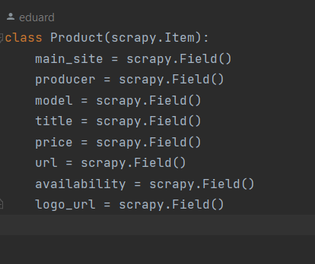
Figure 31 - items.py

In figure 8 is presented the ‘Event’ class that inherits from ‘scrapy.Item’.In Scrapy,an Item acts as a container for the scraped data and is used to represent structured data extracted from gien URLs:
- main_site : the url of the main page of the site that the phone is
- producer : the producer of the phone (E.g. Samsunt,Apple)
- title: a short description of the phone
- price : the price of the phone
- url: the URL of the webpage of the phone
- availability
- logo_url : the url to the logo of the main site
Code from pipelines.py:
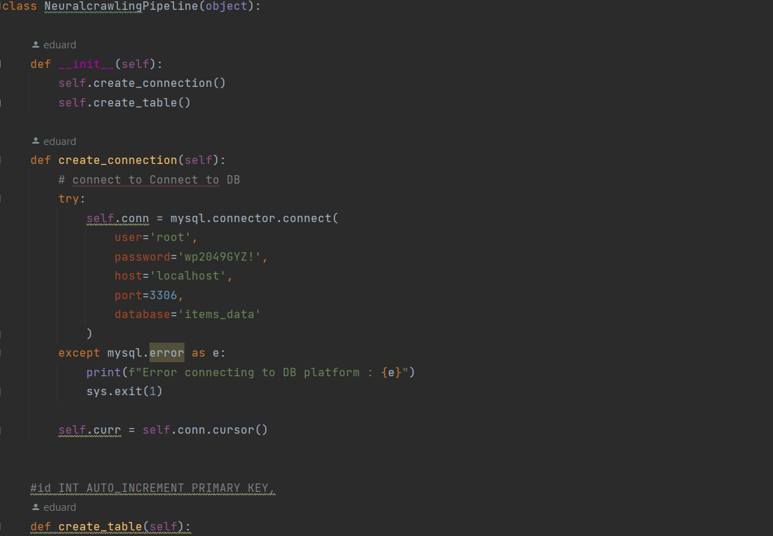
Figure 32 - NeuralcrawlingPipeline class
The NeuralcrawlingPipeline class is a pipeline that handles storing scraped data in a MySQL database.On the contrusctor,I created the connection with my local database and created the data table.
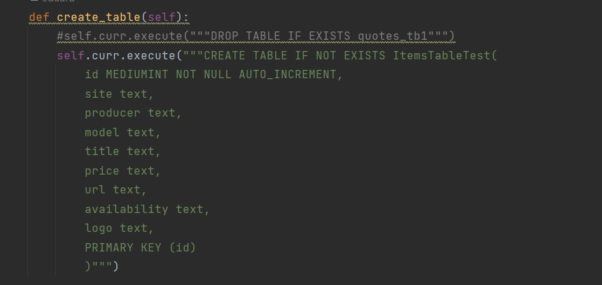
Figure 33 - create_table function
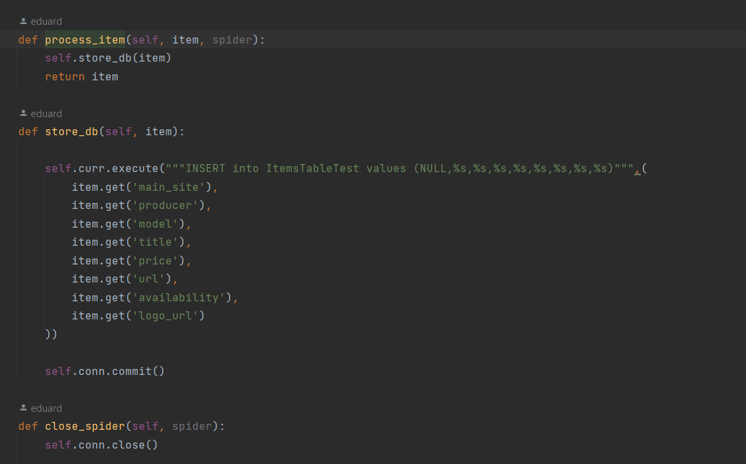
Figure 34 - other functions used in pipelines.py

In figure 11, there are other functions used in my pipeline class. ‘store_db’ function has the role to pass the information from scapy.Item to the database.

ASP.NET WEB API implementation
Because I used the entity framework and scaffolding command, the model and data transfer object classes were generated.
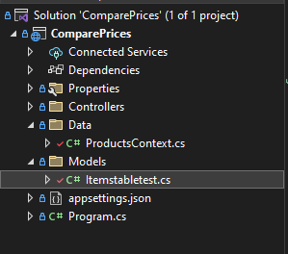
Figure 35 -API project setup
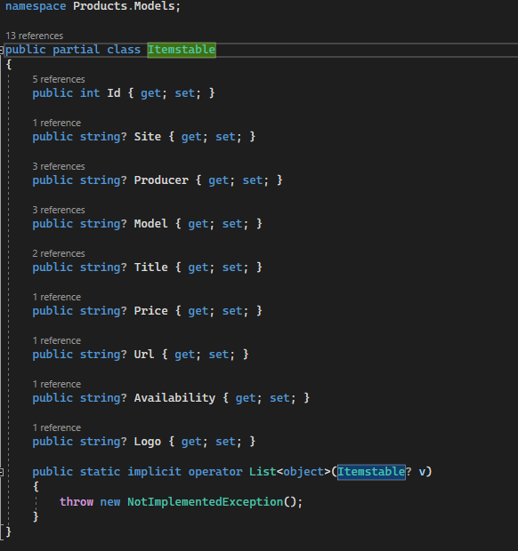
Figure 36 - Itemstable class
In Figure 13 we can see the data model of an item from the database.This data model makes easier to interact with database and to perform database operations using C# language.

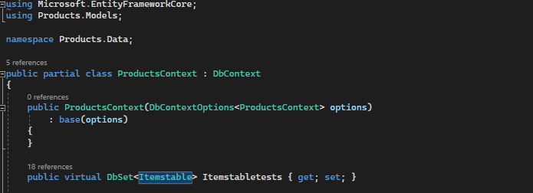
Figure 37 - generated ProductsContextClass

The ProductsContext is a class generated by scaffolding method. This class inherits from DbContext.
“A DbContext instance represents a combination of the Unit Of Work and Repository patterns such that it can be used to query from a database and group together changes that will then be written back to the store as a unit. DbContext is conceptually similar to ObjectContext.”

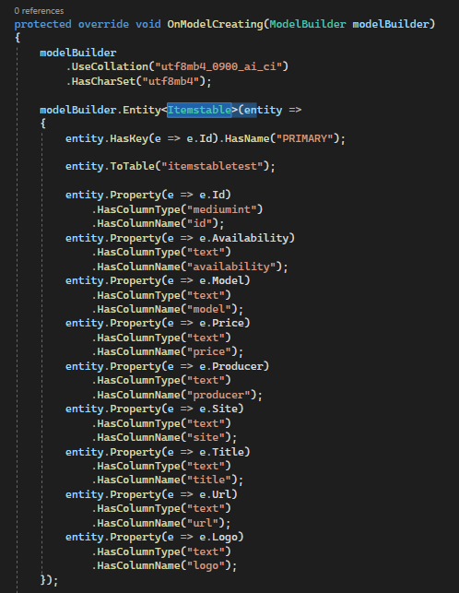
Figure 38 -method for ProductsContext class
This generated method is used to interact with the database in a high-level, object-oriented manner.
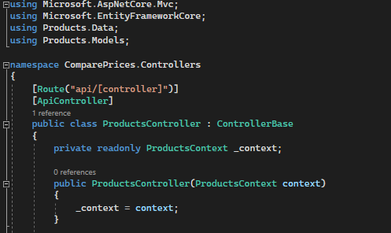
Figure 39 - ProductsControllers class

My main role in this web API app was to create the controllers. A controller plays a crucial role in handling incoming HTTP requests and generating appropriate HTTP responses. The primary role of a controller is to act as an intermediary between the client (e.g., a web browser, a mobile app, or another application) and the underlying data or business logic.
The controllers I created are the following :
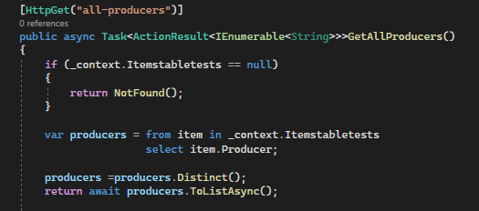
Figure 40 - GetAllProducers() function
As the name says this method is used to get all phone producers from the db.
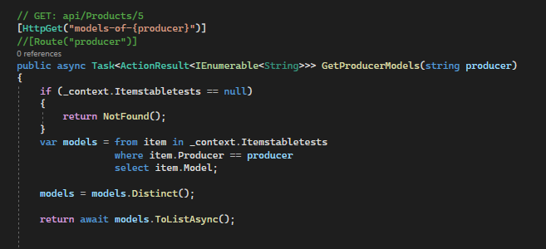
Figure 41 - GetProducerModels() function
The GetProducerModels() function is used to identify all models of a producer (brand of phone) that exist on at least one of the three webistes.
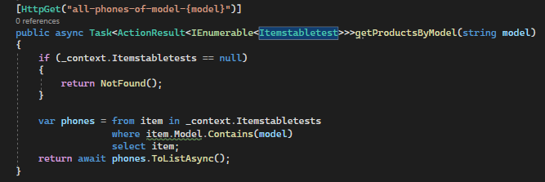
Figure 42 - getProductsByModel() function
The method associated with Figure 19 is used for finding all phones that correspond with the given model of phone.
The functions shown in Figure 17, Figure 18 and Figure 19 are used for ‘Search by category’ functionality from Angular front-end application.
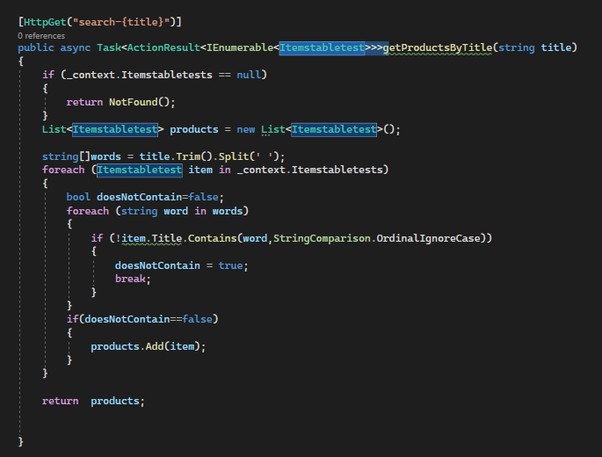
Figure 43 - getProductsByTitle() function
The method displayed in Figure 20 is used for searching an item by its title .It is used in Angular app on search bar for finding the desired phone.
All these [HttpGet] methods were tested using Swagger UI before they were used further.

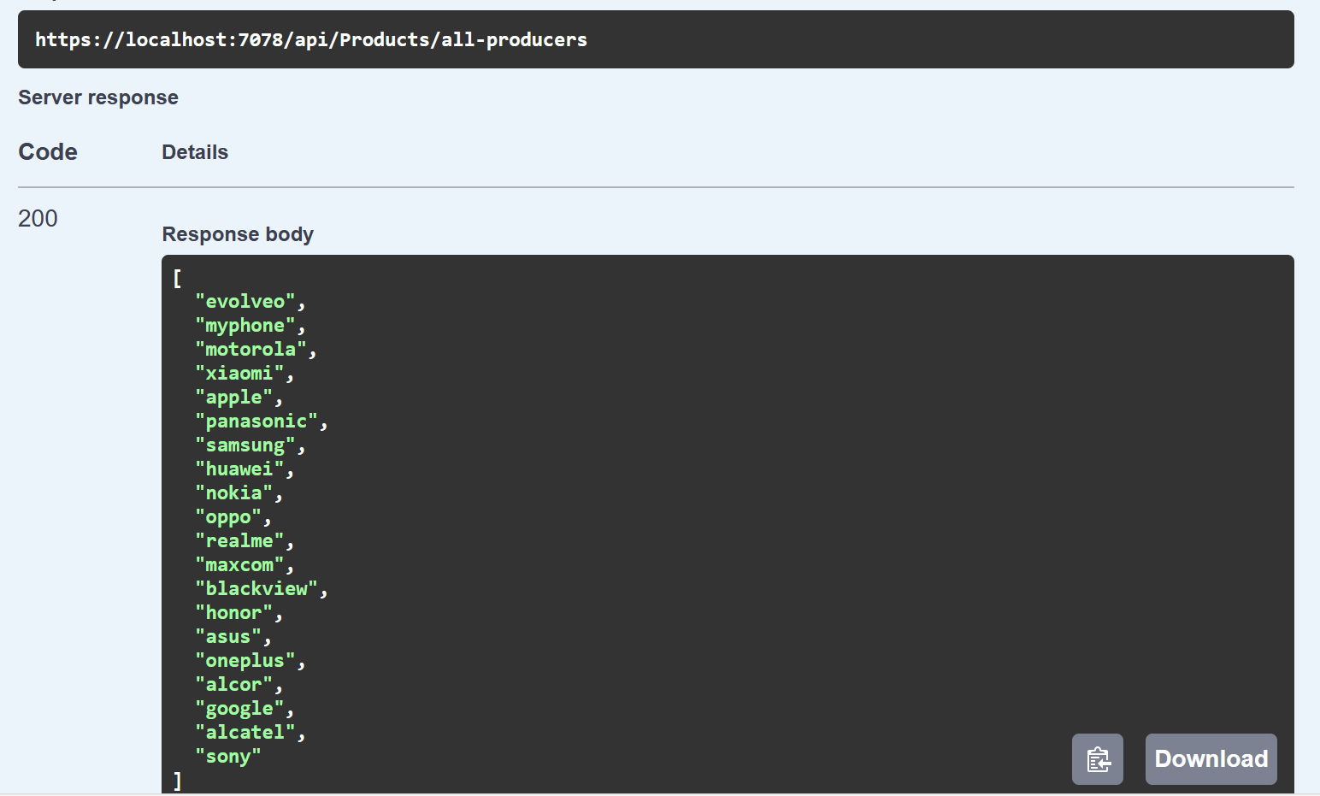
Figure 44 Swagger UI method tested

“Swagger UI is a popular open-source tool that simplifies and streamlines the process of documenting, testing, and interacting with RESTful APIs. It provides a user-friendly web-based interface that allows developers, testers, and other stakeholders to visualize and interact with an API without the need for specialized tools or software. Swagger UI is often used in conjunction with the Swagger framework (or OpenAPI Specification) to create and display API documentation.”

Angular application implementation:
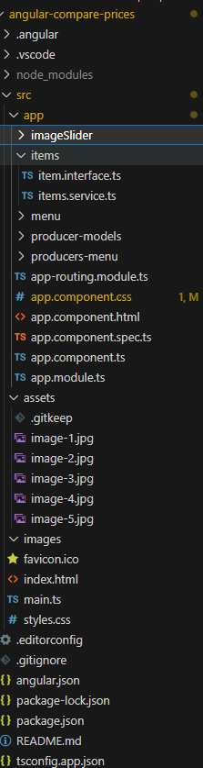
Figure 45 - Angular project structure
In Figure 45 is displayed the structure of the Angular project.The root module of the application is‚app.module.ts’.It declares the components,services and other modules in the app.

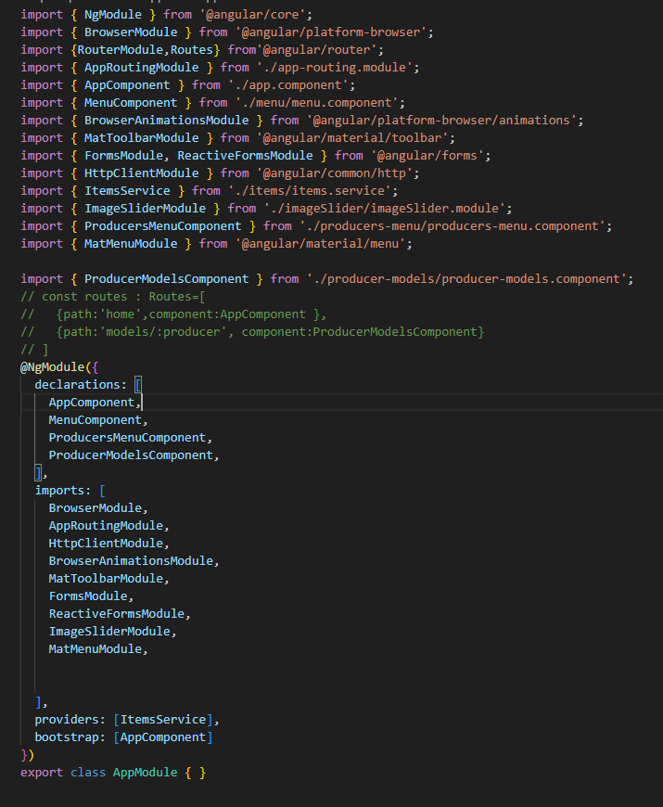
Figure 46 - Root module of Angular app

The app.component.ts, app.component.html, app.component.css : The main application component, which represents the root view of my application.
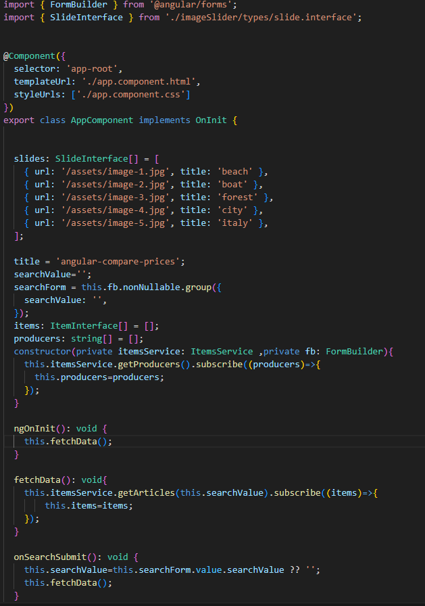
Figure 47 Main component of Angular app
In this module, the services and other reusable components of the application are called and managed.
Each component is organized in its own directory with its own TypeScript, HTML and CSS files.
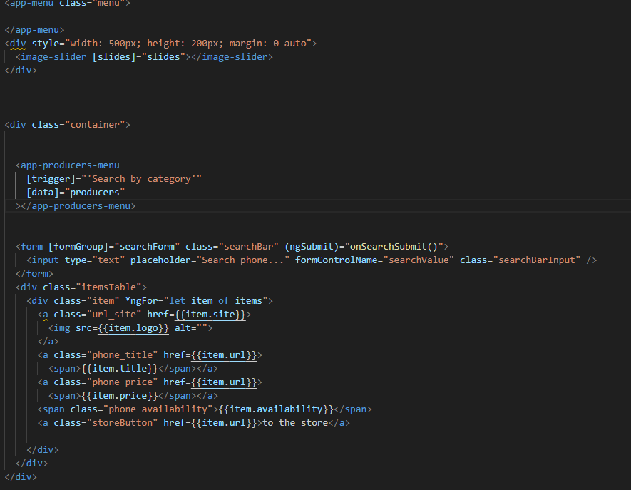
Figure 48 –Html page of main component

“HTML, which stands for HyperText Markup Language, is the standard markup language used to create web pages. It is the fundamental building block of the World Wide Web and is essential for structuring and presenting content on the internet. HTML is not a programming language; instead, it is a markup language used to define the structure and layout of web documents, including text, images, links, forms, and multimedia.”[22]
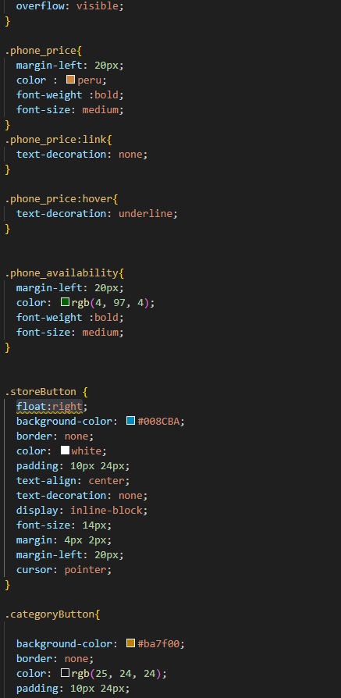
Figure 49 -CSS page of main component
“CSS, which stands for Cascading Style Sheets, is a stylesheet language used for describing the presentation and layout of web documents written in HTML and XML. CSS is an essential technology for web development because it separates the content (HTML structure) of a web page from its visual design and layout, allowing developers to control the appearance of web pages and make them visually appealing.”[23]

CONCLUSIONS
In conclusion, the implemented and described solution offers a robust and efficient way to scrape product data from various sales websites. It provides a reliable and scalable approach to web scraping product data from multiple sources. It handles diverse HTML structures, standardizes the extracted data, and ensures data integrity through checks and validation. The modular design allows for easy extension to support additional product sales websites, or scrape additional information to the one existing, making it a versatile solution for product data extraction and analysis.
The web page has some limitations in design or attractiveness, but despite that, it accomplishes its role of being a simple, pragmatic user interface that, in combination with the web crawler, shapes a tool with which users can seamlessly extract, manage, and analyze product data from multiple sources, all within a user-friendly and accessible environment. The system provides a valuable tool for comparing the prices of products on several sites and making the right choice in terms of buying an item at the best price.

REFERENCES
[1] - Web crawler – Wikipedia. Last edited on 18 June 2023. Retrieved from Web crawler - Wikipedia [2] –Will Hillier, What Is Web Scraping? A Complete Beginner’s Guide, August 2021. Retrieved from What Is Web Scraping? [A Complete Step-by-Step Guide] (careerfoundry.com)
[3] – Cloudfare, What is a web crawler? | How web spiders work, 2023. Retrieved from What is a web crawler? | How web spiders work | Cloudflare
[4] – W3Schools, XPath Tutorial. Retrieved from XPath Tutorial (w3schools.com)
[5] – Scrapy Developers, Scrapy at a glance, last updated on May 2023. Retrieved from Scrapy at a glance — Scrapy 2.9.0 documentation
[6] – Python Software Foundation, What is Python? Executive Summary. Retrieved from What is Python? Executive Summary | Python.org
[7] - Git. Retrieved from Git (git-scm.com)
[8] - Wikipedia, GitHub, last edited on 28 June 2023. Retrieved from GitHub - Wikipedia
[9] - Oracle, MySQL Workbench, 2023. Retrieved from MySQL :: MySQL Workbench
[10] – PyCharm, last edited on 30 May 2023. Retrieved from PyCharm - Wikipedia
[11] – Wikipedia, Integrated development environment, last edited on 10 June 2023. Retrieved from Integrated development environment - Wikipedia
[12] – Wikipedia, Python (programming language), last edited on 22 June 2023. Retrieved from Python (programming language) - Wikipedia
[13] – Wikipedia, Version control, last edited on 31 May 2023. Retrieved from Version control - Wikipedia
[14] – Wikipedia ASP.NET, last edited on 21 August 2023 . Retrieved from ASP.NET -Wikipedia
[15] – Wikipedia Web API , last edited on 26 July 2023. Retrieved from Web API - Wikipedia
[16] – Visual Studio , last edited on 9 August 2023.Retrieved from Visual Studio - Wikipedia
[17] – Visual Studio Code, last edited on 30 August 2023. Retrieved from Visual Studio Code - Wikipedia
[18] - C sharp (C#) ,last edited on 05/04/2023 .Retrieved from A tour of the C# language – Microsoft
[19]- C sharp (programming language),last edited on 30 August 2023 . Retrieved from C sharp - Wikipedia
[20] - TypeScript ,last edited on 27 August 2023. Retrieved from TypeScript - Wikipedia
[21] – Angular , last edited on 22 August 2023. Retrieved from Angular(web framework) - Wikipedia
[22] – HTML, last edited on 28 August 2023. Retrieved from HTML - Wikipedia
[23] – CSS , last edited on 28 August 2023. Retrieved from CSS - Wikipedia
[24] – Entity Framework last edited on 25 March 2023. Retrieved from Entity Framwork - Wikipedia
[25] – Spiders, Scrapy 2.9.0 documentation, last updated on 08 May 2023. Retrieved from Spiders — Scrapy 2.9.0 documentation
[26] – Signals, Scrapy 2.9.0 documentation, last updated on 08 May 2023. Retrieved from Signals — Scrapy 2.9.0 documentation
[27] – Link Extractors, Scrapy 2.9.0 documentation, last updated on 08 May 2023. Retrieved from Link Extractors — Scrapy 2.9.0 documentation
[28] – Exceptions, Scrapy 2.9.0 documentation, last updated on 08 May 2023. Retrieved from Exceptions — Scrapy 2.9.0 documentation
[29] – Core API, Scrapy 2.9.0 documentation, last updated on 08 May 2023. Retrieved from Core API — Scrapy 2.9.0 documentation
[30] - Logging, Scrapy 2.9.0 documentation, last updated on 08 May 2023. Retrieved from Logging — Scrapy 2.9.0 documentation
[31] - Items, Scrapy 2.9.0 documentation, last updated on 08 May 2023. Retrieved from Items — Scrapy 2.9.0 documentation
[32] – Wikipedia, macOS, last edited on 24 June 2023. Retrieved from macOS – Wikipedia
[33] – Wikipedia, Linux, last edited on 27 June 2023. Retrieved from Linux - Wikipedia
[34] – Wikipedia, Proprietary software, last edited on 22 June 2023. Retrieved from Proprietary software – Wikipedia
[35] – Wikipedia, Cross-platform software, last edited on 27 June 2023. Retrieved from Cross-platform software - Wikipedia
[36] – Wikipedia, Apache License, last edited on 24 March 2023. Retrieved from Apache License - Wikipedia
[37] - Wikipedia, JetBrains, last edited on 26 June 2023. Retrieved from JetBrains - Wikipedia

SOURCE CODE
You can find all three applications on my github repository :
Python app(web crawler): LiviuBana/WebCrawlerLicenta
C# app(web API) : LiviuBana/ComparePrices
Angular app : LiviuBana/angular-compare-prices

