DOCUMENTATION

ASSIGNMENT 1

STUDENT NAME: Tcaci Liviu
GROUP: 30221

CONTENTS

1. Assignment Objective 3
2. Problem Analysis, Modeling, Scenarios, Use Cases 3
3. Design 3
4. Implementation 3
5. Results 3
6. Conclusions 3
7. Bibliography 3

Assignment Objective
The primary goal of this assignment is to design and implement a Polynomial Calculator capable of performing various operations on polynomials, including addition, subtraction, multiplication, derivation, and integration. This application aims to simplify these operations, which are typically complex and time-consuming when done manually, by providing a user-friendly graphical interface.

Sub-Objective | Description | Addressed in Section
Problem Analysis and Requirements | Identify and outline the functional and non-functional requirements for the polynomial calculator. | Section 2
Design | Develop a clear and efficient object-oriented design for the application, including UML diagrams to illustrate the structure. | Section 3
Implementation | Implement the designed solution in Java, ensuring all functionalities are properly developed and integrated. | Section 4
GUI Development | Create a graphical user interface (GUI) using Java Swing, allowing users to easily interact with the calculator. | Section 4
Testing | Perform comprehensive testing, including unit testing with JUnit, to ensure all functionalities work as expected. | Section 5

Problem Analysis, Modeling, Scenarios, Use Cases
2. Problem Analysis, Modeling Scenarios, Use Cases

The Polynomial Calculator is designed to simplify mathematical operations involving polynomials for students and educators alike. This section delves into the specific functionalities the application aims to provide and outlines the user interactions through use case scenarios.

Functional Requirements:

1. Input Polynomials: Users can input polynomials in a textual format, where each term is represented by its coefficient followed by the variable 'x' and its exponent.
2. Select Operations: The application offers the capability to choose from a variety of operations: addition, subtraction, multiplication, derivative, and integration.
3. Display Results: After performing the selected operation, the result is displayed in a simplified polynomial format.
4. Error Handling The application provides feedback for invalid inputs or operations that cannot be performed.

Use Cases:

- Add Polynomials:
1. The user enters two polynomials into the designated input fields.
2. The user selects the 'Add' operation.
3. The application calculates the sum of the two polynomials and displays the result.

- Subtract Polynomials:
1. Two polynomials are inputted by the user.
2. The 'Subtract' operation is chosen by the user.
3. The application computes and shows the difference between the two polynomials.

- Multiply Polynomials:
1. The user inputs two polynomials.
2. The 'Multiply' function is selected.
3. The product of the polynomials is calculated and shown by the application.

- Derive Polynomial:
1. A single polynomial is entered by the user.
2. The user selects the 'Derive' option.
3. The application determines the derivative of the polynomial and displays it.

- Integrate Polynomial:
1. The user provides one polynomial.
2. The 'Integrate' function is selected.
3. The application calculates the integral of the polynomial and presents the result.

Design
3. Design

The design phase of the Polynomial Calculator is crucial for establishing a robust and scalable application architecture. This section details the object-oriented design approach, emphasizing class relationships, data structures, and the utilization of design patterns to enhance modularity and maintainability.

Overall System Architecture:

The application adopts the Model-View-Controller (MVC) architecture to separate concerns, improve code organization, and facilitate future enhancements. This architecture divides the application into three interconnected components:

1. Modl - Represents the application's dynamic data structure, directly managing the data, logic, and rules of the application.
2. View- Any representation of information, such as a chart, diagram, or table. Multiple views of the same information are possible.
3. Controller- Accepts input and converts it to commands for the model or view.

UML Class Diagram:

The UML class diagram below illustrates the primary classes and relationships within the Polynomial Calculator:

- PolynomialCalculatorUI (View): Manages the graphical user interface, capturing user inputs and displaying results.
- PolynomialController (Controller): Acts as an intermediary between the view and the model, handling user actions and invoking model operations.
- Polynomial (Model): Encapsulates a polynomial's data structure and operations, including addition, subtraction, multiplication, derivative, and integration.
- Operation (Model): An enumeration defining the supported polynomial operations.
- PolynomialOperations (Model: An interface defining the contract for polynomial operations.
- PolynomialParser (Utility):A utility class for parsing string representations of polynomials into `Polynomial` objects.

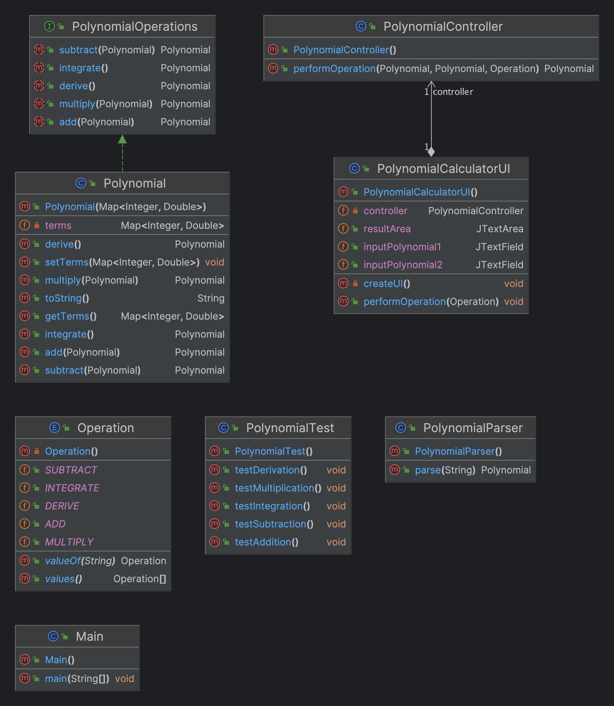

Data Structures:

- Polynomial Representation: A polynomial is represented using a `Map<Integer, Double>`, mapping each term's exponent to its coefficient. This choice facilitates efficient operations and dynamic polynomial degree management.

Design Patterns and Principles:

- Singleton Pattern (optional If a single instance of the PolynomialParser is sufficient, implementing it as a singleton ensures controlled access to a centralized parsing utility.
- Strategy Pattern By encapsulating polynomial operations behind the `PolynomialOperations` interface, different strategies for polynomial manipulation can be easily swapped or extended without altering the clients.
- Open/Closed Principle The system is designed to be open for extension but closed for modification. New polynomial operations can be added without changing the existing code structure.

This design ensures that the Polynomial Calculator is well-structured, with clear responsibilities assigned to each component, facilitating easy maintenance and scalability.

Implementation

In the implementation phase, the Polynomial Calculator was developed using Java, focusing on clarity, efficiency, and adherence to the previously defined design. This section describes the key classes and their functionalities within the project.

Polynomial Class:

The `Polynomial` class is the core of the model, encapsulating the data structure and operations for polynomial manipulation. It utilizes a `HashMap<Integer, Double>` to map each term's exponent to its corresponding coefficient, allowing for efficient access and modification of polynomial terms.

public class Polynomial implements PolynomialOperations {
private Map<Integer, Double> terms;

public Polynomial(Map<Integer, Double> terms) {
this.terms = new HashMap<>(terms);
}

// Implementations of add, subtract, multiply, derive, and integrate methods
}

PolynomialController Class:

The `PolynomialController` acts as the mediator between the UI (view) and the polynomial data model. It interprets user actions, invoking the appropriate polynomial operations and updating the view with the results.

public class PolynomialController {
public Polynomial performOperation(Polynomial poly1, Polynomial poly2, Operation operation) {
switch (operation) {
case ADD: return poly1.add(poly2);
case SUBTRACT: return poly1.subtract(poly2);
// Other cases...
default: throw new IllegalArgumentException("Invalid operation");
}
}
}

PolynomialCalculatorUI Class:

This class constructs the graphical user interface using Java Swing, providing input fields for polynomials, buttons for operation selection, and a text area for displaying results. It registers action listeners for the buttons to capture user inputs and invoke operations through the controller.

public class PolynomialCalculatorUI extends JFrame {
private PolynomialController controller = new PolynomialController();
// UI components initialization and event handling
}

PolynomialParser Utility Class:

`PolynomialParser` is a utility class that translates string representations of polynomials into `Polynomial` objects, enabling the application to interpret user inputs.

public class PolynomialParser {
public static Polynomial parse(String text) {
Map<Integer, Double> terms = new HashMap<>();
// Parsing logic
return new Polynomial(terms);
}
}

Testing with Junit:

Unit tests were written to verify the correctness of polynomial operations, employing JUnit for testing individual methods within the `Polynomial` class. These tests ensure the application's reliability by validating addition, subtraction, multiplication, derivation, and integration functionalities against expected outcomes.

public class PolynomialTest {
@Test
public void testAddition() {
// Test implementation
}
// Other test methods...
}

Results

The Polynomial Calculator was subjected to comprehensive testing to validate its functionality and ensure it met the requirements outlined in the design and implementation phases. This section presents the results of these tests, including both unit testing for individual operations and integration testing for the application as a whole.

Unit Testing

Unit tests were conducted using JUnit to assess the correctness of the polynomial operations implemented in the `Polynomial` class. Each operation (addition, subtraction, multiplication, derivation, and integration) was tested with a variety of polynomial inputs to cover normal cases, edge cases, and potential error scenarios. Below are summaries of the test cases and their outcomes:

- Addition Tests: Confirmed that polynomials are correctly added, including tests for polynomials of different degrees and testing the addition of a polynomial to itself.
- Subtraction Tests: Verified that polynomial subtraction accurately reflects the mathematical operation, including the subtraction of a polynomial from itself resulting in a zero polynomial.
- Multiplication Tests: Ensured that polynomial multiplication produces the correct result, with special attention to the multiplication of a polynomial by a constant and by another polynomial.
- Derivation Tests: Tested the derivative operation, confirming that coefficients are correctly multiplied by their exponents, and that the exponent is decremented by one.
- Integration Tests: Checked integration functionality, ensuring that coefficients are correctly divided by their new exponent, and the exponent is incremented by one.

Integration Testing

Integration testing focused on the interaction between the application's components—the UI, controller, and model. Tests were conducted to ensure that the application behaves as expected when performing operations through the graphical user interface. Key aspects tested include:

- Input Validation: Confirmed that the application correctly handles invalid inputs, such as non-polynomial strings, and displays appropriate error messages.
- Operation Execution: Tested the complete flow from inputting polynomials, selecting an operation, and displaying the result, ensuring the application responds correctly for each operation type.
- Result Display: Verified that the results are displayed in a simplified and readable polynomial format, regardless of the operation performed.

Test Scenarios and Outcomes

1. Adding Two Polynomials: Inputs: "2x^2 + 3x + 1" and "x^2 - x". Outcome: The application correctly displayed "3x^2 + 2x + 1".
2. Deriving a Polynomial: Input: "3x^3 + 5x^2". Outcome: The derivative "9x^2 + 10x" was correctly calculated and displayed.
3. Multiplying Polynomials: Inputs: "x - 1" and "x + 1". Outcome: The application accurately returned "x^2 - 1".

Conclusions
The development and testing of the Polynomial Calculator have successfully demonstrated its ability to offer a user-friendly and efficient tool for performing polynomial operations. This project not only provided a practical application for understanding and manipulating polynomials but also served as a valuable learning experience in software development, from initial design through to implementation and testing.

Key achievements include the successful integration of a graphical user interface with the underlying logic to perform polynomial additions, subtractions, multiplications, derivatives, and integrations accurately. The application's design, adhering to the MVC architecture, has ensured a scalable and maintainable codebase.

Future developments could include extending the calculator's capabilities to support more complex mathematical operations, improving the UI for an even more intuitive user experience, and optimizing performance for handling larger polynomials. This project lays a solid foundation for such enhancements, offering a robust starting point for further exploration and development in the realm of mathematical computing tools.

Bibliography

1. Oracle "The Java Tutorials."
2. Eckel, Bruce.** *Thinking in Java (4th Edition)
3. JUnit Team"JUnit 5 User Guide."
4. How to Create a Test on IntelliJ (JUnit)

