Air Traffic Controller

Designing monitor screens

livjyot singh

2021

**Table of Contents**

Introduction 3

Description 3

Purpose 4

Readouts 4

Controls 4

Consequences 4

Environmental Factors 4

Research 5

Explanation of Ergonomics 5

System Issues 6

Safety 6

Comfort 7

Business Risks 8

Privacy Threats 9

Technical Standards 10

Content Plan 11

Wireframes 13

Prototypes 15

Conclusion 17

References 18

**AIR TRAFFIC CONTROL**

## INTRODUCTION

In this project, I will be making a system for an Air Traffic Control (ATC) which will consist of a monitor screen with a panel size 23.5’’ which is exactly 59.69 cm. It is a touch screen monitor with a high [4K] 3840 x 2160 resolution which will overall increase the system’s performance.

## DESCRIPTION

This system will use monitors, radars, radios and other special instruments to provide proper guidance to the flying aircrafts. In other words, it would provide ground controllers complete details of the flight that would help them in directing an aircraft while remaining on the ground, and can even provide advisory services to the non- controlled airspace.

The main purpose and goal of the designed system is to make air travel completely safe by avoiding the risk of aircraft collisions with the increasing number of aircrafts that can fly safely at the same time. This system uses an aircraft navigation and communication system in constantly locating the plane with its speed and altitude for every individual aircraft that is flying. It would play an important role in managing air traffic with their monitors, and help instructing the pilots to maintain a safe operation of the aircrafts.

The system computers will show a list of readouts and controls that would be digitally viewed by ATC instructors to guide an aircraft’s pilot. These include:

* **Readouts** for the aircraft that will show all the visual record or display all the information of the plane either by searching it or by filtering planes by entering the flight number in the filter menu. These show the **flight name by its number**,

**image**, **scheduled takeoff** and **landing time**, and will be able to see all other necessary details. We would also able to see its:

* + **Location:** A complete world map is shown on their monitors to locate or navigate a specific aircraft at any time we want.
  + **Route:** The entire route of an aircraft is assigned before its travel, and ATC has full records from where it would depart from, and where it would be landing with its exact timings and a pre-assigned path which will be unique for every flight with respect to its altitude, speed and time of travel.
  + **Weather Reports:** They can detect the weather conditions for the entire route in which the plane would be travelling in future, so that it could not create any kind of problem and can easily warn the pilots and suggest delays or the change of flight route.
  + **Others:** It will show the speed and altitude of the aircraft and many other necessary information if needed in more option.
* **Controls** will help to change the **map view** to day, night, terrain, satellite or hybrid view. It will also allow us to search a specific flight by its number to know all its details by using **filters** options in the bottom menu. Also, we will be able to change the time zone, clock time, speed, altitude and distance units in the **settings** option in the main menu.

The failure of the system is although rare, but if it happens it could lead to adverse results. For example, if the system’s radar is faulty then, it would not track the current location of the airplane resulting in panic situations as the ground controller would be unable to assist the pilots. Also, it could lead to partial or complete communication failure if aircraft is not identified by the system.

The environmental factors too have a huge impact on the system’s usage. This may include human factors which is a subject of discussion as it greatly increases human errors which can result in drastic consequences. It is a fact that the job of being an air traffic controller is a highly stressful job because it needs a lot of focus at all times and it could be a lot harder as there is an increase in the demand for air services everyday. The most common sources of stress are related to operational stress, such as peaks of traffic load, limited time and equipment. It can be also because of organizational aspects, such as shift management and conflicting roles.

# RESEARCH

## PART A

Ergonomics is the science and the art of fitting the job and the workspace to workers needs. It is derived from two Greek words namely “Nomoi” meaning natural laws and “Ergon” meaning work. Hence, ergonomists study human capabilities in relationship to work.

The objective of ergonomics is to improve the efficiency of operation by taking into account a typical person’s size, strength, speed and visual acuity and physiological stresses, such as fatigue, speed of decision making, and demands on memory and perception. A successful ergonomics program utilizes the skills of many disciplines, including engineering, psychology, medical, safety and the management.

The benefits of applying ergonomics principles:

* Maximize productivity, efficiency and quality
* Improve employee morale
* It can help you do work safely
* It can make you more comfortable
* It can prevent injuries

## PART B

For the air traffic control system, there might be some risks associated with it.

These can be related to the safety, comfort, business risks and privacy threats to the system.

**Safety:** There is always some kind of risk in the context of workspace safety which should not be taken for granted. Ergonomics disorders is the fast growing category of work related illness because of several reasons. It can cause carpal tunnel syndrome, tendinitis, rotator cuff injuries, muscle strains, and low back injuries due to risk factors like high task repetition, forceful exertions, and repetitive awkward postures.

### Solution:

1. Engineering Controls – Eliminating excessive force and awkward posture
2. requirements will reduce worker fatigue and allow high repetition tasks to be performed without a significant increase in MSD risk for most workers.

(ii) Job Rotation – Job task enlargement is a way to reduce duration, frequency and severity of MSD risk factors. Workers can rotate between workstations and tasks to avoid prolonged periods of performing a single task, thereby reducing fatigue that can lead to MSD.

### Hardware Design Solutions:

1. Controls within easy operating reach and operable with good posture such as wrists neutral and elbows close to the body.
2. Push buttons or switches used repetitively for machine start cycle design ergonomically to eliminate excessive force
3. Consider a seated or sit/stand workstation for high repetition and low force work with minimal reaching and movement requirements.

(ii) For sitting workstations like ATC, good ergonomic chair or stool with adjust-ability,

lumbar support features.

## Comfort

Ergonomics is very important when it comes to helping humans feel comfortable in their activities. This is because many of them found themselves using a computer for a larger part of the day. Poor workspace design and layout can contribute to workspace injuries and illness.

### Solutions:

1. Chair: Adjust the height of your chair so that your feet rest comfortably on the floor.

If this makes your chair too low in relation to the desk, use a footrest and raise the chair up to the desired height.

1. Monitor: The monitor should be roughly an arm’s length away. The top of the screen should be at eye level or just below so that you look down at a slight angle to your work. Even with these adjustments, your eye muscles can become tired when you do a lot of work. Remember to rest them every 30 minutes or so by looking away or blinking your eyes a couple of times .
2. Desk: Desk area should be deep enough to accommodate your monitor at the appropriate distance and to place the things you use most often directly in front of you. Make sure everything you need is within reach so that you don’t have to stretch for things. Stand up to get items that are further away.

### Hardware Design Solutions:

1. Ideally, use a swivel chair that has 5 feet. Castor wheels should be fitted if the chair is on carpet. On a smooth surface, however, as castors are too unstable, the chair should be fitted with glides (flattened smooth egg-shaped feet).
2. Monitor: Screen size should be not less than 146 cm, and The Raptor RP5824 with a 57.5-inch 4K × 2K resolution. Its large 8 megapixel screen allows controllers to view

more data simultaneously in a single location.

1. Desk: Desk with a matte surface helps minimize glare.

## Business Risks

Study shows that there is a direct correlation between ergonomics and business performance, stock performance, improved productivity, human capital and more. Poor ergonomics can lead to substantial social and financial consequences, which would not always convince business stakeholders of the value of ergonomics. All the ergonomics factors (i.e., safety, comfort, etc) should be taken care of to avoid risks in any business.

### Solutions:

1. Companies should invest in good ergonomics to better manage human capital,
2. which includes the skills, knowledge, and abilities employees bring to their work.
3. They should invest in providing ergonomics training to all employees, deploying a management system for ergonomics, measuring the system’s effectiveness, and publishing lost-time injuries.

### Design Solutions:

1. Cost must be considered because it is a critical component of any operation. With limited funds, companies must choose wisely among various alternatives.
2. Team Approach: It’s important to work with your team and consider how any proposed engineering controls will affect the entire process, both upstream and downstream. Team approach plays a crucial role in determining the best solution to any business which further leads to improvement.
3. Increasing Awareness: Employees should put their efforts in educating team members, and reducing injuries to employees is important in deploying a sustainable ergonomics process across the organization leading to an improved business

performance.

## Privacy Threats

As technology is growing day by day, attacks on the systems are increasing very rapidly and becoming more and more common. This can be because of outdated softwares that does not get updated with the regular time span. So, it becomes very easy for hackers to find the weakness of old devices with modern technologies.

### Solutions:

1. Encryption: Encryption of data is one of the most important measures to mitigate the risk in the middle attacks.
2. Traceability: It is key to fixing security issues, identifying suspicious activity, tracing attackers, and recovering quickly from an attack.
3. Multi-Factor Authentication: Multi-Factor Authentication adds another step to the login process, requiring users to confirm their identity through a secondary authentication mechanism.

### Design Solutions:

1. Encryption: It is recommended to always use HTTPS/WSS, i.e. SRTP/SIPS, services to provide protection. The guardREC® ATC system encrypts all stored data, databases, and files, and offers hash stored passwords to prevent outsiders from gaining access to sensitive information.
2. Traceability: The guardREC® ATC system offers several functions to improve traceability within your system: These may include **alarms** when suspicious activity occurs which will warn everyone. Also, **audit trails** allow you to see exactly what the user did in the system, and when. You are provided with a complete trail of every single action, assisting you in identifying why and how the problem arose.
3. Multi-Factor Authentication: Common MFA mechanisms are codes sent through

email and SMS, token generators, biometrics, and third-party authenticators.

## TECHNICAL STANDARDS

* Fonts: Segoe UI, Comic sans, Times new roman, Microsoft YaHei Regular, Microsoft YaHei Light, Poppins.
* Font Size: Mostly, all pages have a text size of 20.
* Colors Used: Black and White with opacity, Silver, Green Red, Yellow, etc. .
* Colour Gradient: Black and Dark Grey gradients are used in the website.
* The buttons are in a round style by giving them a border radius which makes them more attractive and stylish.
* Search feature is given in the header with a search icon to locate any necessary information.
* The website has a simple schematic design with a simple menu (settings, weather, filters, important) placed at the bottom of the screen.
* It follows all the web design standards especially the accessibility standards to make it accessible for all.

# CONTENT PLAN

## Main Page

**Header:** It consists of search feature to find any necessary information at the top right corner of the page. Also, it has five map views that include day, night, terrain, satellite, hybrid and terrain views. Some quick information about the flying aircrafts, arriving planes and planes that are already landed.

**Content:** (i) This include a background image of the day map of United States with the flying aircrafts in different directions with different routes, speed and altitudes.

(ii) Further, it has a zoom in and zoom out buttons that would help to locate the planes easily by zooming in and out.

**Footer:** It consists of menu with four different options that are settings, weather, filters and important.

## Readout Page

**Header:** It consists of search feature to find any necessary information at the top right corner of the page. Also, it has five map views that include day, night, terrain, satellite, hybrid and terrain views. Some quick information about the flying aircrafts, arriving planes and planes that are already landed.

**Content:** (i) This include a background image of the day map of United States with the flying aircrafts in different directions with different routes, speed and altitudes.

1. Also, it has readouts that give all the necessary flight details like its scheduled time for takeoff and landing. It specifies the route with weather conditions for its entire path and can also calculate its flying speed.
2. Further, it has a zoom in and zoom out buttons that would help to locate the planes easily by zooming in and out.

**Footer:** It consists of menu with four different options that are settings, weather, filters and important.

## Controls Page

**Header:** It consists of search feature to find any necessary information at the top right corner of the page. Also, it has five map views that include day, night, terrain, satellite, hybrid and terrain views. Some quick information about the flying aircrafts, arriving planes and planes that are already landed.

**Content:** (i) This include a background image of the day map of United States with the flying aircrafts in different directions with different routes, speed and altitudes.

1. It has various input controls for map that include day, night, terrain, hybrid and terrain views.
2. Filter controls to filter planes airline, airport, altitude and speed with the

help of the aircraft number which is unique for all.

1. Settings control which helps to set the units of time zone, clock, temperature, plane speed, altitude and distance.

(iii) Further, it has a zoom in and zoom out buttons that would help to locate the planes easily by zooming in and out.

**Footer:** It consists of menu with four different options that are settings, weather, filters and important.

## Message Box Page

**Header:** It consists of search feature to find any necessary information at the top right corner of the page. Also, it has five map views that include day, night, terrain, satellite, hybrid and terrain views. Some quick information about the flying aircrafts, arriving planes and planes that are already landed.

**Content:** (i) This include a background image of the day map of United States with the flying aircrafts in different directions with different routes, speed and altitudes.

1. Further, it has a zoom in and zoom out buttons that would help to locate the planes easily by zooming in and out.
2. Message Box appears on the page to show the change in the map view with a Night Mode, and it changes the background content to light (like yellow planes, white menu, etc) because of the dark background color.

**Footer:** It consists of menu with four different options that are settings, weather, filters and important.

# WIREFRAMES

Note* I have tried my best to match all the page requirements to the nearest as possible.

## MAIN PAGE

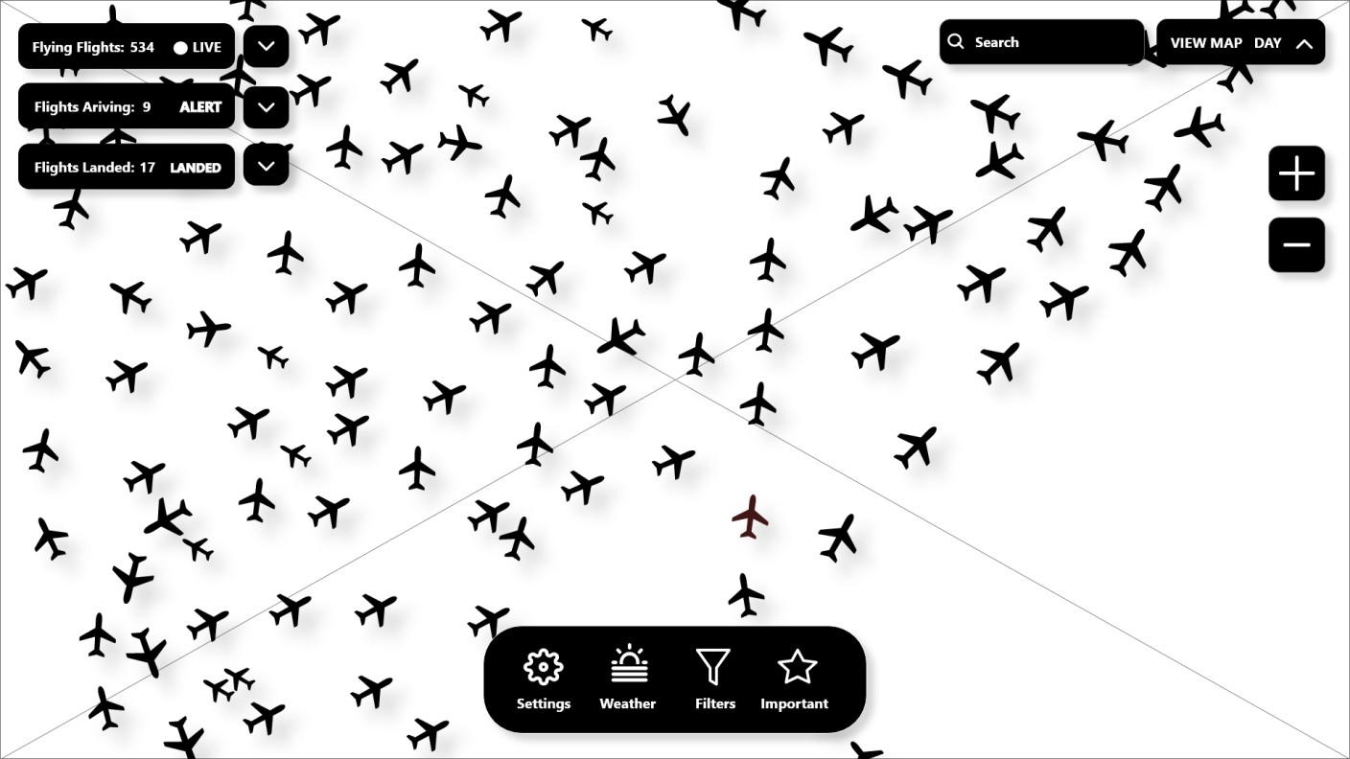

**READOUTS PAGE**

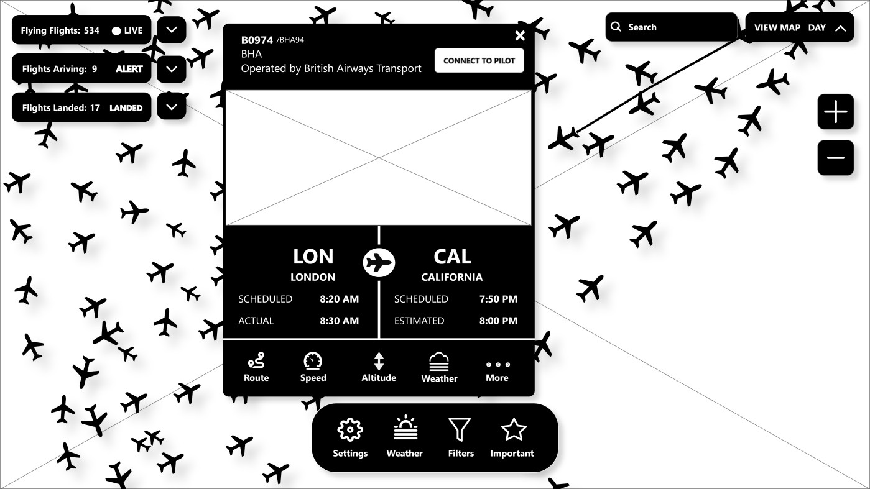

## CONTROLS PAGE

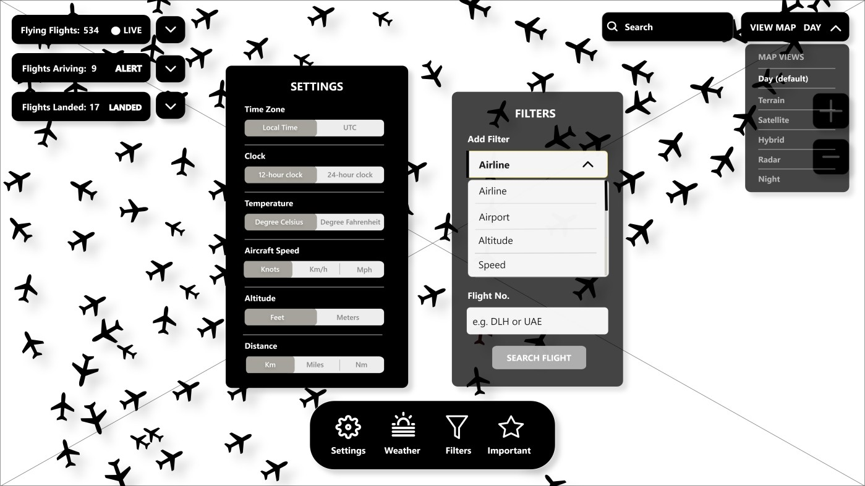

**MESSAGE BOX PAGE**

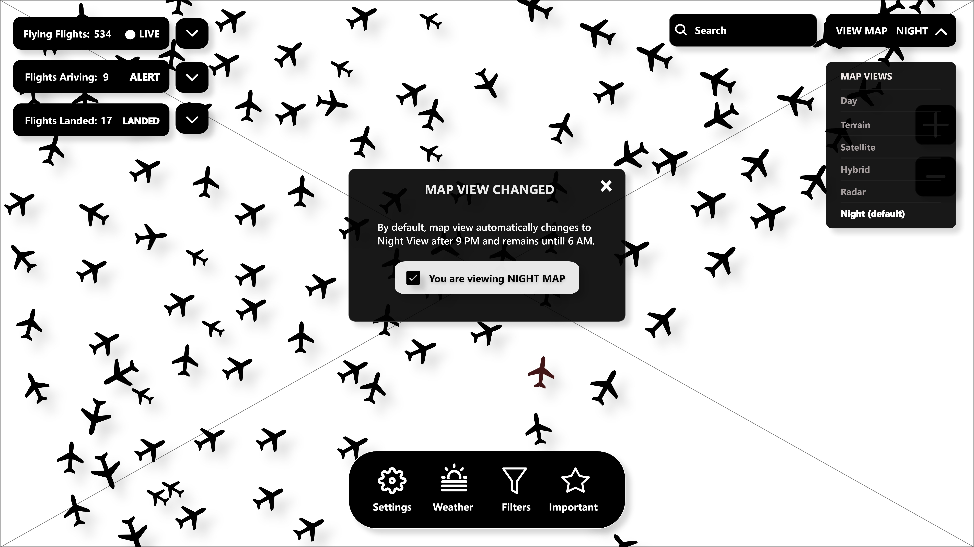Note* I have made a message box indication for change in view instead of warning box.

# FINAL PROTOTYPES

## MAIN PAGE

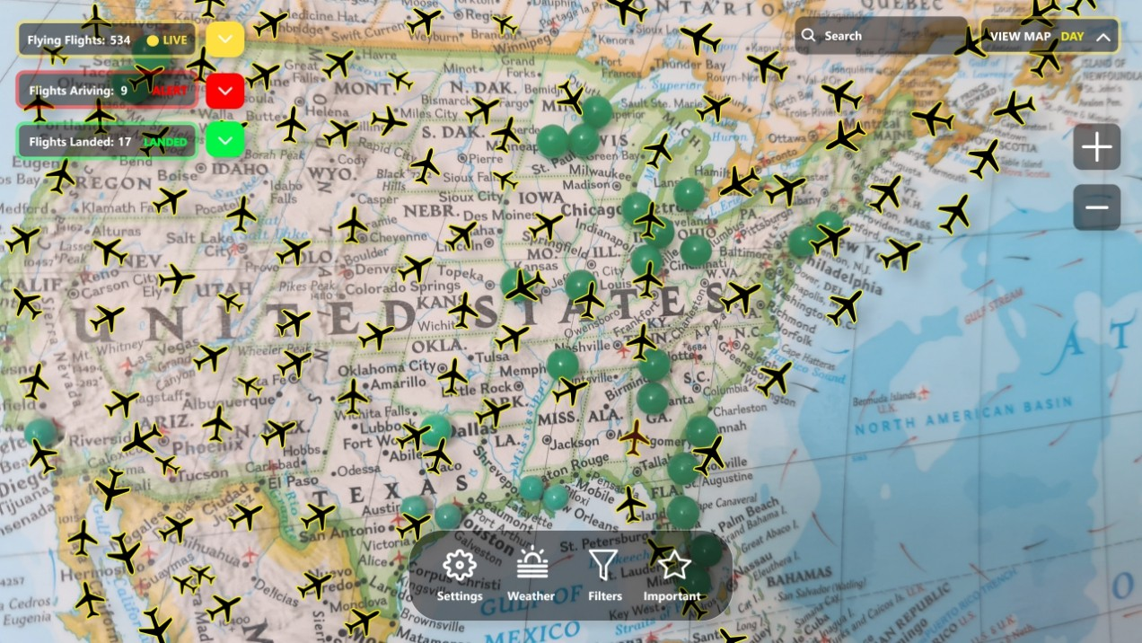

**READOUTS PAGE**

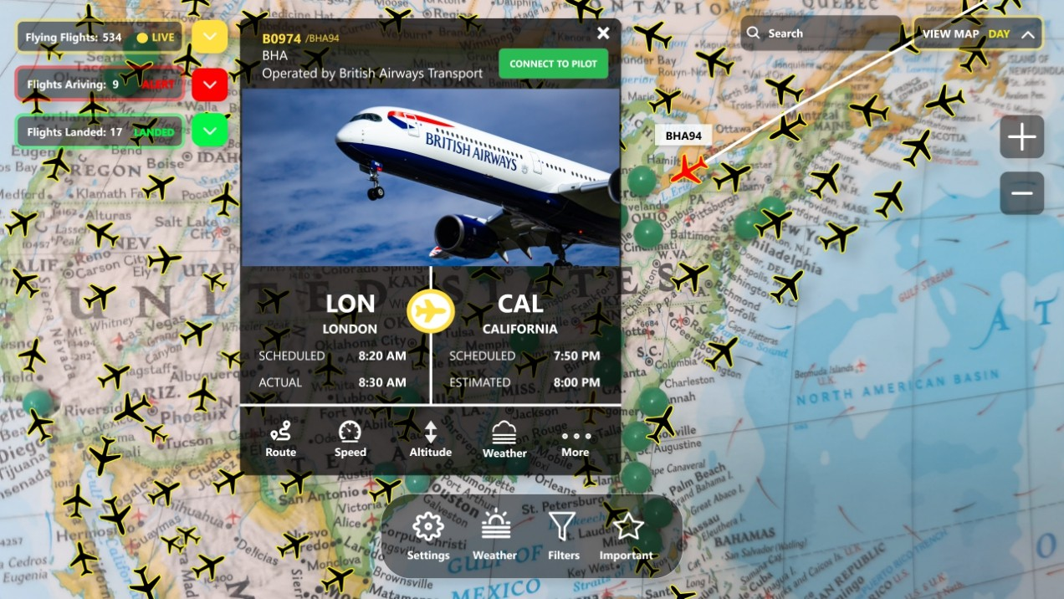

## CONTROLS PAGE

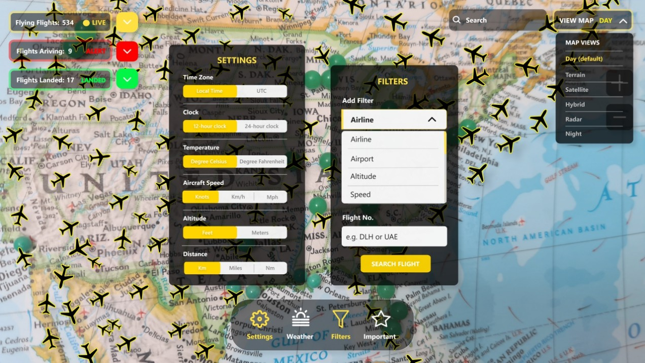

**MESSAGE BOX PAGE**

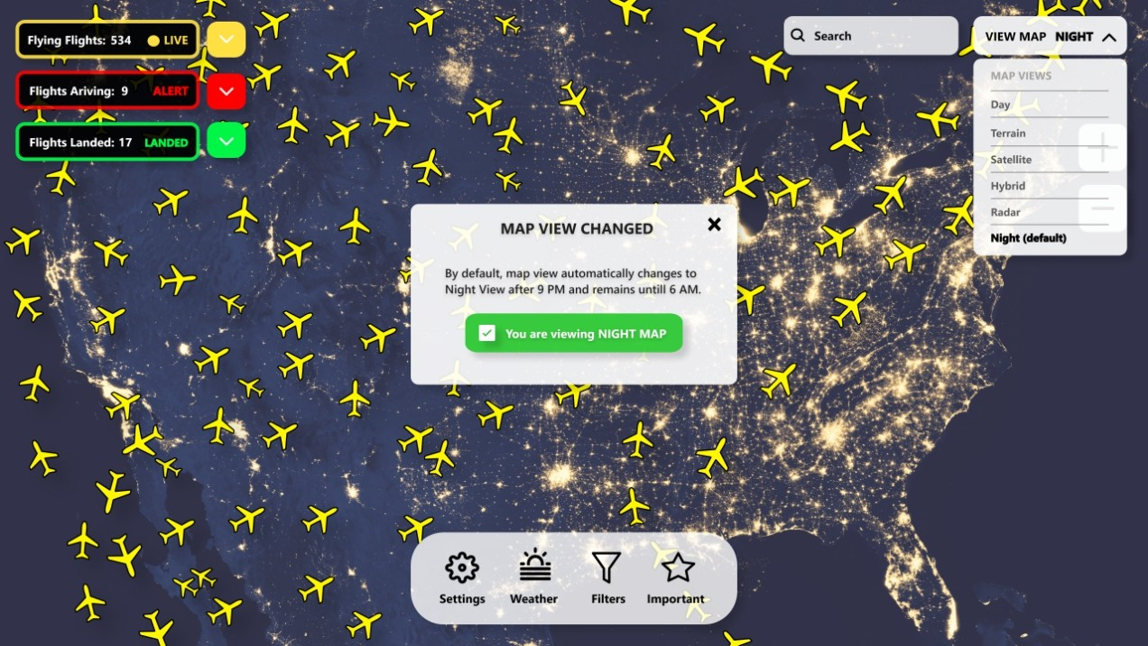

.

## CONCLUSION

To conclude, the system has been designed by deeply studying and understanding the basic principles of ergonomics which will increase the quality, efficiency and productivity of the system as a whole. This simple schematic design is based on the virtual reality that is similar to the system in real world. But makes it a completely different for the ground controllers as it proves to provide a more safe and comfortable experience to its employees. Overall, the system’s hardware and software is designed in such a way that it would deal with every aspect of ergonomics and will be able to solve all the problems in the existing work environment.

## REFERENCES

Ergonomics Guide

<https://ergo-plus.com/wp-content/uploads/Ergonomics-Guide.pdf>

Definition and Applications of Ergonomics

<https://ergo-plus.com/ergonomics-definition-domains-applications/>

Ergonomics Problems and its Solutions

<https://news.briotix.com/5-common-ergonomic-problems-and-solutions>