Data Visualization

dashboard for investment funds

livjyot Singh

2021

**CASE STUDY**

You are creating a website that serves as a dashboard for investment funds for mining holdings – where “mining” refers to extraction of minerals such as gold, silver, zinc, iron, aluminum, petroleum, etc. A “fund” is a collection of investments in which investors can buy shares – just like the stock market, but instead of buying shares in individual stocks, investors buy shares in the fund, which owns many investments. . Experts in the field, usually from investment banks, manage these funds. In this case, such investments would include mineral mines, natural gas and oil wells, as well as the processing plants needed to turn the raw materials into usable commodities. The dashboard will allow professionals in this field, such as buyers, appraisers and managers of such mines and processing plants to monitor commodity prices (for example gold prices) and prices of land in certain geographic areas. It also shows interest rates, and cost of labour in certain geographic areas as well as mortgage rates and performance indicators for the economy (such as employment statistics).

# DESCRIPTION

Commodities plays an important aspect when it comes to our daily life. They are considered as an essential product which can be exchanged or traded. For example, these can be the agricultural commodities such as wheat, barley, rice, pork, chicken, etc. Similarly, their trading is equally important so that they can be bought and sold freely.

This system of financial trading would be highly beneficial for exchanging goods for the professionals due to various reasons. These include:

* **Protection against inflammation:** Due to increase in demand of goods and services, there is increase in their prices of commodities. In such scenario, interest rate rises which will reduce profit margins leading to inflammation. But in this trading system, professionals will be able to save and protect their capital from the effects of inflation and maintain their value.
* **High Profits:** Commodity trading can help one to make more profits due to the insignificant fluctuation in the prices of the commodities which can result in huge discounts and gains. Hence, the possibility of return increases.
* **More Accessible:** In comparison to traditional system of trading, this online trading makes its more accessible for all platforms to buy and sell their goods and services. Each person would able to buy any product from anywhere which makes it a more beneficial system as compared to others.
* **Fair Price:** This trading platform helps in deciding a fair price for both the buyer and the seller. It eliminates the risk of any kind of manipulation which enables transparency. Hence, it help agricultural products to arrive at an accurate and market-oriented price
* **Diversification:** Commodity prices are prone to weather conditions and supply

demand. Accordingly, commodities are an independent asset class, and can prove

to be an effective means of diversification in one’s investment portfolio.

# TARGET MARKET

The software mainly focuses on trading which means buying and selling of online commodities and is mainly directed at people who want to do trading of the agricultural commodities such as wheat, barley, rice, pork, chicken, etc. These people could be the professional traders, investors, people who do import and export, producers, farmers or a large-scale consumer of the product.

For example, the investors or traders purchase assets for short periods of time and employ certain strategies as a way of profiting from changes in the asset's price. In such scenarios, investors hope to profit from changes in the price of the futures contract. For people associated with farming, can buy and sell their crops through this trading platform and can set up automated sales and purchases. They can take advantage of the price signals emanating from a futures market. Price signals given by long duration futures contract can help farmers to take decision about cropping pattern and the investment intensity of cultivation. The farmers could benefit by the dissemination of the futures prices of the exchange traded products as it improves his bargaining capacity.

# INFLUENCE ON DESIGN

The trading of commodities by such people makes it a more wider platform and has a huge impact on its design. This explains that the system will be used by a wide range of people, and has to designed in a way that can help them better understand how this system of trading works. This aspect will surely influence the design as it will be created according to the psychology of people of all age groups, making sure that the colors are vibrant enough, and do not create problems for the one who have disabilities. Design has to be fully accessible to all so that they can easily trade their commodities by keeping track of their prices and sales.

**PERSONAS**

**TRADER**

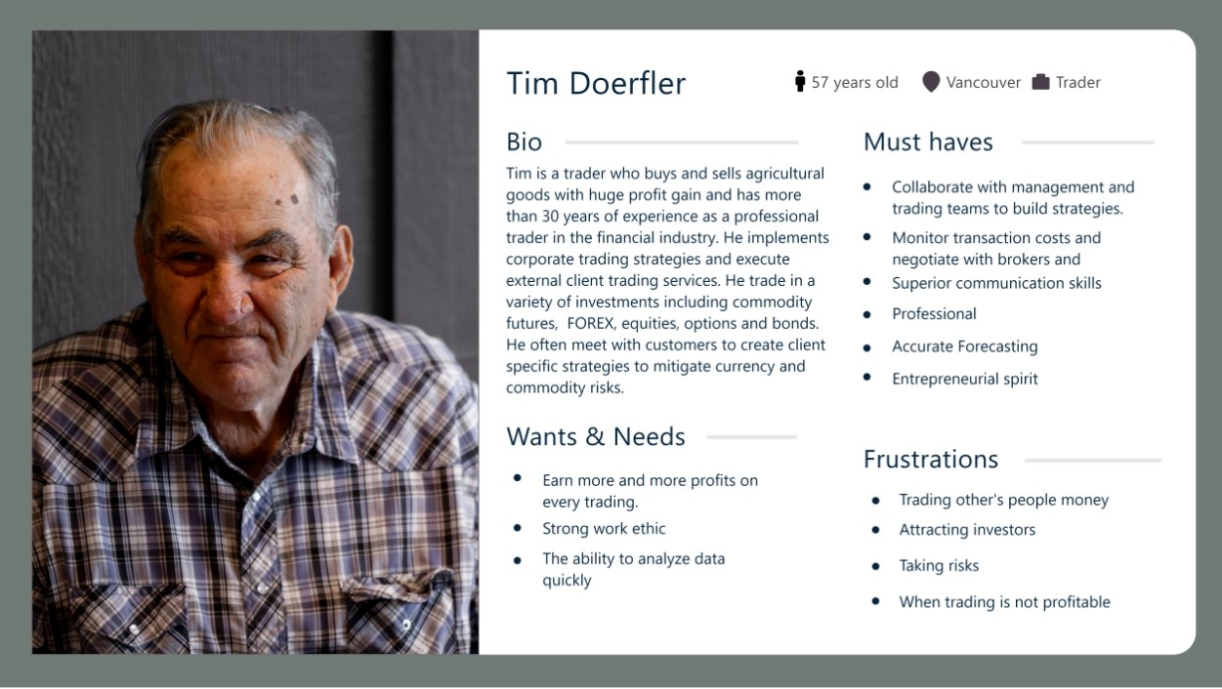

**FARMER**

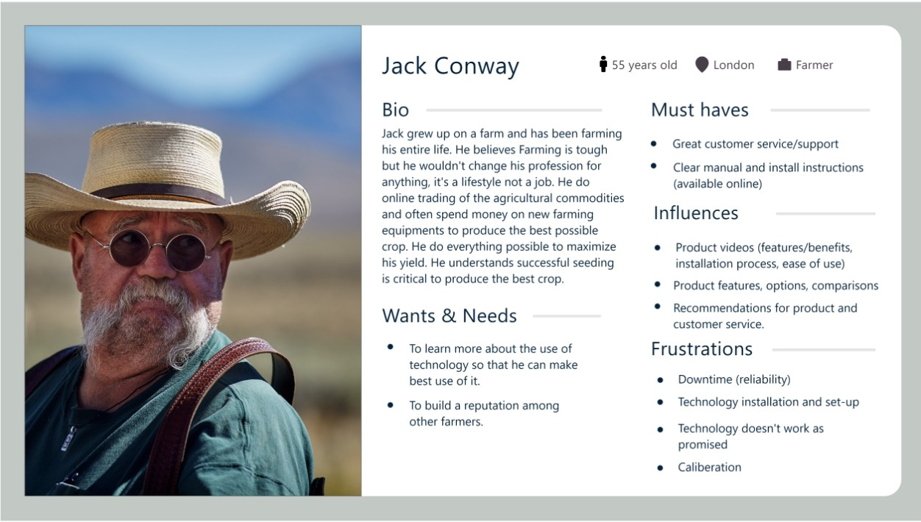

# RESEARCH

The design is influenced by various factors including the diversity of organizations and its cultures associated with financial markets. According to several theories, a lot of forethought, imagination and engineering go into the design process. Instead, influence of design starts with the understanding the goals, motivation and frustrations of users. In order to design a system, we have to keep in mind of various considerations that may include symbols, colors, accessibility, and the cultures of various trading market that will definitely influence the design process.

**Symbols:** The ability of symbols to convey information and culture has made them an invaluable part of our shared visual language. Symbols can help people better understand the system. For example, logos, color, graphics, and text are used throughout our daily life as symbols to communicate deeply held meaning. This recognition and how quickly they can communicate an idea or concept that makes them so powerful. For e.g. all three bar graph with arrows shows a different meaning:

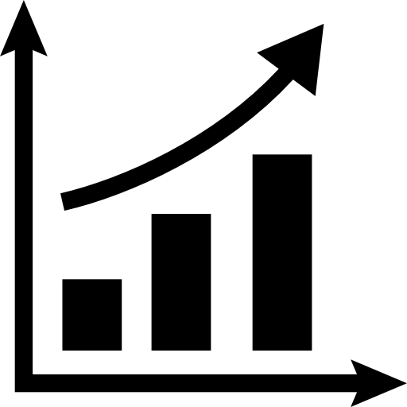 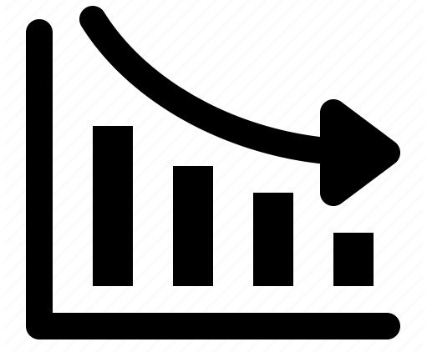 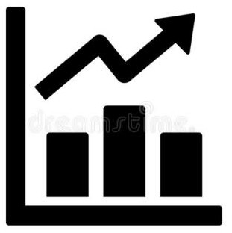

*Increase Decrease Fluctuation*

**Market Cultures:** Its has a great importance and has been addressed as an influencing factor when it comes to designing. We have the understanding about what is good in one culture, might mean something very different in another. The architecture of the system should reflect cultures associated with financial markets while designing the system.

Link: <https://boldthinkcreative.com/culturedesign/>

As a designer of the system, I’ll try to incorporate these considerations by matching the market standards and make it more accessible so that it could be accessed by people with disabilities.

**Color:** I will use the color techniques with some color temperate and make sure that the design is user-friendly.

Link: <https://simplicable.com/new/color-temperature>

For artistic and design influences, I will mainly follow the works of [**Paul Klee**](http://www.metmuseum.org/toah/hd/klee/hd_klee.htm) (1879— 1940) who was a Swiss Painter and used **symbols** extensively in his artwork, working from dreams, his intellect, and his imagination. He deeply explored color theory and saw the importance of colors in the design.

Link: <https://www.liveabout.com/symbols-in-drawing-2578255>

In this system, I will represent the data in the form of graphic representation with some cool colors. Also, use of symbols and icons which would help to understand the performance of the commodities.

# DESIGN FOR LOGO



**TECHNICAL STANDARDS**

* **Fonts:** Source Sans Pro, Trebuchet MS, Microsoft YaHei Regular, Microsoft YaHei Light, Poppins, Javanese Text and Segoe UI.
* **Colors:** Light green, black, white, purple, blue, maroon, red, grey and silver.
* **Gradients for Bar Graphs:** Blue, green and purple

# Number of Panels: 3

Navigation Panel: It is on the left side of the page with a logo and some links like home, dashboard, commodities, contact, about us and settings.

Top Panel: It has search option for finding commodities, quick links for settings and contact us, alert icon when commodities suddenly fall or rise and profile of the user.

Bottom/Content Panel: It consists of small sub panels which indicates the performance of the three commodities I.e. wheat, rice and chicken, input controls and graphics panel with some detailed performance.

* **Navigability:** It is similar to navigation panel which consists of a logo and some quick links like home, dashboard, commodities, contact, about us and settings.

# ACCESSIBILTY CONSIDERATIONS

Web accessibility states that the web or a technology must be designed in such a way that the person with disabilities can even use the web to it’s full potential. These disabilities can be visual, auditory, cognitive physical and many more.

According to the guidelines set by WCAG 2.1, the website should be:

**Understandable:** The content should be easily perceivable and operable. It should be clear terms, have simple instructions and explain complex issues. You must also make your website function in a way that your users understand, by avoiding unusual, unexpected or inconsistent functions.

To make this more understandable:

* The font size for the text should be big enough to see each and every word in the sentence which will overall help people to read the content more easily.
* Provide captions, comments or other text alternatives for images if an image fails to load. However, will be used in screen reading to help users read and to understand the image properly.
* Use the images to provide a great source of information and creates a great relation between the written text, and makes it easy to relate and understand the content.
* Underlining of links and some meaningful names can help the users identify the links within the content.

**Perceivable:** All users must be able to perceive your content. Some of the users may have difficulties with one or more of their senses, making them reliant on assistive technology to browse the website.

To make this more perceivable:

* For visually impaired, do not use colors like yellowish-green or reddish-green as they will affect the those who are color blind. Use of audio feature for text that would help people with visual and auditory impairments.
* For hearing impaired, use of subtitles or any text feature for audios and videos that would give him real life hearing experience.
* For people who are physically disabled, I will try to use a scrolling up and down feature on both keyboard and mouse as it increases the accessibility for the website.

# WIREFRAME

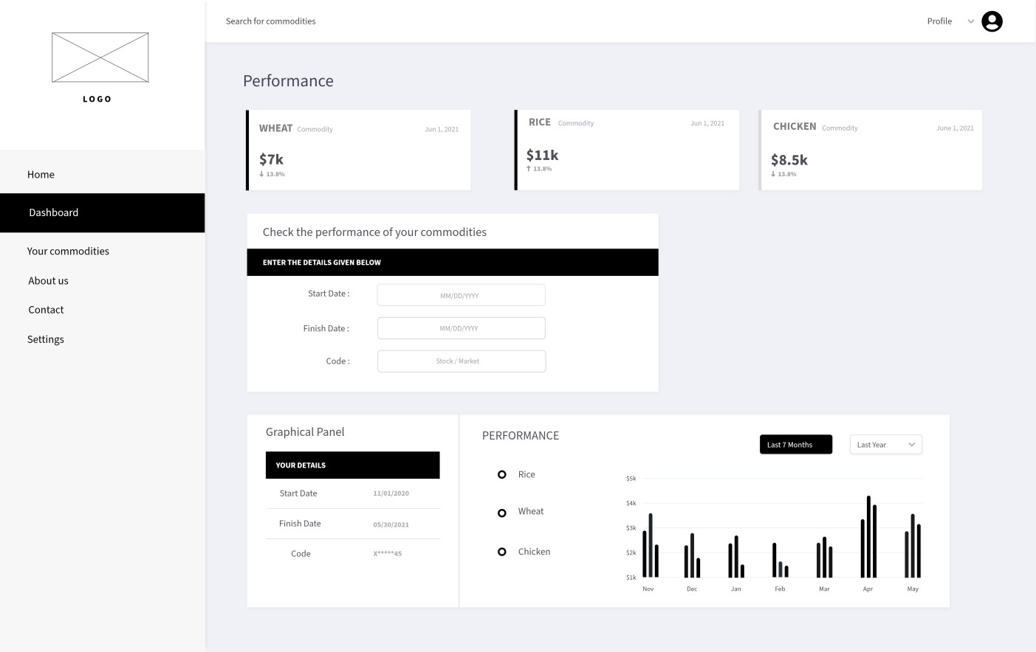

**PROTOTYPE**

