Website Design

Non-profit organisation

livjyot singh

2021

1

|  |  |
| --- | --- |
|  | 2 |

**PART A - RESEARCH**

**DESCRIPTION**

The non-profitable organization in Kitchener-Waterloo area of Ontario comes with the vision and a mission in their mind to respectfully and compassionately empower persons who are homeless with the hope of providing emergency and temporary shelter with the help of our volunteers. Our dedicated volunteers tend to serve who are in real need, and help them by providing clothing and food which are the basic necessities for the survival. In addition, our centers offer educational support to interested citizens who don’t have enough resources but still want to educate themselves. The site completely runs upon the donations of the people who do like our work, and want to appreciate us in some way. The organization works with the motive of removing the barriers from people’s life and instead, comes with the mindset of solving any problem they comes across.

Also, we have a special corner for our workers that show their full potential and passion for their work throughout the year. So, it’s our responsibility to take care of our volunteers, and show some love to them by scheduling functions to keep them motivated for their journey of making a world a better place for all.

If someone want to help, they can do it by:

* Coming to our site physically, and help them who are in real need
* Introducing to the people who want to help and the organization further connects them with the people who really want it.
* Also, there are many ways to support our work across the country. Yo

|  |  |
| --- | --- |
|  | 3 |

can donate dollars, blankets for extreme weather or basic clothing that includes old clothes. One can bring food from their home in order to feed some.

Any kind of help that contributes and makes the community even more stronger is really appreciable.

**TARGET MARKET**

The purpose and goals of this website is to attract the people which may include **volunteers** or the **people who want to help others who are in real need** are the primary target audience. To elaborate, people who can help inany kind whether its small or big, doesn’t matter. People who can help by raising awareness for the basic motive of helping others can also be a secondary target audience we are looking for.

This aspect will surely influence the design as it will be created according to the psychology of people of all age groups, making sure that the colors are vibrant enough, and do not create problems for the one who have disabilities. Also, in order to look to have an easy focus on the website, the font size of text should be big enough so that it can be easily accessible to all. Overall, the website will be following and addressing its content according to the principles derived laid by the WCAG guidelines.

|  |  |
| --- | --- |
|  | 4 |

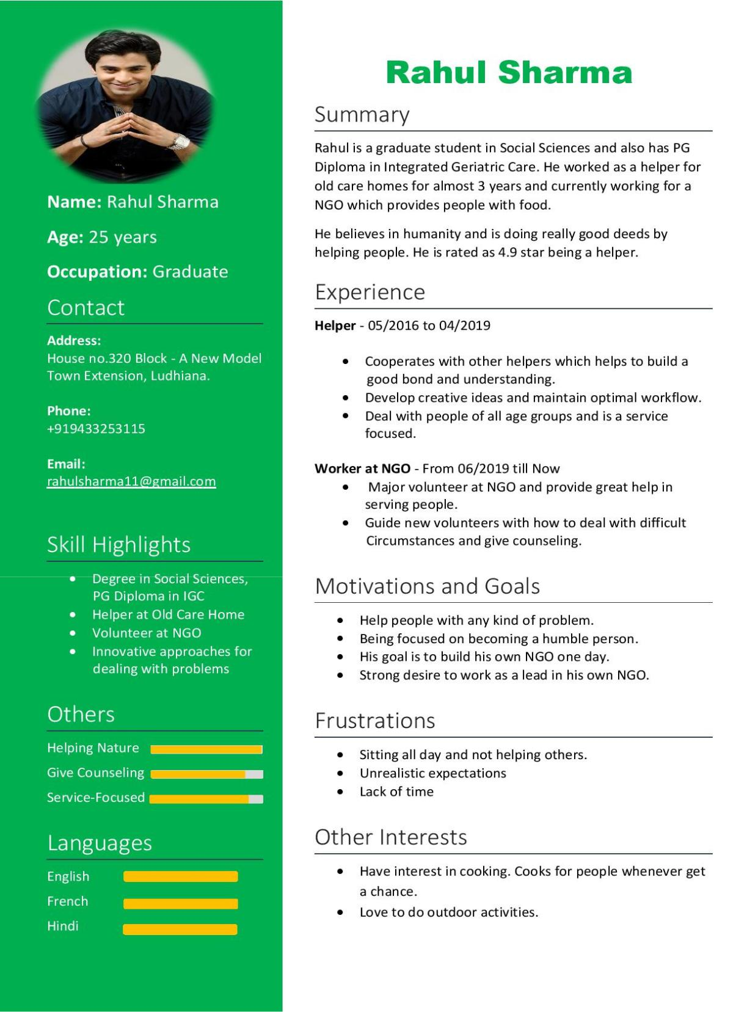

*Persona 1*

|  |  |
| --- | --- |
|  | 5 |

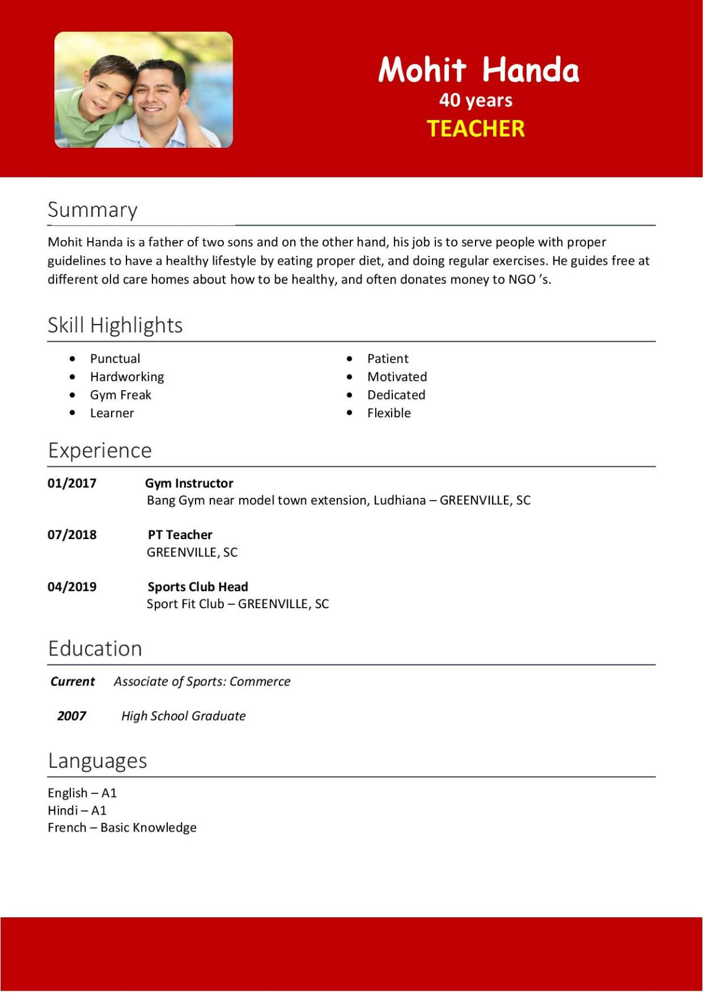

*Persona 2*

|  |  |
| --- | --- |
|  | 6 |

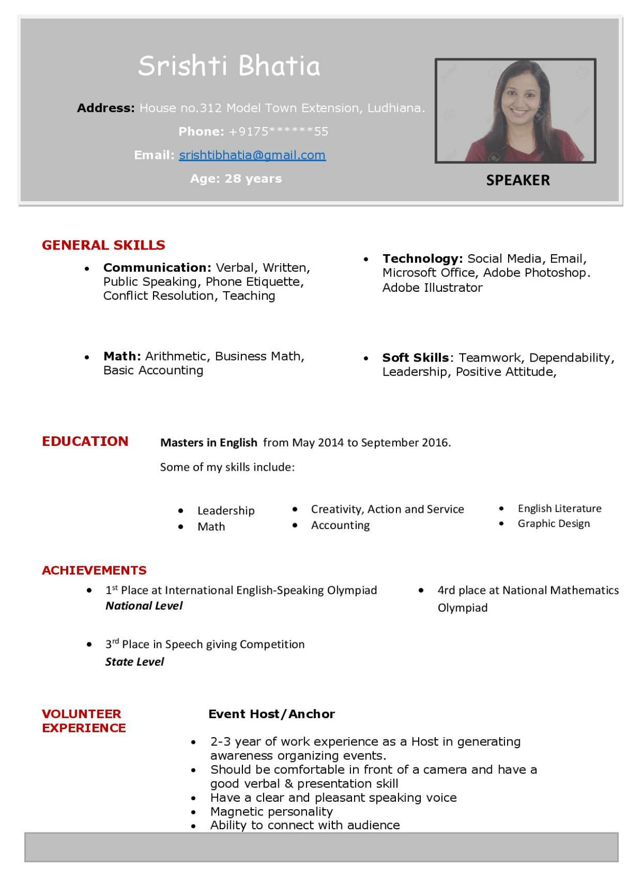

*Persona 3*

|  |  |
| --- | --- |
|  | 7 |

**RESEARCH**

Design can be influenced by various cultural or sociological reasons or even by difference in age groups. Often people equate influence by difference in their perspectives. Instead, influence of design starts with the understanding the goals, motivation and frustrations of users. In order to design a website, we have to keep in mind of various considerations that may include local topology, history and the design influences.

* The psychology of every person plays a crucial role in influencing design. This is because people belonging to every age group should be kept in mind while building the design so that they can able to access and understand the content of the website.
* Local topology for the area where the organization mostly deals with, like for example, images can be shown serving the people who cannot afford the basic amenities will influence the creation of web graphics.
* History of **Swiss Design** which is also called as “The International Typography Style” provides a structured framework to align different elements. Now, this is considered essential for UI and graphic design. It gives more preference to realistic photography than expressive illustrations.

**Link:** 

* Norval Morrisseau also referred as the Picasso of the north is the native artist which also creates the artistic effect on the software design. And it is important to apply the native influence with great sensitivity.

**Link:** 



|  |  |
| --- | --- |
|  | 8 |

We will incorporate pictures that are more realistic than animated or designed.

1. For example, in case of a **homeless person**, the image could be: https://www.npr.org/2018/01/09/576825276/shelters-reach-capacity-in-cold-weather-as-homeless-population-rises
2. In case of a person that is starving, the image could be like:



This is because the use of realistic images will corresponds to the depth of situation and provides a sense of understanding which will really affect the visual graphic of the site. Also, their will be use of moderate colors rather than bright colors to make it more accessible to all generations.

**HEADER LOGO**



*Header Logo*

|  |  |
| --- | --- |
|  | 9 |

**FOOTER LOGO**



*Footer Logo*

**TECHNICAL STANDARDS**

**Fonts:** Comic sans, Times new roman, Microsoft YaHei Regular, Microsoft YaHei Light, Poppins, Javanese Text and Segoe UI.

**Colors Used**: Dark Turquiose, Silver, Black, White, etc.

**Colour Gradient:** Light and dark Turquiose is used in the website

The website is not meant to be very crowded as it is built to be used by all age groups. So the navigation bar is all set to the top center and the logo as usual in the top left of the screen.

The major components are shown on the home page but most of the content such as how we can find an accommodations is placed in the second level page.

10

**HOME PAGE**

**Header:** It consists of the site logo at the top left corner as usual, search directory and the donate button which can be used for donating to the organization.

**Navigation Bar:** It is located at the top center of the page. The navigation tab contains five buttons that includes Our Services, Get Help, About Us, Ways to Help and Covid-19.

**Content:** The content include images and shows the facilities given by the organization to the needful i.e., giving shelter, clothing, food, educate and volunteers. Then, it displays how one can donate money according to their will. It consists of four options of $50, $100, $250 and $500 and by donating we can make someone’s day.

**Footer:** It consists of services, taking or giving help, and the details of the organization. Also, provide us with their contact details with social media handles.

**SECOND LEVEL PAGE**

**Header:** It consists of the site logo at the top left corner as usual, search directory and the donate button which can be used for donating to the organization.

**Navigation Bar:** It is located at the top center of the page. The navigation tab contains five buttons that includes Our Services, Get Help, About Us, Ways to Help and Covid-19.

**Content:** The content includes images and quick link to find affordable housing. Also, there is a detailed description for the types of housing

|  |  |
| --- | --- |
|  | 11 |

and how one can search for it. The types include homeless shelters, traditional shelters, permanent housing and others.To find a house around, one can put on the city, zip code or state name for scheduling accommodations for clients.

**Footer:** It consists of services, taking or giving help, and the details of the organization. Also, provide us with their contact details with social media handles.

**ACCESSIBILITY CONSIDERATIONS**

Web accessibility states that the web or a technology must be designed in such a way that the person with disabilities can even use the web to it’s full potential. These disabilities can be visual, auditory, cognitive physical and many more.

According to the guidelines set by **WCAG**, the website must be:

**Perceivable:** The principle of a website being perceivable is all about the senses people use when browsing the web. Some of the users may have difficulties with one or more of their senses, making them reliant on assistive technology to browse your website.

**Operable:** The principle of a website being operable is about the actions people take when browsing. This covers the different ways in which your users browse the web. Some of them may have motor difficulties, which means they

|  |  |
| --- | --- |
|  | 12 |

use their keyboard to navigate and some users who have sight impairments often prefer to use a keyboard rather than a mouse too.

**Understandable:** A perceivable and operable website means nothing if your users can’t understand it. Your website must use clear terms, have simple instructions and explain complex issues. You must also make your website function in a way that your users understand, by avoiding unusual, unexpected or inconsistent functions.

**Robust:** The website must meet recognized standards, such as using clean HTML and CSS. This minimizes the risk of your users relying on technology that cannot correctly process your website.

According to me while making the website accessible, one should,

* Not use colors like yellowish-green or reddish-green as they will affect the those who are color blind.
* The font size for the text should be big enough to see each and every word in the sentence which will overall help people to read the content more easily.
* To make the website more accessible, I will try to use a scrolling up and down feature on both keyboard and mouse as it increases the accessibility for the web.
* For people who are visually impaired or can’t see properly. For them, I will introduce an audio feature for text that would help people with visual and auditory impairments.
* Use the images to provide a great source of information and creates a

|  |  |
| --- | --- |
|  | 13 |

great relation between the written text, and makes it easy to relate and understand the content.

* Provide captions, comments or other text alternatives for images if an image fails to load. However, will be used in screen reading to help users read and to understand the image properly.
* Underlining of links and some meaningful names can help the users identify the links within the content.

|  |  |
| --- | --- |
|  | 14 |

**PART B - WIREFRAMES**

**HOME PAGE**

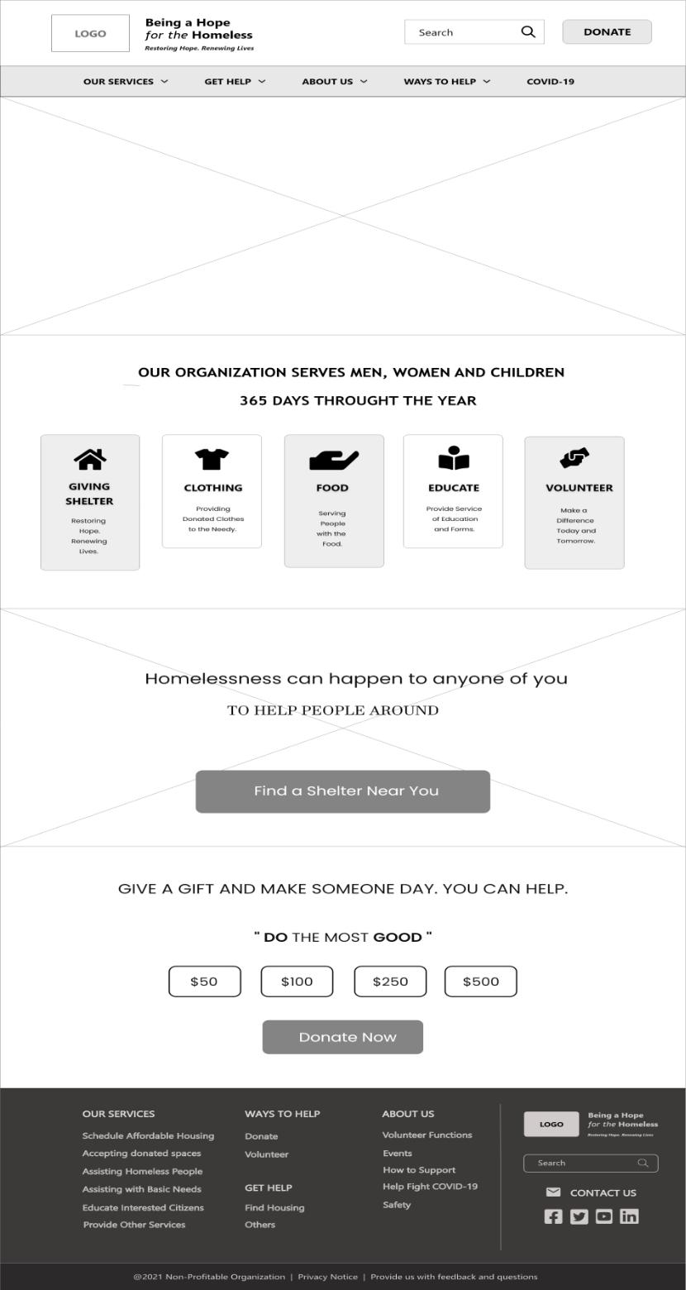

*Home Page*

|  |  |
| --- | --- |
|  | 15 |

**SECOND LEVEL PAGE**

**Embedded Link:** HOME PAGE / Our Services (Navigation Button)

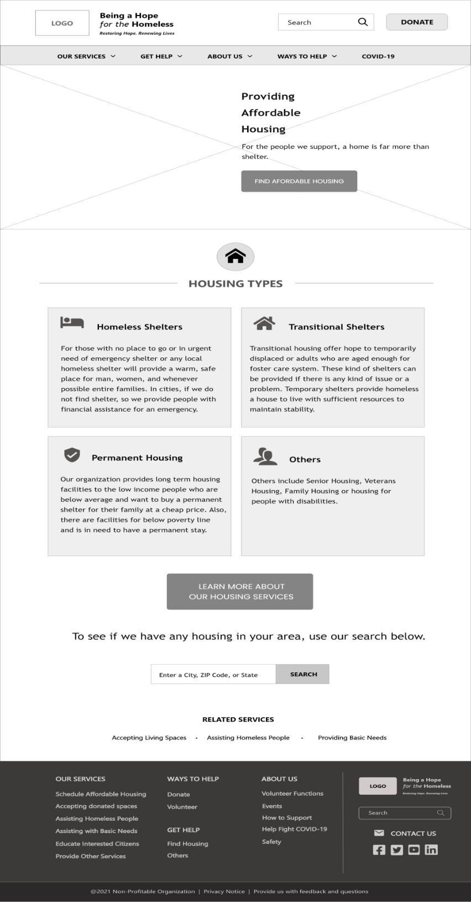

*Second Level Page*

|  |  |
| --- | --- |
|  | 16 |

**PART C - PROTOTYPES**

**HOME PAGE**

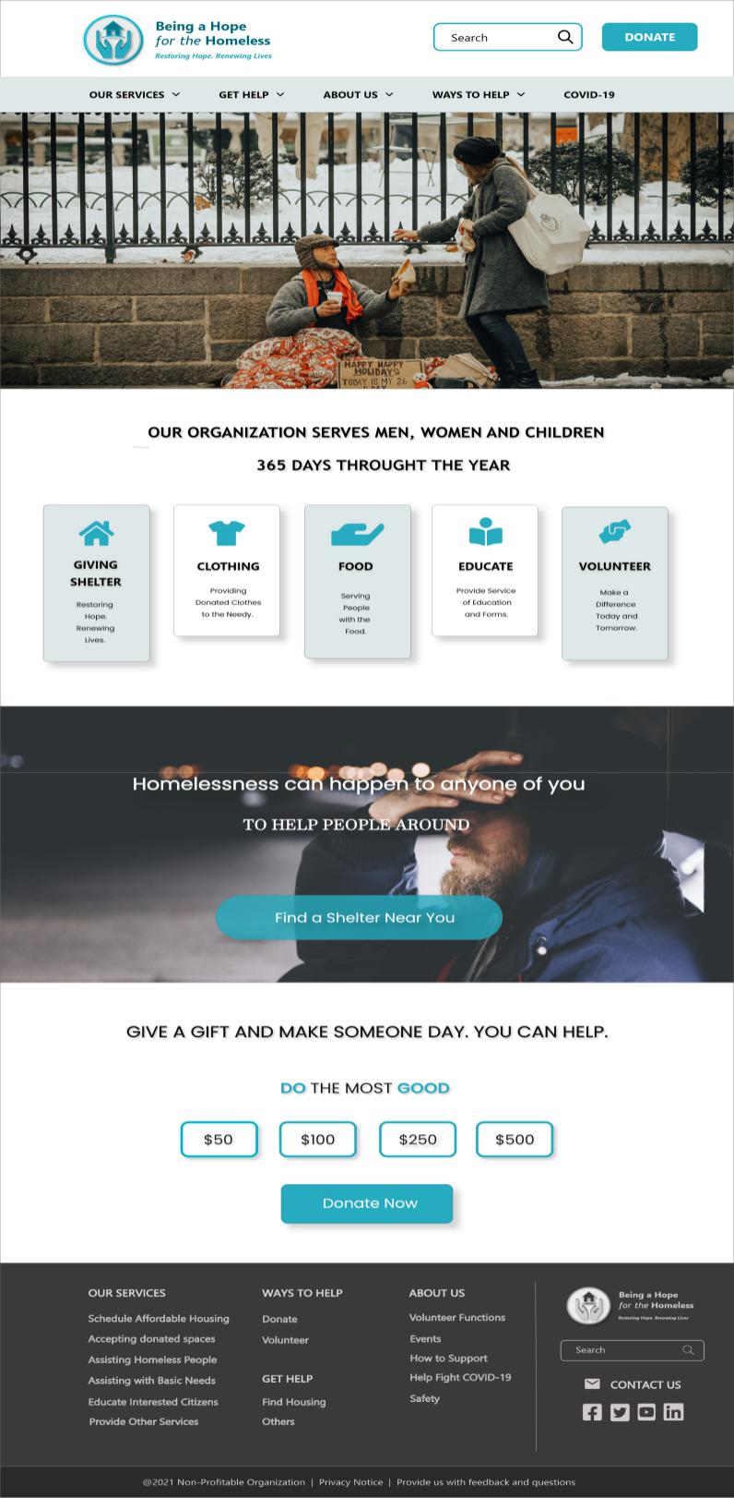

*Home Page*

|  |  |
| --- | --- |
|  | 17 |

**SECOND LEVEL PAGE** *(includes scheduling accommodations for clients)

**Embedded Link:** HOME PAGE / Our Services (Navigation Button)

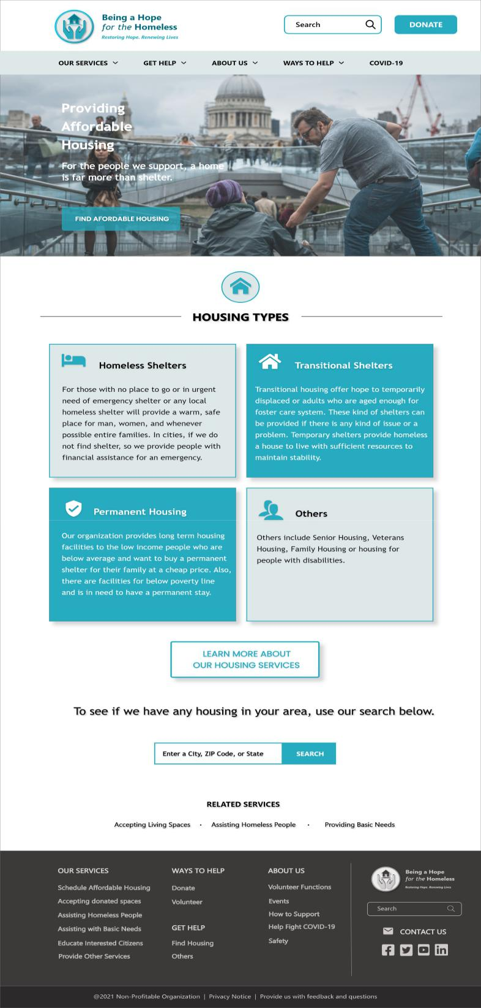

*Second Level Page*

|  |  |
| --- | --- |
|  | 18 |

**References**

Swiss Design



Norval Morrisseau’s artist design



Homeless People Images

https://www.npr.org/2018/01/09/576825276/shelters-reach-capacity-

in-cold-weather-as-homeless-population-rises



People Starving for Food Images



WCAG Website

<https://www.w3.org/WAI/standards-guidelines/wcag/>

Images used in Final Prototype

www.pexels.com