Report

Project name: MyGymClub

Team members: 19829047_李莉Lily, 16301144_朱诺仪

Minimum SDK: 24

Target SDK: 28

# Technical features:

**Navigation between UI pages:**

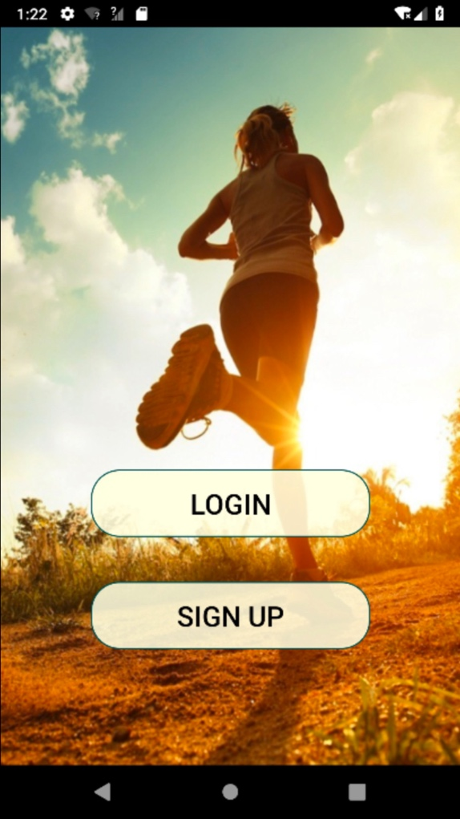

When you click the ‘LOGIN’ button, you will jump to the login page:

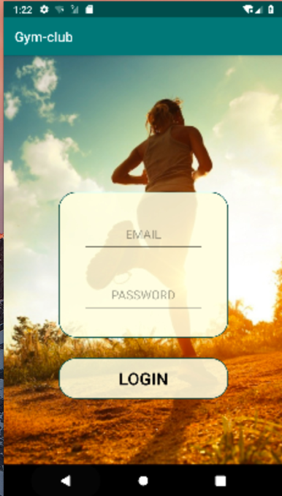

When you click the ‘SIGN UP’ button, you will jump to the signup page:

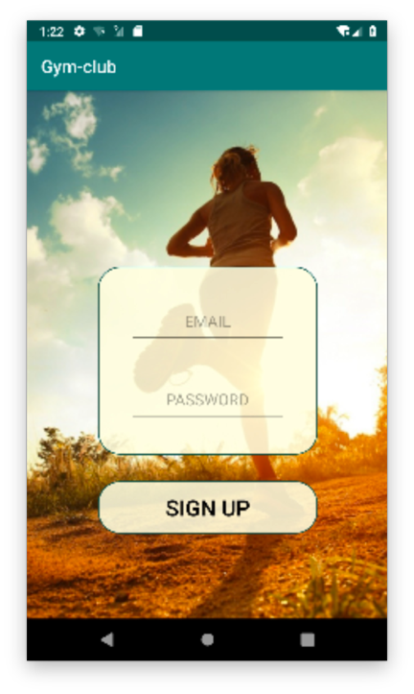

The app uses a bottom navigation bar that has 4 elements:

Fit Page – Where you can see your schedule

Find Page – Where you can browse courses and trainers and see online courses

News Page – Where you can see the latest news from the trainers

Me Page – Where you can see your own information: Your diary, Settings and logout

After login the user is directed to the fit page:

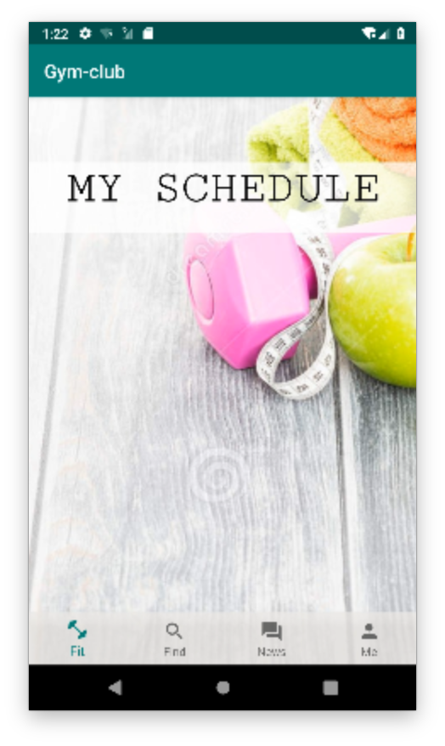

The by clicking on the Find tab in the bottom navigation bar, this page will be shown:

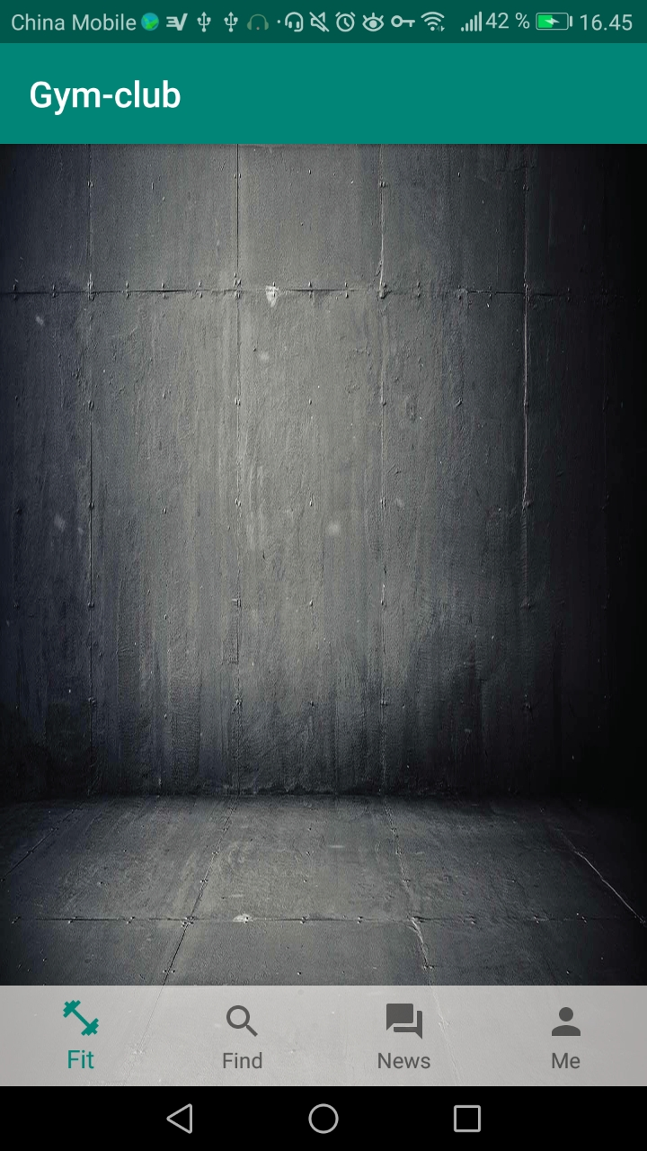

Then by clicking the news tab, this page appears:

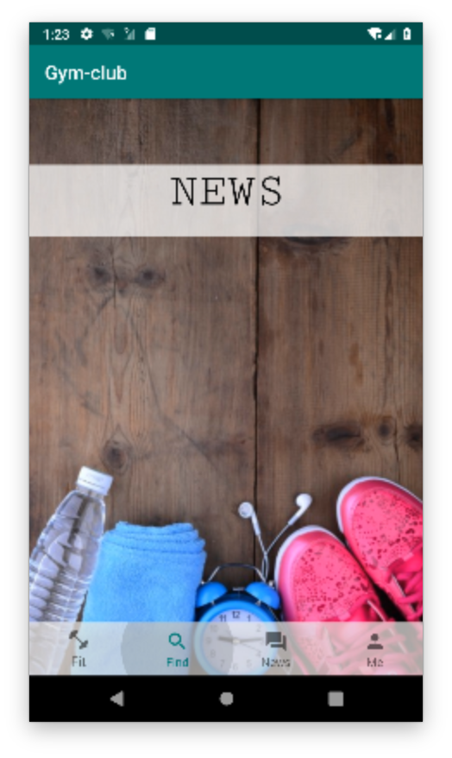

And the last tab on the navigation bar will lead to this page:

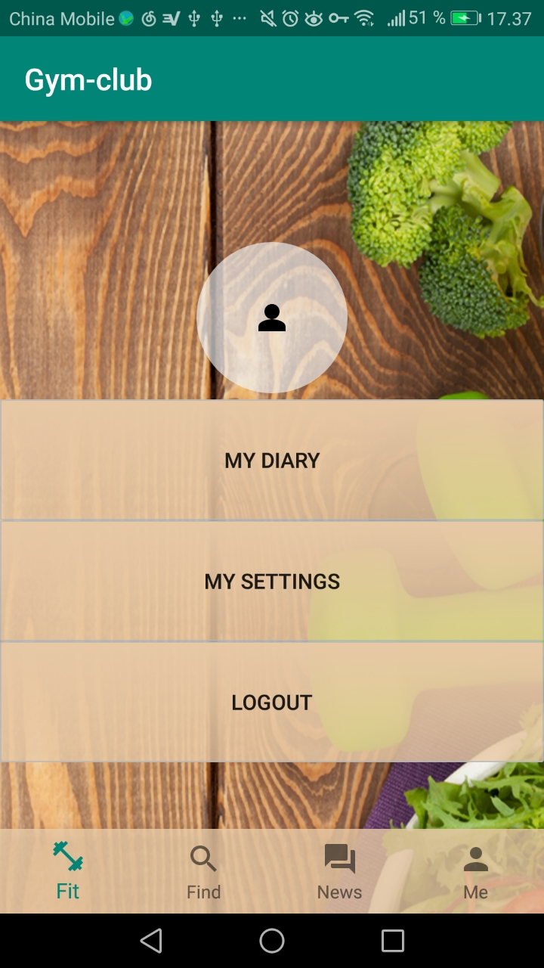

By clicking the button “My diary”, the user will reach this page:

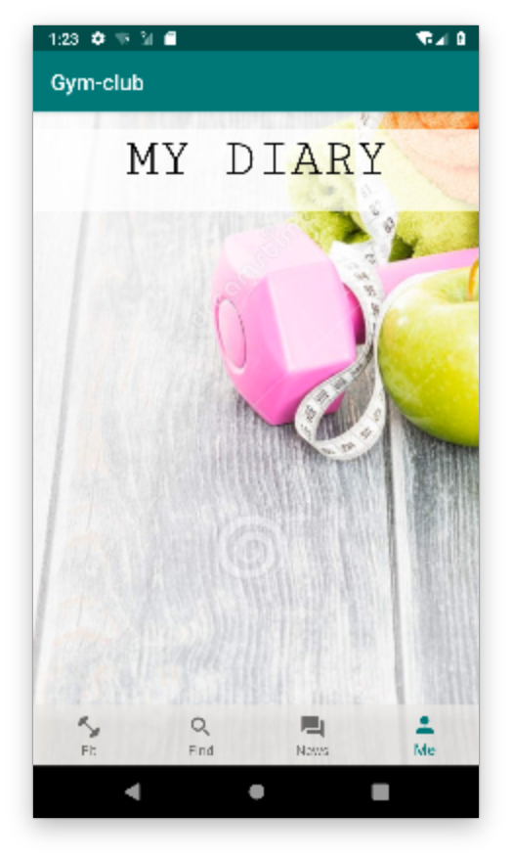

By clicking the button “My settings” the user will reach this page:

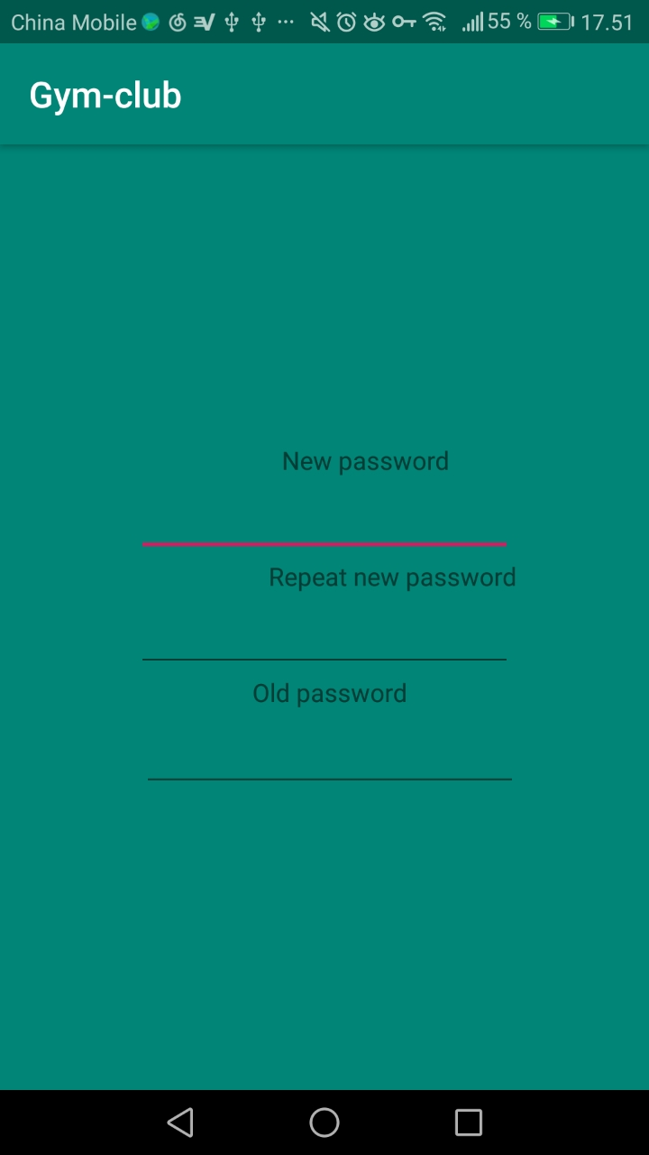

The layout is not fully implemented as the news activity, diary activity and schedule activity requires actual input from the user. That will be implemented in later versions.

When clicking ‘LOGIN’ and ’SIGN UP’ buttons, the buttons will change colors. When users turn back to the first page, the button will change back into original colors.