Report

Project name: MyGymClub

Team members: 19829047_李莉Lily, 16301144_朱诺仪

Minimum SDK: 24

Target SDK: 28

# Technical features:

**Login and signup:**

For this version we used BMOB to login and signup, by creating a BMOB user with the username and password given in the signup page.

We were not able to take a screenshot of the toast error messages following errors in signup or login (But you can run the app, and see it for yourself).

We made the following checks for the signup:

* Toast: “Please fill up everything” if the user left some textfields blank
* Toast: “Two passwords don’t match” if the repeated password is wrong
* Toast: “Succeeded to sign up”
* Toast: “Failed to sign up”

We made the following checks for the login:

* Toast: “Please fill out username and password”
* Toast: “Succeeded to login”
* Toast: “Failed to login”

**Get inserted user from BMOB:**

The username is then retrieved from the database in BMOB, and posted in the profile page:

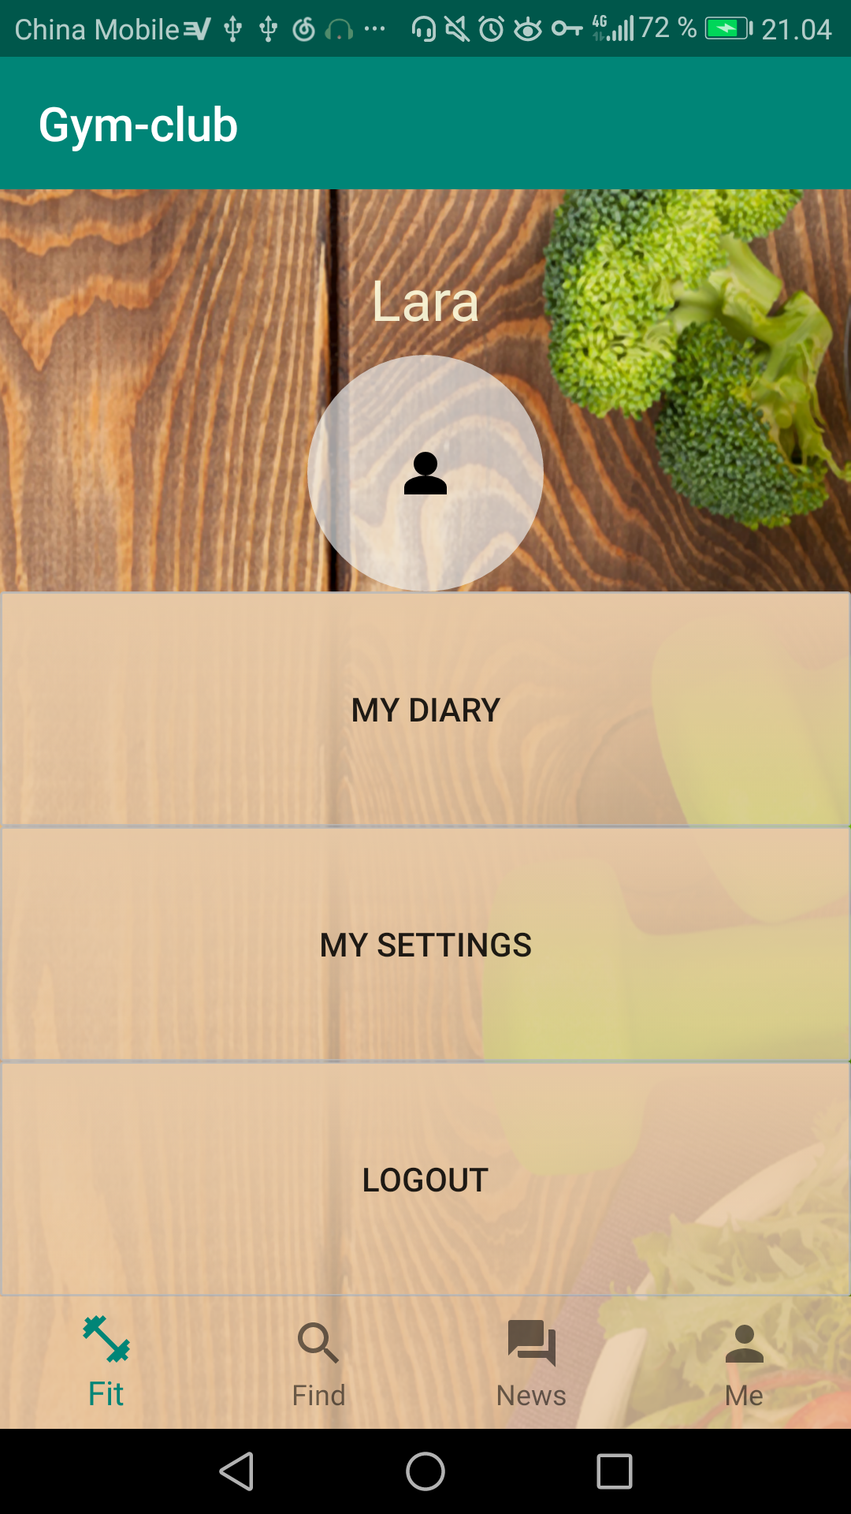

Similarly news information is retrieved from the database and posted in cardviews in the news page.

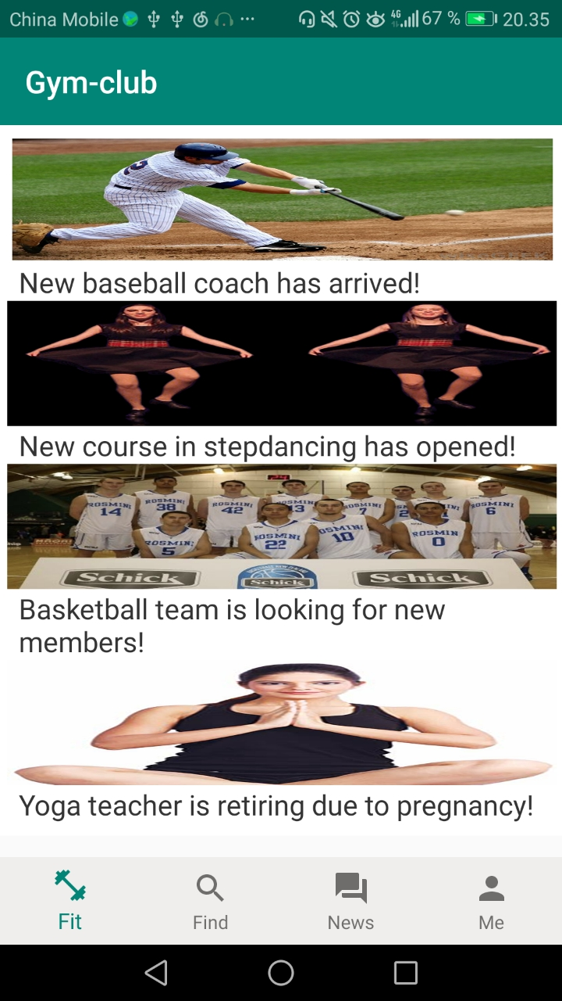

**RecyclerView with youtube videos:**

In the find page, there has also been added youtube videos in the recyclerView:

