Report

Project name: MyGymClub

Team members: 19829047_李莉Lily, 16301144_朱诺仪

Minimum SDK: 24

Target SDK: 28

# Technical features:

**Youtube video:**

From the earlier assignment youtube videos had been added to the app version, which fulfills the requirement of watching training videos online.

**Call function:**

The trainer can also be contacted by the user, by clicking the call button:

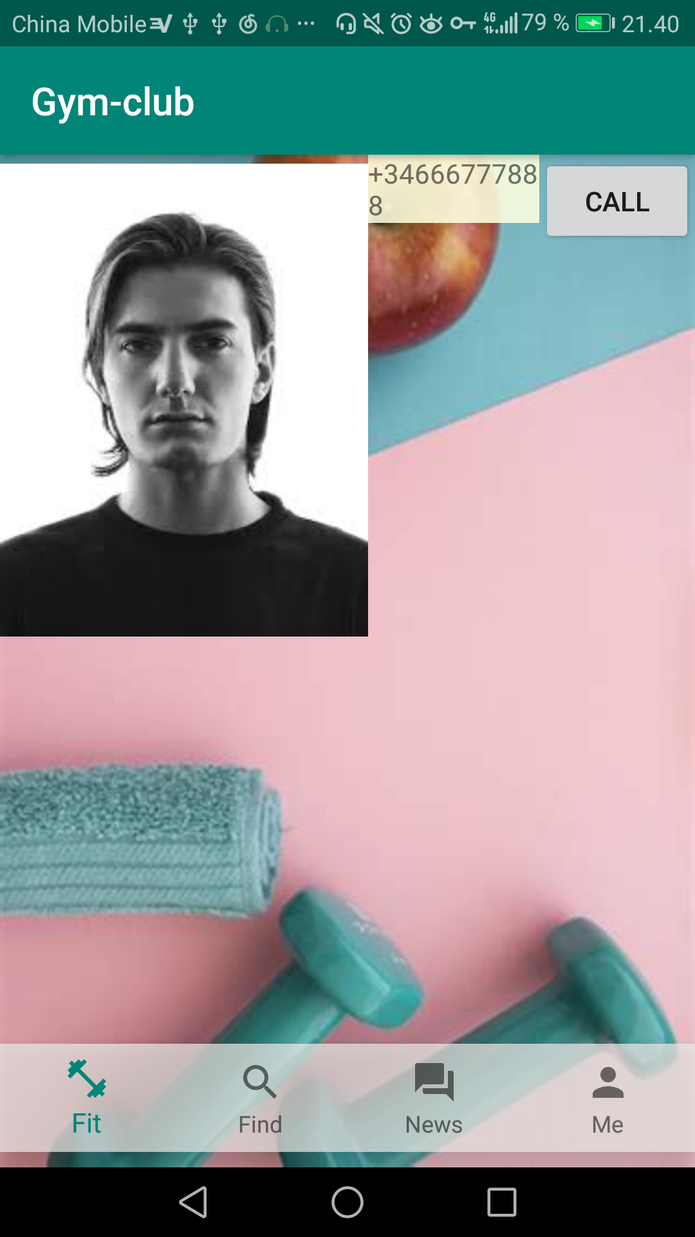

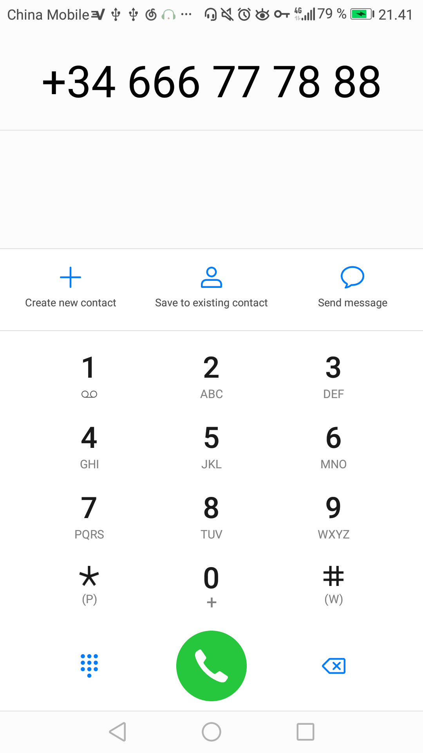

**The map function:**

The map function was not implemented, as I needed to pay to use google maps and couldn’t commit my API key to github – as others would then use my API key.