Report

Project name: MyGymClub

Team members: 19829047_李莉Lily, 16301144_朱诺仪

Minimum SDK: 24

Target SDK: 28

# Technical features:

**Login with Facebook:**

To use Facebook login, the developer must apply to be a Facebook developer. Every app, then gets a unique id, which is written in the strings.xml file.

That ID was not committed to GitHub, as other would then be able to use my ID.

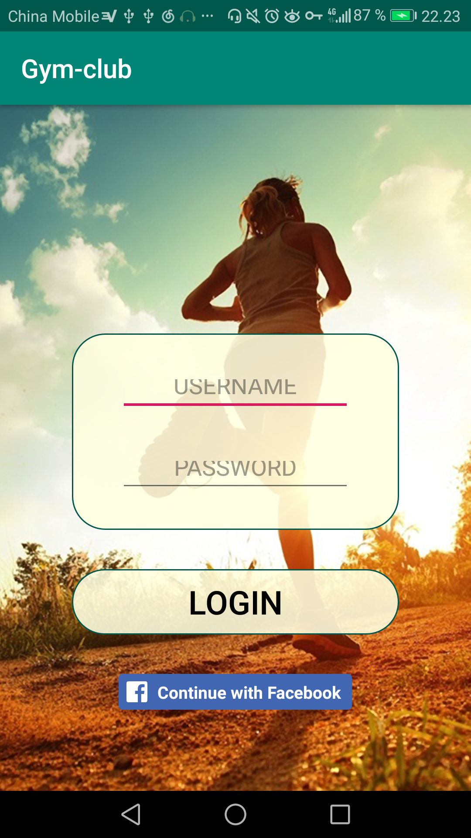

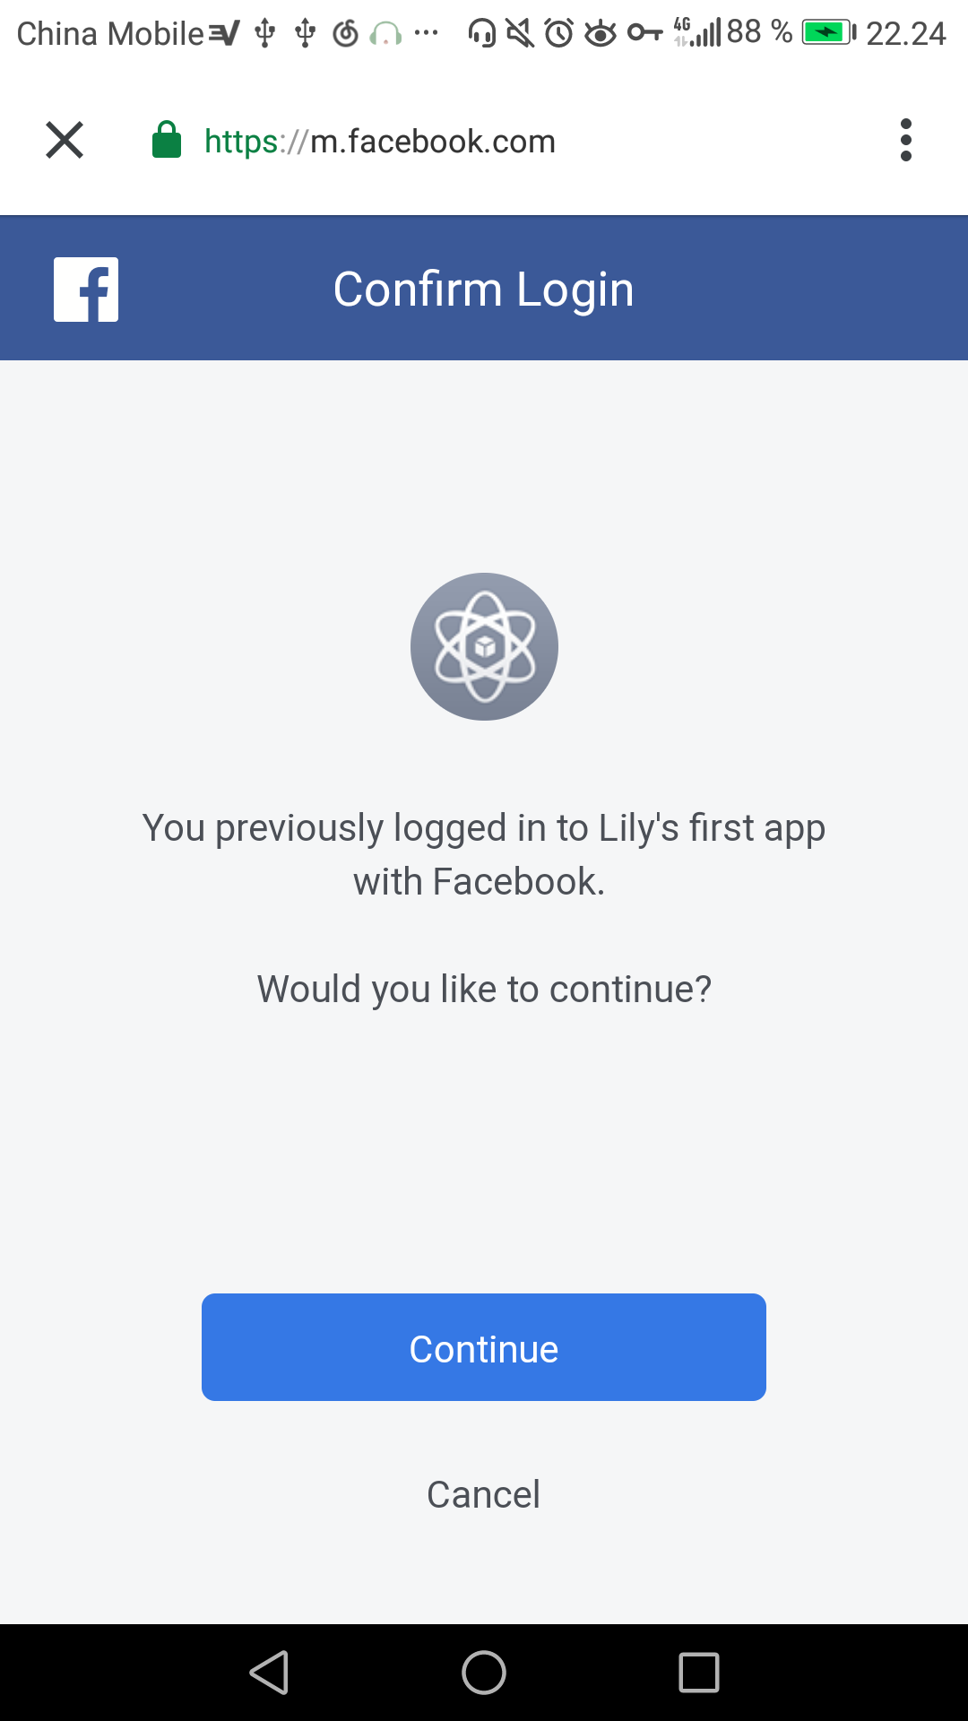

Originally the fit page was supposed to be a google calender, where the user could see what courses they had signed up for, but as there wasn’t enough time – this page didn’t get implemented in version 5.