addi $1,$0,10

addi $2,$0,20

addi $3,$0,30

addi $5,$0,50

addi $6,$0,60

sw $5, 100($2)

sub $2, $1, $3

and $12, $2, $5

or $13, $6, $2

add $14, $2, $2

lw $15, 100($2)

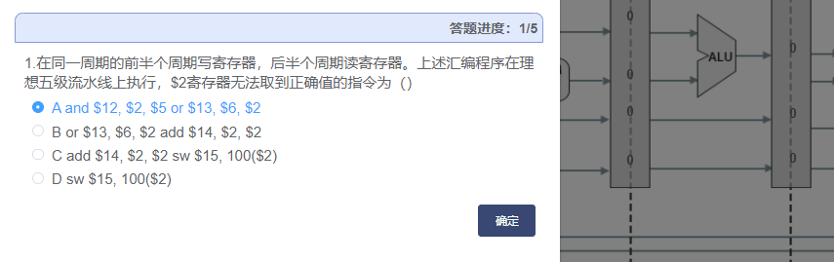

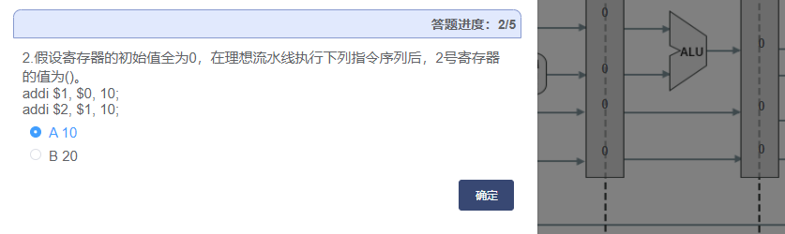

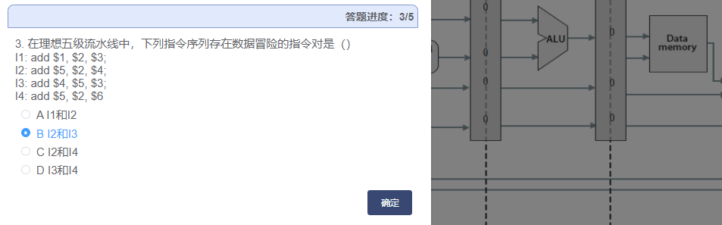

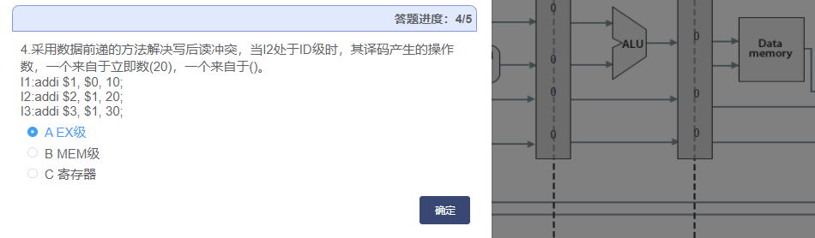

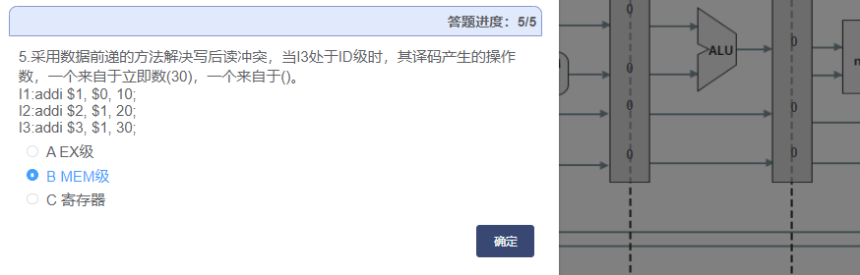

顺序：先写会，再访存，依次往前

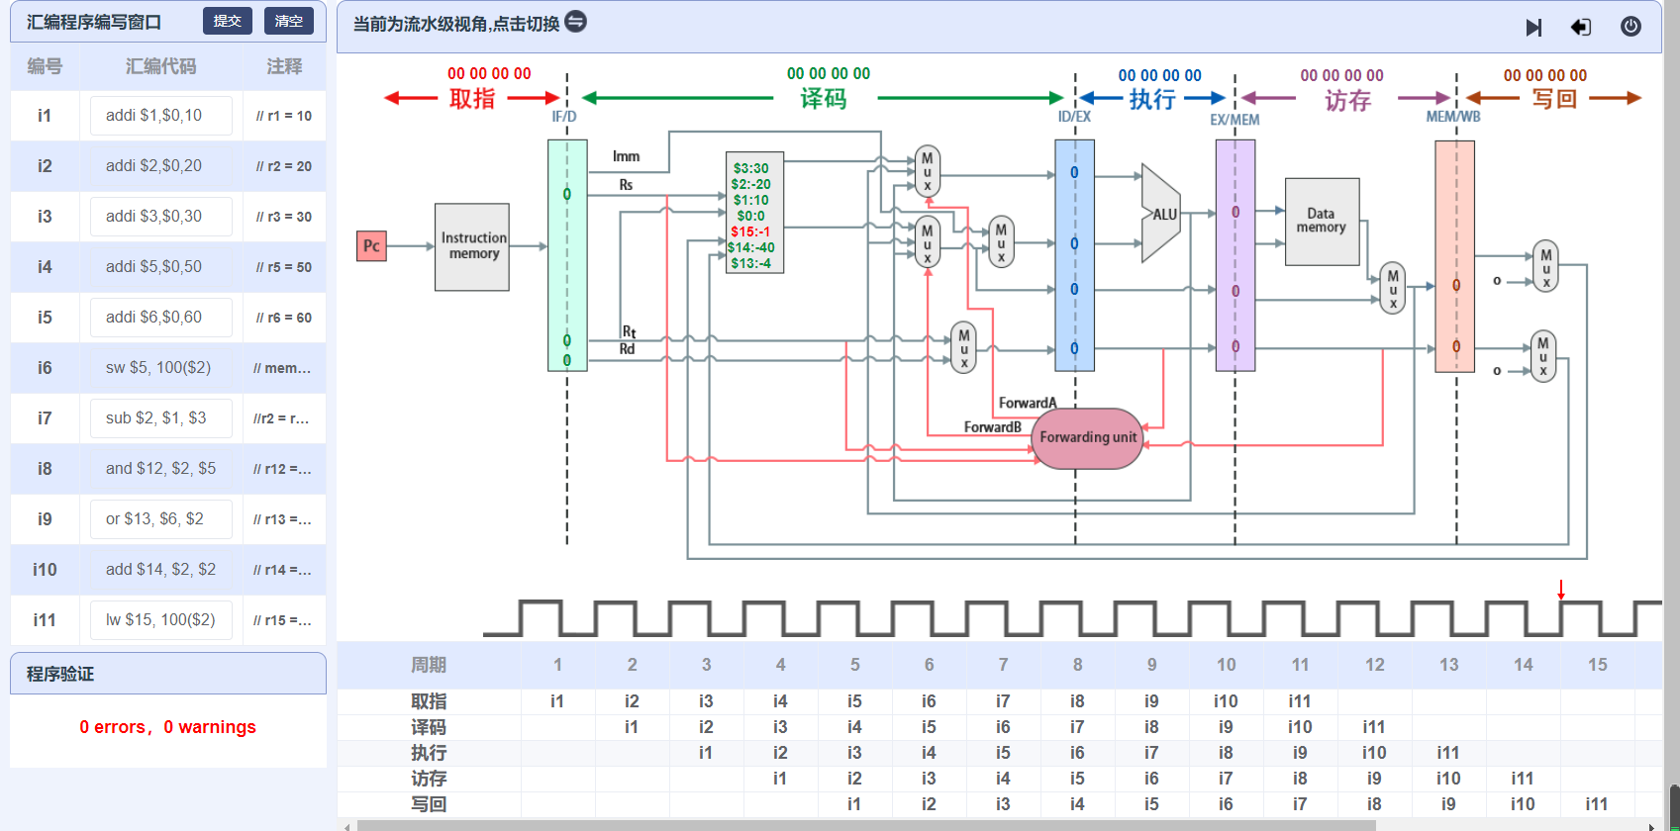

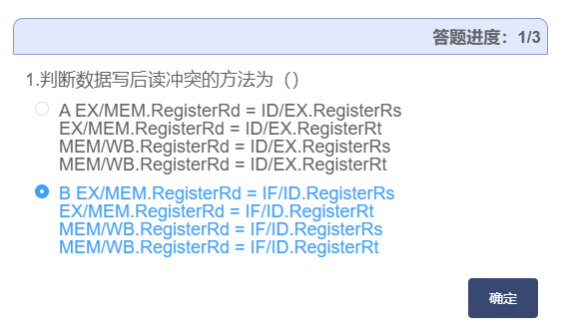

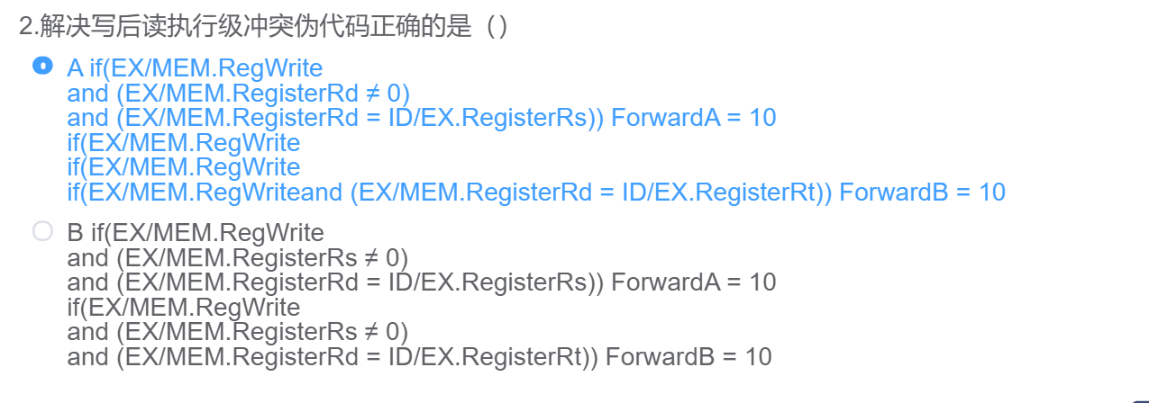

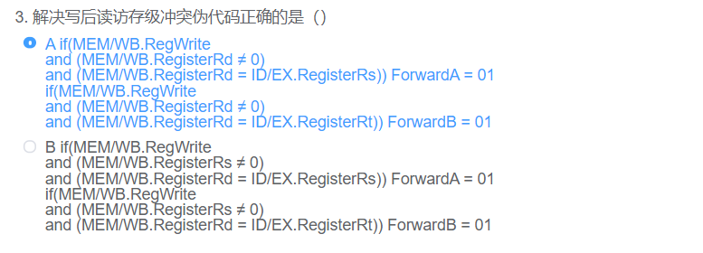

addi $1,$0,10

addi $2,$0,20

addi $3,$0,30

sw $1, 20($1)

addi $5,$0,50

addi $6,$0,60

addi $7,$0,70

lw $2, 20($1)

and $4, $2, $5

or $8, $2, $6

add $9, $4, $2

slt $1, $2, $7

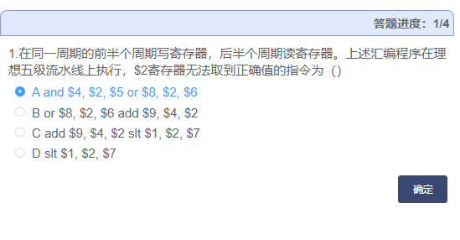

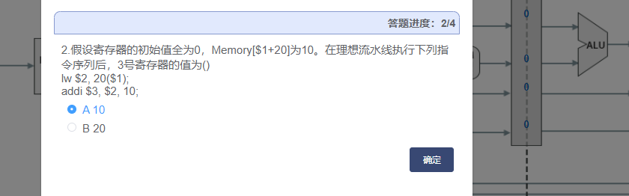

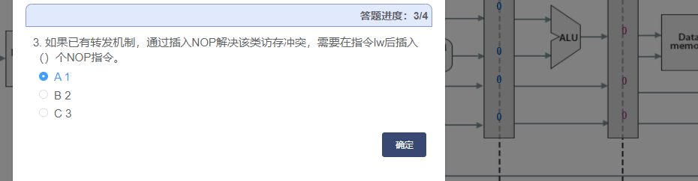

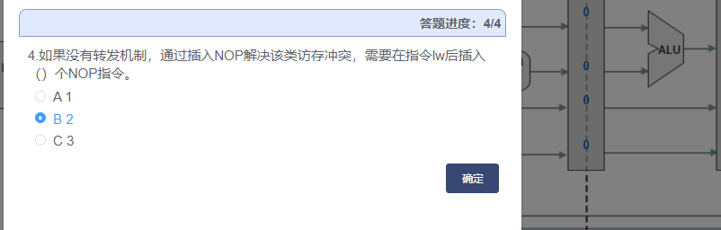

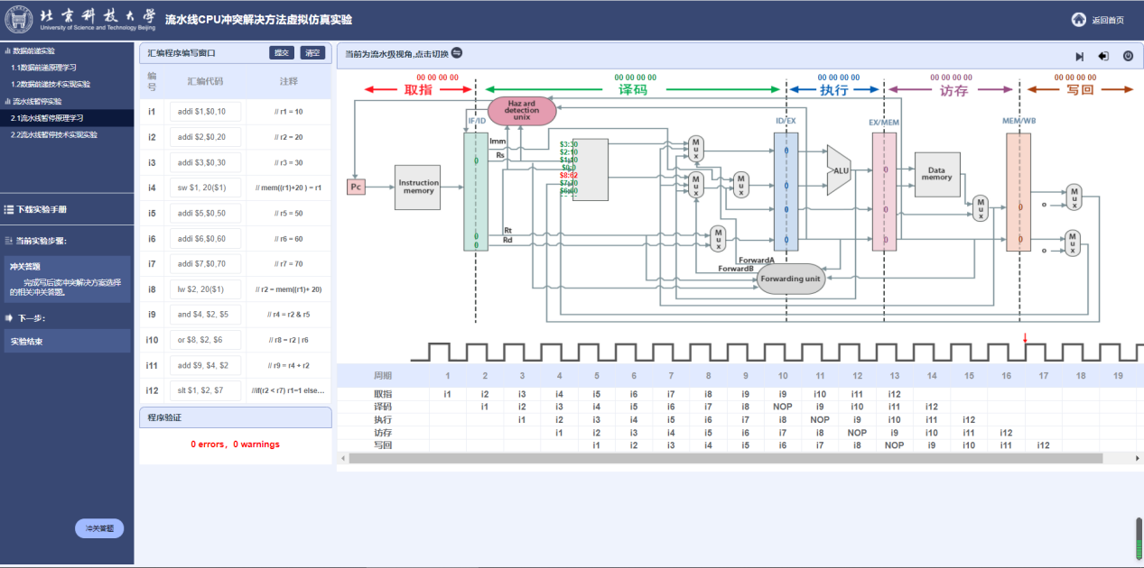

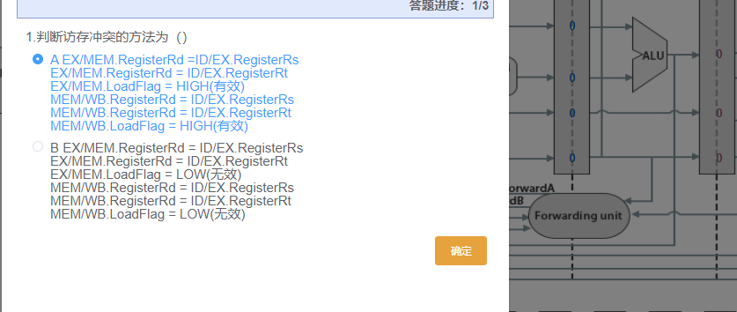

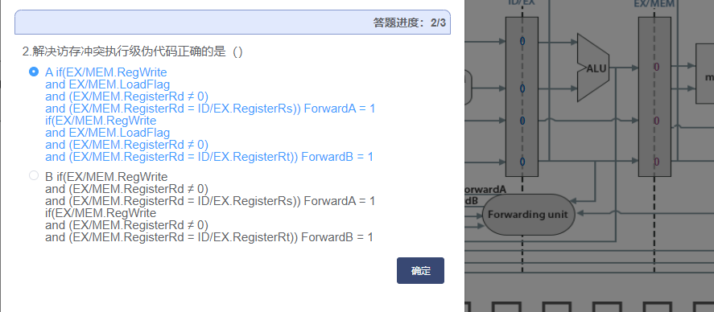

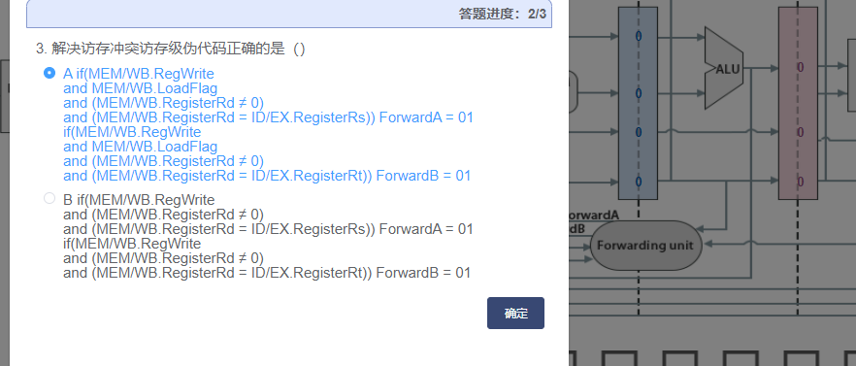

|  |  |
| --- | --- |
| ID | //待补充，完成对stall_request的赋值  assign stall_request = (load_related_1 || load_related_2); |
| RegReadProxy | //待补充，完成对load_related_1、load_related_2的赋值  assign load_related_1 = (ex_load_flag && read_addr_1==reg_write_addr_from_ex) || (mem_load_flag && read_addr_1==reg_write_addr_from_mem ) ;  assign load_related_2 = (ex_load_flag && read_addr_2==reg_write_addr_from_ex) || (mem_load_flag && read_addr_2==reg_write_addr_from_mem ) ; |
| PipelineDeliver | always @(posedge clk) begin  if (rst) begin  out <= 0;  end  else if (stall_current_stage && !stall_next_stage) begin  out<=0;  end  else if (!stall_current_stage) begin  out<=in;  end  //待补充，实现暂停功能  end |
|  |  |
|  |  |
|  |  |
|  |  |

