# CHAPTER I

# INTRODUCTION

1. **INTRODUCTION**

Sentiment Analysis also known as Opinion Mining is a field within [Natural Language Processing](https://monkeylearn.com/blog/definitive-guide-natural-language-processing/) (NLP) that builds systems that try to identify and extract opinions within text. Usually, besides identifying the opinion, these systems extract attributes of the expression e.g.:

* *Polarity:* If the speaker expresses a positive or negative opinion.
* *Subject :* The thing that is being talked about,
* *Opinion holder:* The person, or entity that expresses the opinion.

Currently, sentiment analysis is a topic of great interest and development since it has many [practical applications](https://monkeylearn.com/sentiment-analysis/#sentiment-analysis-use-cases-and-applications). Since publicly and privately available information over Internet is constantly growing, a large number of texts expressing opinions are available in review sites, forums, blogs, and social media.

With the help of sentiment analysis systems, this unstructured information could be automatically transformed into structured data of public opinions about products, services, brands, politics, or any topic that people can express opinions about. This data can be very useful for commercial applications like marketing analysis, public relations, product reviews, net promoter scoring, product feedback, and customer service.

**1.1 Sentiment Analysis Algorithms**

There are many methods and algorithms to implement sentiment analysis systems, which can be classified as:

* **Rule-based** systems that perform sentiment analysis based on a set of manually crafted rules.
* **Automatic** systems that rely on machine learning techniques to learn from data.
* **Hybrid** systems that combine both rule based and automatic approaches.

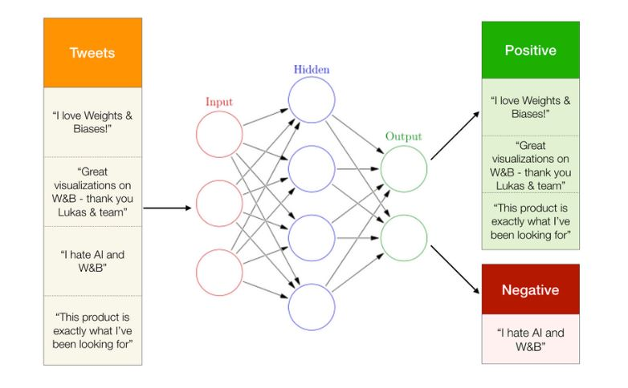

Figure 1. Processing in Sentiment analysis

**1.2 Types of sentiment analysis**

1. **Fine-grained sentiment analysis** provides a more precise level of polarity by breaking it down into further categories, usually very positive to very negative. This can be considered the opinion equivalent of ratings on a 5-star scale. e.g.: Very Positive = 5 stars and Very Negative = 1 star.
2. **Emotion detection** identifies specific emotions rather than positivity and negativity. Examples could include happiness, frustration, shock, anger and sadness.
3. **Intent-based analysis** recognizes actions behind a text in addition to opinion. For example, an online comment expressing frustration about changing a battery could prompt customer service to reach out to resolve that specific issue.eg:“Your customer support is a disaster. I’ve been on hold for 20 minutes”.
4. **Aspect-based analysis** gathers the specific component being positively or negatively mentioned. For example, a customer might leave a review on a product saying the battery life was too short. Then, the system will return that the negative sentiment is not about the product as a whole, but about the battery life.

**CHAPTER II**

# LITERATURE REVIEW

1. **LITERATURE REVIEW**

**2.1 Supervised Learning Approach**

This method contains two sets of documents which are training and a test set. To learn about the document, training set is used by classifier. For validation purpose test set is used. For review classification many techniques can be used.

Types of supervised learning methods:

**2.1.1 Decision tree classifier**

Decision tree classifier provides a hierarchical decomposition of the training data space in which a condition on the attribute value is used to divide the data. The condition or predicate is the presence or absence of one or more words. The division of the data space is done recursively until the leaf nodes contain certain minimum numbers of records which are used for the purpose of classification.

In [1] Movie review features obtained from IMDb was extracted using inverse document frequency and the importance of the word found. Principal component analysis and CART were used for feature selection based on the importance of the work with respect to the entire document. The classification accuracy obtained by LVQ was 75%.

Exploring emotional variation in adolescent age and reasons behind these changes using data mining techniques is proposed in [2]. By classifying emotions and using decision tree different emotional variations are analyzed. If-then rules are also generated from decision tree. Outlier analysis is used to identify emotion variation in child having any kind of disability.

**2.1.2 Linear classifier**

**a. Support vector machine:**

Text data are ideally suited for SVM classification because of the sparse nature of text, in which few features are irrelevant, but they tend to be correlated with one another and generally organized into linearly separable categories.

In [3], machine learning (SVM) combined with domain specific lexicons is implemented for aspect classification and polarity identification of product review. SVM is trained to model aspect classification and this trained SVM is used for polarity classification per aspect. The experimental results indicate that the proposed techniques have achieved about 78% accuracy. Web based data are applied to emotion cause extraction sub system and complementary feature selection method, based on the output of these features are merged. In training process, web post with unknown emotions are given to SVM and SVR classification model and the output gives information about the type of emotion [4].

**2.1.3 Rule based classifier**

In rule based classifiers, the data space is modeled with a set of rules. The left hand side represents a condition on the feature set expressed in disjunctive normal form while the right hand side is the class label. The conditions are on the term presence. Term absence is rarely used because it is not informative in sparse data.

[5] proposes a rule-based approach to emotion cause component detection for Chinese micro-blogs. It presents the emotion model and extracts the corresponding cause components in fine-grained emotions. The emotional lexicon can be constructed manually and automatically from the corpus. Meanwhile, the proportions of cause components can be calculated in the influence of the multi-language features based on Bayesian probability. The experiment results show the feasibility of the approach.

**2.1.4 Probabilistic classifier**

**a. Naïve Bayes**

The Naive Bayes classifier is the simplest and most commonly used classifier. Naive Bayes classification model computes the posterior probability of a class, based on the distribution of the words in the document. The model works with the BOWs feature extraction which ignores the position of the word in the document. It uses Bayes Theorem to predict the probability that a given feature set belongs to a particular label.

The system which is proposed in [6] extracts aspects in product customer reviews. The nouns and noun phrases are extracted from each review sentence. Minimum support threshold is used to find all frequent aspects for the given review sentences. Naïve Bayesian algorithm using supervised term counting based approach is used to identify whether sentence is positive or negative opinion and also identifies the number of it.

The paper [7] presents a method of sentiment analysis, on the review made by users to movies. Classification of reviews in both positive and negative classes is done based on a naive Bayes algorithm. As training data we used a collection (pre-classified in positive and negative) of sentences taken from the movie reviews. To improve classification we removed insignificant words and introduced in classification groups of words (n-grams). For n = 2 groups we achieved a substantial improvement in classification.

**b. Maximum entropy**

The Maximum entropy Classifier (known as a conditional exponential classifier) converts labeled feature sets to vectors using encoding. This encoded vector is then used to calculate weights for each feature that can then be combined to determine the most likely label for a feature set.

In [2], a novel method is used to collect various learners twitter messages On this dataset preprocessing for sentiment analysis is performed It involves various intermediate operations remove ambiguity. The pre-processed dataset is used to built user‟s emotional state classification and SVM, ME and naïve bayes classifiers are applied and the results are very efficient.

**CHAPTER III**

**THEORETICAL BACKGROUND**

**3.1 THEORETICAL BACKGROUND**

K-nearest neighbour classifier is one of the introductory supervised classifier, which

every data science learner should be aware of. Fix &Hodges proposed K-nearest neighbour classifier algorithm in the year of 1951 for performing pattern classification task. For simplicity, this classifier is called as Knn Classifier. To be surprised k-nearest neighbour classifier mostly represented as Knn, even in many research papers too. Knn address the pattern recognition problems and also the best choices for addressing some of the classification related tasks. The simple version of the K-nearest neighbour classifier algorithms is to predict the target label by finding the nearest neighbour class. The closest class will be identified using the distance measures like Euclidean distance.

The KNN algorithm is a robust and versatile classifier that is often used as a benchmark for more complex classifiers such as Artificial Neural Networks (ANN) and Support Vector Machines (SVM). Despite its simplicity, KNN can outer form more powerful classifiers and is used in a variety of applications such as economic forecasting, data compression and genetics. For example, KNN was leveraged in a2006 study of functional genomics for the assignment of genes based on their expression profiles.

* 1. **CONCEPTS & METHODOLOGY**

The main goal of the research is to analyse the data from the surveys and to decide whether it is suitable to be analysed with the use of the discussed data mining methods. The algorithm used here for classification are described below.

**3.2.1 K-Nearest Neighbour Classifier**

K-NN is a type of instance-based learning, or lazy learning where the function is only approximated locally and all computation is deferred until classification. It is non parametric method used for classification or regression. In case of classification the output is class membership (the most prevalent cluster may be returned), the object is classified by a majority vote of its neighbours, with the object being assigned to the class most common among its k nearest neighbours. This rule simply retains the entire training set during learning and assigns to each query a class represented by the majority label of its k-nearest neighbours in the training set.



Figure 2. K-NN Classifier flowchart 1

The Nearest Neighbour rule (NN) is the simplest form of K-NN when K = 1.Given an unknown sample and a training set, all the distances between the unknown sample and all the samples in the training set can be computed. The distance with the smallest value corresponds to the sample in the training set closest to the unknown sample. Therefore, the unknown sample may be classified based on the classification of this nearest neighbour. The K-NN is an easy algorithm to understand and implement, and a powerful tool we have at our disposal for sentiment analysis. K-NN is powerful because it does not assume anything about the data, other than a distance measure can be calculated consistently between two instances. As such, it is called non-parametric or non-linear as it does not assume a functional form. The flowchart of k-nn classifier is given in Figure 3.2.1.

It is a simple algorithm that stores all available cases and classifies new cases by a majority vote of its k neighbours. The case being assigned to the class is the most common among its K nearest neighbours measured by a distance function. These distance functions can be Euclidean, Manhattan, Minkowski,levenshtein and Hamming distance. If K = 1, then the case is simply assigned to the class of its nearest neighbour. At times, choosing K turns out to be a challenge while performing KNN modeling. The algorithm looks at different centroids and compares distance using some sort of function (usually Euclidean), then analyzes those results and assigns each point to the group so that it is optimized to be placed with all the closest points to it.

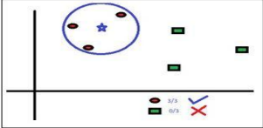

Figure 3. Example for KNN algorithm

The score can be calculated using:

Positivity Score = ${\left(\sum_{1}^{j}{score \left(pos\right)}+\sum_{1}^{k}{score \left(neg\right)}\right)}/{\sum_{1}^{s}{maximum score}}$

-Equation (3.2.1)

Here s=j+k, ie. Count of both positive and negative together. In weighted k-NN method they first of all tokenise the sentences and removed the stop words from the comments they have fetched. The algorithm proposed by the authors of is carried out in two parses. A positive score is assigned to each reviews after the first parse. This is passed for second parsing and an input of neutral review is given. Using this the score is modified if required. It is done for better positivity determination and an output file consisting of review ID and its positive score is determined.

Strings are broken into tokenized arrays of single words. These words are analysed against TXT files that contain emotion words with ratings, emoticons with ratings,booster words with ratings and possible polarity changers. A score is then calculated based on this analyse and this forms the "Sentiment analysis score".

**3.2.2 Pseudo-code for KNN:**

We can implement a KNN model by following the below steps:

1. Load the data
2. Initialise the value of k
3. For getting the predicted class, iterate from 1 to total number of training data points
   1. Calculate the distance between test data and each row of training data.

Here we will use Levenshtein Distance as our distance metric since it’s the most popular method.

The other metrics that can be used are Chebyshev,Levenshtein, cosine, etc.

* 1. Sort the calculated distances in ascending order based on distance values
  2. Get top k rows from the sorted array
  3. Get the most frequent class of these rows
  4. Return the predicted class

**3.2.3 Levenshtein Distance:**

The Levenshtein distance is a string metric for measuring the difference between two sequences. Informally, the Levenshtein distance between two words is the minimum number of single-character edits (i.e. insertions, deletions, or substitutions) required to change one word into the other**.**

$${lev}_{a,b}\left(i,j\right)=\left\{\begin{aligned} max\left(i,j\right) ifmin\left(i,j\right)=0, \\ min\left\{\begin{aligned}{lev}_{a,b}\left(i-1,j\right)+1 \\ {lev}_{a,b}\left(i,j-1\right)+1 \\ {lev}_{a,b}\left(i-1,j-1\right)+1_{\left(a_{i}≠b_{j}\right)}\end{aligned}\right.otherwise\end{aligned}\right.$$

*-*Equation(3.2.2)

Here, 1(ai≠ bi) is the indicator function equal to 0 when ai≠ biand equal to 1 otherwise, and ${lev}_{a,b}\left(i,j\right)$  is the distance between the first i characters of a and the first j characters of b.

* + 1. **Phrase Analysis**

This function is key to identifying whether the phrase in questions can be compared to phrases that we have analysed and stored before. It uses Levenshtein distance to calculate distance between word length phrases against the dataset we already have. We also make use of PHP's similar_text to double verify proximity.This means that the more phrases we have analysed previously improves the entire dataset and allows phrases to be more accurately scored against historical data.

1. The phrase is broken up into n-gram lengths.
2. The array is reverse sorted so we compare 10 word length phrases first, then 9, and so on
3. Phrases are matched against positive, negative and neutral phrases in the relevant TXT files
4. Only matches that meet the minimum levenshtein min distance &similiarity_min_distance are kept.
   1. **DESIGN & MODELLING**

**3.3.1 Diagrams**

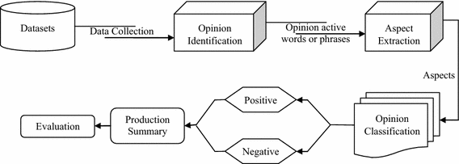

Figure 4. Opinion Mining Process

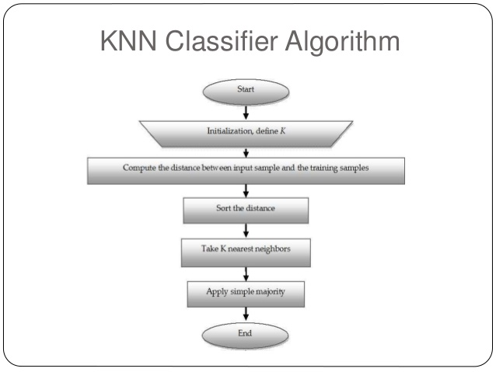

Figure 5. K-NN Classifier flowchart 2.

**3.3.2 Table Design**

**1.tbl_userfeedback**

Primary Key : uf_id

Foreign Key : r_id,h_id[references from tbl_registration & tbl_addresort]

|  |  |  |  |  |
| --- | --- | --- | --- | --- |
| **Field Name** | **Data Type** | **Length** | **Description** | **Contraint** |
| uf_id | INT | 2 | Rate_id | Primary Key |
| r_id | INT | 2 | User id | Foreign key from tbl_registration |
| h_id | INT | 10 | Resort id | Foreign key from tbl_addresort |
| uf_msg | Varchar | 10 | Review Message | Null |
| uf_date | Date | 2 | Date | Null |
| uf_rate | INT | 10 | Rating | Null |
| rate_status | INT | 1 | Status | Null |

Table 1. tbl_userfeedback

**2.tbl_registration**

Primary Key : r_id

|  |  |  |  |  |
| --- | --- | --- | --- | --- |
| **Field Name** | **Data Type** | **Length** | **Description** | **Constraint** |
| r_id | int | 2 | User id | Primary Key |
| r_name | varchar | 10 | First name | Null |
| r_lname | varchar | 10 | Last name | Null |
| r_address | varchar | 10 | Address | Null |
| r_dob | date | 5 | Date of Birth | Null |
| r_gender | varchar | 10 | Gender | Null |
| r_phone | varchar | 10 | Phone number | Null |
| r_email | varchar | 20 | Email | Null |
| r_status | int | 2 | Status | Null |

Table 2. tbl_registration

**3.tbl_addresort**

Primary Key : h_id

Foreign Key : r_id,d_id [references from tbl_registration & tbl_district]

|  |  |  |  |  |
| --- | --- | --- | --- | --- |
| **Field Name** | **Data Type** | **Length** | **Description** | **Constraint** |
| h_id | int | 2 | Resort id | Primary Key |
| r_id | int | 2 | User_id | Foreign key from tbl_registration |
| h_name | varchar | 10 | Resort Name | Null |
| h_address | varchar | 10 | Resort Address | Null |
| h_star | int | 2 | Resort Star classification | Null |
| d_id | int | 2 | District id | Foreign key from tbl_district |
| s_id | int | 2 | State | Null |
| h_pin | int | 10 | Pin number | Null |
| h_location | varchar | 10 | Resort location | Null |
| h_des | varchar | 20 | Resort Description | Null |
| h_open | time | 5 | Opening time | Null |
| h_close | time | 5 | Closing Time | Null |
| h_phone | varchar | 10 | Phone number | Null |
| h_url | varchar | 10 | Site url | Null |
| h_email | varchar | 10 | Email | Null |
| h_image | varchar | 20 | Image | Null |

Table 3. tbl_addresort

**CHAPTER IV**

**PROJECT IMPLEMENTATION**

**IV. PROJECT IMPLEMENTATION**

The opinion mining has become one of popular research area. The challenge is in process of opinion mining or sentiment analysis that is unstructured and noisy data on website.

There are mainly three types of opinion mining techniques (figure. 4.1)**:**

1. **Supervised Learning Techniques** : The most widely used supervised learning techniques are Support Vector Machines(SVM), Neural network, Multi-Layer Perceptron (MLP), Decision tree, Naïve Bayes(NB) Classification, Maximum Entropy(MaxEnt),K-NN Algorithm.

2. **Unsupervised Learning Techniques:** Mostly used technique are Clustering algorithm, expectation maximization algorithm, matrix factorization, principal component analysis.

3. **Case-Based Reasoning:** It is an emerging artificial techniques. CBR is an intelligent tool of computer reasoning and solves the problem in such a real time

scenario. Solution is stored in CBR repository also known as case base.

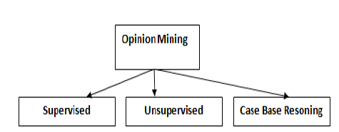

Figure 6. Types of Opinion Mining Techniques

A part of opinion mining refers using of natural language processing (NLP) by proposed different method of dictionary for sentiment analysis.They tried to extract word from sentences for removal stop word or unnecessary word automatically. In addition, various dictionaries are solved by machine learning methods which try to rank scoring of various dictionaries. For example, K-NN algorithm to collect the ranking of different dictionary into rule for classify the opinion.After word segmentation process is removal stop words by dictionary checking. It focuses on the calculating polarity of words to trend in positive , negative or nuetral in a cluster of interest's customer that are extracted from texts and compared the word occurrence of whole sentence. If the word extractions have weight from dictionary of emotional words, it is calculated to answer the comment as positive or negative.

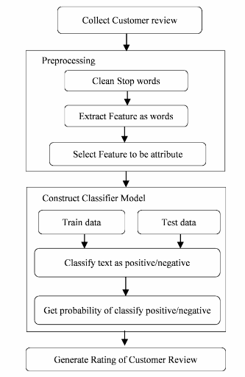

Figure 7. Proposed Methodology for generating score of customer review using

opinion mining

The proposed methodology used customer review's resorts from a website which service in resort reservation directly. The target of classify customer review from this website because the comment is posted from customer who is serviced checked-in and checked-out from resort. The system has cleaned the promotion of resort's comment which has only existed customer review given comment.The open opinion texts are collected customer reviews that are used service to checked-in/out the resorts. The process is started from collected data and preprocessing is cleaned data by removal stop words,Calculate the distance between test data and each row of training data. Using Levenshtein Distance sort the calculated distances in ascending order based on distance values.Get top k rows from the sorted array and the most frequent class of these rows and return the predicted class.

**CHAPTER V**

**RESULTS OF ANALYTICAL**

**V. RESULTS OF ANALYTICAL**

Opinion Mining for Resort Review system is a natural language processing system that detects hidden sentiments in reviews of the customer and rates the reviews accordingly.

The precision of the proposed system is approx. 82 percent. The recall of the proposed system is 81.5 percent. The accuracy achieved by the proposed system is up to 86 percent.

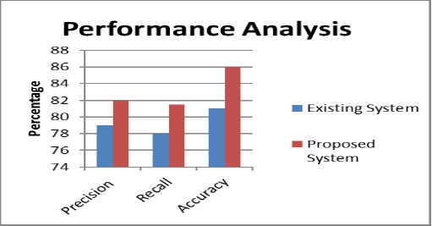

Figure 8. Performance Analysis

When processing time is considered it is shown that the processing time is totally depend upon the size of test set as the size increases the processing time increases and remain same for these classifiers and if different number of documents (and of different test size) are used then we can observed the processing time differences.

**CHAPTER VI**

**CONCLUSIONS AND SCOPE FOR FUTURE WORK**

**VI. CONCLUSIONS AND SCOPE FOR FUTURE WORK**

Various sentiment analysis methods and its different levels of analyzing sentiments have been studied here. Our ultimate aim is to come up with Sentiment Analysis which will efficiently categorize various reviews. Research work is carried out for better analysis methods in this area, We use the K-Nearest Neighbour algorithm to effectively calculate the polarity of the reviews. In the world of Internet majority of people depend on social networking sites to get their valued information, analysing the reviews from these blogs will yield a better understanding and help in their decision-making.

**Sentiment Analysis Scope:**

Sentiment analysis can be applied at different levels of scope:

* Document level sentiment analysis obtains the sentiment of a complete document or paragraph.
* Sentence level sentiment analysis obtains the sentiment of a single sentence.
* Sub-sentence level sentiment analysis obtains the sentiment of sub-expressions within a sentence.

The research scope in opinion mining and sentiment analysis are:

* Spam Detection using Sentiment Analysis.
* Sentiment Analysis on short Sentence that include abbreviations.
* Improvement of existing sentiment word identification algorithm.
* Developing fully automatic tools for analysis.
* Effective Analysis of policy documents which containing opinion content.
* Managing the of bi polar sentiments successfully.
* Designing and Generation of highly content corpus database.

**Future Work**

Opinion mining and sentimental analysis is an emerging field of data mining used to extract the knowledge from a huge volume of customer comments, feedback and reviews on any product or topic etc. A lot of work in opinion mining in customer reviews has been conducted to mine opinions in form of document, sentence and feature level sentiment analysis. In future, Opinion Mining can be carried out on set of discovered feature expressions extracted from reviews. The Opinion Mining and in natural language processing community, Sentiment Analysis become a most interesting research area. A more innovative and effective techniques needed to be invented which should overcome the current challenges faced by Opinion Mining and Sentiment Analysis.

**APPENDIX 1**

**Sample Project code/ Algorithm**

<?php

include ('Research/lib/sentiment_analyser.class.php');

$sa = new SentimentAnalysis();

$sa->initialize();

if (isset($_POST['save_dats'])) {

$rating = $_POST['rating'];

$text = $_POST['text'];

$sa->import_sentiment_custom($text,$rating);

die();

} else { ?><!doctype html>

<body><div class='wrapper'>

<?php

if (isset($_POST['sent_data'])){ ?>

<div class='returned_data'>

<?php

$sent_data = explode("\n",$_POST['sent_data']);

$min_submit_lev_score = $sa->return_levenshtein_min_submit_distance();

$analysed_array = array();

$i = 0;

foreach ($sent_data as $dataset) {

$original_data = $dataset;

$check = $sa->analyse($dataset);

$rating = $sa->return_sentiment_rating();

$ratings_data = $sa->return_sentiment_calculations();

//echo $ratings_data;

$analysed_array[$i]['dataset'] = implode(' ',$sa->return_tokenized_mention());

$analysed_array[$i]['original_dataset'] = $original_data;

$analysed_array[$i]['rating'] = $rating;

$analysed_array[$i]['preferred_match_type'] = $sa->return_preferred_match_type();

$analysed_array[$i]['sentiment_analysis'] = $sa->return_sentiment_analysis();

$analysed_array[$i]['proximity_analysis'] = $sa->return_phrase_proximity();

$i++;}

foreach($analysed_array as $key => $output) {

$allow_submission = false;

//var_dump($output);

if ($output['preferred_match_type'] == 'sentiment_analysis' || $output['proximity_analysis'][1]['levenshtein'] > $min_submit_lev_score) {

if (count(explode(" ",$output['dataset'])) < 4) {

$allow_submission = false;

} else {$allow_submission = true;}

} else {

$allow_submission = false;}

echo "<tr id='tr_".$key."'>";

if ($allow_submission) {}

else{

echo "<td>&nbsp;</td>";}}

include 'dbconnect.php';

$data=$output['dataset'];

$o=$output['rating'];

$d=date("Y-m-d");

$a=$_SESSION['r_id'];

$sql=mysqli_query($con,"SELECT * FROM `tbl_addresort` WHERE `h_id`='$kid'");

$sql=mysqli_query($con,"SELECT * FROM `tbl_registration` WHERE `r_id`='$a'");

$sql=mysqli_query($con,"INSERT INTO `tbl_userfeedback`(`r_id`, `h_id`, `uf_msg`, `uf_date`, `uf_rate`, `uf_status`) VALUES ('$a','$kid','$data','$d','$o','1')");

echo "</div>";

?>

<?php} ? ?>

</form><div class="reviews_title">reviews</div>

<?php

include 'Rating.php';

$rating = new Rating();

$itemList = $rating->getItemList();

foreach($itemList as $item){

$average = $rating->getRatingAverage($item["h_id"]);

$itemDetails = $rating->getItem($_GET['uid']);

?>

<?php } ?>

<?php

$itemRating = $rating->getItemRating($_GET['uid']);

$ratingNumber = 0;

$count = 0;

$fiveStarRating = 0;

$fourStarRating = 0;

$threeStarRating = 0;

$twoStarRating = 0;

$oneStarRating = 0;

foreach($itemRating as $rate){

$ratingNumber+= $rate['uf_rate'];

$count += 1;

if($rate['uf_rate'] >4.5 and $rate['uf_rate'] <=5) {

$fiveStarRating +=1;

} else if($rate['uf_rate'] >3.5 and $rate['uf_rate'] <=4.5) {

$fourStarRating +=1;

} else if($rate['uf_rate']> 2.5 and $rate['uf_rate'] <=3.5) {

$threeStarRating +=1;

} else if($rate['uf_rate'] >1.5 and $rate['uf_rate'] <=2.5) {

$twoStarRating +=1;

} else if($rate['uf_rate'] >0 and $rate['uf_rate'] <=1) {

$oneStarRating +=1;}}

$average = 0;

if($ratingNumber&& $count) {

$average = $ratingNumber/$count;}

?>

<h4>Rating and Reviews</h4>

<h2 class="bold padding-bottom-7"><?phpprintf('%.1f', $average); ?><small>/ 5</small></h2>

<?php

$averageRating = round($average, 0);

for ($i = 1; $i <= 5; $i++) {

$ratingClass = "btn-default btn-grey";

if($i <= $averageRating) {

$ratingClass = "btn-warning";}

?>

<button type="button" class="btnbtn-sm<?php echo $ratingClass; ?>" aria-label="Left Align">

<span class="glyphiconglyphicon-star" aria-hidden="true"></span>

</button>

<?php } ?>

<?php

$fiveStarRatingPercent = round(($fiveStarRating/5)*100);

$fiveStarRatingPercent= !empty($fiveStarRatingPercent)?$fiveStarRatingPercent.'%':'0%';

$fourStarRatingPercent = round(($fourStarRating/5)*100);

$fourStarRatingPercent= !empty($fourStarRatingPercent)?$fourStarRatingPercent.'%':'0%';

$threeStarRatingPercent = round(($threeStarRating/5)*100);

$threeStarRatingPercent= !empty($threeStarRatingPercent)?$threeStarRatingPercent.'%':'0%';

$twoStarRatingPercent = round(($twoStarRating/5)*100);

$twoStarRatingPercent= !empty($twoStarRatingPercent)?$twoStarRatingPercent.'%':'0%';

$oneStarRatingPercent = round(($oneStarRating/5)*100);

$oneStarRatingPercent= !empty($oneStarRatingPercent)?$oneStarRatingPercent.'%':'0%';

?>

<div class="progress-bar progress-bar-success" role="progressbar" aria-valuenow="5" aria-valuemin="0" aria-valuemax="5" style="width: <?php echo $fiveStarRatingPercent; ?>">

<span class="sr-only"><?php echo $fiveStarRatingPercent; ?></span></div>

<div class="pull-right" style="margin-left:10px;"><?php echo $fiveStarRating; ?></div></div>

<div class="progress-bar progress-bar-primary" role="progressbar" aria-valuenow="4" aria-valuemin="0" aria-valuemax="5" style="width: <?php echo $fourStarRatingPercent; ?>">

<span class="sr-only"><?php echo $fourStarRatingPercent; ?></span></div>

<div class="pull-right" style="margin-left:10px;"><?php echo $fourStarRating; ?></div>

<div class="progress-bar progress-bar-info" role="progressbar" aria-valuenow="3" aria-valuemin="0" aria-valuemax="5" style="width: <?php echo $threeStarRatingPercent; ?>">

<span class="sr-only"><?php echo $threeStarRatingPercent; ?></span></div>

<div class="pull-right" style="margin-left:10px;"><?php echo $threeStarRating; ?></div>

<div class="progress-bar progress-bar-warning" role="progressbar" aria-valuenow="2" aria-valuemin="0" aria-valuemax="5" style="width: <?php echo $twoStarRatingPercent; ?>">

<span class="sr-only"><?php echo $twoStarRatingPercent; ?></span></div>

<div class="pull-right" style="margin-left:10px;"><?php echo $twoStarRating; ?></div>

<div class="progress-bar progress-bar-danger" role="progressbar" aria-valuenow="1" aria-valuemin="0" aria-valuemax="5" style="width: <?php echo $oneStarRatingPercent; ?>">

<span class="sr-only"><?php echo $oneStarRatingPercent; ?></span></div>

<div class="pull-right" style="margin-left:10px;"><?php echo $oneStarRating; ?></div>

<?php

include 'dbconnect.php';

$kid1=$_SESSION['r_id'];

$res1=mysqli_query($con,"SELECT * FROM `tbl_userfeedback` f1 LEFT JOIN `tbl_registration` r1 on f1.r_id=r1.r_id where f1.h_id='$kid'");

while($row1=mysqli_fetch_array($res1)){

?>

<div class="review_image">

<imgsrc="Uploads/<?php echo $row1['r_image'];?>" alt="https://unsplash.com/@saaout"></div>

<div class="review_title"><?php echo $row1['r_name'];?></div>

<div class="review_rating"><?php echo $row1['uf_rate'];?></div>

<div><span id="stars<?php echo $row1['uf_id'];?>"></span>

<script type="text/javascript">

document.getElementById("stars<?php echo $row1['uf_id'];?>").innerHTML = getStars(<?php echo $row1['uf_rate'];?>);

functiongetStars(rating) {

rating = Math.round(rating * 2) / 2;

let output = [];

for (var i = rating; i >= 1; i--)

output.push('<i class="fafa-star" aria-hidden="true" style="color: gold;"></i>&nbsp;');

if (i == .5) output.push('<i class="fafa-star-half-o" aria-hidden="true" style="color: gold;"></i>&nbsp;');

for (let i = (5 - rating); i >= 1; i--)

output.push('<i class="fafa-star-o" aria-hidden="true" style="color: gold;"></i>&nbsp;');

returnoutput.join('');}

</script></div><div class="review_text"><p><?php echo $row1['uf_msg'];?></p></div>

<div class="review_date"><?php echo $row1['uf_date'];?></div>

<?php} }?>

**REFERENCES**

**References**

[1] Jeevanandam Jotheeswaran, Dr. Y. S. Kumaraswamy, "Opinion Mining Using Decision Tree Based Feature Selection Through Manhattan Hierarchical Cluster Measure", Journal of Theoretical and Applied Information Technology, 2013

[2] Jasakaran Kaur, Sheveta Vashisht, "Analysis And Indentifying Variation In Human Emotion Through Data Mining", Int.J.Computer Technology & Applications, 2012

[3] Chetashri Bhadane,Hardi Dalal, Heenal Doshi, "Sentiment Analysis: Measuring Opinions", Science Direct, 2015

[4] Weiyuan Li, Hua Xu, "Text-based emotion classification using emotion cause extraction", ELSEVIER, 2013

[5] Kai Gao, Hua Xu, Jiushuo Wanga, "A Rule-Based Approach To Emotion Cause Detection For Chinese Micro-Blogs", ELSEVIER, 2015

[6] A.Jeyapriya, C.S.Kanimozhi Selvi,"Extracting Aspects And Mining Opinions In Product Reviews Using Supervised Learning Algorithm", IEEE, 2015

[7] Ion Smeureanu, Cristian Bucur, "Applying Supervised Opinion Mining Techniques On Online User Reviews", Informatica Economică, 2012