|  |
| --- |
|  |
| Mid-term Project |
| Team Apple |
|  |
| **Jian Wang** |
| **Yulong Luo**  **Qi Zhu** |
| **2013/3/5** |

# Introduction

Apple Inc., is an American corporation that designs, develops, and sells consumer electronics, computer software and personal computers. It is one of the largest mobile phone designers and makers in the world. Its best-known hardware products are the Mac line of computers, the iPod, iPhone, and iPad. Its software includes the OS X and iOS operating systems.

In our research project, we compared three popular mobile phones including iPhone (Apple), Galaxy (Samsung) and Lumia (Nokia), as well as three operating systems including iOS, Android, and Windowsphone.

Through the analysis, we expect to give conclusions in the following aspects: popularity, quality evaluation, and satisfaction.

# Data Source

* Data collected from Twitter API
* Function: tweepy
* We collected data from two ways.
* First way is to collect Tweets with key words, in order to compare these three mobile phones and operating system from detailed aspects. We basically use tweepy directly search data on Twitter.
* Second way is to collect Tweets without keywords in order to calculate the products’ popularity. We collected data from user id, the tweets wrote on March 1st, and then use tweepy to collect all the data in a certain period of time.
* Total Tweets collected:
* Tweets about mobile phone: 289,743
* Tweets about operating system: 421,443
* Tweets without key words: 311,774

# Analysis and conclusion

## 3.1 General analysis (with keywords)

|  |  |  |  |  |
| --- | --- | --- | --- | --- |
| Product | Positive | Negative | Ratio | Tweets_Count |
| iPhone | 12,916 | 955 | 93.12% | 239,328 |
| Galaxy | 338 | 21 | 94.15% | 46,361 |
| Lumia | 123 | 9 | 93.18% | 4,054 |

Figure Mobile phone table

|  |  |  |  |  |
| --- | --- | --- | --- | --- |
| Systems | Positive | Negative | Ratio | Tweets_Count |
| iOS | 1,747 | 101 | 94.53% | 40,280 |
| Android | 5,713 | 435 | 92.92% | 379,752 |
| Windowsphone | 50 | 10 | 83.33% | 1,411 |

Figure Operation system table

* From the data we collected, Galaxy has the highest positive ratio.
* We get few data about Lumia indicates few people mentioned Lumia. Lumia have low user-base.
* iPhone is highly mentioned but the positive ratio is lowest among those three mobile phones.

This indicates that iPhone has the largest user-base; however, the users of Galaxy have the greatest satisfaction of the product.

* Android smartphones are more widely used than iOS and windows OS. The iOS has the highest positive ratio and windows OS has the lowest positive ratio. This indicates that Android system has the largest user-base. On the other hand, the iOS customers are more satisfied than Android’s.

## 3.2 General analysis (without keywords)

|  |  |  |  |  |  |  |
| --- | --- | --- | --- | --- | --- | --- |
| iPhone | Galaxy | Lumia | iOS | Android | Windowsphone | Total tweets |
| 325 | 43 | 60 | 723 | 213 | 13 | 311,774 |

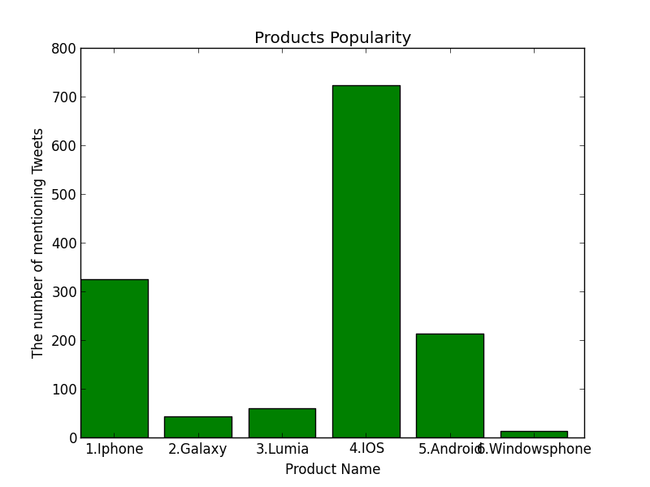

* As the bar chart shows above, iPhone Smartphone and IOS operating system are most popular products that people chose.
* Less people talk about Windowsphone system.

## 3.3 Mobile phone analysis and conclusion

### 3.3.1 Positive words analysis for mobile phones

Positive ratio = positive words / positive words + negative words

|  |  |  |  |  |  |  |  |
| --- | --- | --- | --- | --- | --- | --- | --- |
|  | **Positive words** | **iPhone** | **Ratio** | **Galaxy** | **Ratio** | **Lumia** | **Ratio** |
| Speed | quick | 263 | 2.04% | 11 | 3.25% | 1 | 0.81% |
| fast | 694 | 5.37% | 86 | 25.44% | 18 | 14.63% |
| Looking | elegant | 49 | 0.38% | 3 | 0.89% | 1 | 0.81% |
| pretty | 469 | 3.63% | 13 | 3.85% | 2 | 1.63% |
| good-looking | 1 | 0.01% | 0 | 0 | 0 | 0 |
| beautiful | 2,475 | 19.16% | 9 | 2.66 % | 4 | 3.25% |
| shapely | 0 | 0 | 0 | 0 | 0 | 0 |
|  | comfortable | 28 | 0.22% | 1 | 0.30% | 0 | 0 |
|  | friendly | 31 | 0.24% | 0 | 0 | 0 | 0 |
|  | sensitive | 13 | 0.10% | 0 | 0 | 1 | 0.81% |
|  | easy | 186 | 1.44% | 5 | 1.48% | 5 | 4.07% |
| Qualities | small | 226 | 1.75% | 7 | 2.07% | 1 | 0.81% |
| colorful | 10 | 0.08% | 0 | 0 | 5 | 4.07% |
| thin | 7,282 | 56.38% | 177 | 52.37% | 70 | 56.91% |
| light | 1,186 | 9.18% | 25 | 7.04% | 15 | 12.20% |
| width | 3 | 0.02% | 1 | 0.30% | 0 | 0 |
|  | Total | 12,916 |  | 338 |  | 123 |  |

Figure 3 Positive words ratio

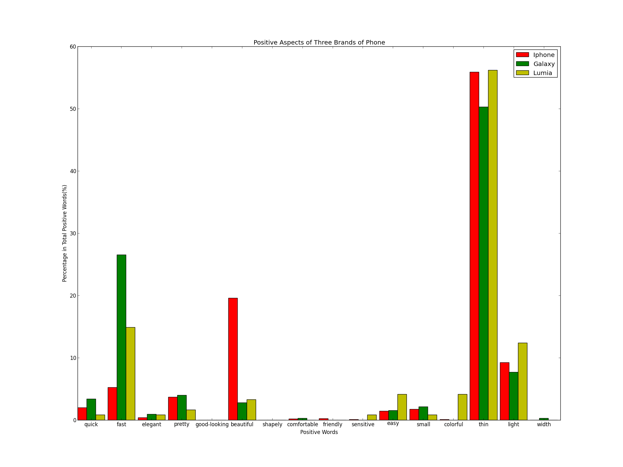

Figure 4 Bar chart for positive word

### 3.3.2 Negative words analysis for mobile phones

|  |  |  |  |  |  |  |  |
| --- | --- | --- | --- | --- | --- | --- | --- |
|  | **Negative words** | **iPhone** | **Ratio** | **Galaxy** | **Ratio** | **Lumia** | **Ratio** |
|  | defective | 10 | 1.05% | 0 | 0 | 0 | 0 |
| price | overpriced | 7 | 0.73% | 2 | 9.52% | 0 | 0 |
| expensive | 68 | 7.12% | 1 | 4.76% | 3 | 33.33% |
| appearance | ugly | 98 | 10.26% | 6 | 28.57% | 0 | 0 |
| bad-looking | 0 | 0 | 0 | 0 | 0 | 0 |
|  | fragile | 10 | 1.05% | 0 | 0 | 1 | 11.11% |
| Qualities | slow | 259 | 27.12% | 4 | 19.05% | 0 | 0 |
|  | poor | 163 | 17.07% | 2 | 9.52% | 2 | 22.22% |
|  | weak | 244 | 25.55% | 2 | 9.52% | 0 | 0 |
|  | large | 60 | 6.28% | 4 | 19.05% | 0 | 0 |
|  | heavy | 32 | 3.35% | 0 | 0 | 3 | 33.33% |
|  | insensitive | 4 | 0.42% | 0 | 0 | 0 | 0 |
|  | Total | 955 |  | 21 |  | 9 |  |

Figure 5 negative words ratio

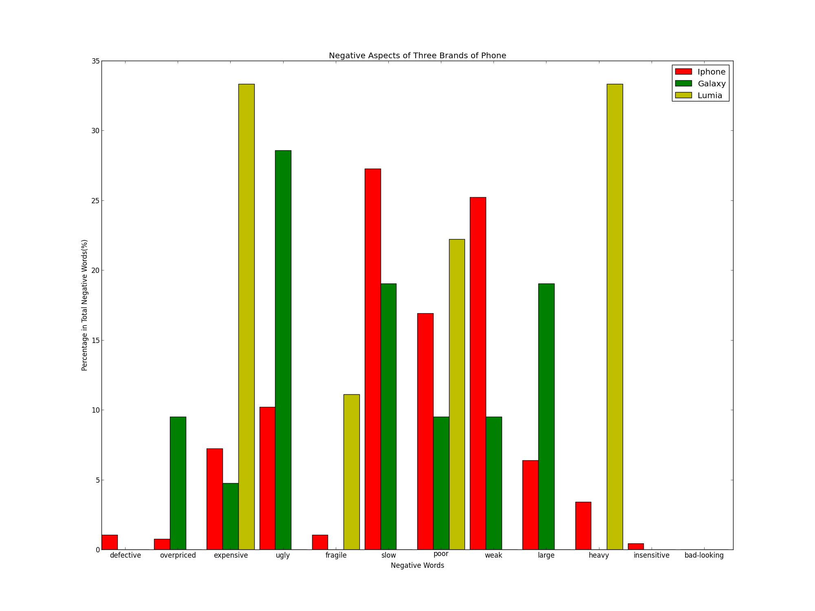

Figure 6 Bar chart for negative words

Conclusion:

* Speed. Larger proportion of customers think Galaxy is fast than iPhone. This indicates that the hardware device used in Galaxy is better than iPhone or the operation system is faster.
* Appearance. People would consider iPhone is much more beautiful than Galaxy and Lumia. Customers could probably think the shape of iPhone is good or have more accessories for iPhone to make it beautiful from outside.
* This is a crucial attraction for female consumers.
* Big proportion of customers thinks that both iPhone and Galaxy are thin and light. This indicates that size and weight are the significant factor that people care about.
* For customers, Lumia’s price is the most expensive or overpriced. Customers are relatively satisfied with the performance of Lumia, but think that price should be dropped.
* The weight of Lumia is much heavier than iPhone and Galaxy. The quality is awesome but it is too heavy.
* A considerable portion of Galaxy consumers think its size is too large.
* Over all, for the outside aspects, iPhone is better. However, customer is not very satisfied with iPhone’s operation speed.

## 3.4 Operating system analysis

### 3.4.1 Positive words analysis for operating systems

|  |  |  |  |  |  |  |
| --- | --- | --- | --- | --- | --- | --- |
| **Positive words** | **iOS** | **Ratio** | **Android** | **Ratio** | **Windowsphone** | **Ratio** |
| smart | 475 | 27.19% | 2013 | 35.24% | 25 | 50.00% |
| fast | 591 | 33.83% | 333 | 5.84% | 5 | 10.00% |
| quick | 40 | 2.29% | 69 | 1.21% | 2 | 4.00% |
| friendly | 19 | 1.09% | 24 | 0.42% | 0 | 0 |
| compatible | 54 | 3.09% | 21 | 0.37% | 1 | 2.00% |
| flexible | 0 | 0 | 8 | 0.14% | 1 | 2.00% |
| fluency | 0 | 0 | 2 | 0.04% | 0 | 0 |
| safe | 21 | 1.20% | 108 | 1.89% | 1 | 2.00% |
| easy | 21 | 1.20% | 159 | 2.78% | 1 | 2.00% |
| good design | 0 | 0 | 0 | 0 | 0 | 0 |
| creative | 26 | 1.49% | 9 | 0.16% | 0 | 0 |
| openness | 0 | 0 | 0 | 0 | 0 | 0 |
| free app | 500 | 28.62% | 2,967 | 52.93% | 14 | 28.00% |
| Total | 1,747 |  | 5,713 |  | 50 |  |

Figure 7 positive words ratio

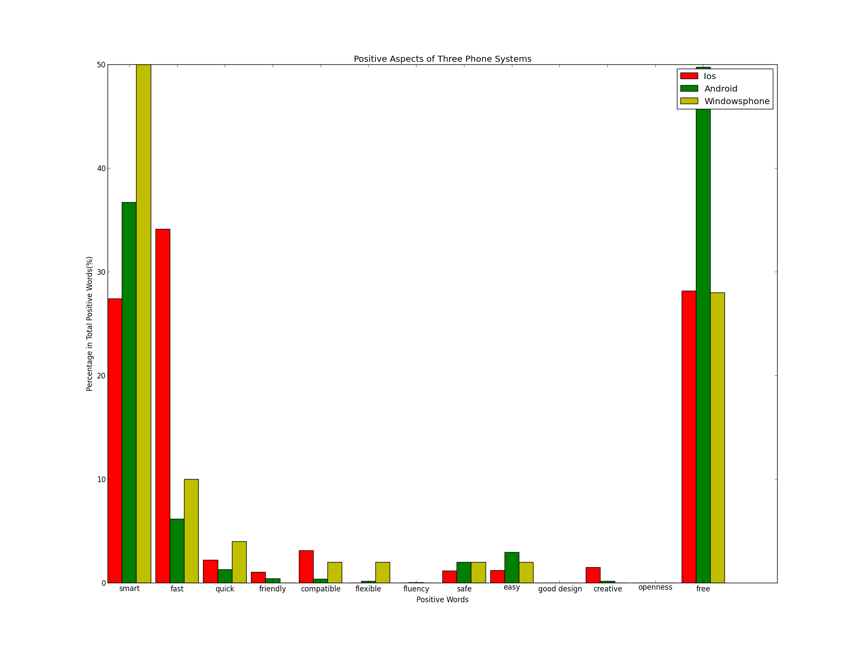

Figure 8 Bar chart for positive words

### 3.4.2 Positive words analysis for operating system

|  |  |  |  |  |  |  |
| --- | --- | --- | --- | --- | --- | --- |
| Negative words | iOS | Ratio | Android | Ratio | Windowsphone | Ratio |
| difficult | 3 | 2.97% | 127 | 29.20% | 1 | 10.00% |
| slow | 25 | 24.75% | 41 | 9.43% | 1 | 10.00% |
| poor | 14 | 13.86% | 34 | 7.82% | 4 | 40.00% |
| unsafe | 1 | 0.99% | 0 | 0 | 0 | 0 |
| expensive | 11 | 10.89% | 14 | 3.22% | 0 | 0 |
| overpriced | 2 | 1.98% | 1 | 0.23% | 0 | 0 |
| hard | 45 | 44.55% | 218 | 50.11% | 4 | 40.00% |
| Total | 101 |  | 435 |  | 10 |  |

Figure 9 Negative words ratio

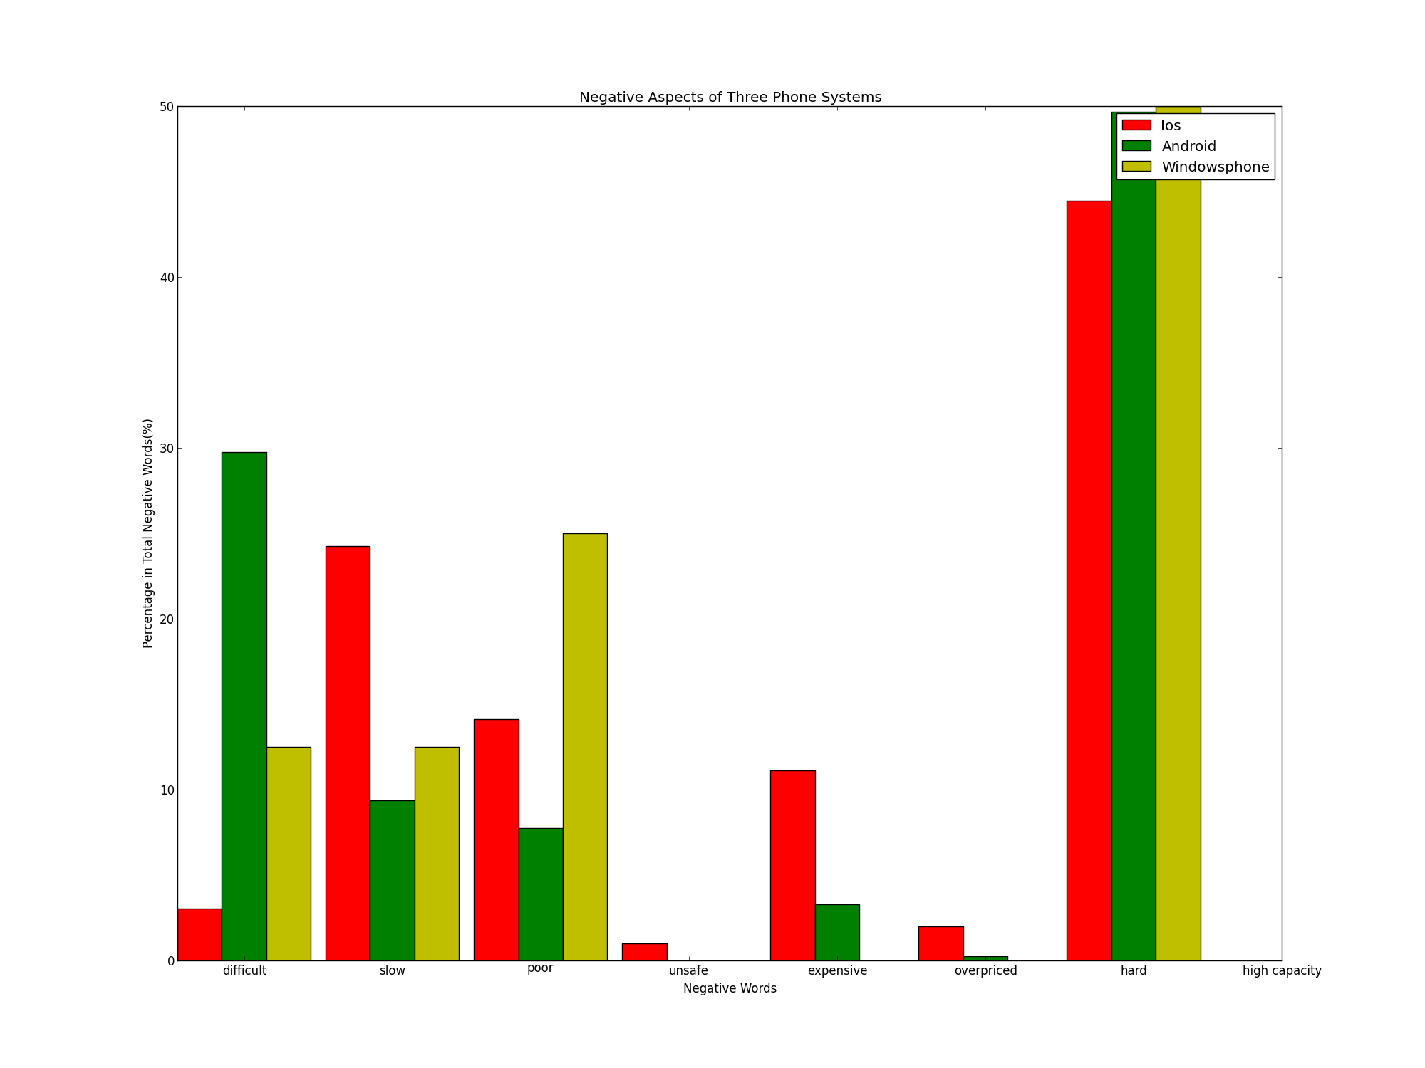

Figure 10 Bar chart for negative words

Conclusion:

* Three main aspects are focused on smart, speed, and free app characters. iOS operating system have highest speed, while opposite to Android and Windows phone. Mobile phones with same configuration, iPhone is running faster than Android phone and windows phone.
* Android does the best in free app aspect compared to the other two systems. Because Android is an open source system, it is easy for companies to develop on that platform.
* Turning to Windows phone, its smart feature is mentioned most. So the three systems have their own advantages.
* iOS has the strongest quality in all these three aspects.

# 4. Recommendations

* Apple should improve the performance of iPhone’s hardware devices.
* Apple should keep its product’s advantage, such as good appearance, size and weight.
* Apple should keep and improve iOS’s fast speed in order to make up the lower performance of hardware.
* More free apps should be provided in Apple store.
* Improve the usability of iOS for people to develop apps.