Front-End UI/UX Mini Project

# Title Page

* + **Project Title**: *"* Advocate Business Card *"*

# Submitted By:

* + - *Team Members :*

1. *Anna Binoy Augustine : 2462040*

[*anna.binoy@btech.christuniversity.in*](mailto:anna.binoy@btech.christuniversity.in)

1. *Liya Stanly : 2462109*

[*liya.stanly@btech.christuniversity.in*](mailto:liya.stanly@btech.christuniversity.in)

1. *Vyshna Biju : 2462172*

[*vyshna.biju@btech.christuniversity.in*](mailto:vyshna.biju@btech.christuniversity.in)

* + **Course**: *UI/UX Design Fundamentals*
  + **Instructor Name**: Mr. Narendra
  + **Institution**: *Christ University*
  + **Date of Submission**: *12/08/2025*

# Abstract

This project aims to designing and developing a professional advocate business card webpage using HTML and CSS. The aim is to provide a visually appealing, easily accessible, and responsive digital contact card for legal professionals. The card includes profile details, professional description, clickable contact links, and Google Maps address. Core technologies used are HTML5 and CSS, focusing on accessibility, layout design and professional branding.

# Objectives

* Design a professional advocate business card
* Include essential contact and profile information with interactive links.
* Ensure responsive design for multiple devices.
* Use semantic HTML for structured content.

# Scope of the Project

Explain what the project includes and any boundaries:

* + The project focuses on the design and development of a single-page digital business card for an advocate.
  + No JavaScript or server-side integration
  + It is purely front-end, no side functionality.
  + Intended for desktop, tablet, and mobile viewports
  + It includes profile image, name, and professional bio.
  + It includes links of email, LinkedIn, law firm link, contact button.
  + Also it facilitates clickable Google Maps addresses.
  + Used only open-source tools and pure code.

# Tools & Technologies Used

|  |  |
| --- | --- |
| **Tool/Technology** | **Purpose** |
| **HTML5** | Markup and content structure |
| **CSS3** | Styling and layout management |
| **VS Code** | Code editor |
| **Chrome DevTools** | Testing and debugging |

1. **HTML Structure Overview**
   * Used semantic tags: <header>, <main>, <section>, <footer>
   * The main sections are: Card Header (profile image and info), Links (Email, LinkedIn, Law Firm, Contact), and Address Section (Google Maps links).
   * Footer contains copyright.

# CSS Styling Strategy

* + Used external CSS file (style.css)
  + Organized with comments and sections
  + Techniques used:
    - Flexbox is used for alignment of elements in Links and Address sections.
    - Buttons have hover effects for interactivity.

1. **Challenges Faced & Solutions**

|  |  |
| --- | --- |
| **Feature** | **Description** |
| **Responsive Design** | Works across desktop, tablet, and mobile devices. |
| **Clickable Contact Links** | Email, LinkedIn, and Law Firm links are directly clickable. |
| **Google Maps Integration** | Addresses linked to Google Maps for easy navigation. |
| **Professional Bio** | Concise description highlighting expertise. |
| **Accessible Fonts & Colors** | High contrast and readable typography |

1. **Challenges Faced & Solutions**

|  |  |
| --- | --- |
| **Challenge** | **Solution** |
| |  | | --- | | **Presenting contact links clearly and**  **consistently.** |  |  | | --- | |  | | Grouped them inside a .links section with a common .btn class for uniform button styling. |
| |  | | --- | | **Keeping design maintained.** |  |  | | --- | |  | | |  | | --- | |  |  |  | | --- | | Externalized styles into style.css so HTML  stays clean and presentation changes are easy. | |
| **Maintaining responsiveness** | Implemented media queries to adapt layout for smaller screens. |

1. **Outcome**
   * Achieved a clean, consistent, and visually engaging front-end layout
   * The advocate business card webpage was successfully created with a clean, professional layout and responsive design.
   * It includes all essential professional and contact details with interactive elements.
   * All key components function as intended using just HTML and CSS
   * Learned about layout responsiveness and UI hierarchy in depth

# Future Enhancements

# Add animations for smoother interaction.

# Include a theme toggler (light/dark mode).

# Integrate backend for a functional contact form.

# Sample Code

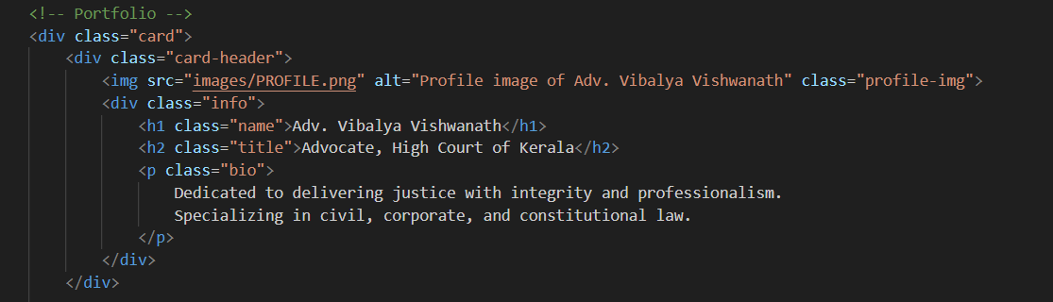

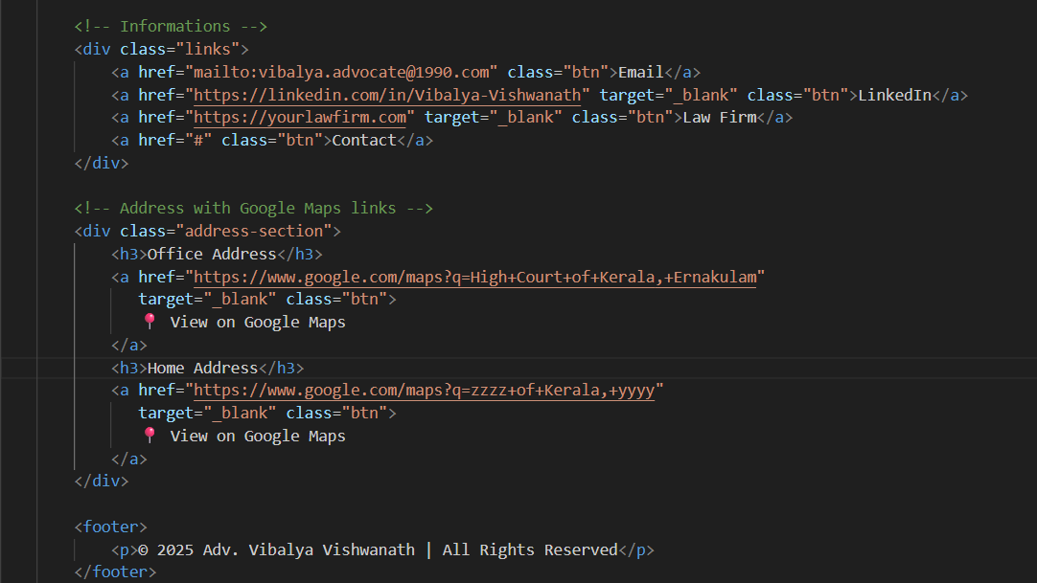

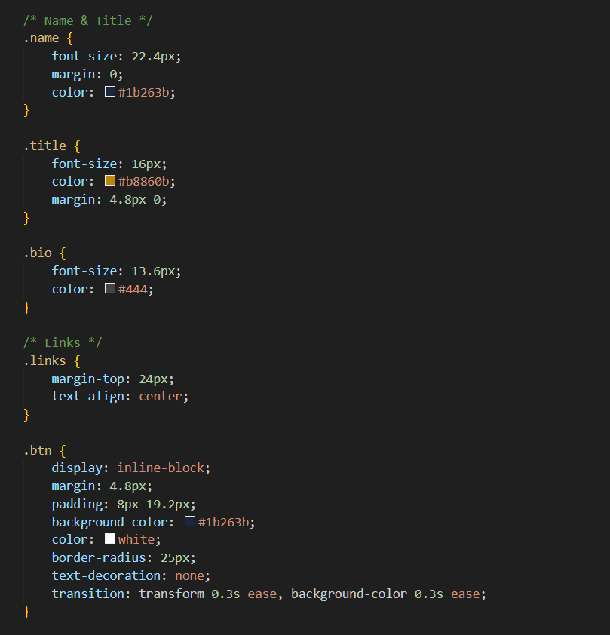

# Screenshots of Final Output

# 

# Desktop

# Conclusion

The advocate business card webpage was successfully created with a clean, professional layout and responsive design. It includes all essential professional and contact details with interactive elements.

This mini project allowed me to apply and refine my front-end development skills using pure HTML and CSS. Through building the advocate business card, I gained valuable experience in structuring semantic HTML, styling with precision using CSS, and implementing visually appealing layouts. Working on elements such as profile sections, clickable links, and address integration enhanced my understanding of clean code organization and user-friendly interface design. The process also strengthened my ability to balance aesthetics with functionality, resulting in a professional and responsive digital business card.

# References

* + L&T LMS : https://learn.lntedutech.com/Landing/MyCourse