UB Feeder Institutions Application

Software Requirements Specification

1.0

29 November, 2020

Aaliyah Ramos
Lead Software Engineer

Prepared for
Fundamentals of Computing—Final Project
Instructor: Mr. Kieran Ryan
Spring 2005

Revision History

Date | Description | Author | Comments
20/11/2020 | Version 1 | Aaliyah Ramos | <First Revision>

Document Approval

The following Software Requirements Specification has been accepted and approved by the following:
Signature | Printed Name | Title | Date
Aaliyah Ramos | Aaliyah Ramos | Lead Software Eng. | 20/11/2020
 | Mr. Kieran Ryan | Instructor, FoC | 20/11/2020

Table of Contents

Revision History ii
Document Approval ii
1. Introduction 1
1.1 Purpose 1
1.2 Scope 1
1.3 Definitions, Acronyms, and Abbreviations 1
1.4 Overview 1
2. General Description 2
2.1 Product Perspective 2
2.2 Product Functions 2
3. Specific Requirements 2
3.1 External Interface Requirements 3
3.1.1 User Interfaces 3
3.1.2 Hardware Interfaces 3
3.1.3 Software Interfaces 3
3.1.4 Communications Interfaces 3
3.2 Functional Requirements 3
3.2.1 <Functional Requirement or Feature #1> 3
3.3 Use Cases 3
3.3.1 Use Case #1 3
3.4 Classes / Objects 3
3.4.1 <Class / Object #1> 3
3.5 Non-Functional Requirements 4
3.5.1 Performance 4
3.5.2 Reliability 4
3.5.3 Availability 4
3.5.4 Security 4
3.5.5 Maintainability 4
3.5.6 Portability 4
3.6 Design Constraints 4
3.7 Logical Database Requirements 4
4. Analysis Models 4
4.1 Sequence Diagrams 5
4.3 Data Flow Diagrams (DFD) 5
4.2 State-Transition Diagrams (STD) 5
5. Change Management Process 5

1. Introduction
This document contains all of the information needed by a software engineer to adequately design and implement the UB Feeder Institutions Application described by the requirements listed in this document.

1.1 Purpose
The purpose of this SRS and the intended audience for this document is Mr. Kieran Ryan.

1.2 Scope
This subsection should:
(1) Identify the software product(s) to be produced by name; for example, Host DBMS, Report Generator, etc
(2) this software will ensure the proper management of newcomers to the University of Belize.

1.3 Definitions, Acronyms, and Abbreviations
GUI (Graphical User Interface) – The part of the application that the user sees and interacts with.

1.4 Overview
The rest of this SRS document includes all diagrams and information needed for the engineers to complete the UB Feeder Application.

2. General Description
This section of the SRS should describe the general factors that affect 'the product and its requirements. It should be made clear that this section does not state specific requirements; it only makes those requirements easier to understand.

2.1 Product Perspective
This application is specifically designed for the University of Belize. The interface will be made to have a similar look and feel that is consistent with other UB applications. Most UB applications have a similar way to display and navigate through data. The display that will be implemented by the UB Feeder Application will be consistent with other applications. This familiar GUI will make the user feel more comfortable navigating and viewing the data on UB systems.

2.2 Product Functions
The functions that the UB Feeder Application will include:
- Collecting and displaying information about the countries High Schools in regards to the computer labs
- The amount of computer classes taught
- Subjects taught at the schools
- Provide feedback on students entered into the program

3. Specific Requirements
This section provides further details on the specific requirements of our application.

- Collect information about the countries High Schools in regards to the computer labs
- Display information about the countries High Schools in regards to the computer labs
- Collect information on the amount of computer classes taught
- Display the amount of computer classes taught
- Collect information on the subjects taught at each high school.
- Display information on the subjects taught at each high school.
- Secure all information provided

3.1 Functional Requirements
This section describes specific features of the software project. If desired, some requirements may be specified in the use-case format and listed in the Use Cases Section.

3.2.1 <Functional Requirement or Feature #1>
3.2.1.1 Introduction
Creates a web application to evaluate all new students entering into the University of Belize.
3.2.1.2 Inputs
The amount of computer classes taught and subjects taught at the schools.
3.2.1.3 Processing
Evaluates to identify students qualified for Information Technology courses.
3.2.1.4 Outputs
Displays an accepted or unaccepted logo to the administrator after evaluating student qualifications.
3.2.1.5 Error Handling
Ensures all grades are processed and everyone is evaluated the same way.

3.2 Use Cases

3.3.1 Use Case Diagram #1
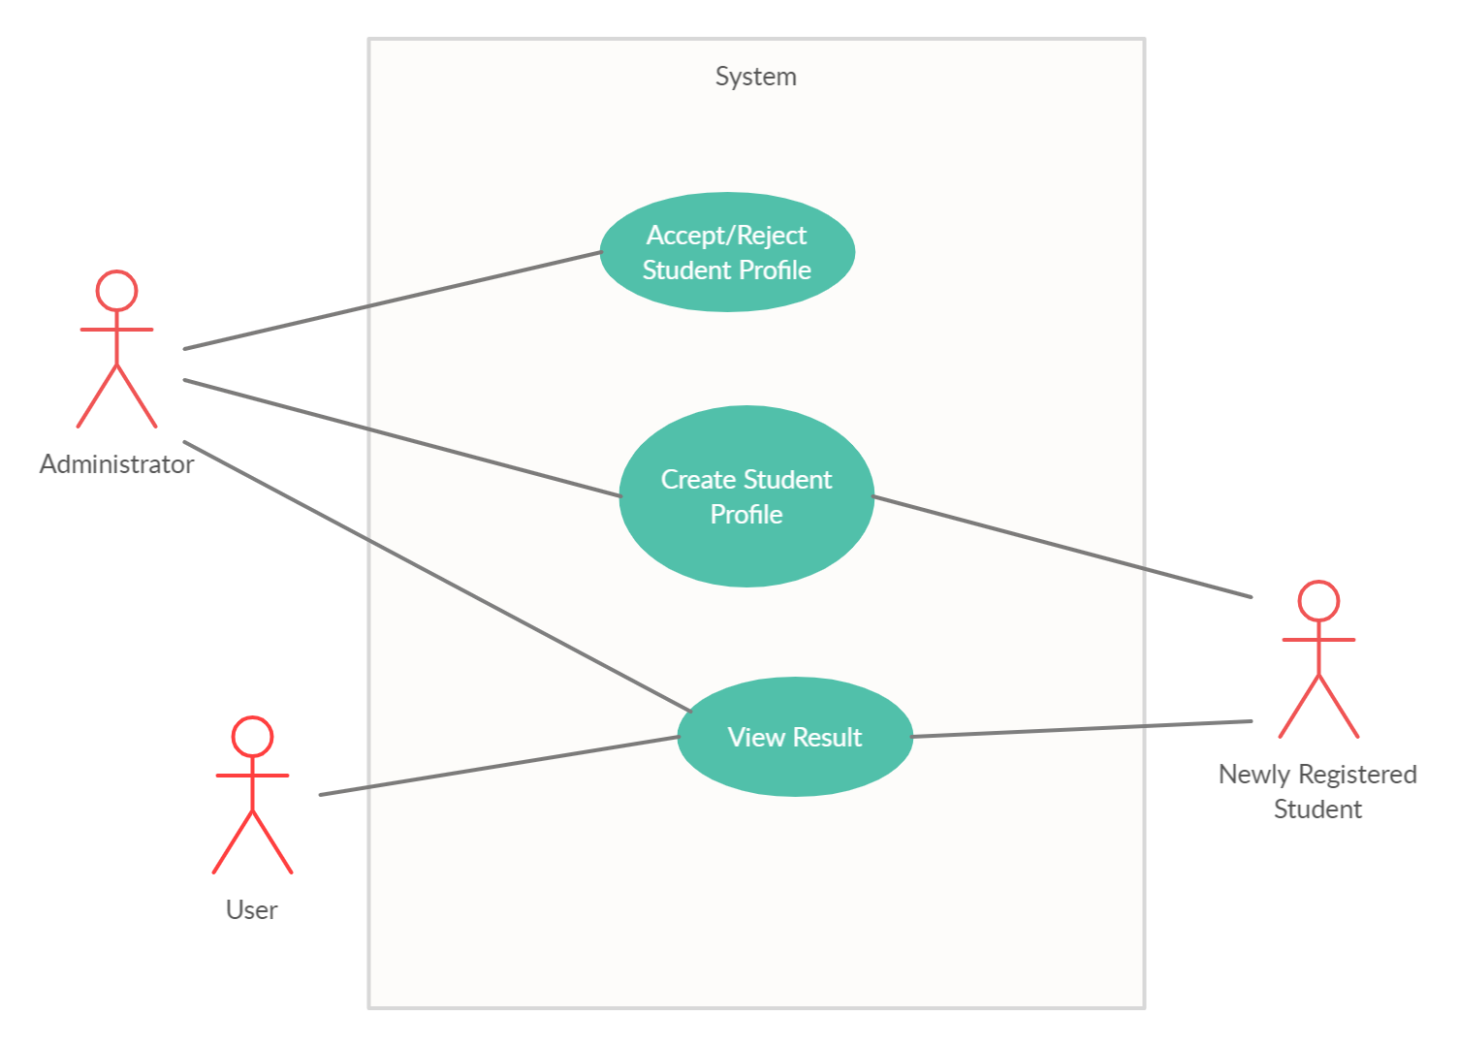

3.3 Classes / Objects

3.3.1 <Class Diagram

3.4.1.1 Attributes/Functions

3.5 Non-Functional Requirements
Non-functional requirements may exist for the following attributes. Often these requirements must be achieved at a system-wide level rather than at a unit level. State the requirements in the following sections in measurable terms (e.g., 95% of transaction shall be processed in less than a second, system downtime may not exceed 1 minute per day, > 30 day MTBF value, etc).

3.5.1 Performance

3.5.2 Reliability

3.5.3 Availability

3.5.4 Security

3.5.5 Maintainability

3.5.6 Portability
Accessible via the web.

3.6 Design Constraints
Specify design constrains imposed by other standards, company policies, hardware limitation, etc. that will impact this software project.

3.7 Logical Database Requirements
Will a database be used? If so, what logical requirements exist for data formats, storage capabilities, data retention, data integrity, etc.

4. Analysis Models

4.1 Sequence Diagrams

4.3 Data Flow Diagrams (DFD)

4.2 State-Transition Diagrams (STD)

5. Change Management Process
This project will be changed any time a function or requirement is added to the UB Feeder Application.

