Create a directory to store Gitea data:



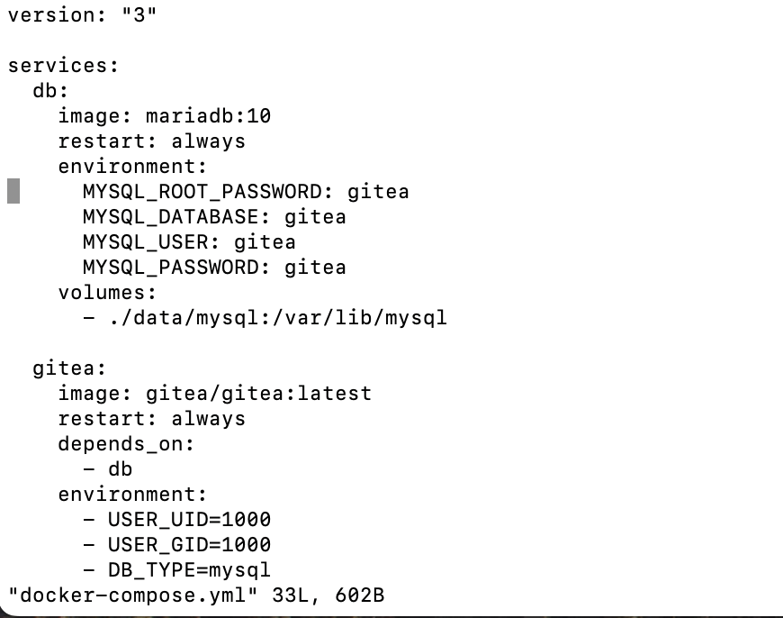

Start service

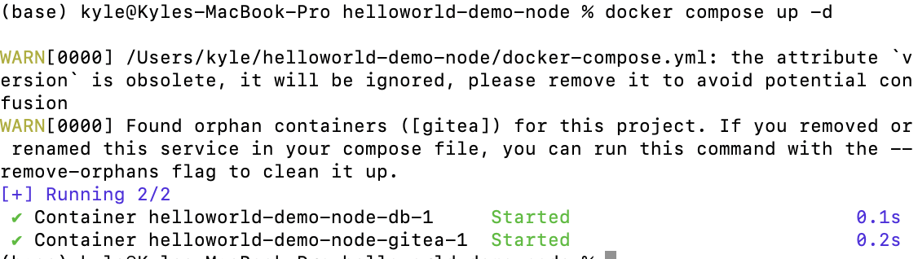

open localhost:3000 then install gitea

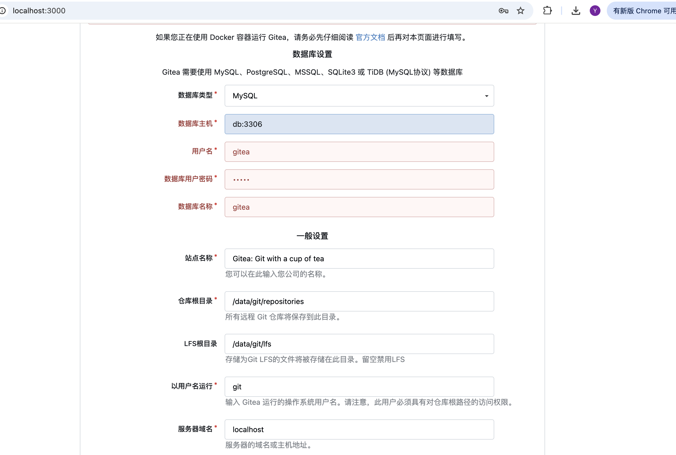

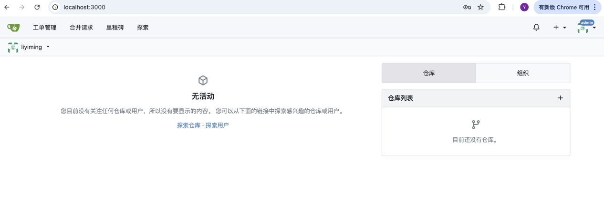

Clone my repository

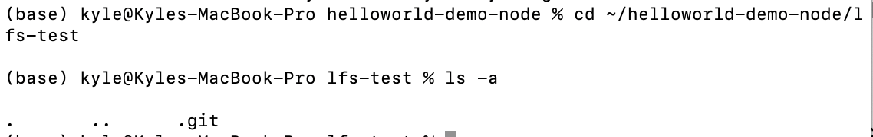

Enable LFS in my repository

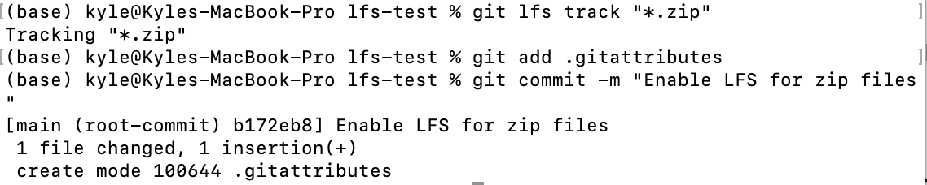



Create a 1GB test file locally on my computer

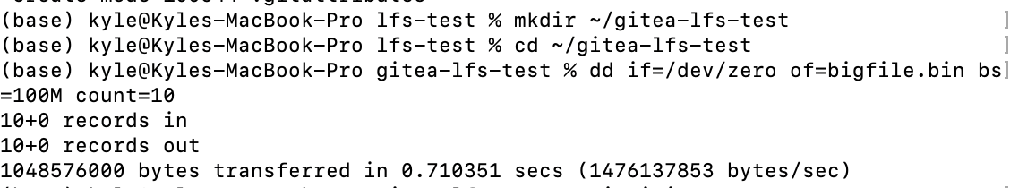

Initialize Git locally and use LFS and add content to the local repository:

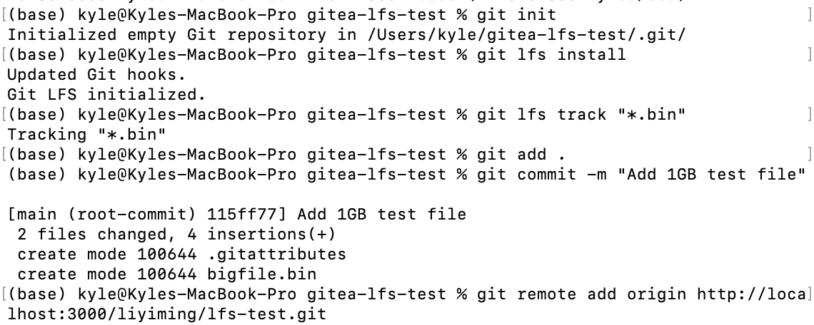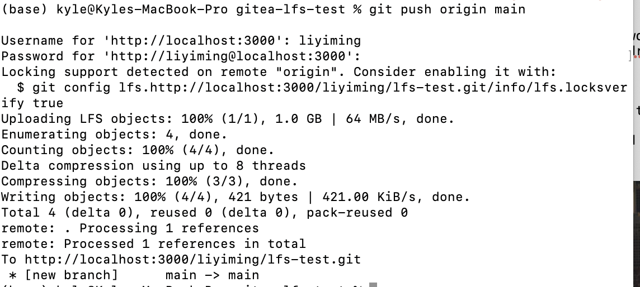



Backup and recovery

截屏2025-10-14 14.36.43