Download and install Istio

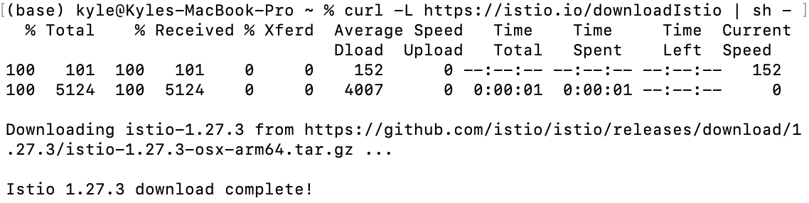

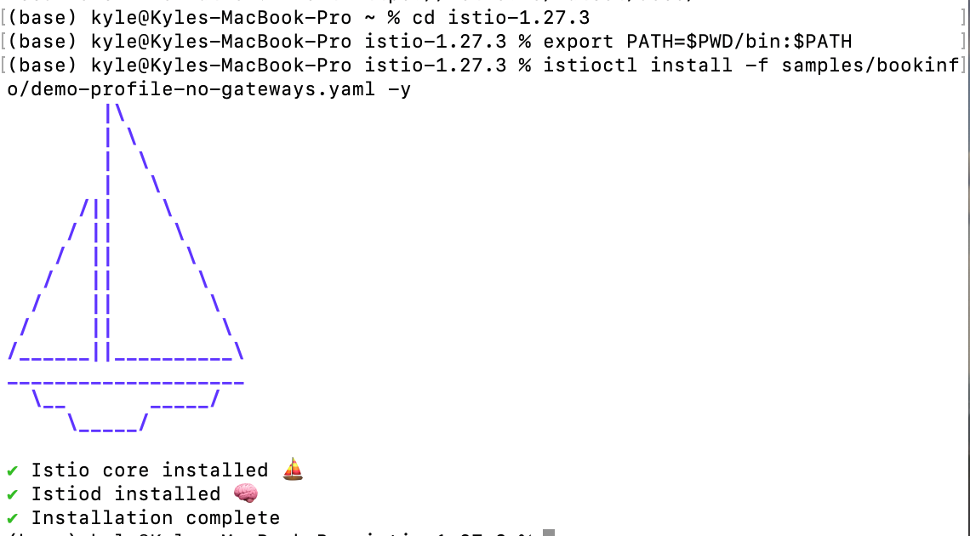

Add a namespace label to instruct Istio to automatically inject Envoy sidecar proxies when you deploy your application later



Deploy the sample application

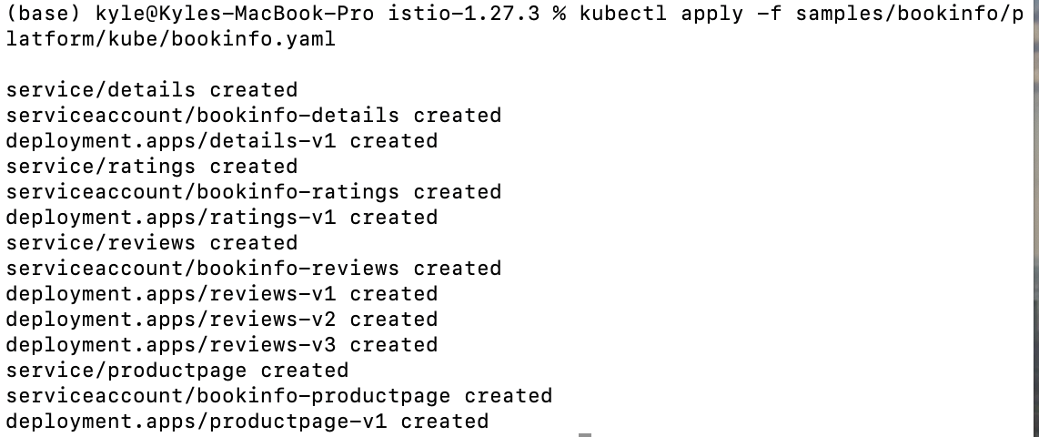

Each pod becomes ready

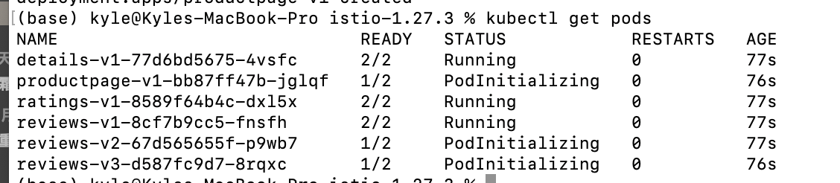

Validate that the app is running inside the cluster by checking for the page title in the response

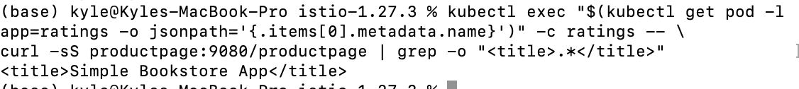

Return the <title>Simple Bookstore App</title>

Open the application to outside traffic

Create a [Kubernetes Gateway](https://gateway-api.sigs.k8s.io/api-types/gateway/" \t "/Users/kyle/Documents\\x/_blank) for the Bookinfo application:

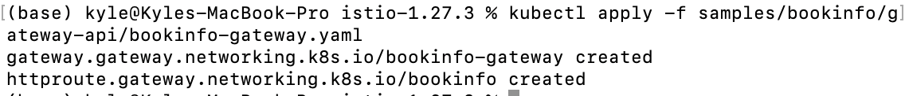

Change the service type to ClusterIP by annotating the gateway

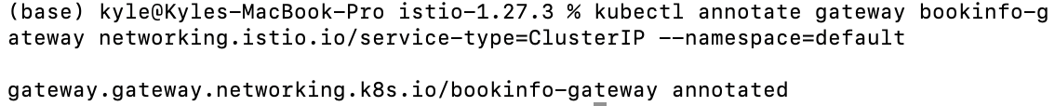

To check the status of the gateway

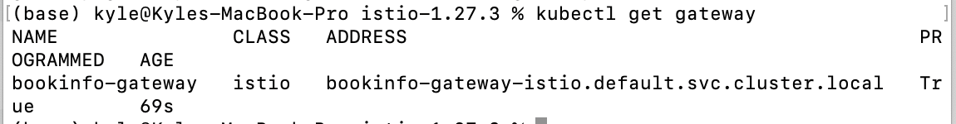

Access the application

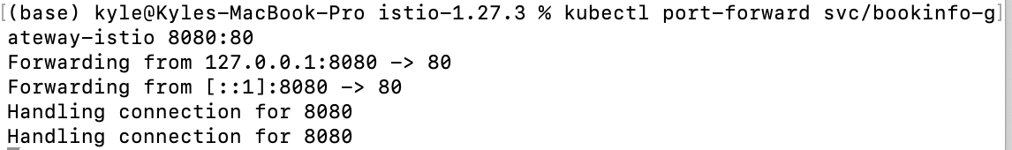

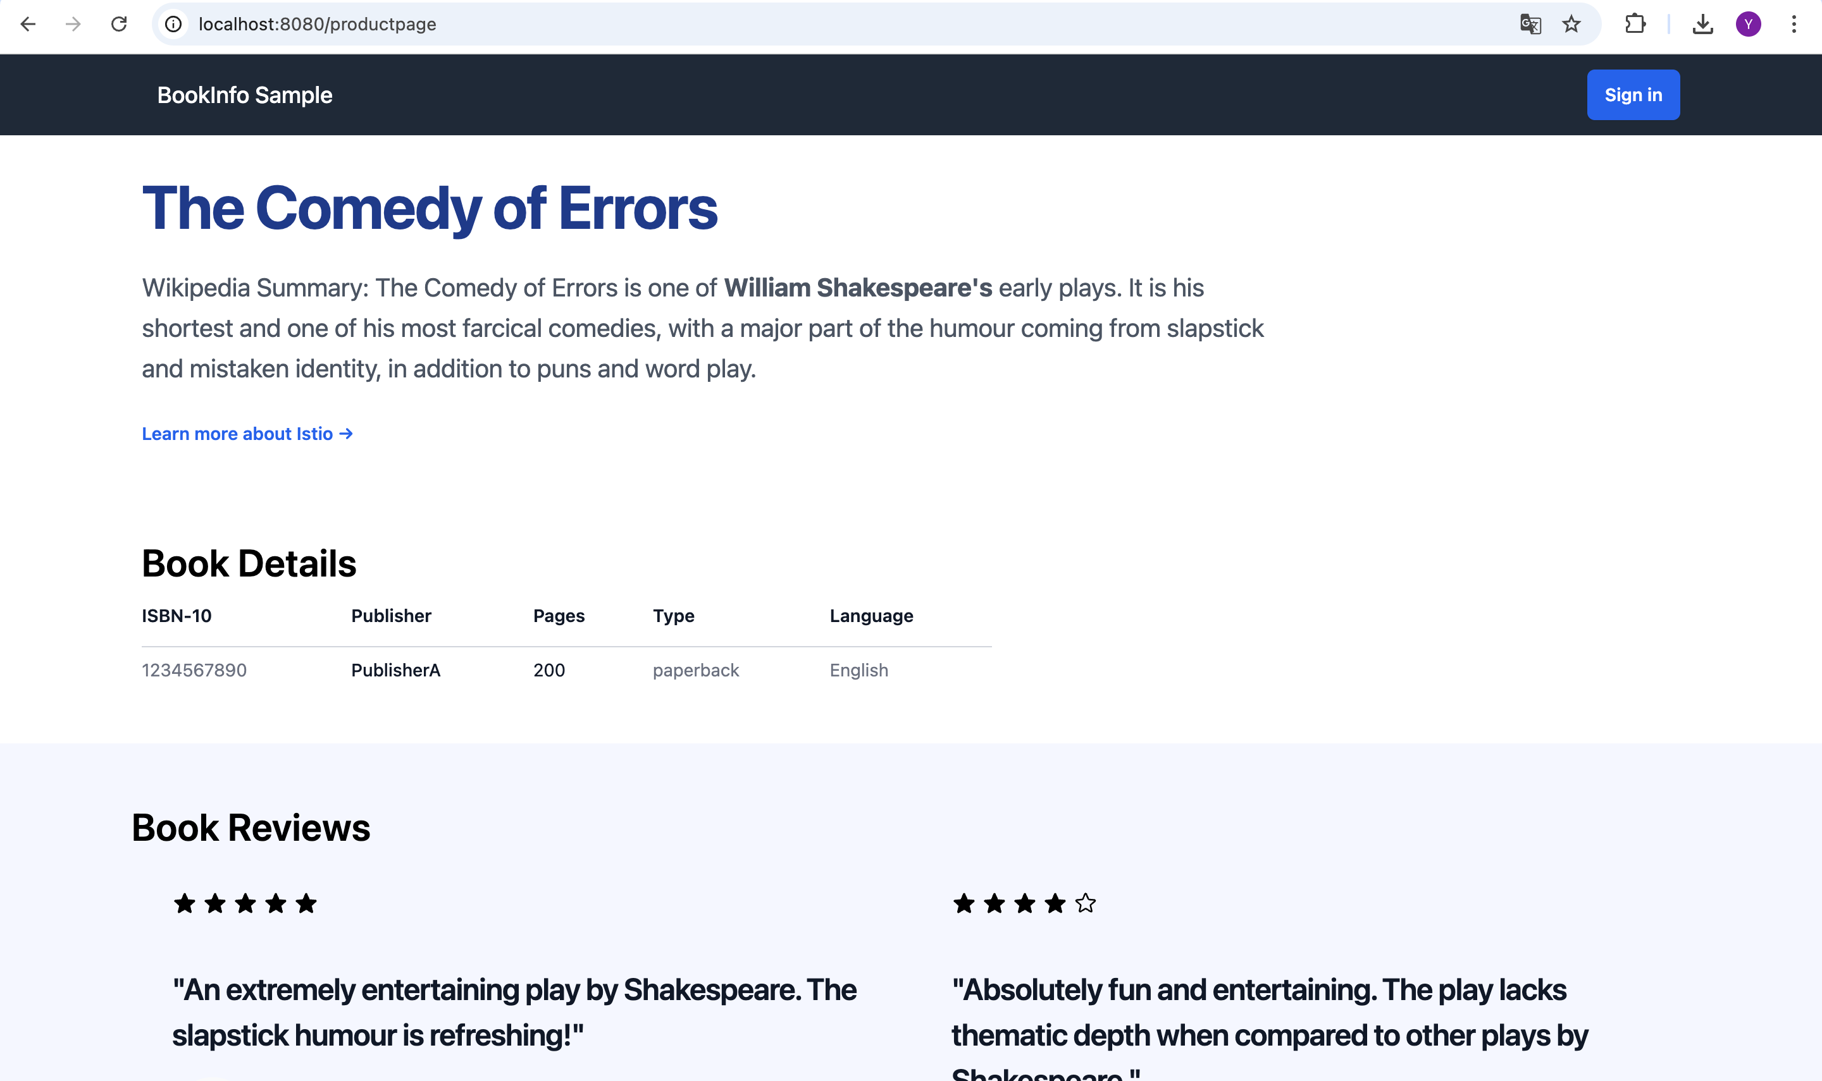

Install [Kiali and the other addons](https://github.com/istio/istio/tree/release-1.27/samples/addons" \t "/Users/kyle/Documents\\x/_blank) and wait for them to be deployed.

