Log in to GitHub and click New Repository.Name it liyimingkyle.github.io,and Inside this repo, create an index.html file.

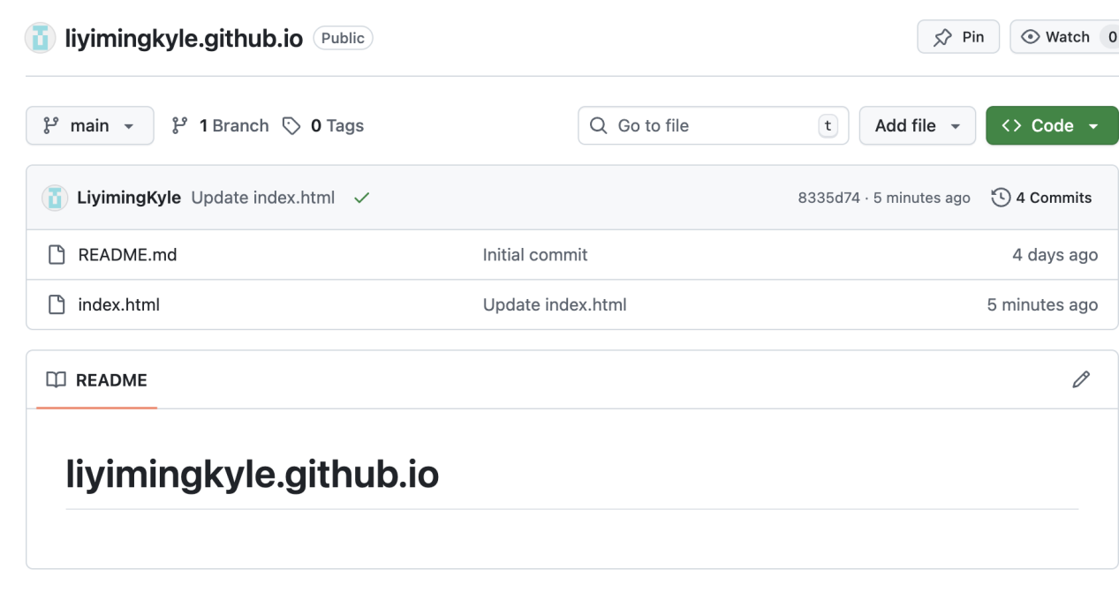

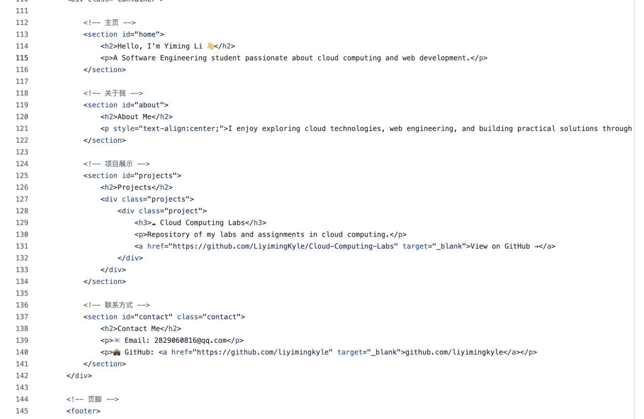

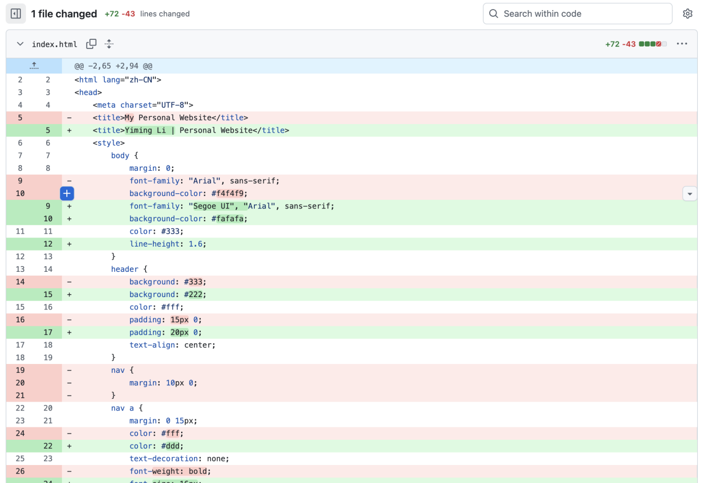

Enable GitHub Pages,Go to my repository on GitHub.

Navigate to Settings → Pages.

Under Branch, select main and / (root) then Save.

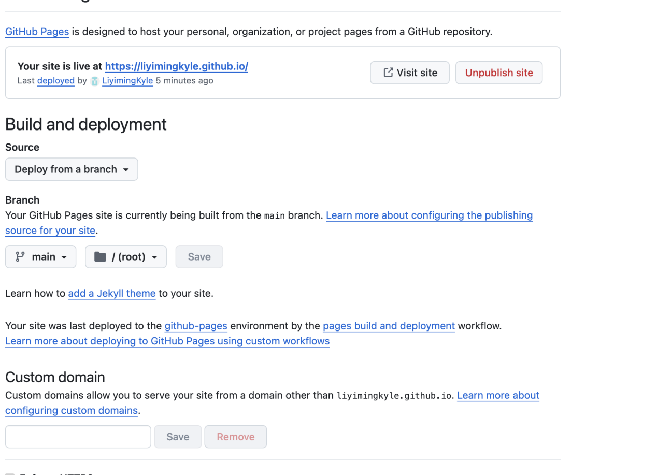

I use html and css to customize the layout

open the <https://liyimingkyle.github.io/>

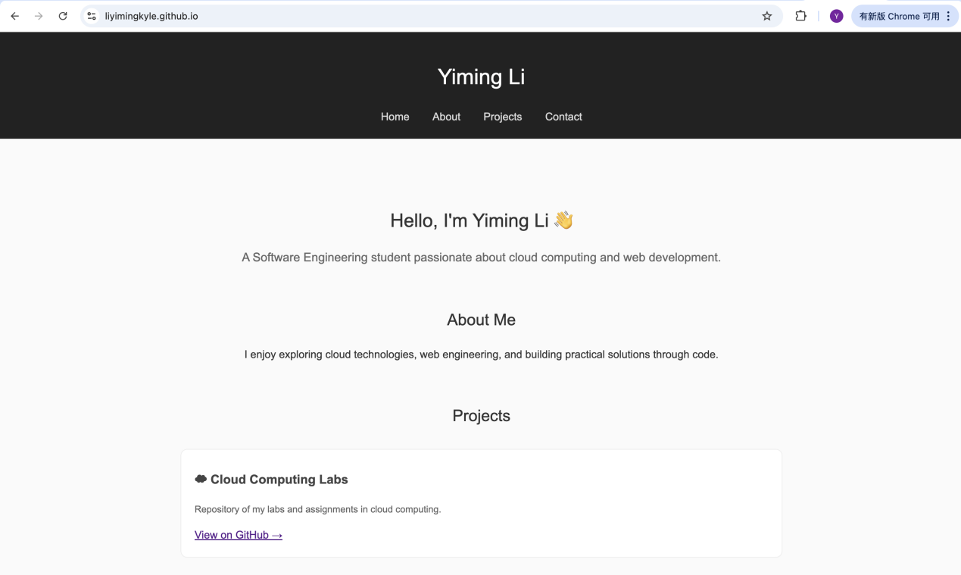

click View on Github,you can access the GitHub repository for all experiments and assignments