Experiment 1: Knative Functions
Create a Node.js function, build it locally as a container image, push it to the local image repository, and complete local running tests. Skip the step of deploying the function to the cloud cluster.
Step 1: Install FuncCLI:
Step 2: Configure and start the local image repository
Create a function project based on a Node.js template using CLI.
Step 3: Build a function image
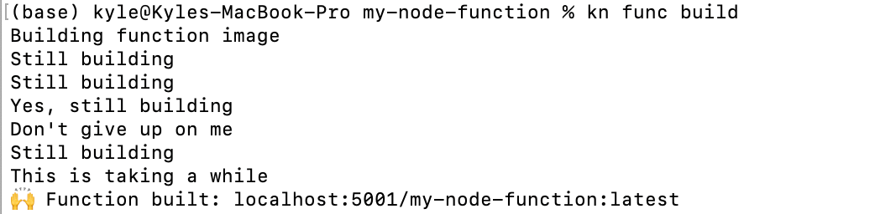
Step 4: Push the image to the local repository
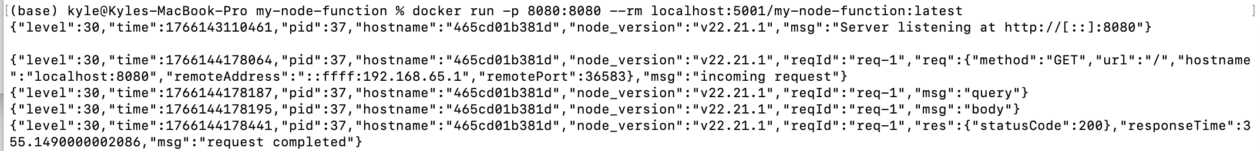
Successfully received the default JSON response returned by the function, proving that the function image is built correctly and can run.
Experiment 2: Knative Serving (Deploying the First Service)

Step 1: Install Knative Serving

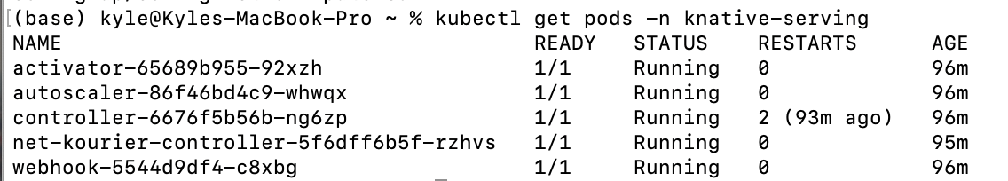
Step 2: Deploy Hello World service
Deploy a sample service using kn CLI.
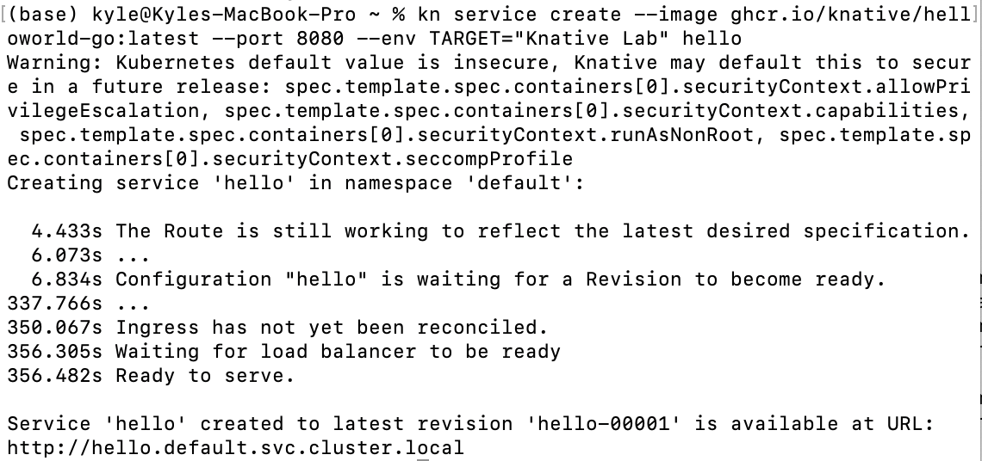
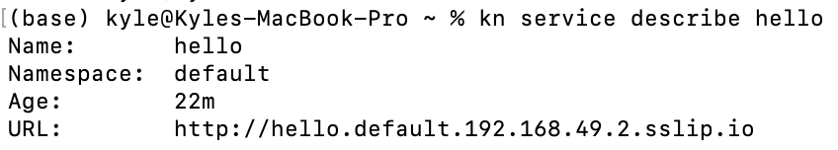
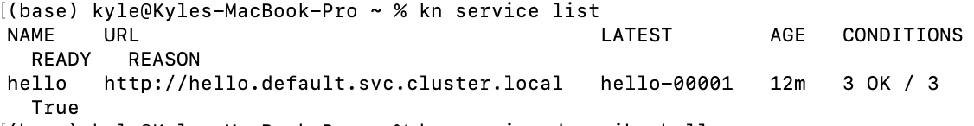
Experiment 3: Knative Eventing
Step 1: Install Knative Eventing

(I have try my best to do the labs but there are too many troubles which I cant solve although I have tried to find a solution document or utilize AI)

