Start Minikube
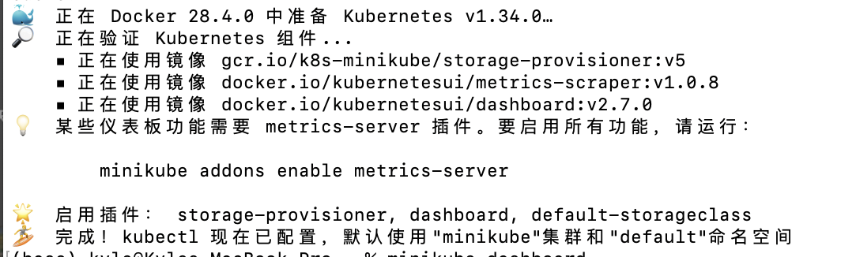
Download and install Istio
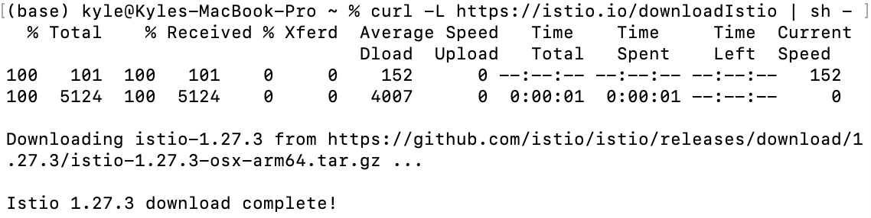
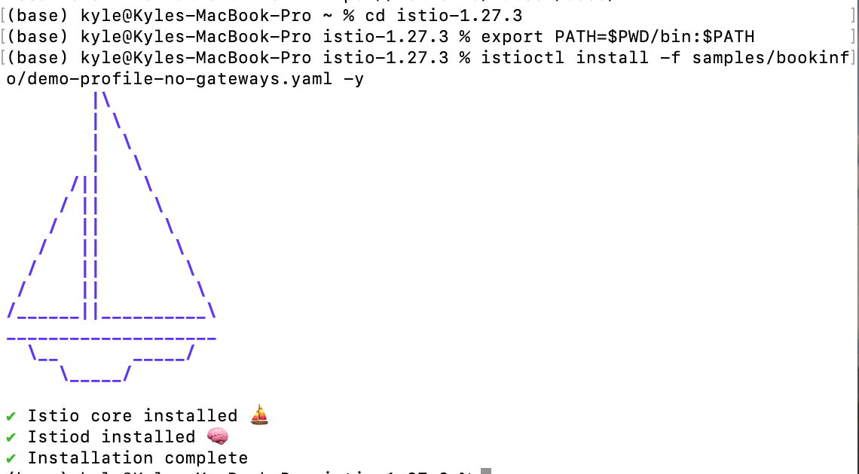
Add a namespace label to instruct Istio to automatically inject Envoy sidecar proxies when you deploy your application later
apply for istio.yaml
