Deploy Bookinfo application
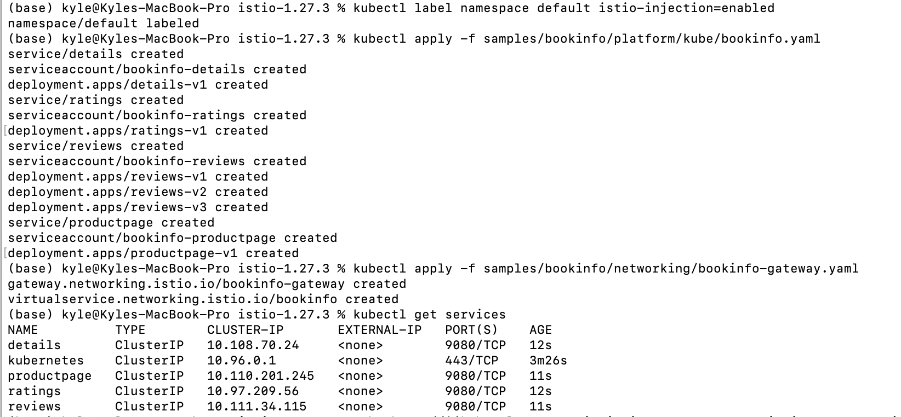
Experiment 1: Traffic Shifting
Apply a VirtualService configuration to allocate the traffic of the reviews service proportionally between v1, v2, and v3 versions.
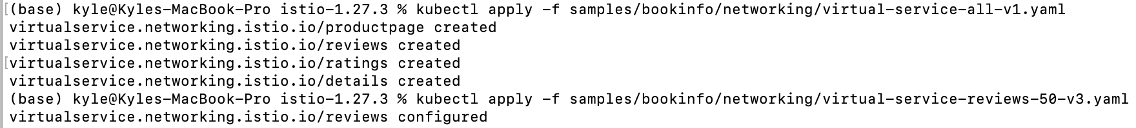
Establish a tunnel and map the port to local 8080
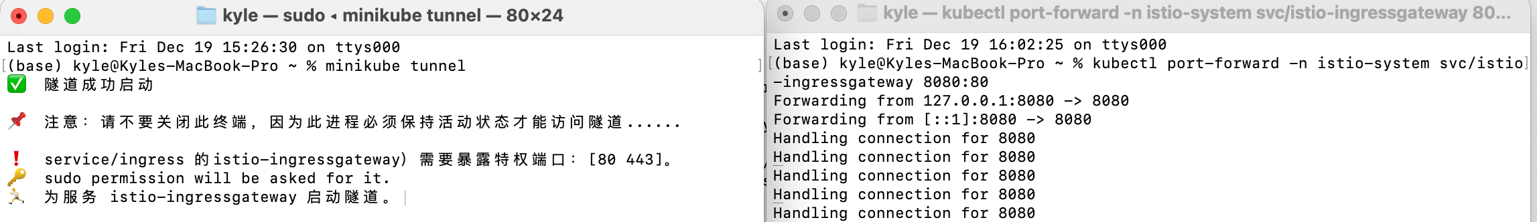
Visit http://localhost:8080/productpage
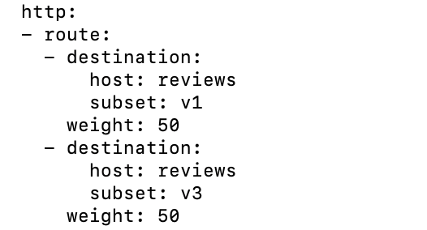
We will see the book review section randomly appearing between two styles: without a star (v1), with a red star (v3),with a proportion that roughly matches the configuration
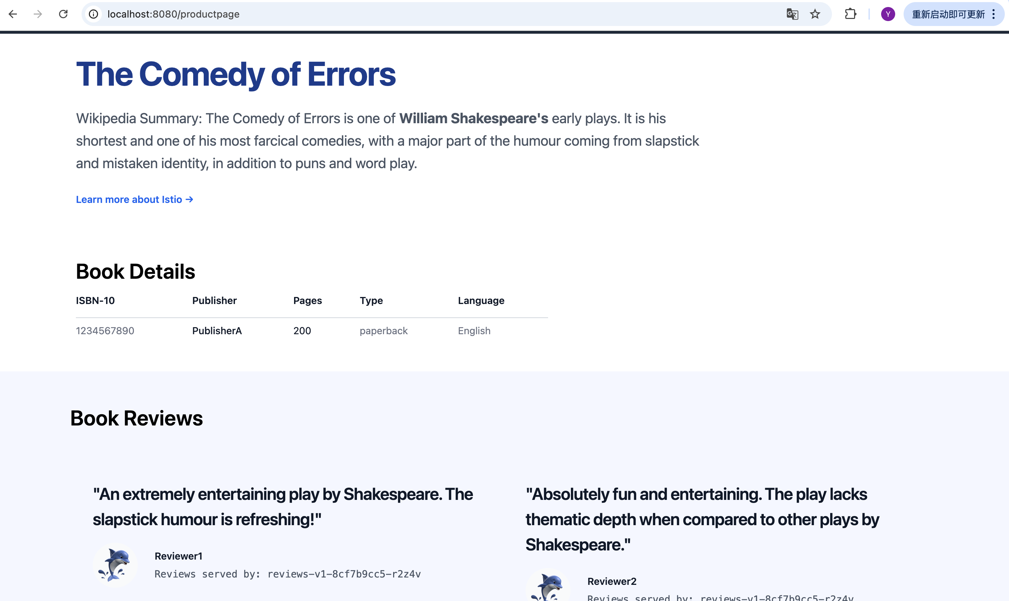
then we fresh it
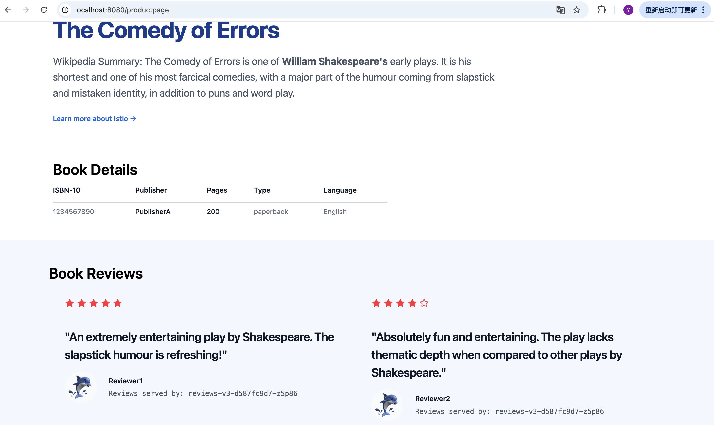
Experiment 2: Request Routing
Route traffic to a specific version based on HTTP header information, such as user identity.
Create rules to allow specific users (such as jason) to access version v2 and other users to access version v1.
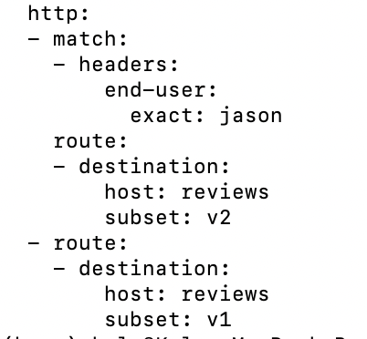
Log in as Jason user
When refreshing the page, we should always see reviews with a black star (v2).
When logging out or accessing with other users, you should always see reviews without stars (v1).
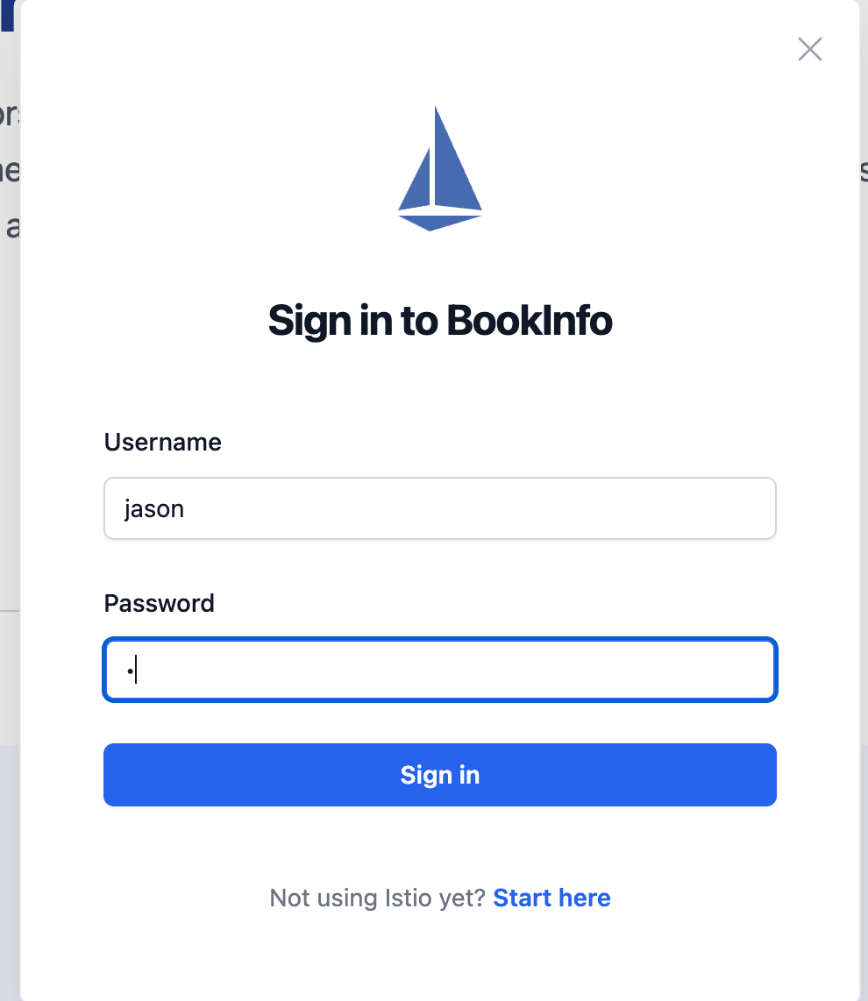
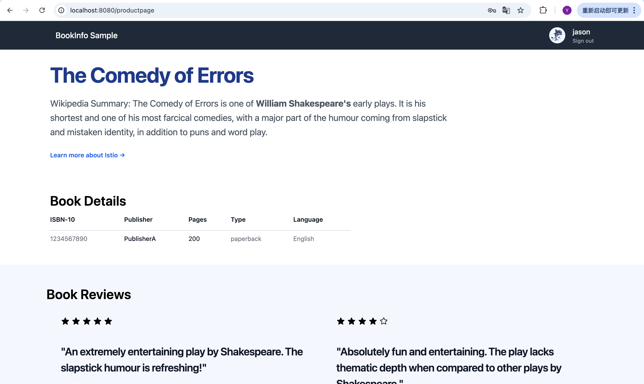
Experiment 3: Fault Injection
This experiment simulates network anomalies and tests the elasticity of the application.
Inject a delay or interruption fault into the ratings service for user Jason.
Log in as Jason user.
Refresh the page, which will load in approximately 7 seconds and display an error message 'Product rating unavailable'.
After logging out and visiting again, the page should immediately load normally. This proves that the malfunction only applies to specific rules.
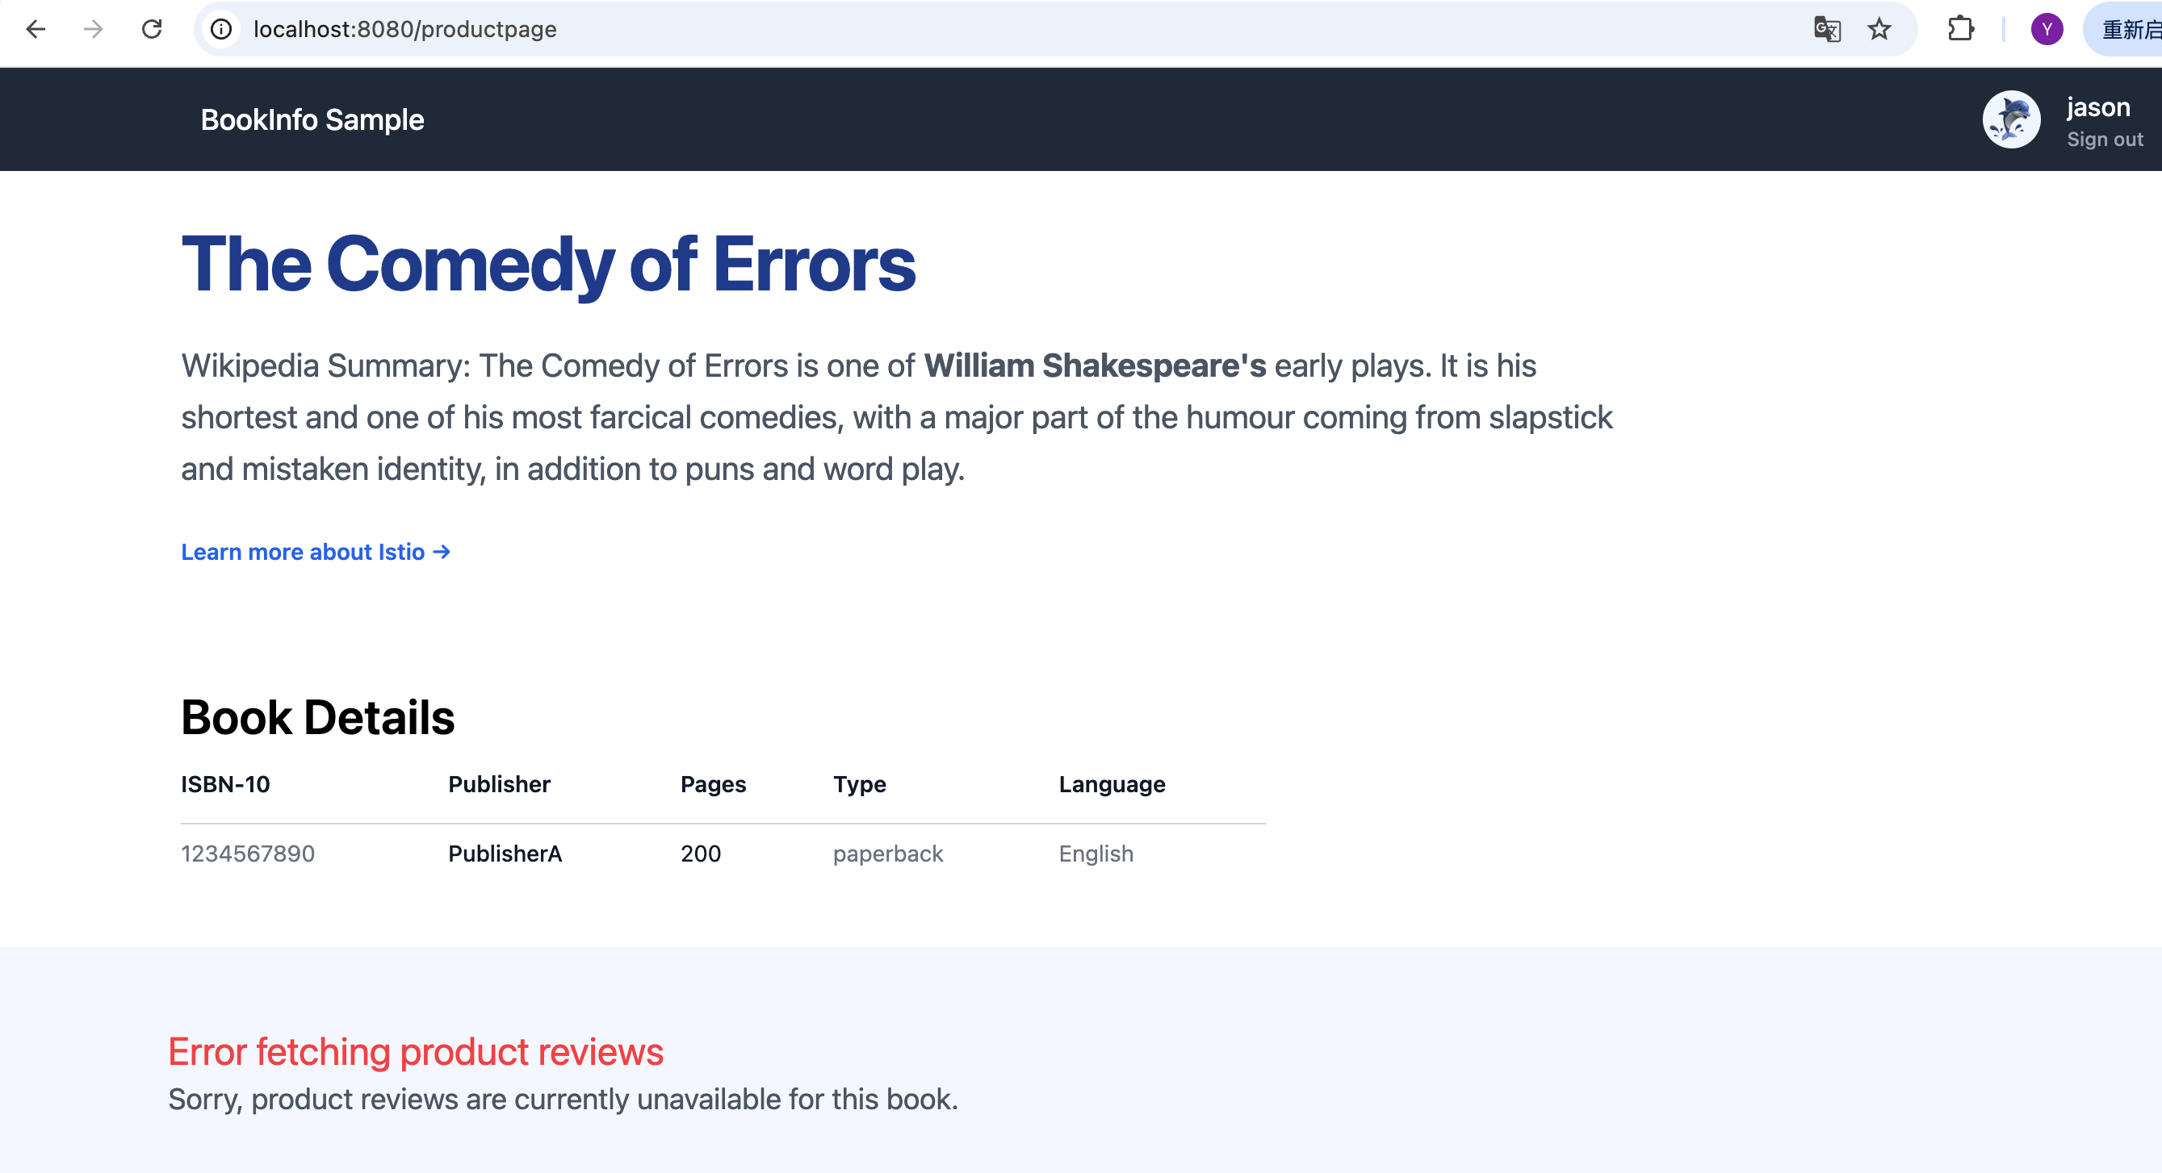
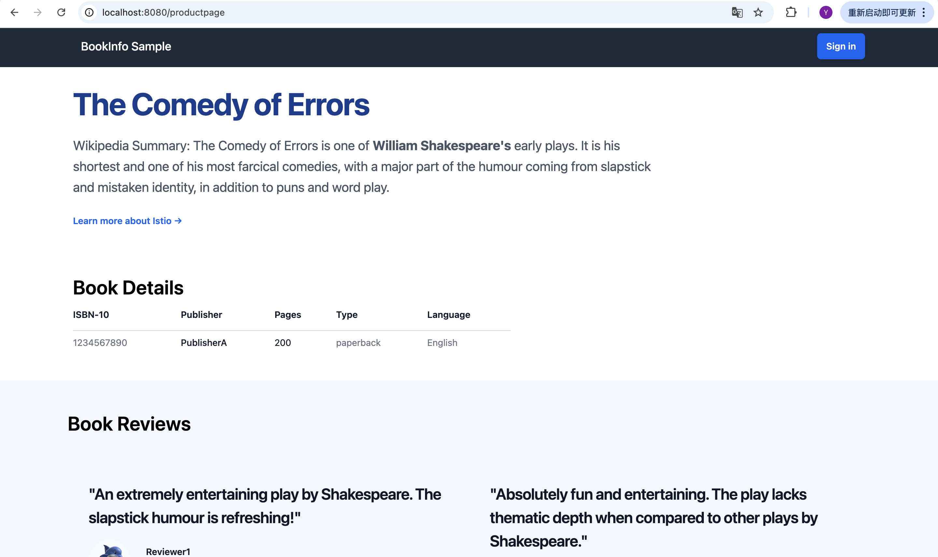
Experiment 4: Circuit Breaking
This experiment demonstrates how to prevent the spread of faults when upstream services are abnormal.
Deploy a test client with fuse rules and simulate concurrent calls to the target service.
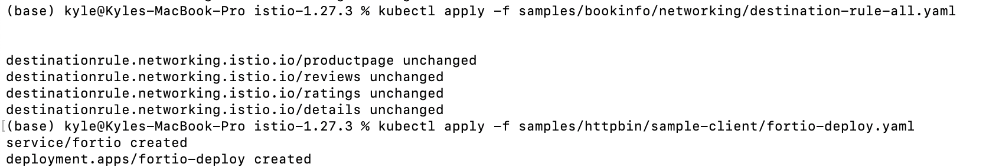
Prepare target service (httpbin)
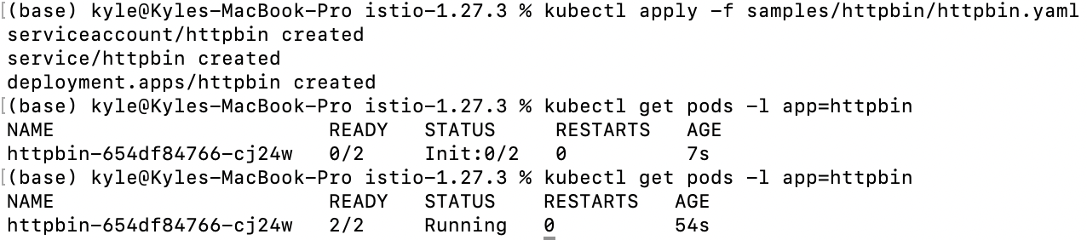
Apply a Destination Rule with pre-defined fuse thresholds.
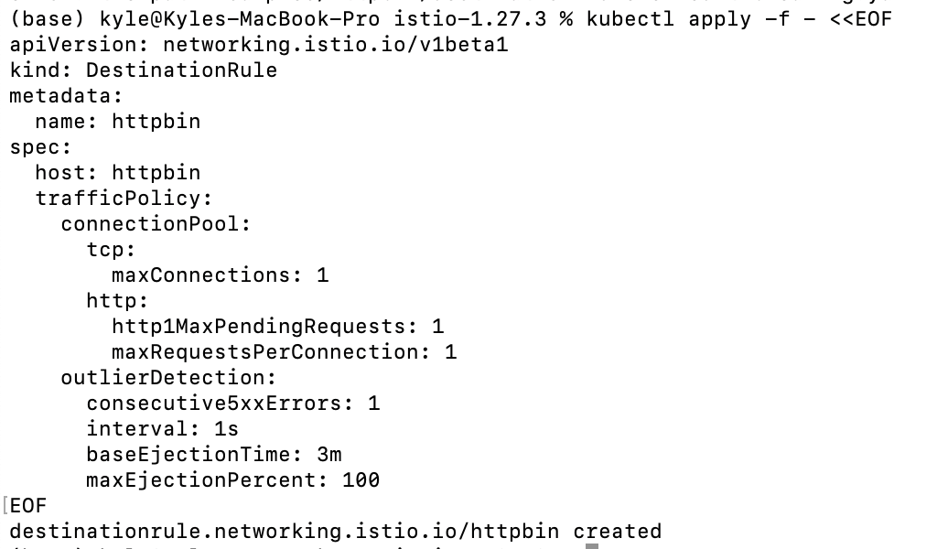
Retrieve the client Pod name and initiate testing: 2 concurrent connections (- c 2), send 20 requests (- n 20)
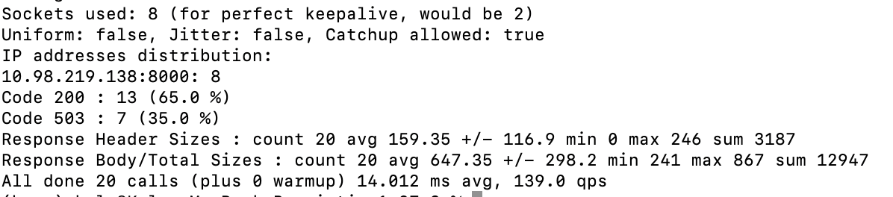
In the returned statistical information, in addition to Code 200, a certain proportion of Code 503 will also appear
Some requests did not reach the httpbin backend Pod, but were directly rejected by the Envoy Sidecar of the client (Fortio) according to the circuit breaker rule.

