Q1:
IaaS: Provides virtualized computing resources (servers, storage, and networking) over the internet. Users are responsible for managing the operating system, middleware, and applications.
Example: A development team rents Amazon EC2 (AWS) virtual machines to set up testing environments.
PaaS: Abstracts hardware and operating system details, allowing seamless scalability. Developers only need to focus on their business logic, not the underlying infrastructure.
Example: Developers deploy apps on Google App Engine, which handles scaling and runtime.
SaaS: Software development, management, and deployment are outsourced to a third party, eliminating technical concerns and allowing for ready-to-use services. Services typically used by ordinary users are SaaS.
Example: Teams uses GitHub or Jira for project management and collaboration.
In short: SaaS → Closest to users: Ready-made software, ready to use (examples: Gmail, Slack).
PaaS → Developer-oriented: Provides an application runtime environment, focusing on business logic (examples: Heroku, App Engine).
IaaS → Lowest level: Provides virtual machines, storage, and networking, allowing you to set up the environment (examples: AWS EC2, Azure VMs).
Q2:
What is Docker?
Docker is an open-source application container engine, built on the Go language and licensed under the Apache 2.0 license.
It allows developers to package their applications and their dependencies into lightweight, portable containers, which can then be deployed to any popular Linux machine, enabling virtualization.
Containers are fully sandboxed, with no interfaces between them (similar to iPhone apps). More importantly, containers offer extremely low performance overhead.
It unleashes the power of computing virtualization, significantly improving application maintenance efficiency and reducing the cost of cloud computing application development.
Scenario
A RESTful API built with Node.js may fail on another machine due to version mismatches. By containerizing with Docker, the same environment runs everywhere.
CI/CD pipeline: Integrate with Jenkins/GitLab CI to achieve automated building and testing.
Cloud native foundation: Orchestration tools such as Kubernetes manage container clusters based on Docker.
Contribution
Consistency: Same environment across dev/test/prod.
Isolation: No conflicts with other applications.
Scalability: Containers can be replicated and orchestrated with Kubernetes.
Efficiency: Containers are lightweight compared to virtual machines.
Q3:
Step 1: Run n8n with Docker
docker run -it --rm \
-p 5678:5678 \
-v ~/.n8n:/home/node/.n8n \
n8nio/n8n
Explanation of the Command:
docker run ->Start a new container
-it ->Run interactively with a terminal
--rm ->Remove container automatically when stopped
-p 5678:5678 ->Map host port 5678 to container port 5678
-v ~/.n8n:/home/node/.n8n ->Persist workflows by mapping local folder to container folder
n8nio/n8n ->Official n8n image from Docker Hub
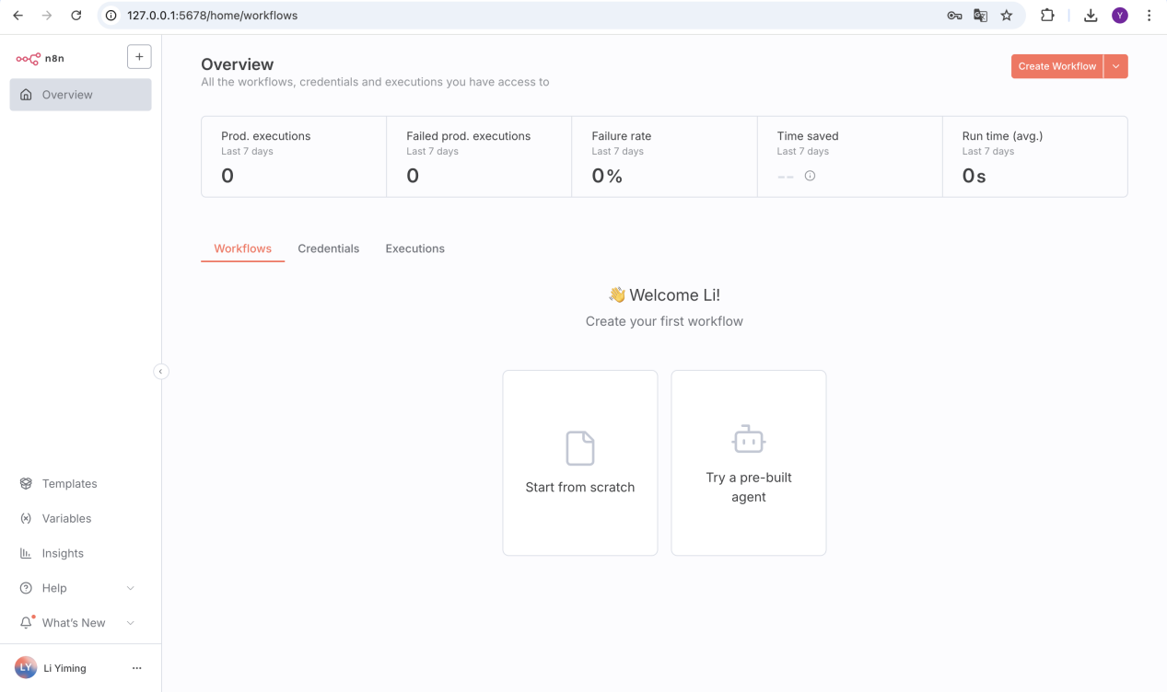Step 2: Access n8n
Open your browser and go to:http://127.0.0.1:5678
