Engineering Planning & Review Skills

Management Retrospective Skill Design

STATUS  Draft for review |  | OWNER  Not assigned |  | LAST UPDATED  September 24, 2026

Authors | Liyuk
Reviewers | Repository maintainer
Related docs | Management retrospective essay; shared evidence contract
Scope | A standalone skill for evidence-based retrospectives of completed engineering and management work.

1. Abstract
management-retro turns the author’s eight management judgments into an evidence-constrained retrospective workflow for Codex and Claude. It examines completed projects, periods, or incidents to identify reusable system patterns, preserve evidence provenance and uncertainty, and select a change that can be tested next time.
Core guarantees: observations, measurements, estimates, inferences, assumptions, unknowns, and conflicting records remain distinct. Insufficient evidence stays unresolved; correlation is not presented as cause. The retrospective ends with a small set of verifiable keep / change / stop actions.

2. Goals and Non-Goals
Goals | Non-goals
Evidence-linked system patterns | Formal root-cause or HR finding
Eight judgments selected by context | Mandatory eight-part checklist
Verifiable next-cycle changes | Authoring a new plan or roadmap
Source, uncertainty, counterevidence | Invented metrics, owners, or certainty

3. Background and Problem Statement
Retrospectives often become status reports, praise or blame sessions, timeline recaps, or unsupported root-cause stories. They fail to answer the useful question: in a similar situation next time, what should we keep, change, or stop? Inputs may include project artifacts, decision records, metrics, incident records, and participant accounts. When records are missing or conflict, the skill states the gap and scope.
Design principle: “Context, not control.” Preserve the context needed for judgment and keep decisions close to the problem. The eight judgments are lenses, not a mandatory checklist; use only those relevant to the case. Interpret individual actions within roles, authority, capacity, handoffs, and feedback systems.

4. Proposed Architecture

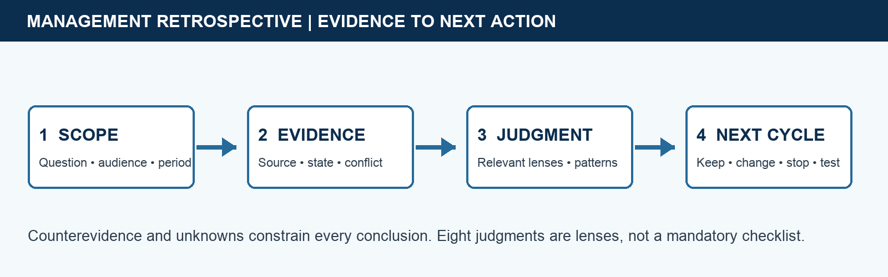
Figure 1. Management Retrospective Workflow.

Skill components

Component | Responsibility | Primary storage | Failure behavior
Scope reader | Fix question, audience, period | User request | Ask only material clarifications
Evidence ledger | Track claim, source, state | Provided materials | Mark missing / disputed
Judgment pass | Apply relevant eight lenses | Essay-derived method | Skip inapplicable lenses
Countercheck | Test pattern and alternatives | Evidence + counterevidence | Weaken or withdraw claim
Action output | Keep / change / stop + test | User-confirmed decisions | Leave owner/date unknown

5. Invocation and Review Lifecycle
- Confirm the request concerns completed work: a finished project, management period, post-incident review, or explicit lookback. Capture the user’s goal, scope, time window, decision need, and available materials.
- Record each claim’s source and state: user-provided, externally sourced, measured, estimated, inferred, assumed, or unknown / to confirm. Keep factual statements, individual experience, interpretation, and preference distinct.
- Reconstruct goals and constraints, then select relevant lenses: judgment; boundaries and responsibility; alignment; context; closure; resources and capacity; team and growth; retrospective learning. Skip irrelevant lenses.
- Look for patterns across time and state them as hypotheses to test. For each material interpretation, list supporting evidence, counterevidence or alternatives, impact, and confidence limits. Do not assert conclusions without supporting evidence.
- Turn analysis into candidate keep / change / stop actions. For each, state the observation, expected mechanism, smallest next step, and verification signal. Name an owner or date only when confirmed by a source.
- Check for missing, conflicting, or anomalous information. Narrow the conclusion; retain each source and its definitions; ask for clarification or name inputs needed for a calculation. Never invent metrics, owners, or causes to fill a template.
- Deliver a scannable retrospective: question and scope, evidence ledger, bounded judgments, system patterns and counterevidence, keep / change / stop actions, unknowns, and next verification. If the user only asks for a summary, provide one without forcing the full workflow.

6. Evidence and Output Contracts

Evidence ledger (per claim)

Field | Type | Required | Description
claim | statement | yes | Observation, interpretation, or proposed action
source | reference | yes | User, document, measurement, or external source
evidence_state | enum | yes | Provided / sourced / measured / estimated / inferred / assumed / unknown
scope | text | when relevant | Population, period, system boundary, metric definition
counterevidence | text | for pattern | Contradiction and strongest alternative explanation
action | text | when useful | Keep / change / stop; step and verification signal
owner_due | text | optional | Only if explicitly confirmed; otherwise unknown

Evidence guarantees

- Keep source and evidence state attached to each conclusion. Do not present user reports as independently verified. Show estimate inputs and method; for unknowns, name missing inputs and a calculation method when available.
- Do not merge records with different periods, populations, scopes, or metric definitions. For conflicts, show each source, date, and definition side by side and mark the issue to confirm.
- Every system pattern needs traceable evidence. Mark causal explanations as hypotheses and include the strongest alternative and an observation that could distinguish them.
- A retrospective is a bounded interpretation and action proposal, not an investigation finding, performance evaluation, or individual accountability ruling.
Skill package and evaluation cases are maintained at
`skills/management-retro/`; this document is the design source for its entrypoint, references, and evals.

7. Missing Data, Conflicts, and Causal Boundaries

With complete records, report supported patterns and a way to verify them. With anecdotes only, describe the reported experience, mark unknowns, and request the key inputs. Preserve both sides of conflicting records; do not average incompatible definitions or cherry-pick a convenient one. A metric change after an intervention does not establish causality. If counterevidence is stronger, revise or withdraw the prevailing explanation. Examine system conditions before personality labels; cite documented behavior accurately and in context without unsupported blame.
Scenario | Expected behavior | Reasoning
Missing evidence | Bound claim; ask for inputs | Do not convert anecdotes into fact
Conflicting records | Show provenance and scope | Do not silently reconcile incompatible values
Causal story challenged | Compare alternatives | Temporal order alone is not causality
Routine update only | Give concise summary | Do not force retrospective workflow

8. Safety and Privacy Considerations

- Analyze documented roles, responsibility, authority, and decision boundaries. Do not infer motivation, identity, or unprovided organizational relationships.
- Use only the material needed for the judgment. Keep an individual’s account attributed; do not turn it into team-wide consensus.
- Do not request sensitive personnel records. When discussing people, state evidence limits; do not use this skill as a formal performance or disciplinary decision process.
- For incidents, prioritize prevention, detection, containment, repair, and learning in that order. If harm is ongoing, address immediate containment before retrospective analysis.
- Include only facts needed in the output. Remove unnecessary identifying details when source material contains personal or organizationally sensitive information.

9. Quality and Evaluation Readiness
Signal | SLO or alert | Owner | Launch gate
Source integrity | Every key claim traceable | Skill maintainer | Required
Uncertainty handling | Unknowns remain explicit | Skill maintainer | Required
Task fit | Routes adjacent tasks correctly | Skill maintainer | Required
Action quality | Steps have a verification signal | Skill maintainer | Required
Tone | No unsupported blame or theater | Skill maintainer | Required
Release gate: no case may pass with fact-restraint below 2 or unsupported causal claims.

10. Alternatives Considered

Alternative | Why considered | Why not selected
Generic retrospective template | Familiar and quick | Often skips evidence state
Root-cause analysis | Useful for bounded incidents | Overclaims in complex social systems
General project report | Readable stakeholder artifact | Overlaps eng-reporting and Han reporting
Plan review | Creates forward-looking next steps | Overlaps tech-review / Han planning

11. Open Questions
- No blocking open question: use `management-retro`; trigger only for reviews of completed projects, periods, or incidents.
- Keep the eight lenses as a compact checklist in the workflow; put detailed examples in references so the entrypoint stays concise.
- Do not automatically produce a full stakeholder report. After conclusions are established, the user may invoke `eng-reporting` to adapt the message to an audience.
- Do not promise multi-agent or model-specific capabilities. Rely on source materials, available tools, and user confirmation.

12. Decision and Next Steps
Create `management-retro` as an independently installable skill grounded in the author’s eight judgments and “Context, not control” principle. Keep invocation boundaries, evidence rules, and the minimum workflow in the entrypoint; place method detail and examples in references, and behavior cases in evals. After approving this design, add normal, missing-data, conflicting-record, counterevidence, blame-pressure, and routing cases, then score and revise them with the repository rubric.
Milestone | Deliverable | Exit criteria
M1 | Write standalone skill package | Boundary and eight judgments encoded
M2 | Run contrastive eval cases | Normal, missing, conflict, counterevidence, blame, routing
M3 | Independent read-only review | Actionable findings fixed; no overlap defects
M4 | Local install / catalog guidance | Codex and Claude-compatible entrypoint verified

Use footnotes for definitions, assumptions, or terms that need precision without interrupting the main narrative.

