Hitchhiker's Guide to the Red Planet

Version 1.0

Revision History

|  |  |  |  |
| --- | --- | --- | --- |
| **Date** | **Version** | **Description** | **Author** |
| 28 October | 1.0 | A unique way of interpreting real world data using a command line interface in python. This data was measured and transmitted via the REMS Rover Environmental Monitoring Station on-board the Curiosity Rover. This data was made public by NASA's Mars Science Laboratory. | Liz Conway |
|  |  |  |  |
|  |  |  |  |
|  |  |  |  |

Table of Contents

1. Introduction 4

1.1 Purpose 4

1.2 Scope 4

1.3 Definitions, Acronyms, and Abbreviations 5

1.4 References 6

1.5 Overview 6

2. Positioning 7

2.1 Business Opportunity 7

2.2 Problem Statement 7

2.3 User Environment 7

3. Product Overview 8

3.1 Product Perspective 8

3.2 Summary of Capabilities 8

4. Product Features 9

4.1 Existing features 9

4.2 Features for the current project 9

4.2.1 Detect holiday activity depending on Mars weather 9

Vision

# Introduction

The purpose of this document is to interrogate the dataset collected from mars. The dataset is from Mars from Sol 1 (August 7, 2012 on Earth) to Sol 1895 (February 27, 2018 on Earth).

This data representing the weather conditions on Mars from Sol 1 (August 7, 2012 on Earth) to Sol 1895 (February 27, 2018 on Earth).Source(s) & Methodology: This data was measured and transmitted via the Rover Environmental Monitoring Station (REMS) on-board the Curiosity Rover. The data was made publicly available by NASA’s Mars Science Laboratory and the Centro de Astrobiología (CSIC-INTA). The Centro de Astrobiología offers a widget and a disclaimer regarding the data collected by Curiosity here.

The information contained in this file is provided by Centro de Astrobiologia (CAB) and is intended for outreach purposes and open to public perusal.. To access REMS scientific data, visit PDS. The environmental magnitudes given in this file are obtained from the values read by the Rover Environmental Monitoring Station (REMS) on board the Mars Science Laboratory (MSL) rover on Mars.

This dataset provides the environmental magnitudes at REMS location, so MSL rover influences those magnitudes (rover position, rover temperature, rover orientation, rover shade, dust depositions on the rover, etc.) REMS does not take measurements continuously and it takes measurements at different times from one day to another. This fact has influence on the variation of the values given in this file from one day to another [. https://www.kaggle.com/imkrkannan/mars-weather-data](https://www.kaggle.com/imkrkannan/mars-weather-data)

## Purpose

To give a high-level overview of this new cli app and gather the requirements. To provide an early synchronisation between Project Manager/Senior Developer Daisy McGirr and development organisation on :

* High level requirements
* Business issues
* Stakeholder participation

## Scope

The project provides a python tool cli that will analyse and determine holiday options based on MARS weather reports. The aim is to use real data and interrogate the dataset.

## Definitions, Acronyms, and Abbreviations

Within these fictional holiday options a user will be able to determine based on the weather conditions the best option they can partake while holidaying in mars

|  |  |
| --- | --- |
| Red Planet | Mars |
| REMS |  |
| Rover | Rover Environmental Monitoring Station |
| Sol | One day on Mars |
| CAB | Centro de Astrobiologia |
| MSL | Mars Science Laboratory |
| Centro de Astrobiología | Centro de Astrobiología |
| NASA | North American Space Agency |

The aim is to use the:

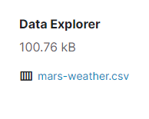

## References

The dataset is continuously updated and a snapshot of the csv file will be preserved for interpreting the favourable weather conditions on mars.

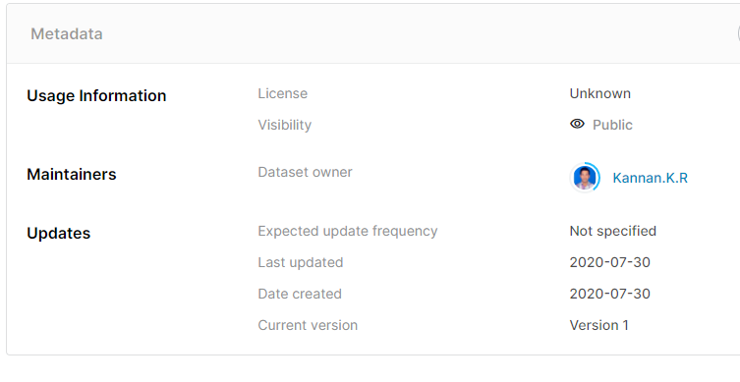

## Overview

This vision document is a high-level view of what the new cli app will entail. How it will be used and what it will accomplish. this data was measured and transmitted via the Rover Environmental Monitoring Station (REMS) on-board the Curiosity Rover. The data was made publicly available by NASA’s Mars Science Laboratory and the Centro de Astrobiología (CSIC-INTA).

Enclosed here is the Curiosity Rover which provides the REMS scientific data, The environmental magnitudes given in this file are obtained from the values read by the Rover Environmental Monitoring Station (REMS) on board the Mars Science Laboratory (MSL) rover on Mars. This file provides the environmental magnitudes at REMS location, calibration, instrument degradation, etc.), some or all of the magnitudes in this file may not be available.

Following this introductory section the main areas in this vision document and their corresponding sections are :

1. Technical

* Feature List (section 5)

1. Business

* Product Positioning (section 2)
* Product Overview (section 4)

1. Stakeholder Participation

* Stakeholder Profiles (section 3)

# Positioning

## Business Opportunity

A unique way of interpreting real world data using a command line interface in python.

Enclosed is the curiosity rover that transmits data in realtime via the Rover Environmental Monitoring Station.

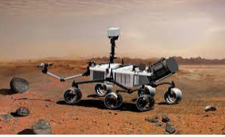

## Problem Statement

Many holiday goers are not aware of the climate conditions and associated activities available on the planet Mars.

|  |  |
| --- | --- |
| The problem of | Not knowing what to pack for your holiday to Mars |
| affects | interplanetary vacationer |
| the impact of which is | having a 40 month round-trip to go back and get a bathing costume |
| a successful solution would be | show the holiday maker the weather conditions and applicable holiday activities on the planet Mars |

## 

## User Environment

* laptop or desktop with a command line interface

# Product Overview

• Product perspective – Assist in determining holiday choices on Mars

## Product Perspective

The cli app is independent and totally self-contained.

## Summary of Capabilities

The major benefits and features the product will provide.

**Table 4-1 Customer Support System**

|  |  |
| --- | --- |
| **Customer Benefit** | **Supporting Features** |
| Find out what holiday activities were available on Mars | Give the applicable activities for the weather on Mars for a give date |
| Ease of use | Simple command interface that is OS independent and not pertaining to any computer architecture |

# 

# Product Features

## Existing features

None. This is version 1.0 of the Hitchhiker’s Guide to the Red Planet system.

## Features for the current project

### Detect holiday activity depending on Mars weather

Enclosed is the decision table that will be used to create the logic and satisfy the python assessment.

|  |  |  |  |
| --- | --- | --- | --- |
| **Temperature** | **Opacity** | **Wind speed** | **Holiday Option** |
| High | High | High | **Paragliding** |
| High | High | Low | **Sunbathing** |
| High | Low | High | **Blind Date** |
| High | Low | Low | **Happy Hour** |
| Low | High | High | **Star gazing** |
| Low | High | Low | **Volleyball** |
| Low | Low | High | **Ski at poles** |
| Low | Low | Low | **Play Sardines** |