**Name:** Weiqian Zhang **USC ID:** 3972192394

**DSCI 510 HW5 Project Description**

**Description:** For this project, I identify some countries (USA, Brazil, India, Russia, Mexico, France, UK, Peru, Bulgaria, Bosnia and Herzegovina, Hungary, Georgia) with regard to the highest number of death rate, deaths, and confirmed cases from the url, and then I have created the dataset cases_and_deaths_dataset.csv with each country's death rate, death number, total number of confirmed cases of covid-19, and the date, March 29, 2022, for analysis; according to data about the countries from dataset named cases_and_deaths_dataset.csv, then I created the dataset covid_vaccine_dataset.csv with each country's vaccination rate, vaccination number, and the date, March 29, 2022, for analysis; in addition, another dataset titled population_and_recovered_dataset.csv with each country's population, number of recovered, and the date, March 29, 2022, for analysis. After getting these data information, there is the analysis about how the fully vaccination affect recovered situation for these countries with severe situation during the covid-19 pandemic.

**Motivation:** It’s been 2 years since covid-19 started in 2020, and there are more and more people around the world get the fully vaccinated (fully vaccination represents that people get two doses of Covid-19 vaccines and one dose of booster vaccine); therefore, I am really curious about whether the fully vaccinations could affect people the country with severe situations (high death rate, high deaths, and high confirmed cases) or not by March 29, 2022, the date that I wanted to started this project.

**Data Sources:**

**1**: Total Cases, Death Rate, and Deaths by Country Over the World ([https://www.bbc.com/news/world-51235105](https://www.bbc.com/news/world-51235105https:/www.nytimes.com/interactive/2020/us/covid-19-vaccine-doses.html))

One dataset table from this URL shows the total number of confirmed cases, death rate, and deaths from over 100 different countries respectively by March 29th, 2022 after covid-19 outbreak. I will use top 5 countries (US, Brazil, India, Russia, and Mexico) based on the highest number of covid-19 death cases during this covid-19 outbreak, other 5 top countries (US, India, Brazil, France, and UK) in terms of highest cases of covid-19, and other top 5 countries (Peru, Bulgaria, Bosnia and Herzegovina, Hungary, and Georgia) with regard to highest death rates for this covid-19 outbreak into my analysis dataset 1.

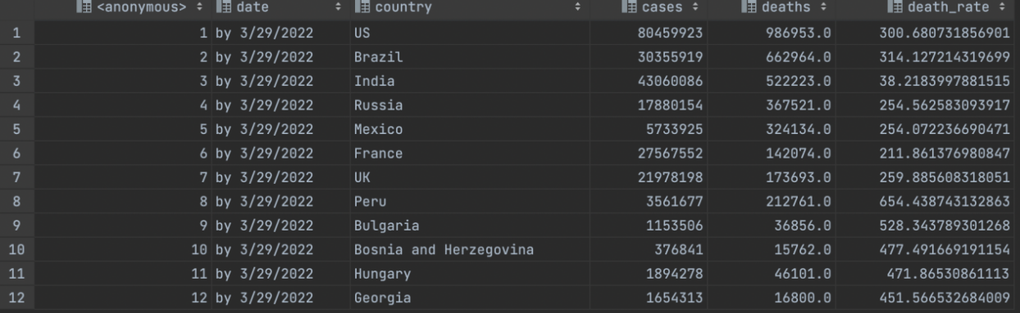

Fig 1. cases_and_deaths_dataset

**2.** Number of Vaccination and Vaccination Rate by Country Around the World

([https://www.bbc.com/news/world-51235105](https://www.bbc.com/news/world-51235105https:/www.nytimes.com/interactive/2020/us/covid-19-vaccine-doses.html))

Another dataset table from this website reflects the total number of fully vaccinations and vaccination rates from over 100 different countries respectively by March 29th, 2022 after covid-19 outbreak. Based on dataset 1, I will track the number of doses of vaccination and vaccination rates from countries of dataset 1 around the world during this covid-19 outbreak and put these data into my analysis dataset 2.

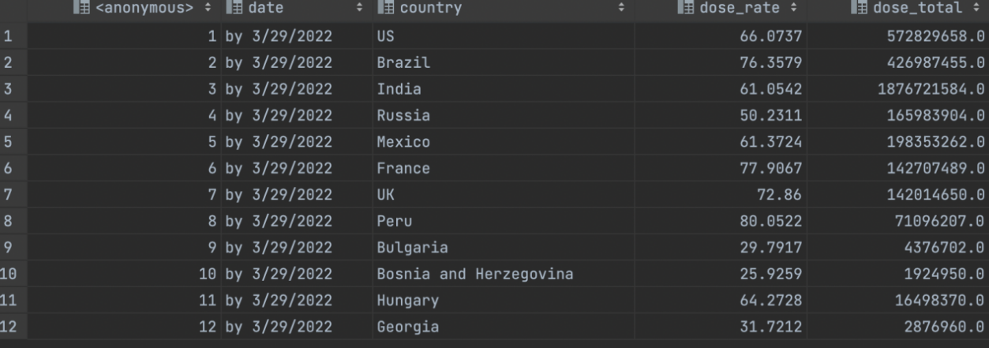

Fig 2. covid_vaccine_dataset

1. Detailed Information of Different Countries Related to Covid-19

(https://about-corona.net/documentation)

json Link: https://corona-api.com/countries

Based on dataset 1 and dataset 2, I will use this API to identify the countries which I choose from dataset 1 and dataset 2 to get the overall number of

recovered cases and population of each country by March 29th, 2022 in my analysis dataset 3.

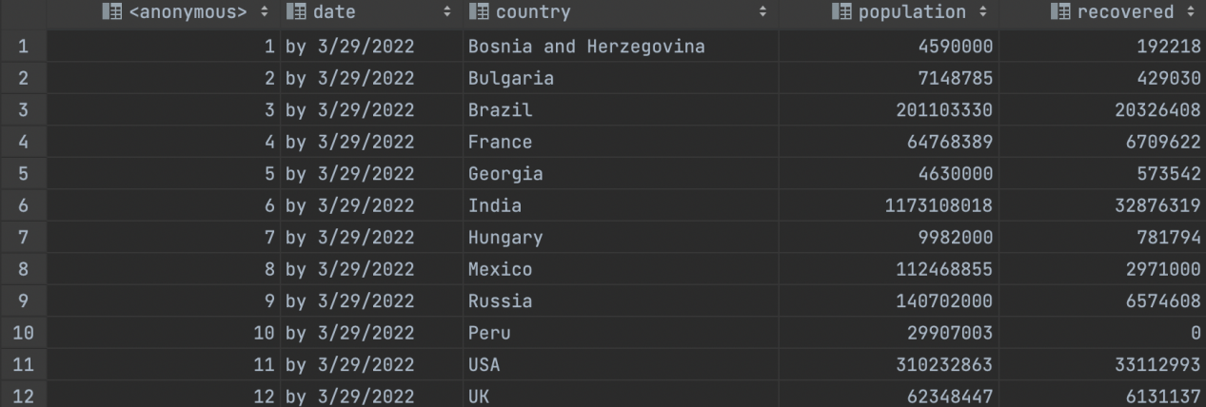

Fig 3. population_and_recovered_dataset

**FLOWCHART FOR DATASET GENERATION:**

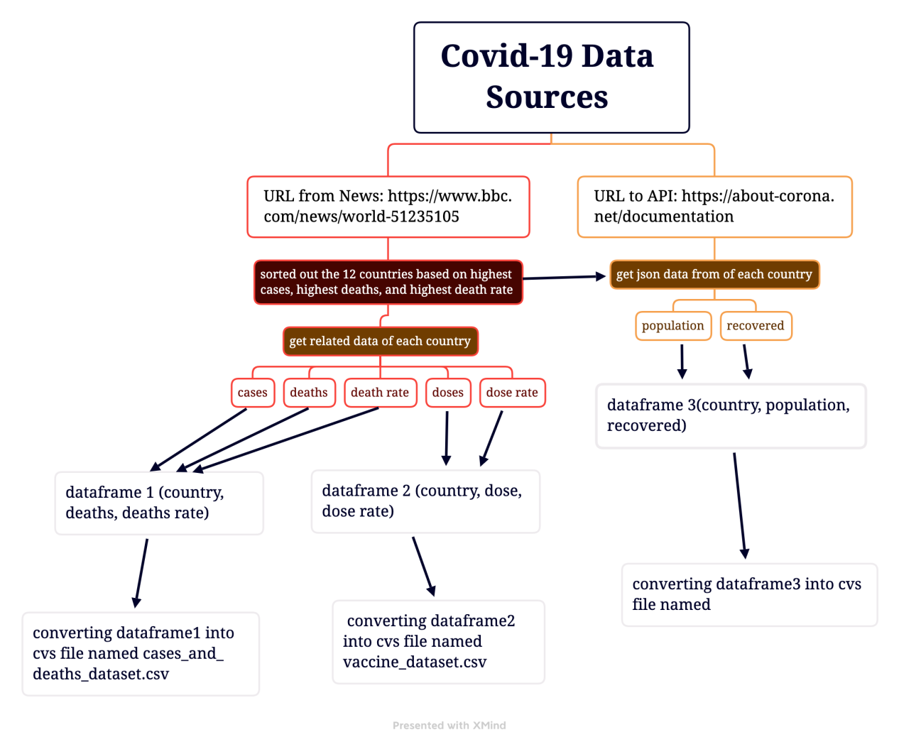

**Analysis performed:**

Firstly, the features of each country should be took a look, therefore, I get each country’s population number by March 29th, 2022 from Population_and_Recovered_Dataset, death number by March 29th, 2022 from Cases_and_Deaths_Dataset, dose number by March 29th, 2022 from Covid_Vaccine_Dataset, and recovered number by March 29th, 2022 from Population_and_Recovered_Dataset.

The following are bar charts of each country's death number, population, dose number, and recovered number respectively.

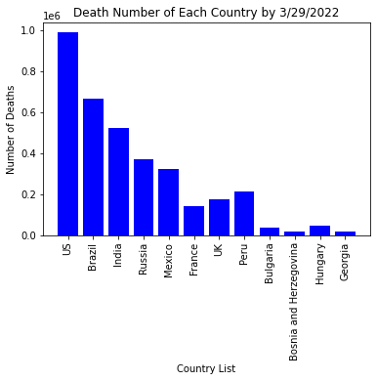

Fig 4. Bar Graph for Death Number of Each Country by 3/29/2022

## Based on the graph of death number of each country above, the death number of US, Brazil, and India were the highest by March 29th, 2022, because the death number in US, Brazil, and India was over 500,000, especially US with approaching to 1,000,000; on the other hand, the number of deaths from Bosnia and Herzegovina, and Georgia was the lowest respectively by March 29, 2022, because only under 100,000 people in Bosnia and Herzegovina, and Georgia died respectively by March 29th, 2022.

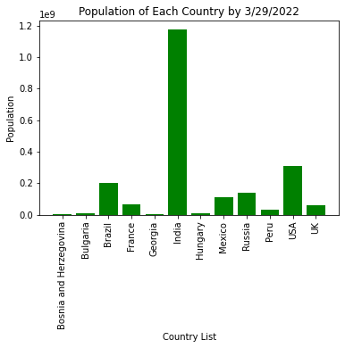

Fig 5. Bar Graph for Population of Each Country by 3/29/2022

In terms of bar graph of population of each country above, the population in India was highest with about 1,100,000,000 by March 29, 2022, while the population of Bosnia and Herzegovina, Georgia, Bulgaria, and Hungary was the lowest respectively by March 29, 2022, with under 100,000,000 respectively.

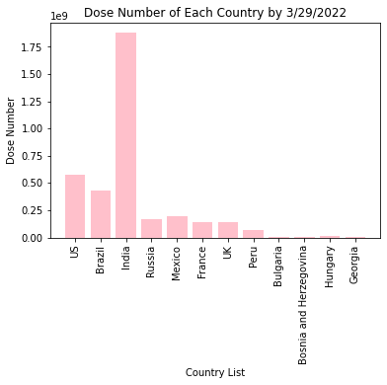

Fig 6. Bar Graph for Dose Number of Each Country by 3/29/2022

According to the bar graph of dose number of each country above, we could notice that the dose number of US, Brazil, and India respectively was higher than that of any other country respectively by March 29, 2022 with over about 400,000,000 respectively, maybe due to the maximum death number, especially India, a country with surprising over 1,750,000,000 getting fully vaccination. In addition, the dose the dose number of France was almost the same as that of UK with about 150,000,000, meanwhile, the number of people getting fully vaccinated in Bosnia and Herzegovina, Georgia, Bulgaria, and Hungary respectively is still lowest with only under 100,000,000 by March 29, 2022.

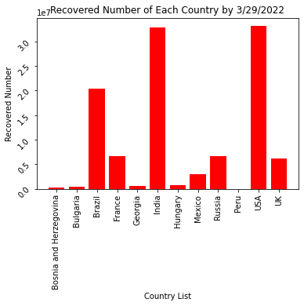

Fig 7. Bar Graph for Recovered Number of Each Country by 3/29/2022

As for the bar graph for recovered number of each country above, the number of the recovered number of US, Brazil, and India respectively was higher than that of other countries respectively by March 29th, 2022, maybe because of highest death number and dose number, clearly, the recovered number for India and USA respectively was over 30,000,000, and the recovered number of Brazil was about 20,000,000 by March 29th, 2022. Meanwhile, the recovered number in Russia, UK and France was the same respectively with about 7,000,000. Surprisingly, the number of people getting recovered in Peru is the lowest with only 0 by March 29th, 2022.

After analyzing each country’s population,death number, dose number, and recovered number by March 29th, 2022, respectively, we have to think about the effect of fully vaccination nationally by March 29th, 2022, because data of each country’s population,death number, dose number, and recovered number only shows the comparisons globally, in the end, I get the recovered percentage in each country, specifically, I just use recovered number of each country to divide the population of each country to see the how the recovered effect from covid-19 vaccine nationally by March 29, 2022.

The following graph is what I have obtained for recovered rate of each country.

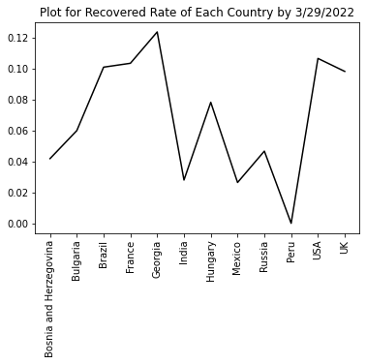

Fig 8. Plot for Recovered Rate in Each Country by 3/29/2022

In terms of plot for recovered rate of each country above, the standard for effectiveness of fully vaccination by March 29, 2022 is whether the recovered rate was above or equal to 0.06 or not by March 29,2022, based on this plot chart above, these countries shows the overall effectiveness of fully vaccination: Bulgaria, Brazil, France, Georgia, Hungary, USA, UK, while these countries shows minimal effect of fully vaccination: India, Mexico, Russia, Peru, Bosnia and Herzegovina.

The fully vaccination shows no effective on Peru, because there were about 100,000,000 people from Peru getting fully vaccination but there was no recovered people by March 29, 2022. Besides Peru, as for India, even though the dose number, population number, recovered number was largest while death number was lower than that of Brazil and USA (kindly note: USA from Bar Graph for Recovered Number of Each Country by 3/29/2022 and Plot for Recovered Rate in Each Country by 3/29/2022 is the same as US from other graphs), the recovered rate in India was not really high with about 0.03, compared with other countries, especially with USA and Brazil, this means that fully vaccinations shows the least effect towards people from India. Meanwhile, the Mexico’s recovered rate was almost same as India’s by March 29, 2022, and Russia’s recovered rate was the highest among countries with recovered rate which was lower than 0.06, even though Russia’s dose number was lower than Peru’s and Russian’s population was slightly higher than Peru’s. In addition, even though the recovered number in UK, Russia, and France was almost same, only Russia showed the ineffectiveness of fully vaccination mainly because of slightly higher population. Furthermore, among Bosnia and Herzegovina, Georgia, Bulgaria, and Hungary with least population, minimum dose number, slight recovered number and minimum deaths, Georgia’s recovered rate was highest with almost 0.12 by March 29th, 2022, and the recovered rate in Bulgaria was about 0.06 by March 29th, 2022, and Hungary was higher than 0.06 by March 29th, 2022, but Bosnia and Herzegovina only got 0.04 recovered rate by March 29th, 2022, this phenomenon means that the fully vaccinations seems almost effective towards country with minimum population.

**Conclusion:**

Based on the analysis, there exists the conclusion that fully vaccination was not remedy the for every country with severe situations (high death rate, high deaths, and high confirmed cases) by March 29th, 2022, because some countries’ recovered rate was not above 0.06 based on each country’s population and recovered number by March 29, 2022, therefore, covid-19 might still be a big challenge in the world.