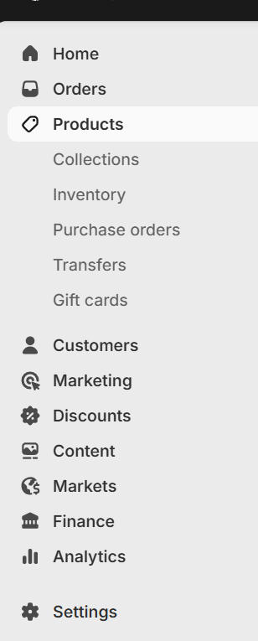

products
inventory management
supplier
customer relationship

operation
software to optimise the entire operation

stakeholders
investors/shareholders
trade unions
regulators
environmentalists
government
power

analytics -data
market
accounting
sales
finance
it

add own events
promote the events through the community
Run the events with the organisers
Let them discuss the issues and make changes during their team meetings
rewards for those who are doing it well, tickets to shows
trainings about how the process and system works
field trips to farming / volunteering

