sFamous Poems About DeathFamous Short Poems

- 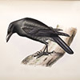
The Raven
by Edgar Allan Poe
Once upon a midnight dreary,
While I pondered, weak and weary,

- 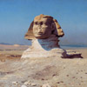
Ozymandias
by Percy Bysshe Shelley
I met a traveler from an antique land
Who said: 'Two vast and trunkless legs of stone

The Road Not Taken
by Robert Frost
Two roads diverged in a yellow wood,
And sorry I could not travel both

- 
Annabel Lee
by Edgar Allan Poe
It was many and many a year ago,
In a kingdom by the sea,

Invictus
by William Ernest Henley
Out of the night that covers me,
Black as the pit from pole to pole,

Nothing Gold Can Stay
by Robert Frost
Nature's first green is gold,
Her hardest hue to hold.

- 
Sonnet 18: Shall I Compare Thee to a Summer's Day
by William Shakespeare
Shall I compare thee to a summer’s day?
Thou art more lovely and more temperate:

- 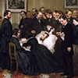
O Captain! My Captain!
by Walt Whitman
O Captain! my Captain! our fearful trip is done,
The ship has weather’d every rack, the prize we sought is won,

- 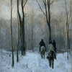
Stopping By Woods on a Snowy Evening
by Robert Frost
Whose woods these are I think I know.
His house is in the village though;

- 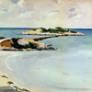
No Man is an Island
by John Donne
No man is an island,
Entire of itself,

Casey at the Bat
by Ernest Lawrence Thayer
The outlook wasn’t brilliant for the Mudville nine that day;
The score stood four to two with but one inning more to play

- 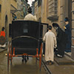
Because I could not stop for Death
by Emily Dickinson
Because I could not stop for Death,
He kindly stopped for me;

The Love Song of J. Alfred Prufrock
by T. S. Eliot
Let us go then, you and I,
When the evening is spread out against the sky

- 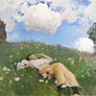
I Wandered Lonely as a Cloud
by William Wordsworth
I wandered lonely as a cloud
That floats on high o'er vales and hills,

- 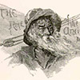
The Rime of the Ancient Mariner
by Samuel Taylor Coleridge
It is an ancient Mariner,
And he stoppeth one of three.

- 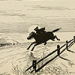
Paul Revere's Ride
by Henry Wadsworth Longfellow
Listen, my children, and you shall hear
Of the midnight ride of Paul Revere,

- 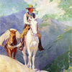
If—
by Rudyard Kipling
If you can keep your head when all about you
Are losing theirs and blaming it on you,

- 
Kubla Khan
by Samuel Taylor Coleridge
“In Xanadu did Kubla Khan
A stately pleasure-dome decree:”

- 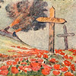
In Flanders Fields
by John McCrae
In Flanders fields the poppies blow
Between the crosses, row on row,

- 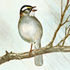
Hope is the thing with feathers
by Emily Dickinson
Hope is the thing with feathers
That perches in the soul,

- 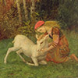
Endymion
by John Keats
A thing of beauty is a joy for ever:
Its loveliness increases; it will never

- 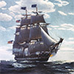
Old Ironsides
by Oliver Wendell Holmes
Ay, tear her tattered ensign down!
Long has it waved on high,

- 
Sonnet 43: How Do I Love Thee?
by Elizabeth Barrett Browning
How do I love thee? Let me count the ways.
I love thee to the depth and breadth and height

- 
She Walks in Beauty
by George Gordon, Lord Byron
She walks in beauty, like the night
Of cloudless climes and starry skies;

- 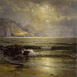
Dover Beach
by Matthew Arnold
The sea is calm tonight.
The tide is full, the moon lies fair

- 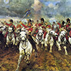
The Charge of the Light Brigade
by Alfred, Lord Tennyson
Half a league, half a league,
Half a league onward,

- 
Thanatopsis
by William Cullen Bryant
To him who in the love of nature holds
Communion with her visible forms, she speaks

- 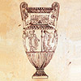
Ode on a Grecian Urn
by John Keats
Thou still unravish'd bride of quietness,
Thou foster-child of silence and slow time,

- 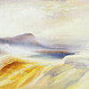
Fire and Ice
by Robert Frost
Some say the world will end in fire,
Some say in ice.

- 
The Lady of Shalott
by Alfred, Lord Tennyson
On either side the river lie
Long fields of barley and of rye,

- 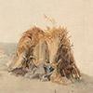
John Barleycorn
by Robert Burns
There was three kings into the east,
Three kings both great and high,

The Highwayman
by Alfred Noyes
The wind was a torrent of darkness among the gusty trees.
The moon was a ghostly galleon tossed upon cloudy seas.

- 
The New Colossus
by Emma Lazarus
Not like the brazen giant of Greek fame,
With conquering limbs astride from land to land;

The World is Too Much With Us
by William Wordsworth
The world is too much with us; late and soon,
Getting and spending, we lay waste our powers;—

- 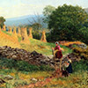
Mending Wall
by Robert Frost
Something there is that doesn't love a wall,
That sends the frozen-ground-swell under it,

The Sun Rising
by John Donne
Busy old fool, unruly sun,
Why dost thou thus,

- 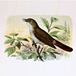
Ode to a Nightingale
by John Keats
My heart aches, and a drowsy numbness pains
My sense, as though of hemlock I had drunk,

- 
We Wear the Mask
by Paul Laurence Dunbar
We wear the mask that grins and lies,
It hides our cheeks and shades our eyes,—

- 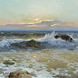
A Dream Within a Dream
by Edgar Allan Poe
Take this kiss upon the brow!
And, in parting from you now,

- 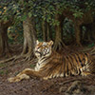
The Tyger
by William Blake
Tyger Tyger, burning bright,
In the forests of the night;

See It Through
by Edgar Albert Guest
When you’re up against a trouble,
Meet it squarely, face to face;

I heard a Fly buzz when I died
by Emily Dickinson
I heard a Fly buzz when I died;
The stillness round my form

The House by the Side of the Road
by Sam Walter Foss
There are hermit souls that live withdrawn
In the peace of their self-content;

- 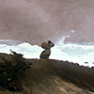
Ode to the West Wind
by Percy Bysshe Shelley
O wild West Wind, thou breath of Autumn's being,
Thou, from whose unseen presence the leaves dead

The Wreck of the Hesperus
by Henry Wadsworth Longfellow
It was the schooner Hesperus,
That sailed the wintry sea;

The Passionate Shepherd To His Love
by Christopher Marlowe
Come live with me and be my love,
And we will all the pleasures prove,

Song: to Celia
by Ben Jonson
Drink to me only with thine eyes,
And I will pledge with mine;

The Cremation of Sam McGee
by Robert Service
There are strange things done in the midnight sun
By the men who moil for gold;

- 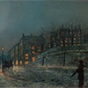
Acquainted with the Night
by Robert Frost
I have been one acquainted with the night.
I have walked out in rain—and back in rain.

- 
To My Dear and Loving Husband
by Anne Bradstreet
If ever two were one, then surely we.
If ever man were loved by wife, than thee;

- 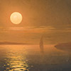
Crossing the Bar
by Alfred, Lord Tennyson
Sunset and evening star,
And one clear call for me!

- 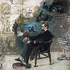
I felt a funeral in my brain
by Emily Dickinson
I felt a funeral in my brain
And mourners, to and fro,

A Noiseless Patient Spider
by Walt Whitman
A noiseless patient spider,
I mark’d where on a little promontory it stood isolated,

When I Have Fears That I May Cease to Be
by John Keats
When I have fears that I may cease to be
Before my pen has gleaned my teeming brain,

Sonnet 29: When, in disgrace with fortune and men’s eyes
by William Shakespeare
When, in disgrace with fortune and men’s eyes,
I all alone beweep my outcast state,

A Psalm of Life
by Henry Wadsworth Longfellow
Tell me not, in mournful numbers,
Life is but an empty dream!

- 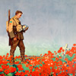
The Soldier
by Rupert Brooke
If I should die, think only this of me:
That there’s some corner of a foreign field

Sympathy
by Paul Laurence Dunbar
I know what the caged bird feels, alas!
When the sun is bright on the upland slopes;

Holy Sonnet 10: Death, be not proud
by John Donne
Death, be not proud, though some have called thee
Mighty and dreadful, for thou art not so;

Ulysses
by Alfred, Lord Tennyson
It little profits that an idle king,
By this still hearth, among these barren crags,

- 
A Red, Red Rose
by Robert Burns
O my Luve is like a red, red rose
That’s newly sprung in June;

- 
Much madness is divinest sense
by Emily Dickinson
Much Madness is divinest Sense
To a discerning eye;

- 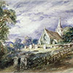
Elegy Written in a Country Churchyard
by Thomas Gray
The curfew tolls the knell of parting day,
The lowing herd winds slowly o’er the lea,

- 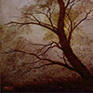
A Poison Tree
by William Blake
I was angry with my friend;
I told my wrath, my wrath did end.

- 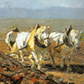
To a Mouse
by Robert Burns
Wee, sleeket, cowran, tim’rous beastie,
O, what a panic’s in thy breastie!

- 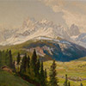
Success is counted sweetest
by Emily Dickinson
Success is counted sweetest
By those who ne'er succeed.

- 
Birches
by Robert Frost
When I see birches bend to left and right
Across the lines of straighter darker trees,

Love and Friendship
by Emily Brontë
Love is like the wild rose-briar,
Friendship like the holly-tree—

Love’s Philosophy
by Percy Bysshe Shelley
The fountains mingle with the river
And the rivers with the ocean,

When I consider how my light is spent
by John Milton
When I consider how my light is spent,
Ere half my days in this dark world and wide,

- 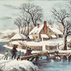
Snow-Bound
by John Greenleaf Whittier
The sun that brief December day
Rose cheerless over hills of gray,

A Valentine
by Edgar Allan Poe
For her this rhyme is penned, whose luminous eyes,
Brightly expressive as the twins of Loeda,

- 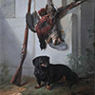
My life had stood — a loaded gun
by Emily Dickinson
My life had stood — a loaded gun —
In Corners — till a Day

- 
To Autumn
by John Keats
Season of mists and mellow fruitfulness,
Close bosom-friend of the maturing sun;

- 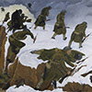
I Have a Rendezvous with Death
by Alan Seeger
I have a rendezvous with Death
At some disputed barricade

Auguries of Innocence
by William Blake
To see a world in a grain of sand,
And a heaven in a wild flower,

Love’s Secret
by Percy William Blake
Never seek to tell thy love,
Love that never told can be;

- 
Horatius at the Bridge
by Thomas Babington Macaulay
Lars Porsena of Clusium,
By the Nine Gods he swore

Abou Ben Adhem
by Leigh Hunt
Abou Ben Adhem (may his tribe increase!)
Awoke one night from a deep dream of peace,

Tell all the truth but tell it slant
by Emily Dickinson
Tell all the truth but tell it slant —
Success in Circuit lies

- 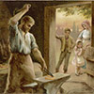
The Village Blacksmith
by Henry Wadsworth Longfellow
Under a spreading chestnut-tree
The village smithy stands;

- 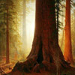
Good Timber
by Douglas Malloch
The tree that never had to fight
For sun and sky and air and light,

My Heart Leaps Up
by William Wordsworth
My heart leaps up when I behold
A rainbow in the sky:

The Destruction of Sennacherib
by Lord Byron
The Assyrian came down like the wolf on the fold,
And his cohorts were gleaming in purple and gold;

- 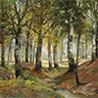
Trees
by Joyce Kilmer
I think that I shall never see
A poem lovely as a tree.

- 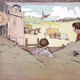
The Hayloft
by Robert Louis Stevenson
Through all the pleasant meadow-side
The grass grew shoulder-high,

Who Has Seen the Wind?
by Christina Rossetti
Who has seen the wind?
Neither I nor you;

Frost at Midnight
by Samuel Taylor Coleridge
The frost performs its secret ministry,
Unhelped by any wind. The owlet’s cry

- 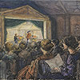
All the world's a stage
by William Shakespeare
All the world’s a stage,
And all the men and women merely players;

- 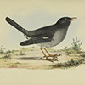
A bird came down the walk
by Emily Dickinson
A bird came down the walk:
He did not know I saw;

- 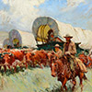
Pioneers! O Pioneers!
by Walt Whitman
Come, my tan-faced children,
Follow well in order, get your weapons ready;

Alone
by Edgar Allan Poe
From childhood’s hour I have not been
As others were—I have not seen

- 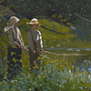
I'm nobody! Who are you?
by Emily Dickinson
I'm nobody! Who are you?
Are you nobody, too?

- 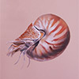
The Chambered Nautilus
by Oliver Wendell Holmes
This is the ship of pearl, which, poets feign,
Sails the unshadowed main,—

- 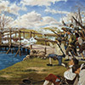
Concord Hymn
by Ralph Waldo Emerson
By the rude bridge that arched the flood,
Their flag to April’s breeze unfurled,

- 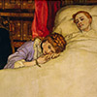
Remember
by Christina Rossetti
Remember me when I am gone away,
Gone far away into the silent land;

- 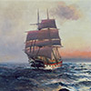
Sea Fever
by John Masefield
I must go down to the seas again, to the lonely sea and the sky,
And all I ask is a tall ship and a star to steer her by;

- 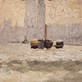
Fog
by Carl Sandburg
The fog comes
on little cat feet.

- 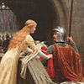
When We Two Parted
by George Gordon, Lord Byron
When we two parted
In silence and tears,

- 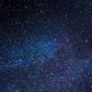
The Night Has a Thousand Eyes
by Francis William Bourdillon
The night has a thousand eyes,
And the day but one;

