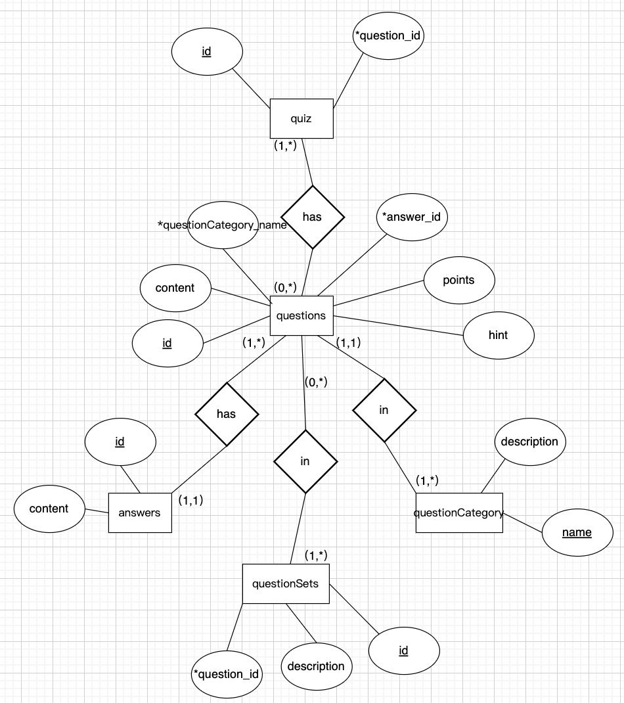

questionCategory(**name**, description)

answers(**id**, content)

questions(**id**, points, content, hint, *answer_id, *questionCategory_name)

quiz(**id**)

questionSets(**id**, description)

questions_quiz(*questions_id, *quiz_id)

questions_questionSets(*questions_id, *questionSets_id)

In DB file:

drop table if exists questions_questionSets;

drop table if exists questions_quiz;

drop table if exists questionSets;

drop table if exists quiz;

drop table if exists question;

drop table if exists answers;

drop table if exists questionCategory;

create table questionCategory (

name varchar(128),

description TEXT

);

create table answers (

id integer not null primary key,

content TEXT

);

create table questions (

id integer not null primary key,

point integer,

content TEXT,

hint TEXT,

answer_id integer not null,

questionCategory_name varchar(128),

foreign key (answer_id) references answers (id),

foreign key (questionCategory_name) references questionCategory (name)

);

create table quiz (

id integer not null primary key

);

create table questionSets (

id integer not null primary key,

description TEXT

);

create table questions_quiz (

questions_id INTEGER not null,

quiz_id INTEGER not null,

primary key (questions_id, quiz_id),

foreign key (questions_id) references questions (id),

foreign key (quiz_id) references quiz (id)

);

create table questions_quiz (

questions_id INTEGER not null,

questionSets_id INTEGER not null,

primary key (questions_id, questionSets_id),

foreign key (questions_id) references questions (id),

foreign key (questionSets_id) references questionSets (id)

);