Model’s performance
STFT

STFT with Delta and Delta-Delta

LogMEL

LogMEL with Delta and Delta-Delta
Epochs
MFCC
10k samples
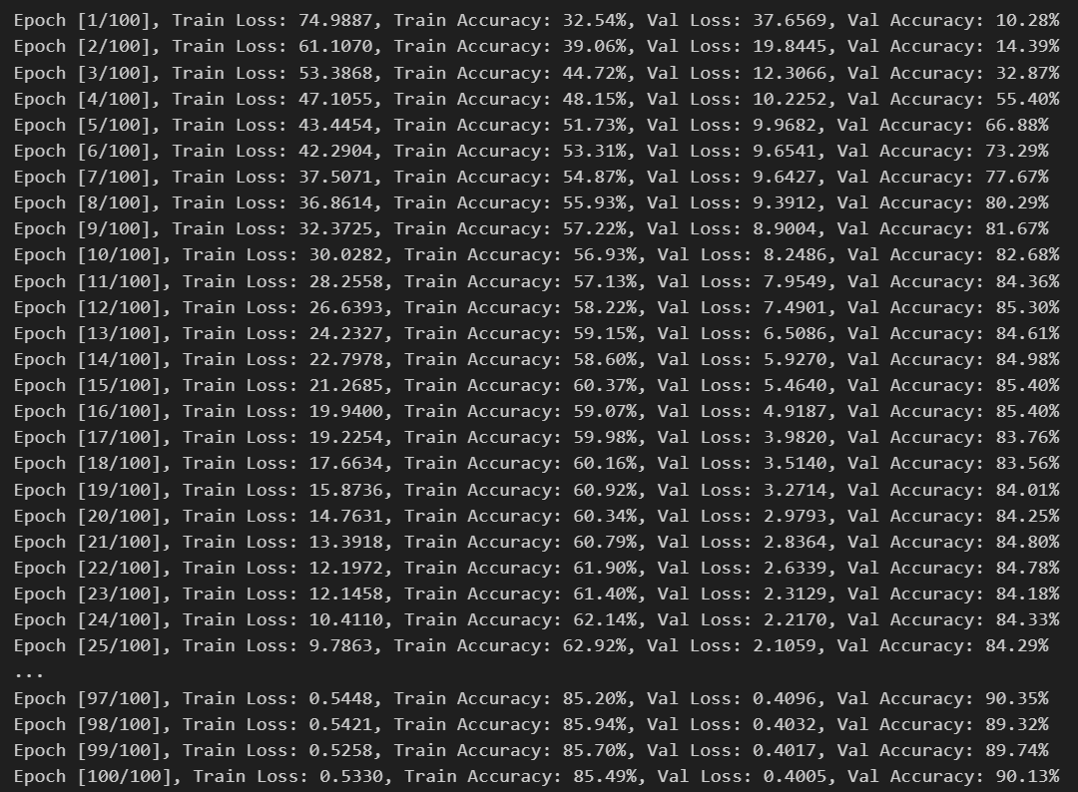
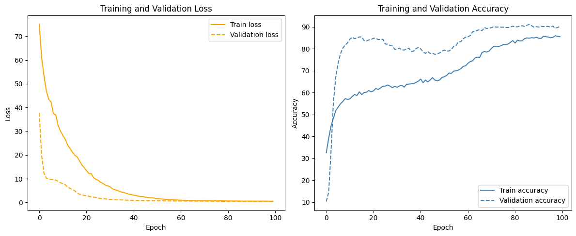
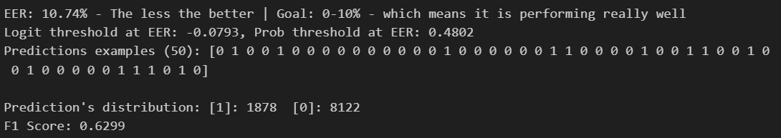
MFCC with Delta and Delta-Delta

LFCC
10k samples:
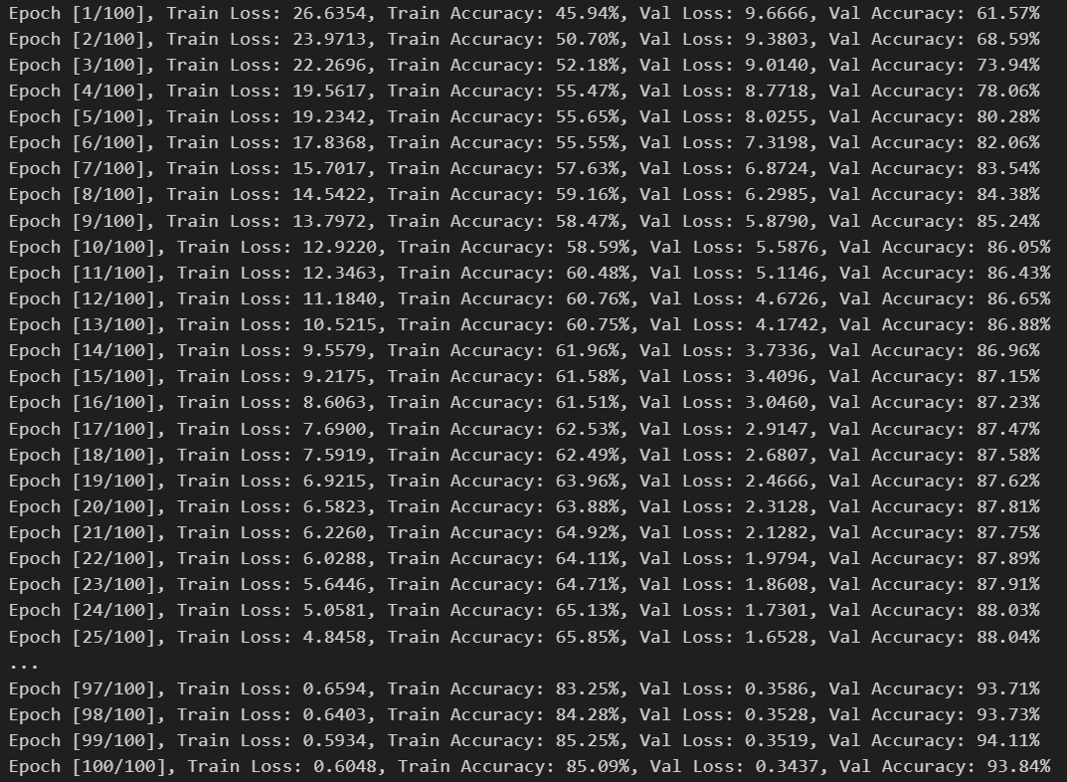
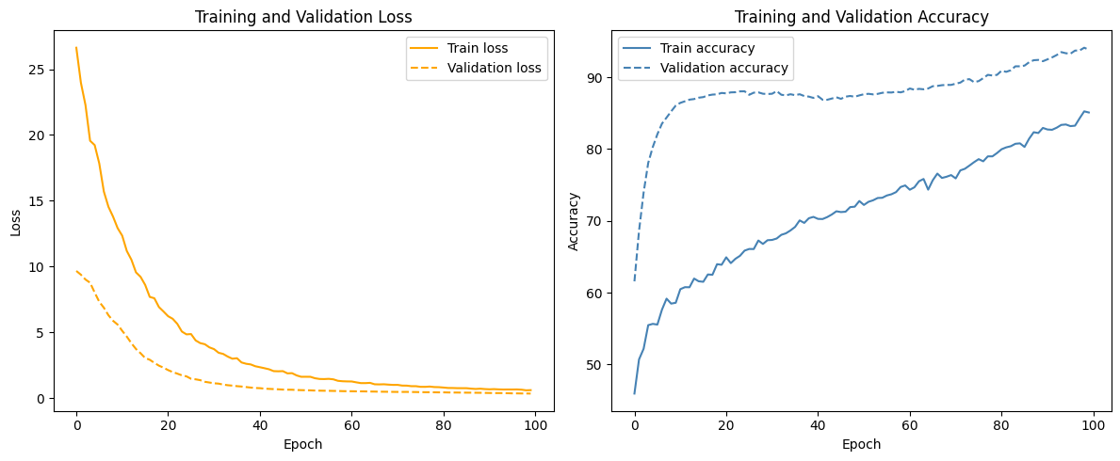
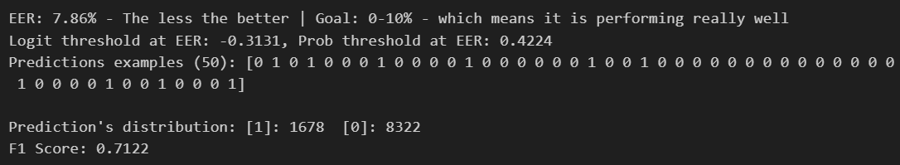

LFCC with Delta and Delta-Delta
10k samples:
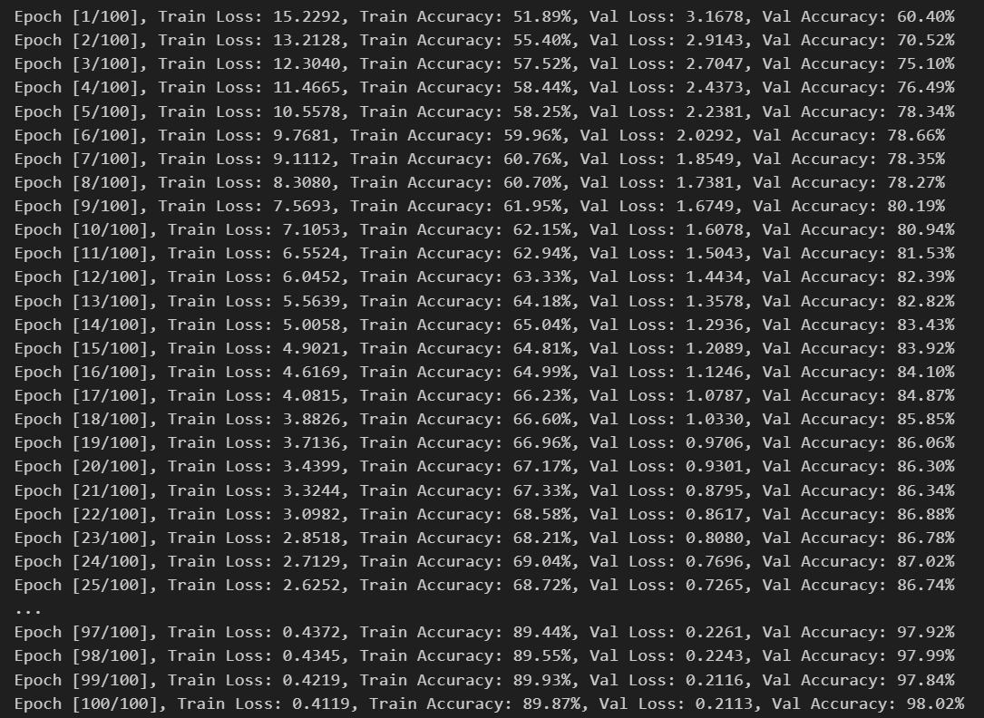
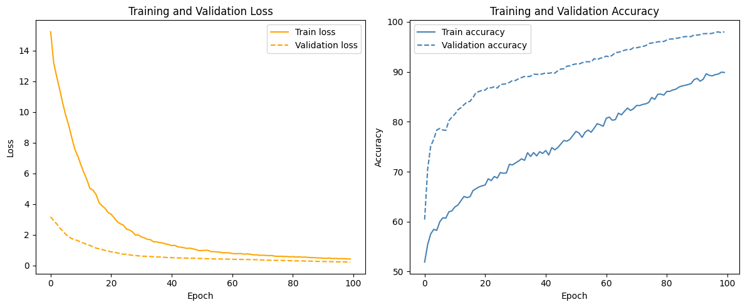
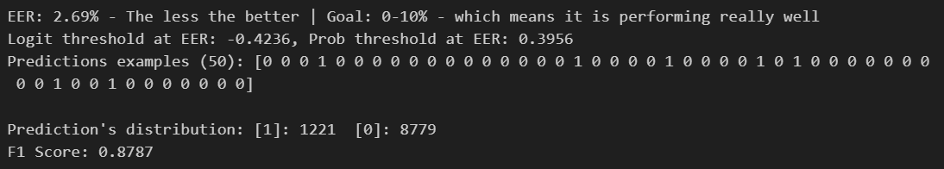

Full dataset:

Wav2Vec

