Home Screen

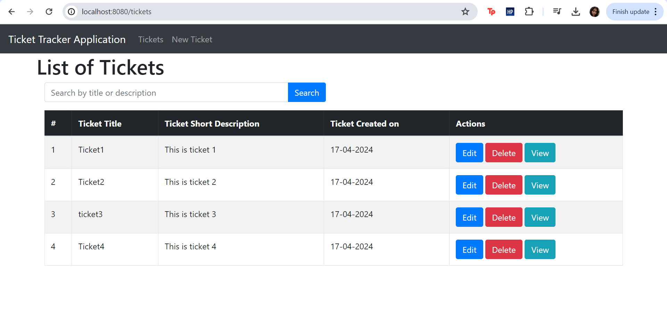

Create ticket page

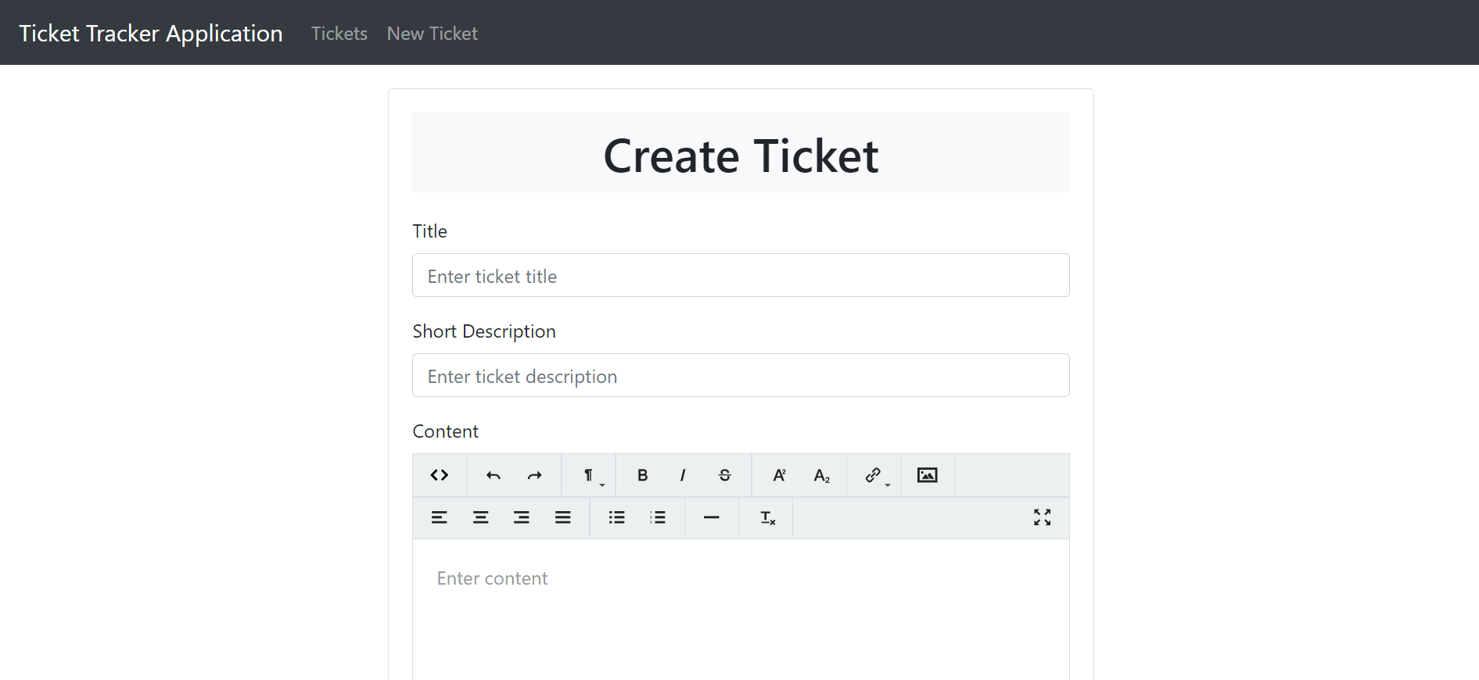

Edit ticket page

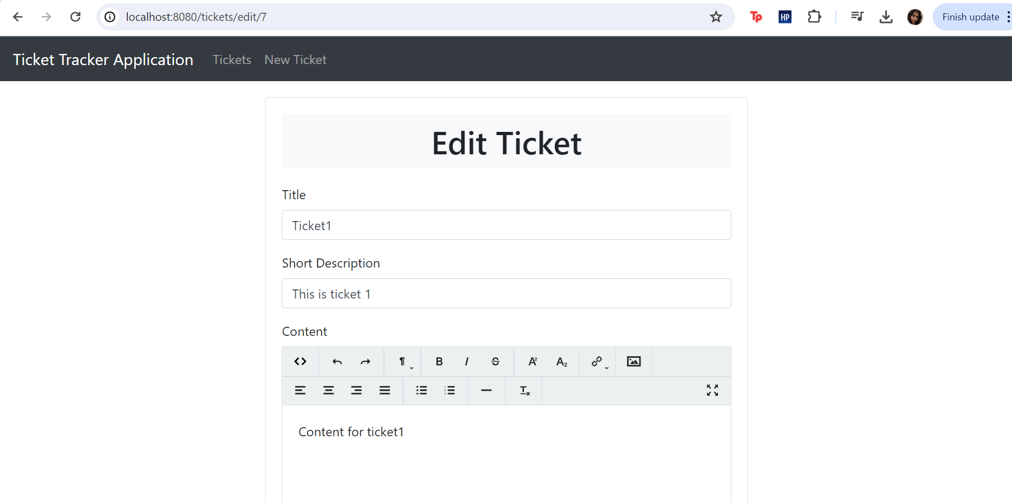

Search page

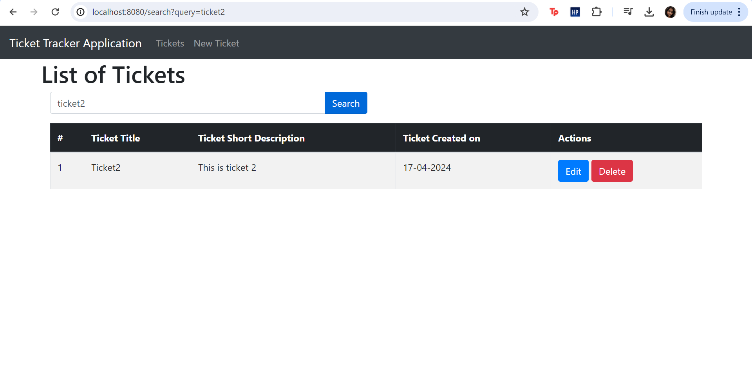

View page

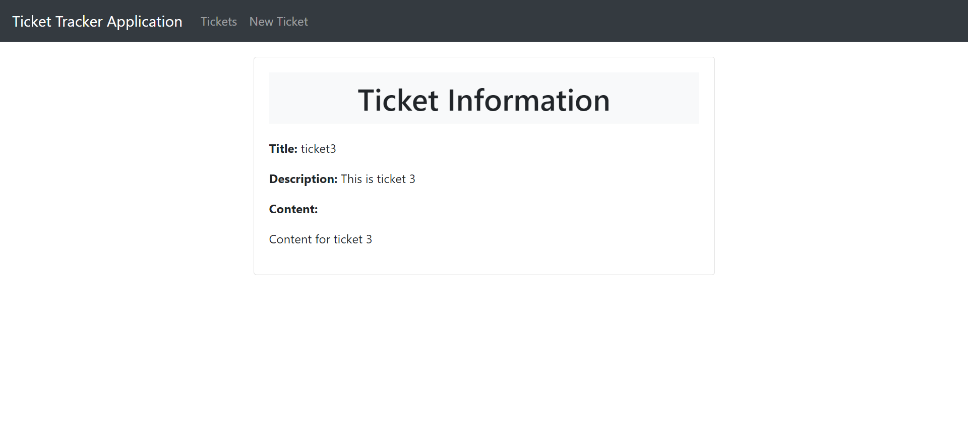

Screen Recording drive link:

<https://drive.google.com/file/d/19LUMrZnbSL0QKU_9X1dDUP8GEy4xYQ6z/view?usp=sharing>