Dataset Characteristics
The fused dataset composition reveals a striking imbalance, as illustrated in Figure 1. Tappy contributes 177,329 samples (98.3% of the total), while MIT-CS1 and MIT-CS2 contribute merely 1,626 (0.9%) and 1,491 (0.8%) samples respectively. This extreme disparity, where home-based data outweighs clinical data by a factor of 58:1 , necessitates careful experimental design to prevent dataset bias. Simple concatenation would risk models learning to recognise data source characteristics rather than disease-specific biomarkers.
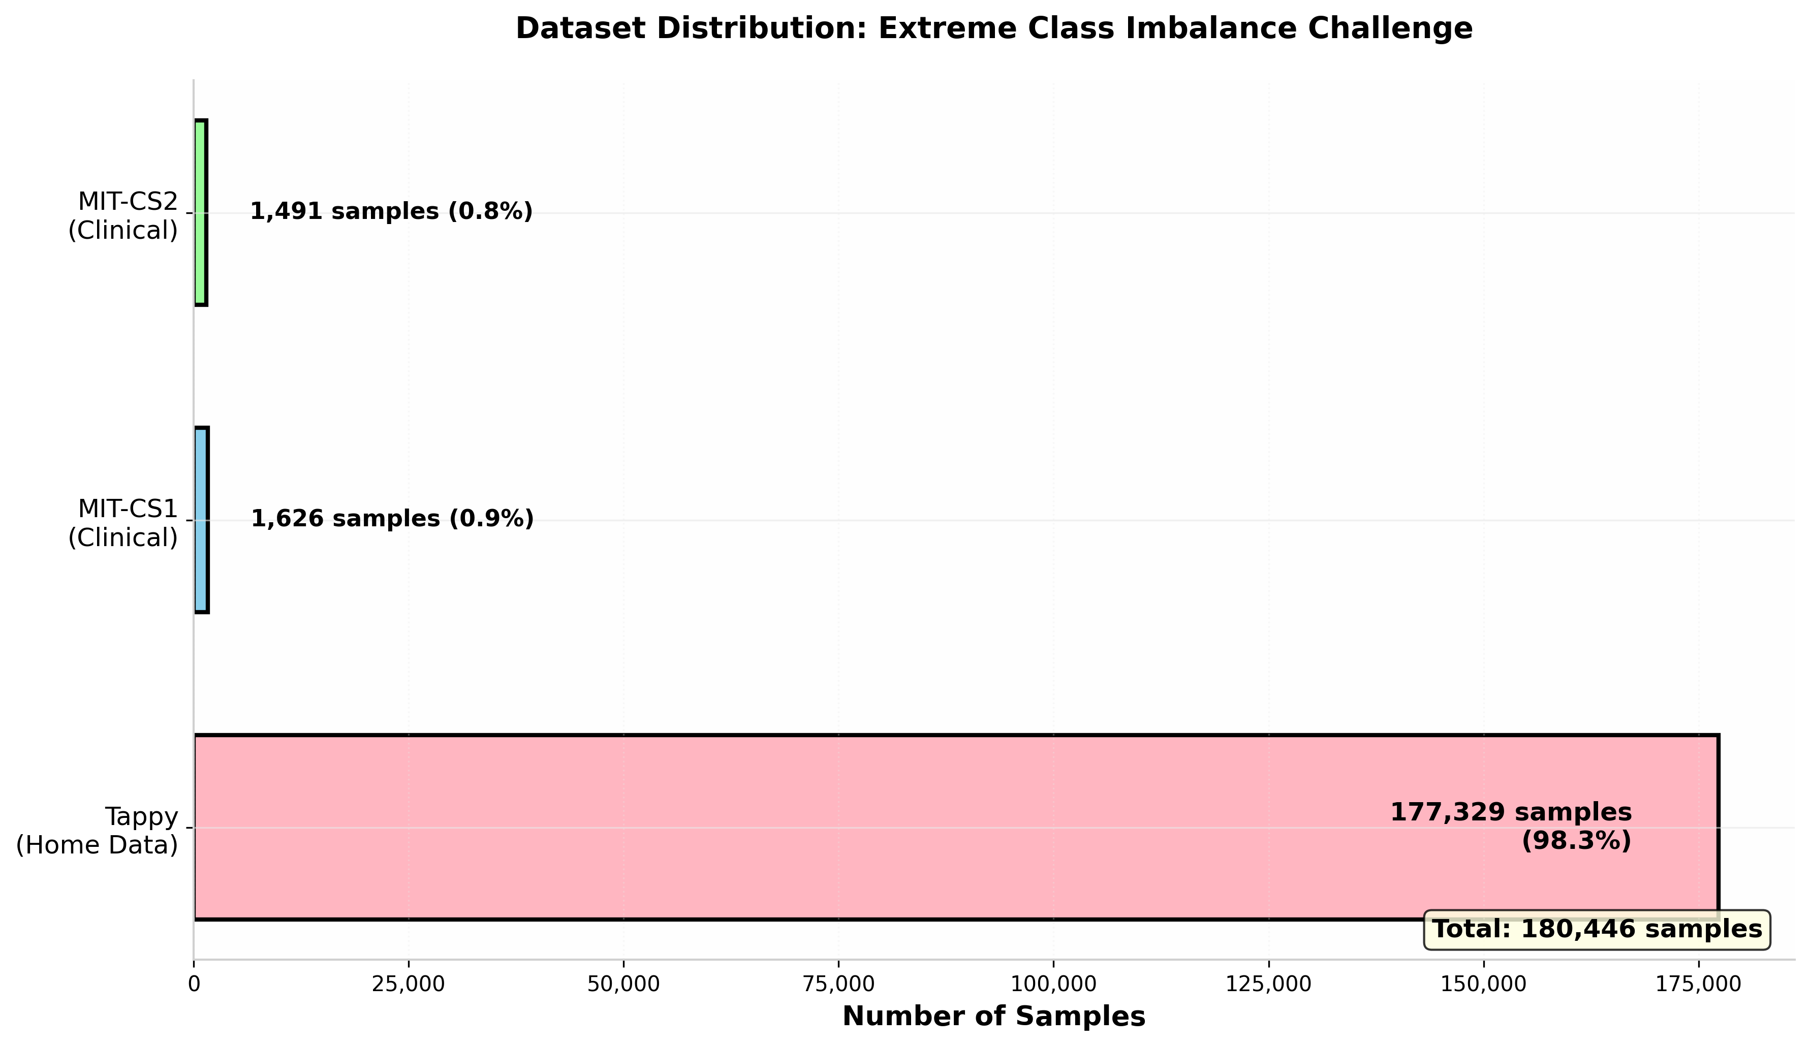
Figure 1: Dataset Distribution

Baseline Performance: Clinical Data Excellence
Evaluation of the MIT clinical datasets (CS1 and CS2 combined) yielded excellent discriminative performance. As shown in Figure 2, Random Forest achieved perfect separation (ROC-AUC = 1.000), while SVM performed nearly as well (ROC-AUC = 0.998). These results demonstrate that keystroke dynamics collected in controlled clinical environments contain robust, highly predictive Parkinson's disease signatures.
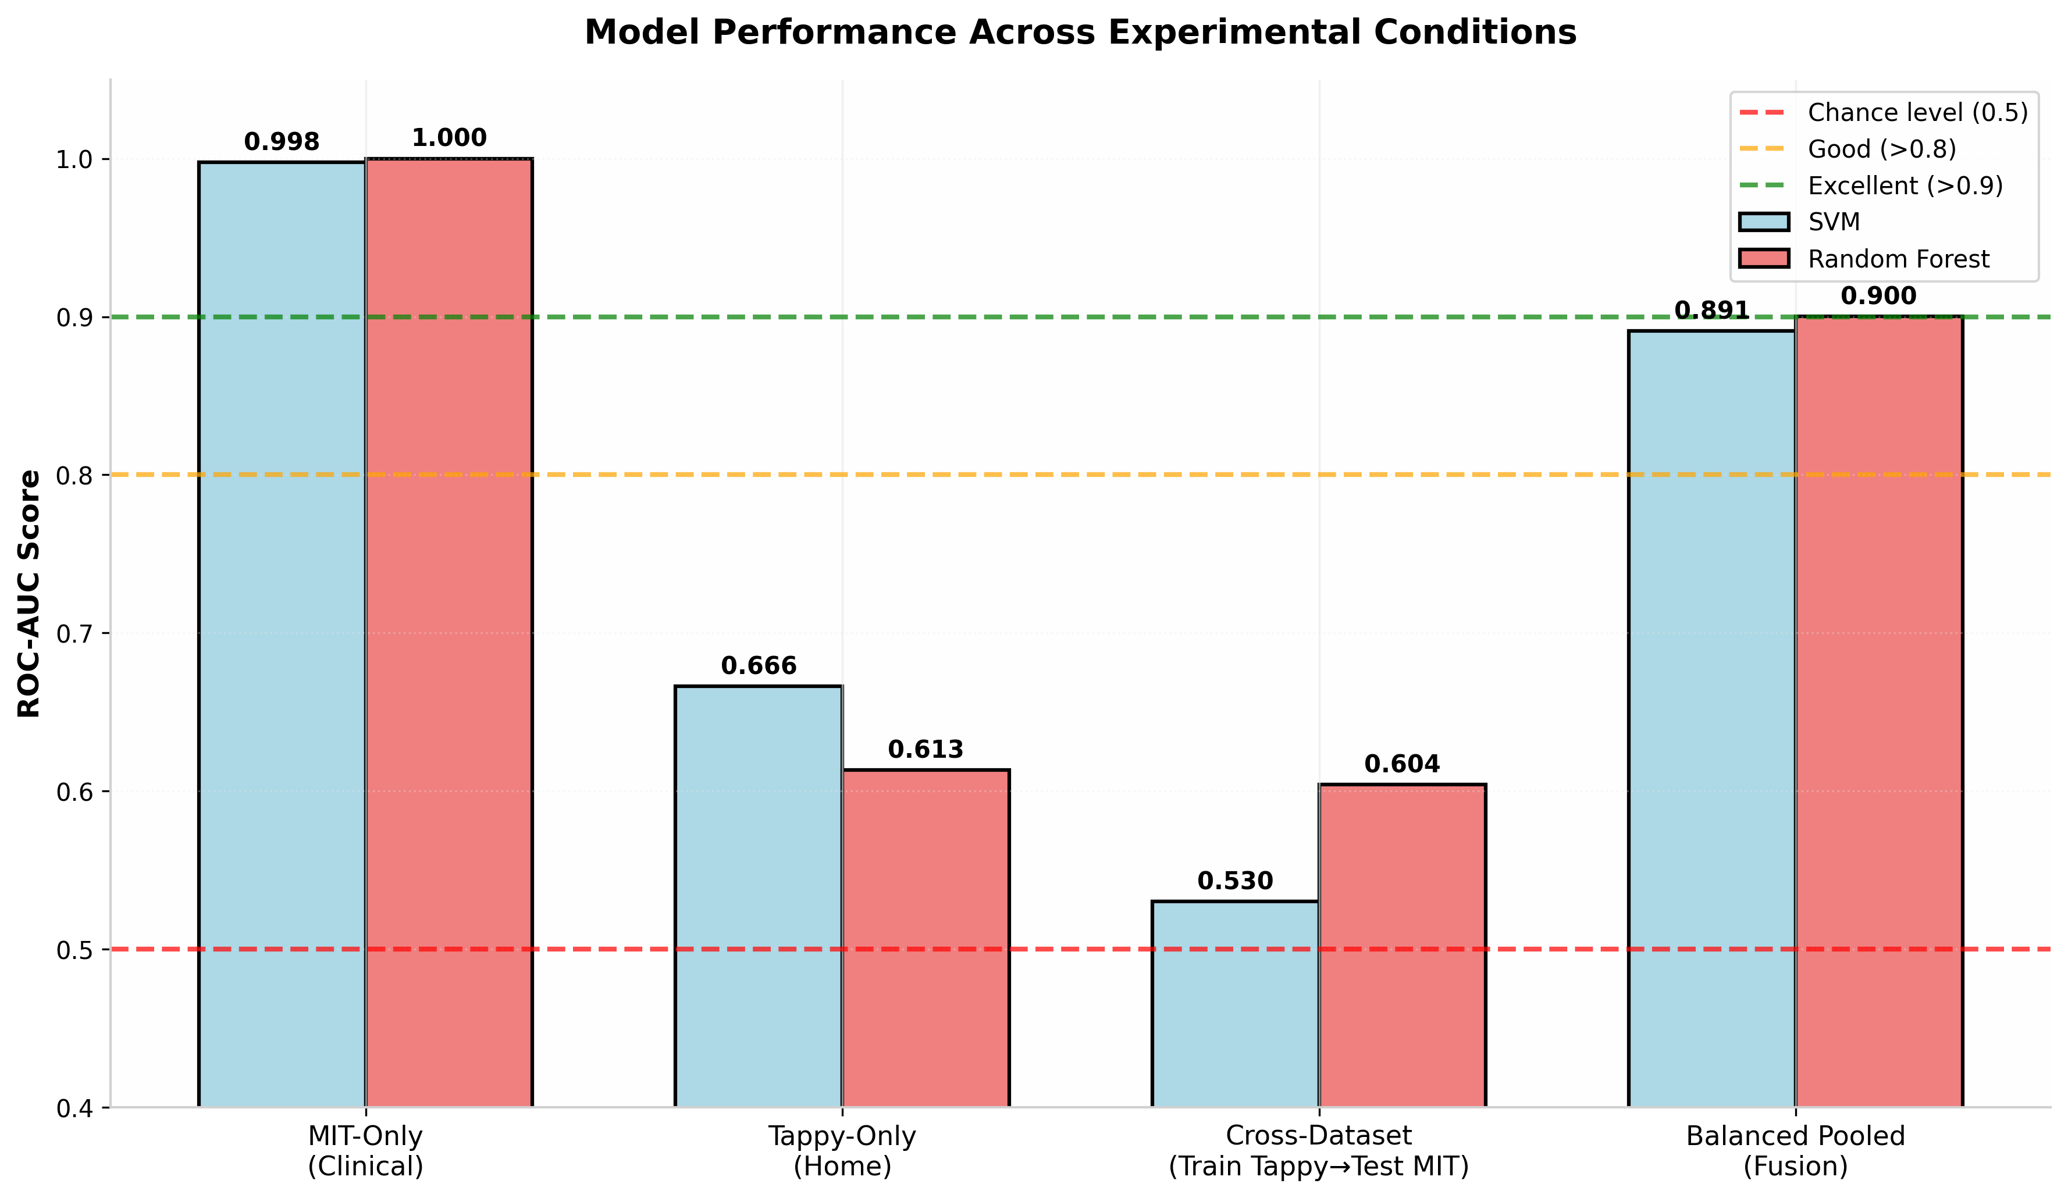
Figure 2: Performance Comparison Across Experimental Conditions

The stability of these results is equally noteworthy. Figure 3 illustrates fold-by-fold consistency across five cross-validation splits, with ROC-AUC scores remaining above 0.99 for all folds. This low variance establishes an upper performance bound and confirms that clinical keystroke analysis has substantial diagnostic potential when data collection protocols are standardised.
Home Data Limitations
In contrast, Tappy-only experiments demonstrated significantly poorer generalization. Random Forest achieved merely 0.613 ROC-AUC, while SVM reached 0.666, far below clinical utility thresholds. Figure 3 reveals concerning volatility across folds, with performance oscillating between 0.53 and 0.74. This instability suggests that uncontrolled home typing data, while abundant, lacks the consistency required for reliable standalone diagnosis. The data's noisiness stemming from variable keyboards, unstructured typing tasks, and diverse user environments, undermines model reliability.
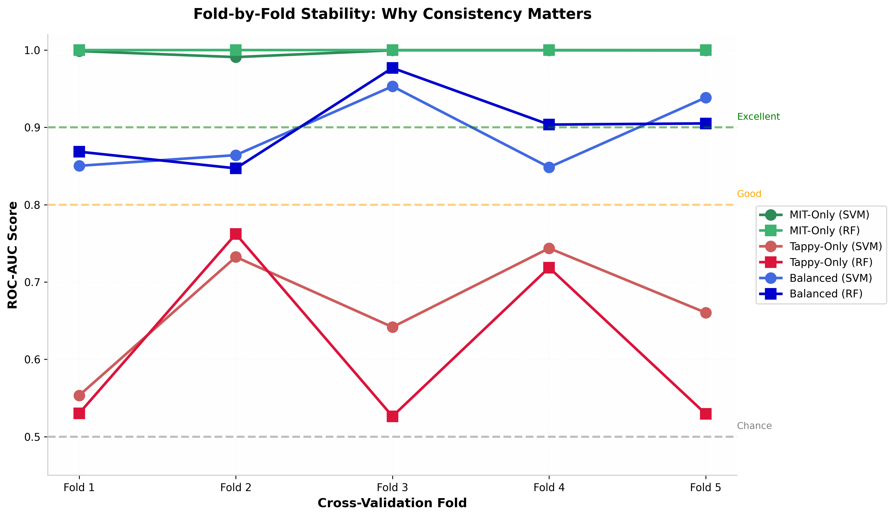
Figure 3: Fold-by-Fold Stability Analysis

The Domain Shift Challenge
The cross-dataset experiment, training on Tappy and testing on MIT, revealed catastrophic domain shift. As shown in Figure 2, both classifiers failed to generalise, achieving ROC-AUC scores of 0.530 (SVM) and 0.604 (Random Forest), effectively performing at chance levels. This demonstrates that models trained on home data learn spurious correlations, likely demographic or hardware-specific patterns, rather than disease-relevant motor impairments.
Figure 4 illustrates this phenomenon conceptually. The MIT and Tappy domains differ fundamentally: MIT employs scripted tasks in supervised clinical settings with specific patient populations, while Tappy captures free-text typing in unsupervised home environments from different demographics. Without domain adaptation, classifiers cannot transfer knowledge across these contexts.
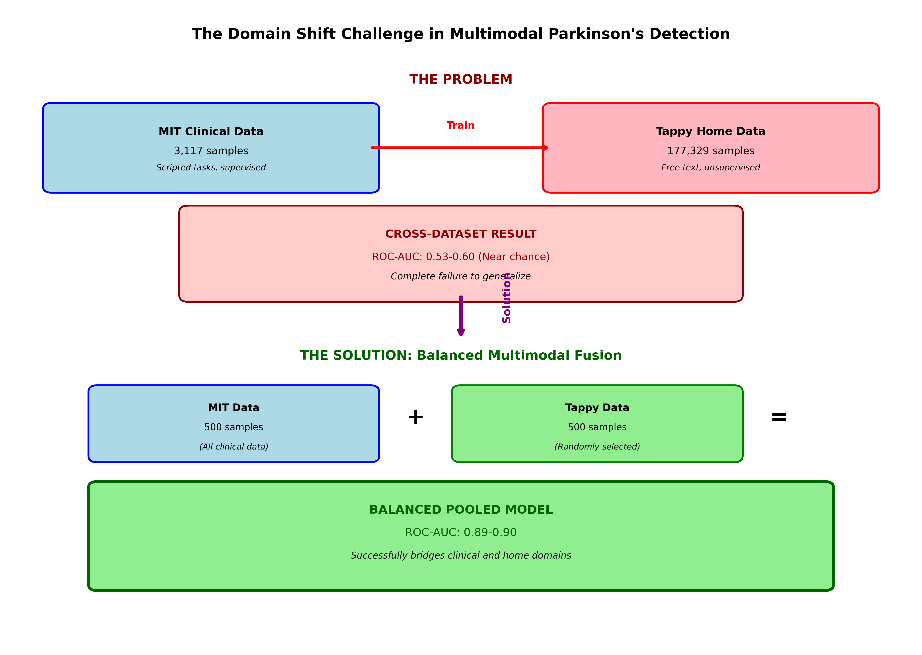
Figure 4: The Domain Shift Challenge and Solution

Balanced Multimodal Fusion: Bridging the Gap
The proposed balanced pooling strategy—matching MIT sample counts with randomly selected Tappy subsets—successfully addressed this challenge. By reducing Tappy from 177,329 to 500 samples (matching the MIT total), the fused model achieved ROC-AUC scores of 0.891 (SVM) and 0.900 (Random Forest), as shown in Figure 2. This represents a 69% relative improvement over naive cross-dataset training.
Figure 3 demonstrates that this approach also improved stability. While some fold-to-fold variation exists, performance remains consistently above 0.84—markedly more reliable than Tappy-only experiments. The balanced model approaches MIT-only performance while leveraging both data sources, suggesting that equal representation forces the classifier to learn domain-invariant PD biomarkers.

Metric Selection Considerations
Figure 5 compares Accuracy, F1-Score, and ROC-AUC across experiments. In medical machine learning, ROC-AUC serves as the gold standard because it remains threshold-independent and handles class imbalance appropriately. The figure reveals why Accuracy can mislead: Tappy-only shows 68% accuracy, which appears moderate until examining the ROC-AUC of merely 0.61. This "accuracy" reflects dataset bias and class imbalance rather than genuine discriminative capacity. F1-scores provide additional context, but ROC-AUC offers the most reliable assessment for this imbalanced diagnostic task.
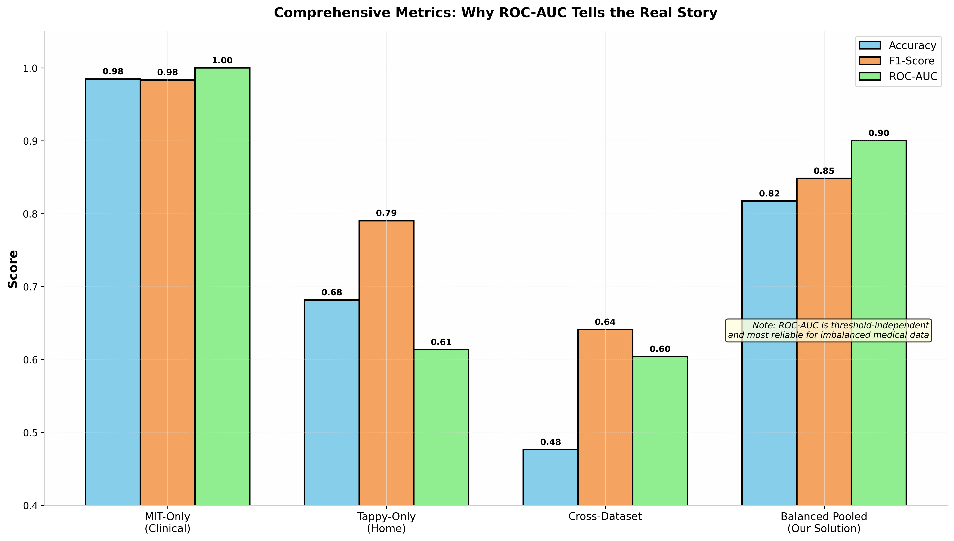
Figure 5: Comprehensive Metrics Comparison
The experimental results yield several important insights. First, clinical keystroke data, when properly collected, enables near-perfect classification—establishing keystroke dynamics as a valid PD biomarker. Second, home data alone proves too noisy for reliable diagnosis despite substantial sample sizes. Third, simple dataset combination fails catastrophically; thoughtful balancing is essential to prevent majority datasets from overwhelming minority signals.
Most significantly, the balanced pooling approach demonstrates that bridging clinical and home domains is feasible. Counterintuitively, discarding 99.7% of Tappy data (from 177,329 to 500 samples) dramatically improves generalization. This finding suggests that dataset balance outweighs raw sample quantity for multimodal fusion, offering a practical pathway for developing robust remote monitoring systems.

Experiment results:
muhammadkhan@Mac Solution-4 % python3 train_experiments.py

===== DATA SUMMARY =====
Total samples: 180446

Dataset distribution:
dataset
tappy 177329
mit_cs1 1626
mit_cs2 1491
Name: count, dtype: int64

Label distribution:
label_pd
1 128535
0 51911
Name: count, dtype: int64

Number of features used: 27
Feature names: ['updrs', 'dd_cv', 'dd_iqr', 'dd_mean', 'dd_median', 'dd_p95', 'dd_std', 'dig_KK_rate', 'dig_KS_rate', 'dig_SK_rate', 'dig_SS_rate', 'hold_cv', 'hold_iqr', 'hold_mean', 'hold_median', 'hold_p95', 'hold_std', 'n', 'pause_rate_dd_gt_1000', 'pause_rate_dd_gt_500', 'pause_rate_dd_gt_750', 'ud_cv', 'ud_iqr', 'ud_mean', 'ud_median', 'ud_p95', 'ud_std']

============================================================
Baseline 1: MIT-ONLY (SVM)
============================================================

Fold 1
Accuracy: 0.9647
F1-score: 0.9666
ROC-AUC: 0.9987

Fold 2
Accuracy: 0.9378
F1-score: 0.9193
ROC-AUC: 0.9909

Fold 3
Accuracy: 0.9710
F1-score: 0.9736
ROC-AUC: 0.9997

Fold 4
Accuracy: 0.9936
F1-score: 0.9934
ROC-AUC: 0.9997

Fold 5
Accuracy: 0.9791
F1-score: 0.9750
ROC-AUC: 0.9995

----- FINAL AVERAGE -----
Mean Accuracy: 0.9692
Mean F1-score: 0.9655
Mean ROC-AUC: 0.9977

============================================================
Baseline 1: MIT-ONLY (Random Forest)
============================================================

Fold 1
Accuracy: 0.9486
F1-score: 0.9502
ROC-AUC: 1.0000

Fold 2
Accuracy: 0.9745
F1-score: 0.9669
ROC-AUC: 1.0000

Fold 3
Accuracy: 1.0000
F1-score: 1.0000
ROC-AUC: 1.0000

Fold 4
Accuracy: 1.0000
F1-score: 1.0000
ROC-AUC: 1.0000

Fold 5
Accuracy: 1.0000
F1-score: 1.0000
ROC-AUC: 1.0000

----- FINAL AVERAGE -----
Mean Accuracy: 0.9846
Mean F1-score: 0.9834
Mean ROC-AUC: 1.0000

============================================================
Baseline 2: TAPPY-ONLY (SVM)
============================================================
/opt/homebrew/lib/python3.13/site-packages/sklearn/impute/_base.py:641: UserWarning: Skipping features without any observed values: ['updrs']. At least one non-missing value is needed for imputation with strategy='median'.
warnings.warn(
/opt/homebrew/lib/python3.13/site-packages/sklearn/impute/_base.py:641: UserWarning: Skipping features without any observed values: ['updrs']. At least one non-missing value is needed for imputation with strategy='median'.
warnings.warn(
/opt/homebrew/lib/python3.13/site-packages/sklearn/impute/_base.py:641: UserWarning: Skipping features without any observed values: ['updrs']. At least one non-missing value is needed for imputation with strategy='median'.
warnings.warn(

Fold 1
Accuracy: 0.8008
F1-score: 0.8874
ROC-AUC: 0.5533
/opt/homebrew/lib/python3.13/site-packages/sklearn/impute/_base.py:641: UserWarning: Skipping features without any observed values: ['updrs']. At least one non-missing value is needed for imputation with strategy='median'.
warnings.warn(
/opt/homebrew/lib/python3.13/site-packages/sklearn/impute/_base.py:641: UserWarning: Skipping features without any observed values: ['updrs']. At least one non-missing value is needed for imputation with strategy='median'.
warnings.warn(
/opt/homebrew/lib/python3.13/site-packages/sklearn/impute/_base.py:641: UserWarning: Skipping features without any observed values: ['updrs']. At least one non-missing value is needed for imputation with strategy='median'.
warnings.warn(

Fold 2
Accuracy: 0.7628
F1-score: 0.8497
ROC-AUC: 0.7324
/opt/homebrew/lib/python3.13/site-packages/sklearn/impute/_base.py:641: UserWarning: Skipping features without any observed values: ['updrs']. At least one non-missing value is needed for imputation with strategy='median'.
warnings.warn(
/opt/homebrew/lib/python3.13/site-packages/sklearn/impute/_base.py:641: UserWarning: Skipping features without any observed values: ['updrs']. At least one non-missing value is needed for imputation with strategy='median'.
warnings.warn(
/opt/homebrew/lib/python3.13/site-packages/sklearn/impute/_base.py:641: UserWarning: Skipping features without any observed values: ['updrs']. At least one non-missing value is needed for imputation with strategy='median'.
warnings.warn(

Fold 3
Accuracy: 0.5930
F1-score: 0.6186
ROC-AUC: 0.6417
/opt/homebrew/lib/python3.13/site-packages/sklearn/impute/_base.py:641: UserWarning: Skipping features without any observed values: ['updrs']. At least one non-missing value is needed for imputation with strategy='median'.
warnings.warn(
/opt/homebrew/lib/python3.13/site-packages/sklearn/impute/_base.py:641: UserWarning: Skipping features without any observed values: ['updrs']. At least one non-missing value is needed for imputation with strategy='median'.
warnings.warn(
/opt/homebrew/lib/python3.13/site-packages/sklearn/impute/_base.py:641: UserWarning: Skipping features without any observed values: ['updrs']. At least one non-missing value is needed for imputation with strategy='median'.
warnings.warn(

Fold 4
Accuracy: 0.7452
F1-score: 0.8464
ROC-AUC: 0.7437
/opt/homebrew/lib/python3.13/site-packages/sklearn/impute/_base.py:641: UserWarning: Skipping features without any observed values: ['updrs']. At least one non-missing value is needed for imputation with strategy='median'.
warnings.warn(
/opt/homebrew/lib/python3.13/site-packages/sklearn/impute/_base.py:641: UserWarning: Skipping features without any observed values: ['updrs']. At least one non-missing value is needed for imputation with strategy='median'.
warnings.warn(
/opt/homebrew/lib/python3.13/site-packages/sklearn/impute/_base.py:641: UserWarning: Skipping features without any observed values: ['updrs']. At least one non-missing value is needed for imputation with strategy='median'.
warnings.warn(

Fold 5
Accuracy: 0.6050
F1-score: 0.6653
ROC-AUC: 0.6603

----- FINAL AVERAGE -----
Mean Accuracy: 0.7013
Mean F1-score: 0.7735
Mean ROC-AUC: 0.6663

============================================================
Baseline 2: TAPPY-ONLY (Random Forest)
============================================================
/opt/homebrew/lib/python3.13/site-packages/sklearn/impute/_base.py:641: UserWarning: Skipping features without any observed values: ['updrs']. At least one non-missing value is needed for imputation with strategy='median'.
warnings.warn(
/opt/homebrew/lib/python3.13/site-packages/sklearn/impute/_base.py:641: UserWarning: Skipping features without any observed values: ['updrs']. At least one non-missing value is needed for imputation with strategy='median'.
warnings.warn(
/opt/homebrew/lib/python3.13/site-packages/sklearn/impute/_base.py:641: UserWarning: Skipping features without any observed values: ['updrs']. At least one non-missing value is needed for imputation with strategy='median'.
warnings.warn(

Fold 1
Accuracy: 0.8366
F1-score: 0.9094
ROC-AUC: 0.5302
/opt/homebrew/lib/python3.13/site-packages/sklearn/impute/_base.py:641: UserWarning: Skipping features without any observed values: ['updrs']. At least one non-missing value is needed for imputation with strategy='median'.
warnings.warn(
/opt/homebrew/lib/python3.13/site-packages/sklearn/impute/_base.py:641: UserWarning: Skipping features without any observed values: ['updrs']. At least one non-missing value is needed for imputation with strategy='median'.
warnings.warn(
/opt/homebrew/lib/python3.13/site-packages/sklearn/impute/_base.py:641: UserWarning: Skipping features without any observed values: ['updrs']. At least one non-missing value is needed for imputation with strategy='median'.
warnings.warn(

Fold 2
Accuracy: 0.7952
F1-score: 0.8756
ROC-AUC: 0.7621
/opt/homebrew/lib/python3.13/site-packages/sklearn/impute/_base.py:641: UserWarning: Skipping features without any observed values: ['updrs']. At least one non-missing value is needed for imputation with strategy='median'.
warnings.warn(
/opt/homebrew/lib/python3.13/site-packages/sklearn/impute/_base.py:641: UserWarning: Skipping features without any observed values: ['updrs']. At least one non-missing value is needed for imputation with strategy='median'.
warnings.warn(
/opt/homebrew/lib/python3.13/site-packages/sklearn/impute/_base.py:641: UserWarning: Skipping features without any observed values: ['updrs']. At least one non-missing value is needed for imputation with strategy='median'.
warnings.warn(

Fold 3
Accuracy: 0.4783
F1-score: 0.6172
ROC-AUC: 0.5263
/opt/homebrew/lib/python3.13/site-packages/sklearn/impute/_base.py:641: UserWarning: Skipping features without any observed values: ['updrs']. At least one non-missing value is needed for imputation with strategy='median'.
warnings.warn(
/opt/homebrew/lib/python3.13/site-packages/sklearn/impute/_base.py:641: UserWarning: Skipping features without any observed values: ['updrs']. At least one non-missing value is needed for imputation with strategy='median'.
warnings.warn(
/opt/homebrew/lib/python3.13/site-packages/sklearn/impute/_base.py:641: UserWarning: Skipping features without any observed values: ['updrs']. At least one non-missing value is needed for imputation with strategy='median'.
warnings.warn(

Fold 4
Accuracy: 0.7589
F1-score: 0.8597
ROC-AUC: 0.7186
/opt/homebrew/lib/python3.13/site-packages/sklearn/impute/_base.py:641: UserWarning: Skipping features without any observed values: ['updrs']. At least one non-missing value is needed for imputation with strategy='median'.
warnings.warn(
/opt/homebrew/lib/python3.13/site-packages/sklearn/impute/_base.py:641: UserWarning: Skipping features without any observed values: ['updrs']. At least one non-missing value is needed for imputation with strategy='median'.
warnings.warn(
/opt/homebrew/lib/python3.13/site-packages/sklearn/impute/_base.py:641: UserWarning: Skipping features without any observed values: ['updrs']. At least one non-missing value is needed for imputation with strategy='median'.
warnings.warn(

Fold 5
Accuracy: 0.5384
F1-score: 0.6895
ROC-AUC: 0.5293

----- FINAL AVERAGE -----
Mean Accuracy: 0.6815
Mean F1-score: 0.7903
Mean ROC-AUC: 0.6133

============================================================
EXPERIMENT 3: CROSS-DATASET GENERALISATION
============================================================

Train: TAPPY → Test: MIT
/opt/homebrew/lib/python3.13/site-packages/sklearn/impute/_base.py:641: UserWarning: Skipping features without any observed values: ['updrs']. At least one non-missing value is needed for imputation with strategy='median'.
warnings.warn(
/opt/homebrew/lib/python3.13/site-packages/sklearn/impute/_base.py:641: UserWarning: Skipping features without any observed values: ['updrs']. At least one non-missing value is needed for imputation with strategy='median'.
warnings.warn(
/opt/homebrew/lib/python3.13/site-packages/sklearn/impute/_base.py:641: UserWarning: Skipping features without any observed values: ['updrs']. At least one non-missing value is needed for imputation with strategy='median'.
warnings.warn(
/opt/homebrew/lib/python3.13/site-packages/sklearn/impute/_base.py:641: UserWarning: Skipping features without any observed values: ['updrs']. At least one non-missing value is needed for imputation with strategy='median'.
warnings.warn(

SVM Results:
Accuracy: 0.4774
F1-score: 0.6463
ROC-AUC: 0.5301
/opt/homebrew/lib/python3.13/site-packages/sklearn/impute/_base.py:641: UserWarning: Skipping features without any observed values: ['updrs']. At least one non-missing value is needed for imputation with strategy='median'.
warnings.warn(
/opt/homebrew/lib/python3.13/site-packages/sklearn/impute/_base.py:641: UserWarning: Skipping features without any observed values: ['updrs']. At least one non-missing value is needed for imputation with strategy='median'.
warnings.warn(

Random Forest Results:
Accuracy: 0.4764
F1-score: 0.641
ROC-AUC: 0.6041

============================================================
EXPERIMENT 4: BALANCED POOLED MODEL
============================================================

============================================================
Balanced Model (SVM)
============================================================

Fold 1
Accuracy: 0.7706
F1-score: 0.7963
ROC-AUC: 0.8503

Fold 2
Accuracy: 0.7386
F1-score: 0.7773
ROC-AUC: 0.8641

Fold 3
Accuracy: 0.8797
F1-score: 0.8750
ROC-AUC: 0.9531

Fold 4
Accuracy: 0.8557
F1-score: 0.9164
ROC-AUC: 0.8484

Fold 5
Accuracy: 0.8315
F1-score: 0.8458
ROC-AUC: 0.9386

----- FINAL AVERAGE -----
Mean Accuracy: 0.8152
Mean F1-score: 0.8422
Mean ROC-AUC: 0.8909

============================================================
Balanced Model (Random Forest)
============================================================

Fold 1
Accuracy: 0.8284
F1-score: 0.8540
ROC-AUC: 0.8685

Fold 2
Accuracy: 0.6584
F1-score: 0.7090
ROC-AUC: 0.8470

Fold 3
Accuracy: 0.9158
F1-score: 0.9195
ROC-AUC: 0.9769

Fold 4
Accuracy: 0.8789
F1-score: 0.9307
ROC-AUC: 0.9036

Fold 5
Accuracy: 0.8042
F1-score: 0.8289
ROC-AUC: 0.9051

----- FINAL AVERAGE -----
Mean Accuracy: 0.8171
Mean F1-score: 0.8484
Mean ROC-AUC: 0.9002
muhammadkhan@Mac Solution-4 %

