FINAL EXAM PORTFOLIO
ITAI 4370
Telecommunications, Artificial Intelligence, and Next-Generation Networks
Elizabeth Carrillo
Houston City College
Instructor: ______________________________
July 2026
Required submission filename: FE Elizabeth Carrillo ITAI 4370.pdf

Portfolio Note
This portfolio documents my activities and learning across the ITAI 4370 course modules. It combines summaries of the lecture materials, assigned readings, written assignments, and Python laboratories. The figures created for this portfolio are based on course-provided concepts and code. Where exact screenshots from my original Canvas submissions were not available, I included recreated graphs or clearly identified evidence that can be replaced with my original screenshots before submission.

Table of Contents
Introduction
Module 1: Telecommunications Fundamentals
Module 2: Network Architecture and Wireless Basics
Module 3: AI and Machine Learning Fundamentals for Telecommunications
Module 4: 5G Network Architecture and AI Integration
Module 5: Open RAN and AI-Driven Networks
Module 6: AI for Network Optimization and Management
Module 7: IoT and Edge Computing with AI
Module 8: Cybersecurity and AI in Telecommunications
Module 9: Sustainable AI and Green Communications
Module 10: Advanced AI Applications in Next-Generation Networks
Module 11: 6G Vision and AI-Native Networks
Module 13: Ethical AI and Future Trends
Module 14: Course Review and Final Project
Overall Course Reflection
References
Appendix: Evidence Checklist

Introduction
ITAI 4370 connected traditional telecommunications concepts with artificial intelligence, machine learning, 5G, Open RAN, edge computing, cybersecurity, sustainability, and the developing vision for 6G. At the beginning of the course, I understood that networks move information between devices, but I did not yet see how many layers of design and decision-making are required to make that communication reliable. The course helped me understand the complete path from a source and transmitter to radio access, core-network functions, edge processing, applications, security, and optimization.
The laboratories were especially valuable because they changed the topics from definitions into measurable results. I used Python to model free-space path loss, generate synthetic network traffic, train a supervised-learning model, evaluate time-series forecasting methods, and compare neural-network architectures for edge devices. These activities showed me that network engineering involves both physical communication limits and data-driven decisions.
This portfolio is organized by the module structure shown in Canvas. Each section explains the activities I completed, the main results, and what I learned from the experience. Modules without a separate graded assignment are represented through their class presentations and assigned readings. Module 12 was not listed in the course modules provided in Canvas, so the portfolio follows the numbering used by the course and continues from Module 11 to Module 13.

MODULE 1
Telecommunications Fundamentals

Module Overview
Module 1 introduced the purpose, structure, and performance of telecommunications systems. The class presentation and practical example explained how information moves from a source to a destination and how the transmitter, channel, and receiver each affect the final result. This module also introduced analog and digital communication, major communication types, and common network topologies.

Activities Completed
- Assignment 01: five written questions on telecommunications systems, communication components, analog versus digital communication, information types, and network topologies.
- Laboratory 01: conceptual communication-system diagram using Draw.io or Lucidchart and signal-flow analysis using Python Matplotlib.

Assignment 01 - Key Concepts
A telecommunications system is a collection of devices, software, transmission media, and procedures used to exchange information across distance. Its modern scope includes voice calls, internet data, video streaming, mobile networks, satellite links, enterprise systems, and machine-to-machine communication. The basic communication model contains a transmitter that prepares the signal, a channel that carries it, and a receiver that reconstructs the information.
I compared analog and digital communication. Analog systems represent information with continuously changing signals, while digital systems represent information with discrete values, usually binary bits. Important performance measurements include bandwidth, noise, latency, throughput, reliability, signal-to-noise ratio, and error rate. I also learned that voice, data, video, and multimedia have different requirements. For example, real-time voice and video require low latency, while a file transfer can tolerate more delay but still requires accurate delivery.
Network topology affects the performance and resilience of the complete system. A star topology is simple to manage but depends on its central device. A mesh topology offers several possible paths and strong fault tolerance but is more expensive. Ring and bus topologies can be useful in specific designs, although they are generally less flexible when a network must expand.

Laboratory 01 - Communication Flow
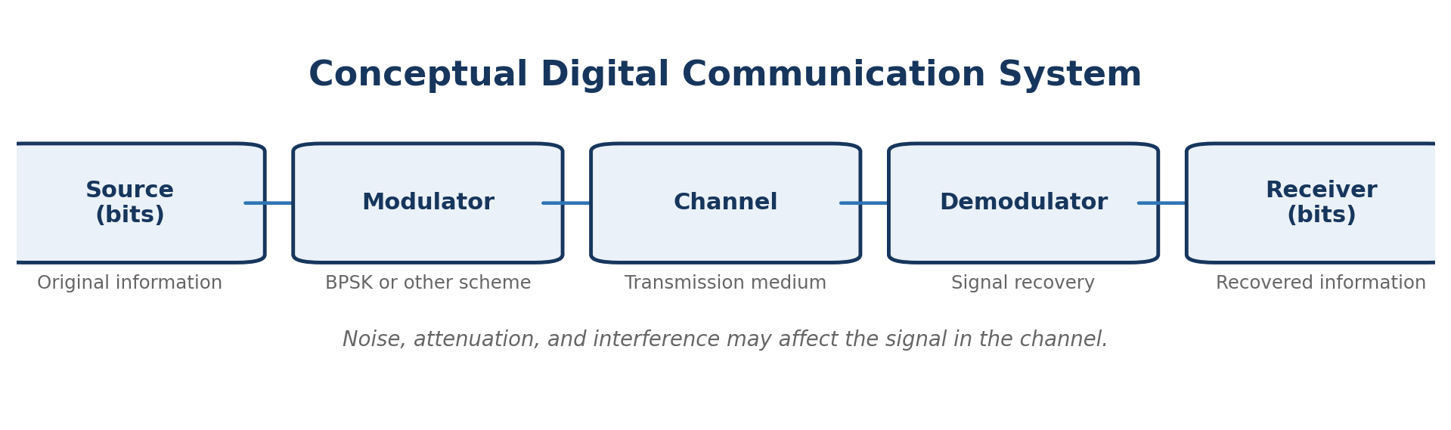
Figure 1. Recreated conceptual communication-system diagram based on Laboratory 01.
The laboratory helped me see that each block changes or protects the information in a different way. The source creates bits, the modulator converts them into a signal that can travel through the channel, the channel introduces possible noise or attenuation, and the demodulator and receiver recover the information. Labeling the diagram with BPSK modulation and channel noise connected the visual model to a realistic digital system.

What I Learned
The main lesson from this module was that successful communication depends on the complete system rather than one device. A strong transmitter cannot fully correct a poor channel, and a receiver must be designed for the type of signal it is expected to recover. I also learned that every network design includes tradeoffs among cost, reliability, speed, and scalability. These fundamentals became the base for the later modules on wireless propagation, 5G, Open RAN, and AI-based optimization.

Course Materials Used
- Module1_Telecom_Fundamentals_with_Frequent_Diagrams.pptx
- Practical Example.pdf
- Assignment 01 instructions
- Laboratory 01 instructions and course-provided Python activity

MODULE 2
Network Architecture and Wireless Basics

Module Overview
Module 2 connected network structure with wireless signal behavior. The presentation and exercises introduced how devices are organized in a network, how radio signals propagate, and why coverage changes with distance and frequency. The graded activities also began introducing 5G core-network concepts.

Activities Completed
- Laboratory 02: Free-Space Path Loss modeling at 2.4 GHz using NumPy and Matplotlib.
- Assignment 02: EPC versus 5GC, network slicing, MEC, AI-based resource allocation, and the Network Repository Function.

Laboratory 02 - Free-Space Path Loss
The laboratory used the standard free-space path-loss equation: FSPL(dB) = 20 log10(d) + 20 log10(f) + 32.44, where distance is measured in kilometers and frequency is measured in megahertz. The Python code evaluated a 2.4 GHz signal from 0.1 km through 20 km. The graph shows that path loss increases logarithmically as distance increases.
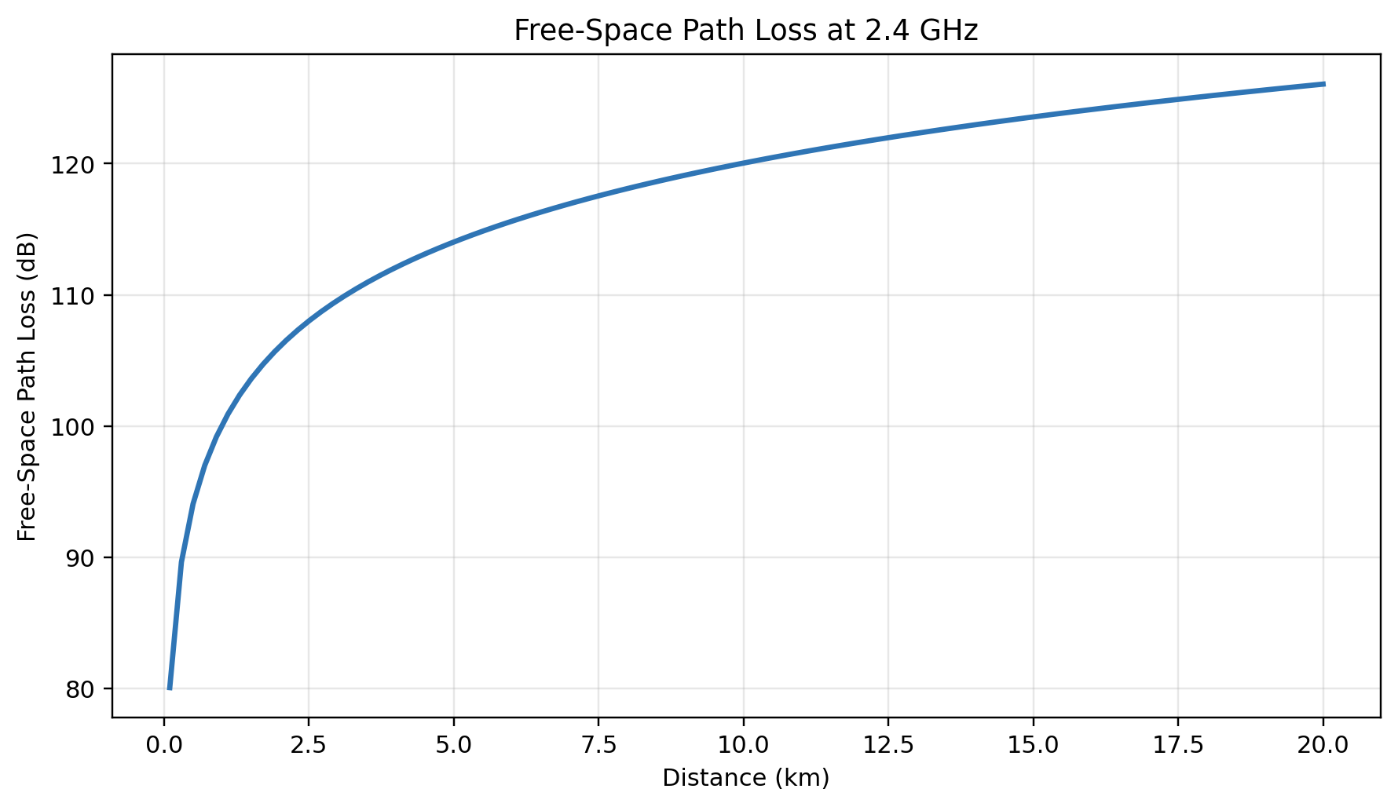
Figure 2. Free-space path loss at 2.4 GHz generated from the Laboratory 02 formula and parameters.
Distance (km) | FSPL at 2.4 GHz (dB)
0.1 | 80.04
1 | 100.04
5 | 114.02
10 | 120.04
20 | 126.06

The calculated loss is approximately 80.05 dB at 0.1 km, 100.05 dB at 1 km, and 126.07 dB at 20 km. This does not mean that communication automatically fails at a particular distance. It means the link budget must account for the increasing loss through antenna gain, transmit power, receiver sensitivity, coding, and the actual environment.

Assignment 02 - 4G and 5G Architecture
The Evolved Packet Core used in 4G is more centralized and contains functions such as the MME, Serving Gateway, and Packet Data Network Gateway. The 5G Core uses a service-based architecture in which network functions communicate through standardized services. This makes 5GC more flexible for automation, cloud deployment, network slicing, and different service requirements.
Network slicing allows one physical network to support separate logical networks. A low-latency slice can support industrial control or connected vehicles, while another slice can prioritize massive numbers of IoT devices. Multi-access Edge Computing reduces delay by processing data closer to the user instead of sending every request to a distant cloud location. AI can then support dynamic resource allocation by predicting demand and assigning spectrum, processing capacity, or bandwidth where it is needed most.
In the 5G service-based architecture, the Network Repository Function maintains information about available network functions and their services. Other functions can use the NRF to discover the appropriate service rather than depending on a fixed connection.

What I Learned
This module showed me that wireless coverage is controlled by physical limits, while modern network architecture tries to use available resources more intelligently. The FSPL lab made the distance-versus-loss relationship visible. Assignment 02 showed how 5G adds flexibility above the radio link through service discovery, edge computing, slicing, and AI-based scheduling.

Course Materials Used
- Module2_Network_Wireless_Basics.pptx
- Exercises.pdf
- Laboratory 02 instructions and Python code
- Assignment 02 instructions

MODULE 3
AI and Machine Learning Fundamentals for Telecommunications

Module Overview
Module 3 introduced artificial intelligence and machine learning as tools for analyzing telecommunications data and making network decisions. The module covered supervised learning, feature engineering, training and testing data, model evaluation, and applications in radio access networks.

Activities Completed
- Assignment 03: AI/ML in radio resource management and Open RAN reliability, SON, predictive maintenance, normalized resource allocation, traditional RAN versus Open RAN, and RIC roles.
- Laboratory 03: supervised network-traffic prediction using a Random Forest regressor.

Assignment 03 - AI/ML in the RAN
AI and machine learning can improve radio resource management by predicting demand and assigning spectrum or scheduling opportunities according to traffic conditions. They can improve reliability by detecting abnormal behavior, forecasting equipment problems, and supporting self-healing responses. In a Self-Organizing Network, self-optimization continually adjusts settings such as handovers or power levels, while self-healing detects faults and attempts recovery or rerouting.
Normalizing user demand in a resource-allocation simulation places different demand values on a comparable scale. This prevents a user with a numerically larger raw value from automatically dominating the allocation and helps the scheduling method divide limited resources according to relative demand. In a real Open RAN system, similar scaling and prioritization can support fair and efficient decisions.
Traditional RAN systems are usually more integrated and vendor-specific. Open RAN separates the Radio Unit, Distributed Unit, and Centralized Unit and uses open interfaces. The Near-Real-Time RIC can run xApps for faster control actions, while the Non-Real-Time RIC can run rApps for longer-term policy, learning, and optimization.

Laboratory 03 - Random Forest Traffic Prediction
The laboratory generated synthetic hourly traffic for one year. The dataset included daily, weekly, annual, and business-hour patterns plus random noise. Feature engineering added traffic from one hour earlier, traffic from 24 hours earlier, and a seven-day rolling average. The data was split chronologically so the first 80 percent trained the model and the final 20 percent tested it.
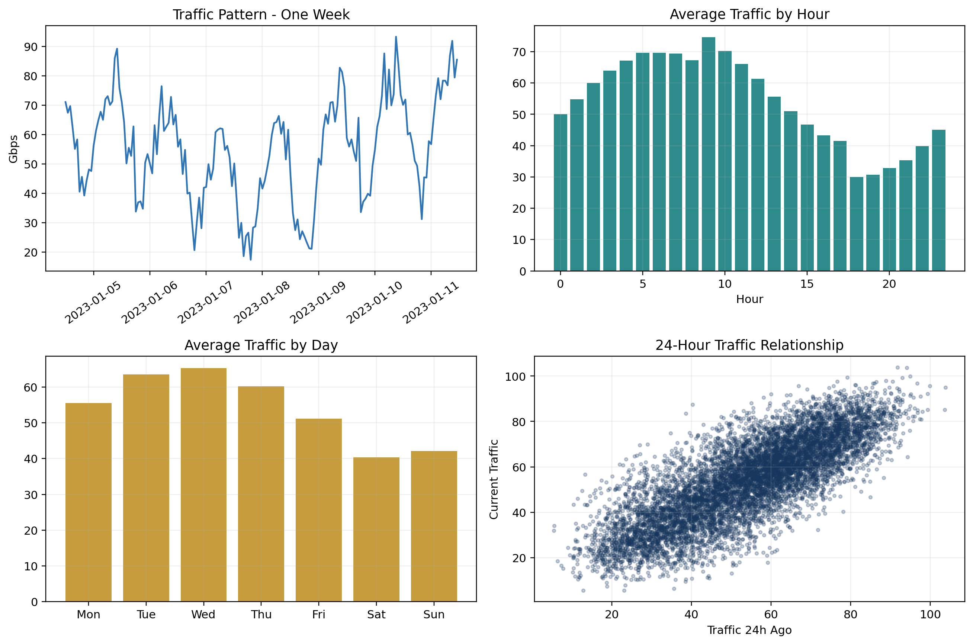
Figure 3. Exploratory analysis of the synthetic network-traffic dataset used in Laboratory 03.
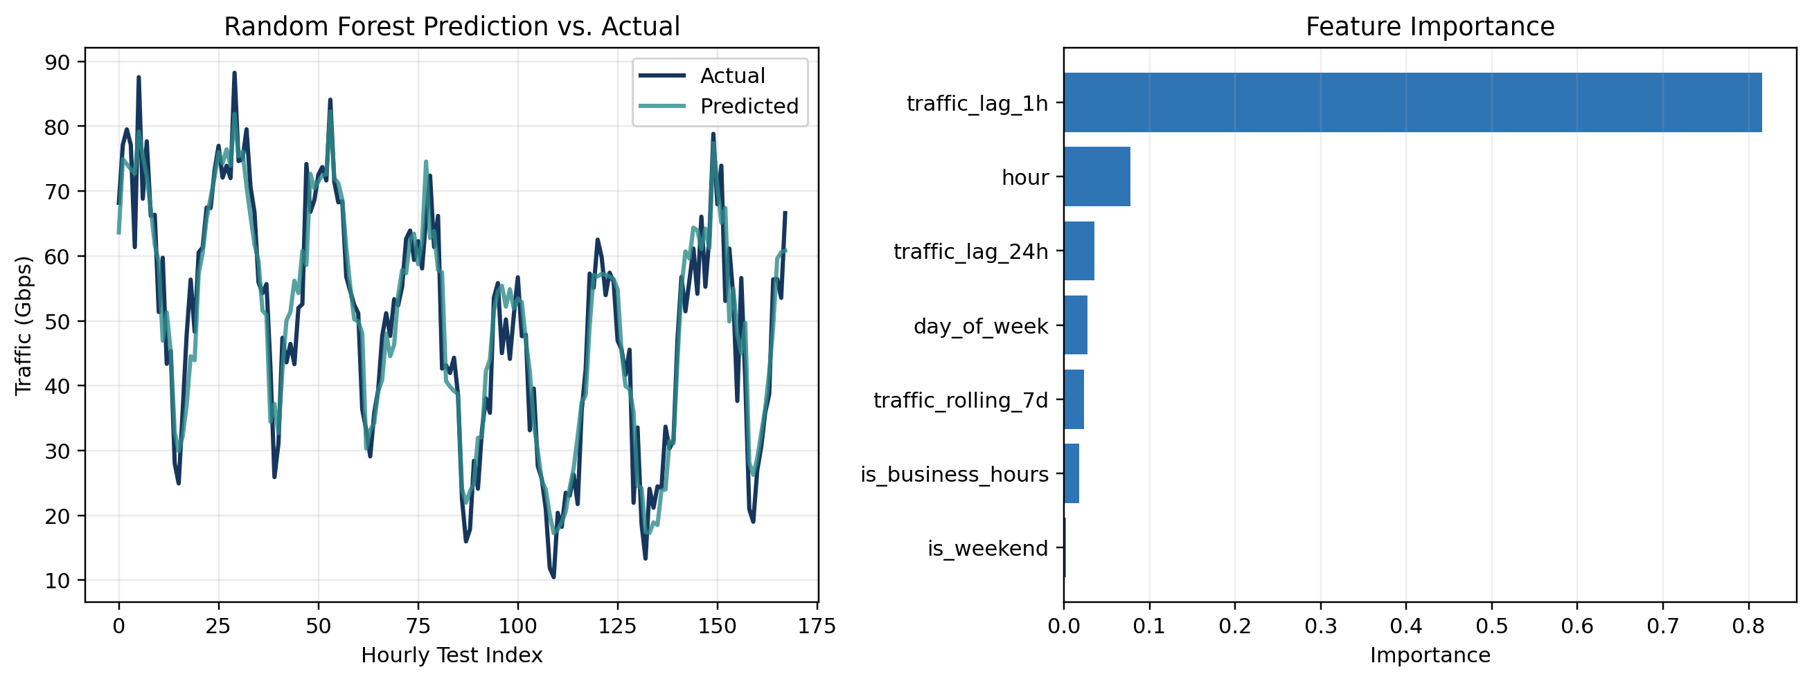
Figure 4. Random Forest predictions and calculated feature importance for Laboratory 03.
Metric | Result
Dataset after removing missing values | 8,570 rows
Training MSE | 17.59
Testing MSE | 34.64
Training R-squared | 0.946
Testing R-squared | 0.893
Most important feature | traffic_lag_1h (0.816)

The testing R-squared was approximately 0.893, meaning the model explained a large amount of the variation in the synthetic test data. The previous hour of traffic was the strongest feature, which is reasonable because network demand often changes gradually from one hour to the next. The difference between training and testing performance also demonstrated why a model must be evaluated on data it did not use during training.

What I Learned
This module made machine learning feel practical instead of abstract. I learned that the quality of a prediction depends on the features, the way data is split, and the evaluation metrics. I also learned that a model is not useful only because it has a high score. The network engineer must understand what information the model is using and whether that information will be available at the time of a real prediction.

Course Materials Used
- Module3_AI_ML_Telecom.pptx
- Exercise 3_1 to 3_3.pdf
- Assignment 03 instructions
- Laboratory 03 course-provided Python code

MODULE 4
5G Network Architecture and AI Integration

Module Overview
Module 4 expanded the 5G concepts introduced in Assignment 02. The lecture and readings focused on 5G architecture, AI-assisted load balancing, IoT integration, smart-grid applications, and the use of edge resources. The main idea was that 5G is not only a faster radio technology. It is also a programmable platform that supports different services and allows intelligence to be integrated into network management.
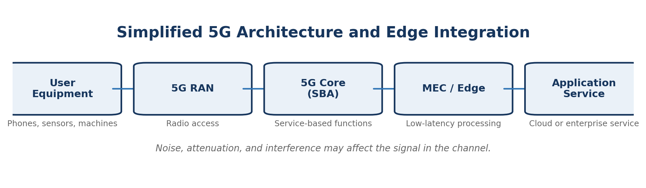
Figure 5. Simplified 5G architecture showing radio access, the service-based core, MEC, and applications.

Activities and Results
I reviewed the Module 4 presentation, the hands-on exercise, and the assigned research on AI-driven load balancing and the integration of AI, IoT, and 5G in smart grids. These materials showed how AI can observe traffic conditions and move workloads or assign resources before a network becomes severely congested. They also showed why edge computing matters for services that cannot wait for a distant cloud response.
A smart-grid example helped connect the architecture to a real system. Sensors, meters, and control devices can send large amounts of data through the network. AI can detect abnormal conditions, forecast demand, and support faster decisions. The 5G network can provide separate service behavior for critical control, routine monitoring, and consumer applications.

What I Learned
I learned to view 5G as a combination of radio access, cloud-native core functions, edge computing, automation, and service requirements. The architecture is valuable because it can be adjusted for different use cases instead of treating every device and application the same. AI integration is most useful when it is connected to a specific objective such as reducing latency, preventing overload, or improving reliability.

Course Materials Used
- Module_4_5G_AI_Integration.pptx
- Hands On Exercise.pdf
- AI-Driven Load Balancing in Paravirtualized 5G Networks.pdf
- Integrating Artificial Intelligence, Internet of Things and 5G for Next-Generation Smart Grid: A Survey of Trends, Challenges and Prospects.pdf

MODULE 5
Open RAN (ORAN) and AI-Driven Networks

Module Overview
Module 5 focused on Open RAN architecture and the use of intelligent controllers. Open RAN separates major radio-access functions and promotes standardized interfaces. This creates more opportunities for software-based optimization and for components from different vendors to work together.
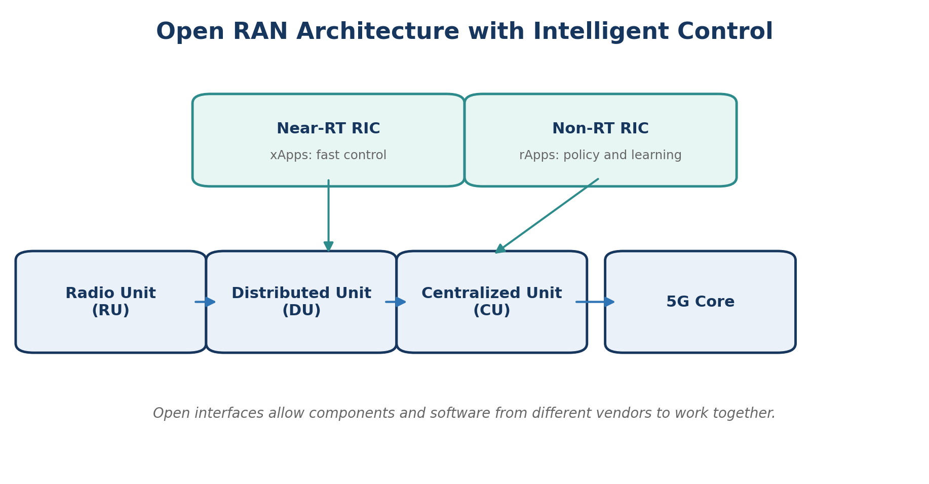
Figure 6. Simplified Open RAN architecture with Near-RT and Non-RT RIC functions.

Activities and Results
The presentation and readings compared traditional RAN design with a more open and disaggregated approach. I reviewed the roles of the Radio Unit, Distributed Unit, Centralized Unit, Near-Real-Time RIC, and Non-Real-Time RIC. I also connected these concepts to the questions in Assignment 03 about interoperability and AI-based control.
The Near-RT RIC is intended for control loops that require faster reactions, such as optimizing scheduling or handover behavior through xApps. The Non-RT RIC works at a longer time scale and can support policy, model training, analytics, and optimization through rApps. Open interfaces make it possible to introduce new applications without replacing the entire RAN platform.

What I Learned
The most important lesson was that openness is not only about using multiple vendors. It also changes how the network can evolve. A software application can improve one part of network behavior, and standardized interfaces give operators more control over how that application communicates with the RAN. At the same time, interoperability, testing, security, and integration become important challenges because more separate components must work correctly together.

Course Materials Used
- Module5_OpenRAN_AI.pptx
- Advancements in Mobile Edge Computing.pdf
- From DeepSense to Open RAN.pdf
- Assignment 03 Open RAN questions

MODULE 6
AI for Network Optimization and Management

Module Overview
Module 6 examined how AI can support traffic forecasting, load balancing, resource allocation, anomaly detection, fault prediction, and network management. Laboratory 04 applied time-series analysis to the same general problem as Laboratory 03 but compared forecasting approaches designed for sequential data.

Activity Completed - Laboratory 04
The laboratory generated 365 days of hourly network traffic with daily activity, weekday and weekend differences, a long-term trend, seasonal changes, random noise, and occasional congestion spikes. I performed exploratory analysis, seasonal decomposition, chronological train/test splitting, an Augmented Dickey-Fuller stationarity test, ARIMA forecasting, and linear regression with engineered features. The lab also introduced LSTM sequence modeling conceptually.
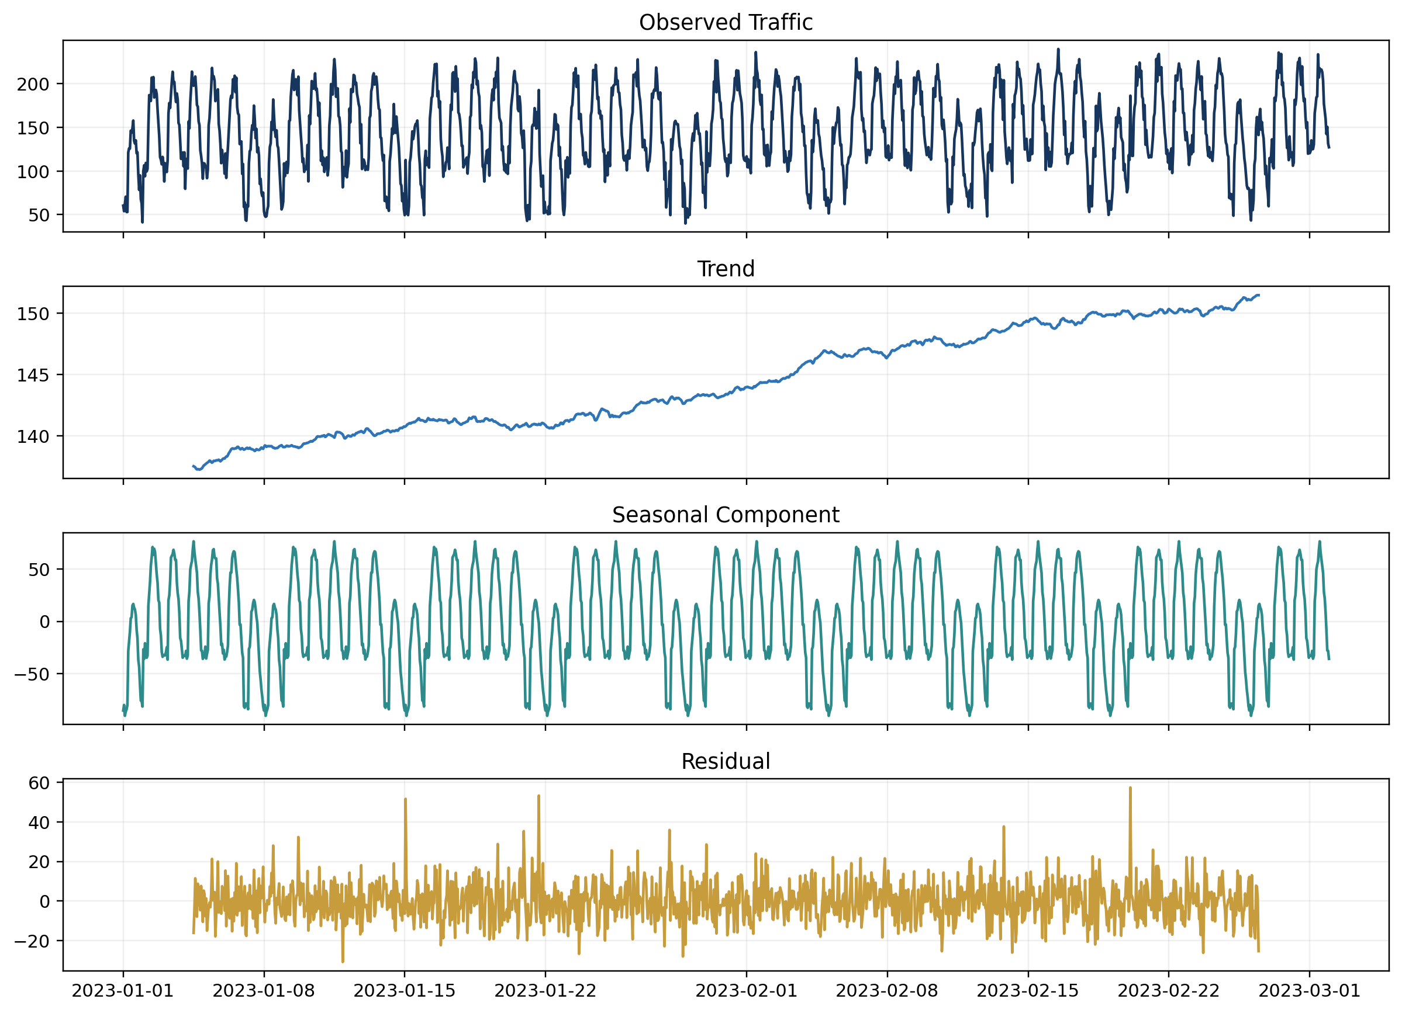
Figure 7. Seasonal decomposition of the simulated traffic series into observed, trend, seasonal, and residual components.
The Augmented Dickey-Fuller test produced a statistic of -12.832 and a p-value below 0.001 for the generated training series. Under the test assumptions, this supported treating the series as stationary for the laboratory data. The decomposition also made it easier to separate repeating behavior from the long-term pattern and random residual changes.
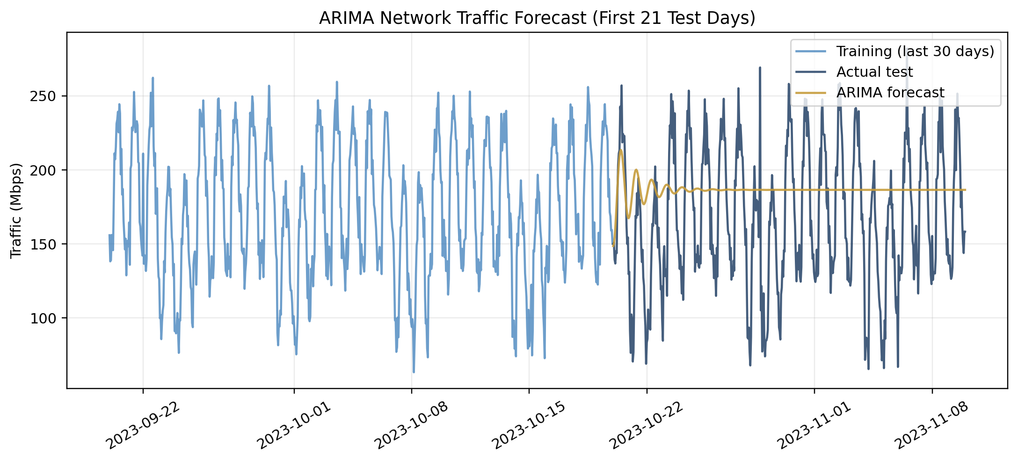
Figure 8. ARIMA(2,1,2) forecast compared with the simulated test traffic.
ARIMA Metric | Result
MSE | 2604.37
MAE | 42.38
RMSE | 51.03

The ARIMA model provided a baseline forecast, but the simulated data contained strong daily and weekly patterns, a changing trend, and spikes that a simple non-seasonal ARIMA configuration did not capture well. This result showed why model selection must match the structure of the data. A seasonal model, additional external features, or a supervised model can be more appropriate when traffic has several repeating patterns.
The feature-engineered linear-regression section also taught an important data-quality lesson. Rolling averages used for prediction should be based only on earlier observations. If a rolling feature includes the current target value, the model receives information that would not be available in a real future forecast. This type of data leakage can make evaluation results look unrealistically strong.

What I Learned
Laboratory 04 showed that time-series forecasting is not only about selecting an algorithm. It requires understanding trend, seasonality, stationarity, anomalies, feature timing, and the difference between fitting historical data and predicting genuinely future values. In network operations, these predictions could help schedule capacity, prepare for peak demand, and detect unusual events before they cause a larger service problem.

Course Materials Used
- Module_6_AI_Network_Optimization_Notes.pptx
- Exploring the Potential of AI-Driven Optimization in Enhancing Network Performance.pdf
- AI-Driven Load Balancing in Paravirtualized 5G Networks.pdf
- Laboratory 04 course-provided Python code

MODULE 7
IoT and Edge Computing with AI

Module Overview
Module 7 focused on processing IoT data closer to where it is generated. Edge computing can reduce latency, limit unnecessary network traffic, support privacy, and allow a system to continue operating when the cloud connection is slow or unavailable. The challenge is that edge devices usually have less memory, processing power, and energy than cloud servers.

Activity Completed - Laboratory 05
Laboratory 05 generated an IoT sensor-classification dataset with 10,000 samples, 20 features, and three classes. The code trained a larger baseline neural network and created smaller architectures representing pruning or reduction and a student model. It also converted the baseline model to TensorFlow Lite with INT8 quantization and compared accuracy, inference time, model size, and parameter count.
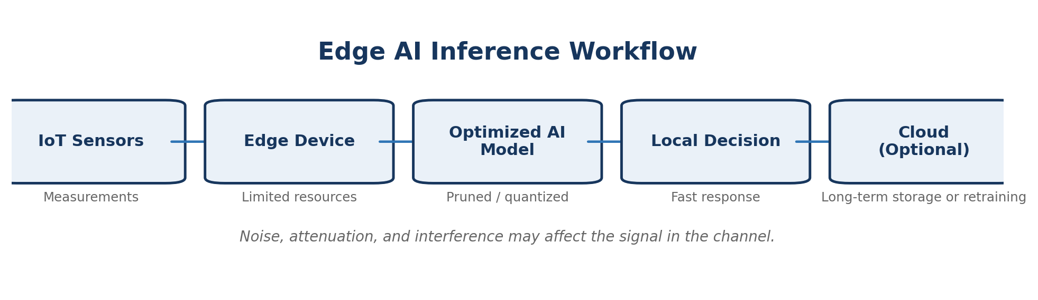
Figure 9. General edge-AI inference workflow for IoT devices.
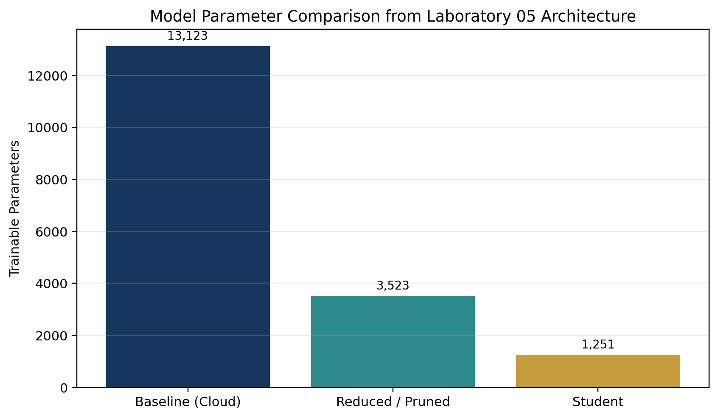
Figure 10. Parameter counts calculated from the neural-network architectures in Laboratory 05.
Architecture | Trainable Parameters | Approx. Float32 Weight Size
Baseline cloud model | 13,123 | 51.26 KB
Reduced / “pruned” model | 3,523 | 13.76 KB
Student model | 1,251 | 4.89 KB

The architecture comparison demonstrates why a smaller model can be better for an edge device even when the largest model offers the highest possible accuracy. A microcontroller may require an INT8 quantized model with a very small memory footprint. An edge gateway can use a reduced or student architecture, while an edge server can support a larger model when accuracy is the main priority.
The code describes the smaller network as a pruned model, although it reduces the layer sizes rather than removing individual trained weights. It also defines a distillation loss, but the student model is trained with the normal sparse categorical cross-entropy loss in the provided implementation. These details helped me understand the difference between the goal of an optimization technique and the exact steps required to implement it fully.

What I Learned
The major lesson was that model deployment is a systems decision. Accuracy must be considered together with model size, energy use, inference time, hardware limits, and the consequences of delay. Edge AI is valuable because it can make local decisions quickly, but the model must be designed for the device where it will actually run.

Course Materials Used
- Module7_IoT_Edge_AI.pptx
- AI Article.pdf
- BrainyEdge.pdf
- Laboratory 05 course-provided Python and TensorFlow code

MODULE 8
Cybersecurity and AI in Telecommunications

Module Overview
Module 8 examined the security risks created by connected telecommunications systems and the ways AI can support detection and response. Threats can target devices, radio access, software, cloud infrastructure, user identities, and data. AI can analyze large amounts of telemetry, but AI systems also create new risks if they are poorly trained, manipulated, or trusted without human review.
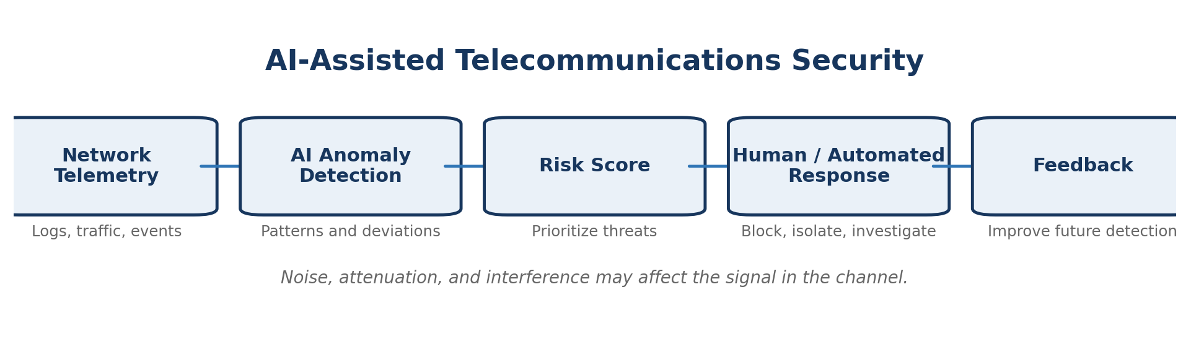
Figure 11. AI-assisted security workflow from telemetry collection to response and feedback.

Activities and Results
I reviewed examples of denial-of-service attacks, malware, spoofing, unauthorized access, data theft, and abnormal traffic behavior. An AI-assisted security system can learn normal patterns and identify deviations that require investigation. It can also assign risk scores so the most serious events are handled first.
However, the result of an AI detector is not automatically the truth. False positives can interrupt legitimate service, while false negatives can allow a real attack to continue. Adversarial inputs, poisoned training data, and weak access controls can also compromise the security model. Strong cybersecurity therefore requires defense in depth, identity controls, encryption, monitoring, model governance, and human oversight.

What I Learned
I learned that AI is most useful as one layer of the security process. It can increase speed and visibility, but it must be tested and monitored like any other critical system. Telecommunications security is especially important because a network problem can affect many users and connected services at the same time.

Course Materials Used
- Module_8_Cybersecurity_and_AI_in_Telecommunications.pptx

MODULE 9
Sustainable AI and Green Communications

Module Overview
Module 9 connected network performance with energy use and environmental impact. Telecommunications infrastructure, data centers, radios, and AI workloads all consume power. Sustainable design attempts to provide needed service while reducing unnecessary computation, transmission, and equipment use.
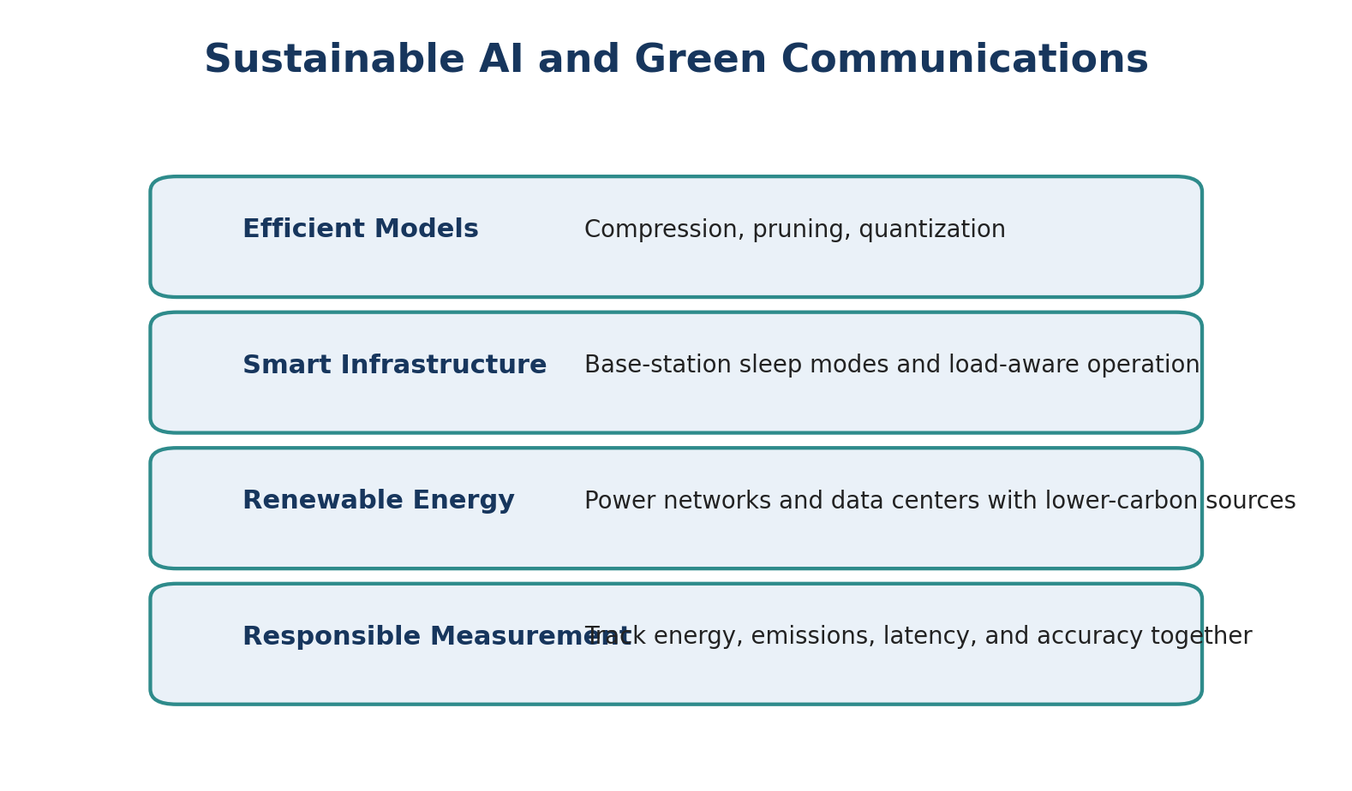
Figure 12. Four strategies for more sustainable AI and communications systems.

Activities and Results
The class presentation, code, sustainability paper, and article introduced methods such as energy-aware routing, base-station sleep modes, renewable-energy integration, model compression, and efficient hardware. These methods show that sustainability can be improved at several levels: the AI model, the network algorithm, the physical infrastructure, and the energy source.
A useful evaluation should measure more than accuracy or throughput. It can also include energy per inference, power consumption, carbon intensity, hardware utilization, latency, and service quality. A system that saves energy but causes unacceptable delay is not successful, and a system that increases accuracy by a very small amount while multiplying energy use may not be responsible.

What I Learned
I learned that future network design should treat energy as a limited resource rather than an invisible cost. AI can increase energy consumption, but it can also help networks operate more efficiently by predicting demand and turning resources on only when they are needed. The best design balances performance, reliability, and environmental responsibility.

Course Materials Used
- Module_9_Sustainable_AI_and_Green_Communications.pptx
- Code.txt
- sustainability-13-08952-v3.pdf
- Article.pdf

MODULE 10
Advanced AI Applications in Next-Generation Networks

Module Overview
Module 10 examined advanced applications including AI-native multi-access networks, digital twin networks, predictive orchestration, and autonomous management. The assigned REASON architecture and digital-twin survey demonstrated how future systems may use models of the network itself to test decisions before applying them to live infrastructure.

Activities and Results
I reviewed the module presentation, the REASON architecture paper, the 6G digital-twin survey, and the midterm project materials. A digital twin can combine topology, device state, traffic, radio conditions, and historical behavior in a virtual representation. Engineers can use the representation to simulate configuration changes, predict failures, and compare optimization strategies without immediately risking the operational network.
AI-native networking means intelligence is designed into the architecture rather than attached after deployment. Data collection, model execution, policy, and feedback become part of the normal control process. This can support closed-loop management in which the system observes conditions, selects an action, measures the result, and improves future decisions.

What I Learned
This module helped me understand why a digital twin is more than a diagram or static model. It must remain connected to real data and be accurate enough to support decisions. I also learned that autonomous operation still requires limits, validation, and the ability for people to review or override decisions when the consequences are significant.

Evidence Placeholder
Before final submission, I can insert one screenshot or summary page from my Midterm Project here to show the specific architecture, analysis, or result I submitted in Canvas.

Course Materials Used
- Module10_Advanced_AI_Applications_in_Networks.pptx
- AI-Native Multi-Access Future Networks: The REASON Architecture.pdf
- A Comprehensive Survey on Revolutionizing Connectivity Through Artificial Intelligence-Enabled Digital Twin Network in 6G.pdf
- Mid Term.txt and Midterm Project materials

MODULE 11
6G Vision and AI-Native Networks

Module Overview
Module 11 explored the developing vision for 6G and the idea that future networks may be AI-native. The module included a quiz and introduced expected research areas such as integrated sensing and communication, digital twins, immersive services, extreme connectivity, very low latency, and higher-frequency communication.
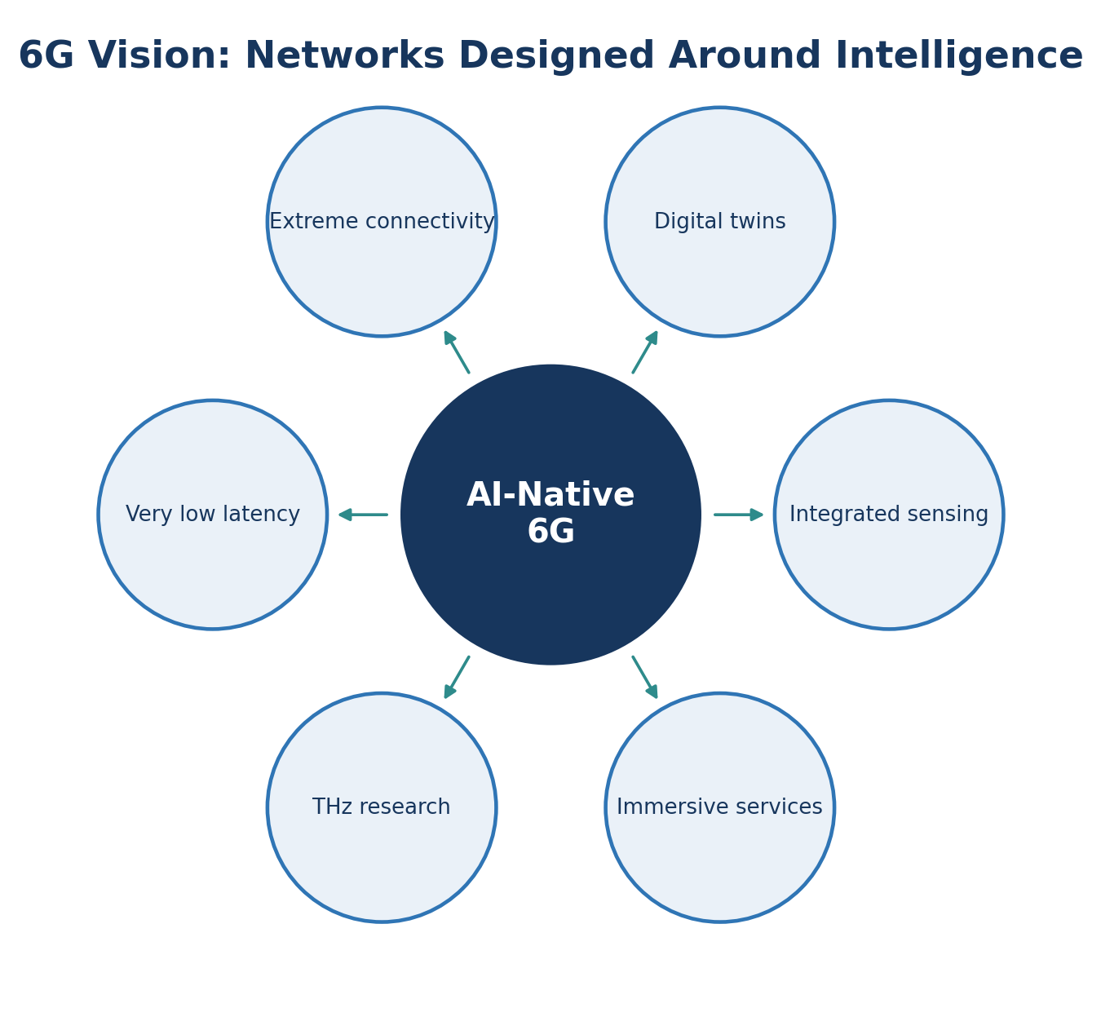
Figure 13. Selected concepts commonly associated with the AI-native 6G vision discussed in Module 11.

Activities and Results
I reviewed how 6G goals extend beyond simply increasing data rate. A future network may need to sense the environment, support digital representations of physical systems, coordinate large numbers of intelligent devices, and provide dependable service for applications that combine communication, control, and computing.
The AI-native concept means the architecture is expected to provide data, compute, model management, and feedback mechanisms as core capabilities. This differs from adding one prediction model to an existing network. Intelligence would influence planning, scheduling, mobility, security, and service orchestration throughout the system.

What I Learned
I learned to treat 6G as an active research vision instead of a completed standard or product. Many of the expected capabilities still involve technical, economic, security, and ethical challenges. The module showed how the concepts from earlier sections - edge computing, Open RAN, AI optimization, sustainability, and digital twins - may come together in a future network.

Course Materials Used
- Module_11_6G_AI_Native_Networks.pptx
- Module 11 quiz concepts

MODULE 13
Ethical AI and Future Trends

Module Overview
Module 13 focused on the responsibilities that come with using AI in systems that affect communication, access, privacy, and public infrastructure. The module covered bias, fairness, transparency, explainability, accountability, privacy, security, and human oversight.
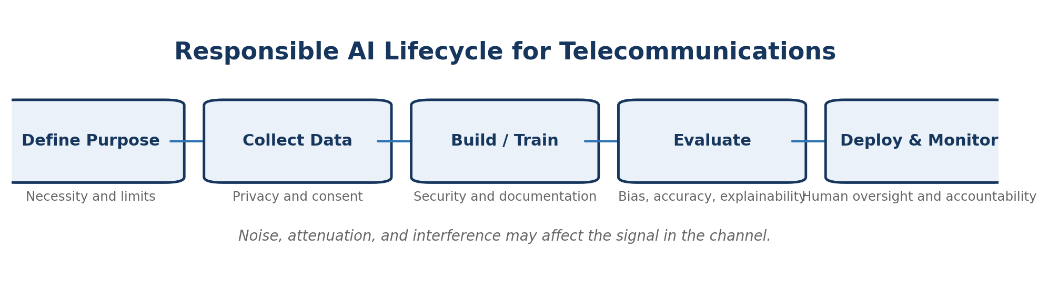
Figure 14. Responsible-AI lifecycle for a telecommunications use case.

Activities and Results
I reviewed the expanded presentation and completed Assignment 04. The central issue was that a technically effective model can still create harm if its purpose is unclear, its data is biased, its decisions cannot be explained, or no person is responsible for its impact. Telecommunications data can reveal location, behavior, relationships, and service usage, which makes privacy and access control especially important.
Responsible AI begins before model training. The project should define why the AI is necessary, which data is appropriate, how long the data will be retained, how performance will be tested across groups and conditions, and what happens when the model is uncertain or wrong. Monitoring after deployment is also necessary because network conditions and user behavior can change over time.

What I Learned
I learned that ethics is not a separate final checklist. It should influence the complete design process. A responsible system needs a valid purpose, limited and protected data, documented testing, meaningful human oversight, and a clear person or organization accountable for the outcome. This is especially important when AI can control access to communication services or automatically respond to users.

Evidence Placeholder
I can replace this paragraph with a screenshot or short excerpt from Assignment 04 before submission if the instructor expects direct evidence from the completed assignment.

Course Materials Used
- Module_13_Ethical_AI_and_Future_Trends_Expanded.pptx
- Assignment 04 submission

MODULE 14
Course Review and Final Project

Module Overview
Module 14 brought the course topics together through the final portfolio. Instead of treating telecommunications, AI, 5G, Open RAN, edge computing, cybersecurity, sustainability, and ethics as separate subjects, the final project required me to explain how they connect across a complete next-generation network.

Capstone Portfolio Process
I first organized the course by the Canvas module structure. I then matched each written assignment and laboratory to the module where it appeared. For the laboratories, I identified the objective, dataset or formula, methods, outputs, and practical meaning. I recreated selected diagrams and graphs to make the portfolio easier to understand and included result tables where the provided code could be evaluated directly.
The portfolio also required source awareness. I identified the lecture decks, assigned papers, laboratory instructions, and course-provided code that contributed to each section. Original summary diagrams were created for this portfolio so the main ideas could be presented clearly without copying an external figure.

Integrated Course Model
Layer or Concern | Course Connection
Physical communication | Signals, channels, noise, bandwidth, and path loss
Network architecture | Topologies, RAN, EPC, 5GC, and service-based functions
Intelligent control | Machine learning, prediction, RIC applications, and optimization
Distributed computing | MEC, IoT, edge inference, and cloud coordination
Protection and responsibility | Cybersecurity, privacy, ethics, and human oversight
Future design | Sustainable AI, digital twins, AI-native architecture, and 6G vision

What I Learned
The final project helped me see the course as one system. Physical signal limits affect the data that reaches the network. The architecture determines where the data can be processed. AI can predict demand and optimize resources, but the model must fit the hardware and be protected from misuse. Sustainability and ethics determine whether the final design is responsible as well as technically effective.
The portfolio also improved my ability to explain technical work. A useful report should not only show code or a graph. It should explain the purpose of the activity, what the result means, what limitations exist, and how the concept could be used in a real telecommunications environment.

Overall Course Reflection
The most valuable part of ITAI 4370 was seeing how artificial intelligence can be applied to a real engineering system. Before this course, I mainly thought about AI as a model that analyzes data. I now understand that the network must collect the correct data, deliver it with acceptable delay, provide computing resources, act on the result, and continue to operate safely when the model is wrong or unavailable.
The Python laboratories were the most challenging and useful activities. Free-space path loss showed the physical limits of wireless communication. The Random Forest laboratory showed how past traffic can help predict future demand. The time-series laboratory showed that seasonality, stationarity, model selection, and data leakage can strongly affect results. The edge-computing laboratory showed that the best model for a cloud server may not be the best model for a sensor, gateway, robot, or other resource-constrained device.
I also gained a stronger understanding of 5G and Open RAN. The 5G Core uses a service-based design that supports discovery and flexible services. Network slicing and MEC allow the network to support applications with different requirements. Open RAN separates components and introduces intelligent controllers, creating more opportunities for software-based optimization and vendor interoperability.
The course also emphasized that technical improvement is not the only goal. Security, privacy, fairness, energy consumption, and accountability must be considered throughout the design. An automated network may be faster, but it still needs clear limits and human responsibility. This perspective will be useful in my Robotics and AI studies and in a future role involving data analysis, intelligent systems, or networked devices.
Overall, the course gave me a foundation for understanding how future communication systems may combine radio engineering, cloud and edge computing, machine learning, automated control, and responsible design. I am leaving the course with a clearer understanding of both the possibilities and the limitations of AI-driven telecommunications.

References
The following references are course-provided materials. Complete author, publisher, and year information was not visible in the Canvas module list, so the entries identify the files as assigned course materials. The instructor name can be added to the lecture citations if required.
Course instructor. (2026). Module 1: Telecom fundamentals with frequent diagrams [PowerPoint slides]. ITAI 4370, Houston City College.
Course instructor. (2026). Practical example [PDF]. ITAI 4370, Houston City College.
Course instructor. (2026). Module 2: Network and wireless basics [PowerPoint slides]. ITAI 4370, Houston City College.
Course instructor. (2026). Exercises [PDF]. ITAI 4370, Houston City College.
Course instructor. (2026). Module 3: AI and machine learning for telecommunications [PowerPoint slides]. ITAI 4370, Houston City College.
Course instructor. (2026). Exercise 3.1 to 3.3 [PDF]. ITAI 4370, Houston City College.
Course instructor. (2026). Module 4: 5G and AI integration [PowerPoint slides]. ITAI 4370, Houston City College.
AI-driven load balancing in paravirtualized 5G networks. (n.d.). [Course-assigned PDF].
Integrating artificial intelligence, Internet of Things and 5G for next-generation smart grid: A survey of trends, challenges and prospects. (n.d.). [Course-assigned PDF].
Course instructor. (2026). Module 5: Open RAN and AI [PowerPoint slides]. ITAI 4370, Houston City College.
Advancements in mobile edge computing. (n.d.). [Course-assigned PDF].
From DeepSense to Open RAN. (n.d.). [Course-assigned PDF].
Course instructor. (2026). Module 6: AI network optimization notes [PowerPoint slides]. ITAI 4370, Houston City College.
Exploring the potential of AI-driven optimization in enhancing network performance. (n.d.). [Course-assigned PDF].
Course instructor. (2026). Module 7: IoT, edge computing and AI [PowerPoint slides]. ITAI 4370, Houston City College.
BrainyEdge. (n.d.). [Course-assigned PDF].
Course instructor. (2026). Module 8: Cybersecurity and AI in telecommunications [PowerPoint slides]. ITAI 4370, Houston City College.
Course instructor. (2026). Module 9: Sustainable AI and green communications [PowerPoint slides]. ITAI 4370, Houston City College.
Sustainability article 13-08952-v3. (n.d.). [Course-assigned PDF].
Course instructor. (2026). Module 10: Advanced AI applications in networks [PowerPoint slides]. ITAI 4370, Houston City College.
AI-native multi-access future networks: The REASON architecture. (n.d.). [Course-assigned PDF].
A comprehensive survey on revolutionizing connectivity through artificial intelligence-enabled digital twin network in 6G. (n.d.). [Course-assigned PDF].
Course instructor. (2026). Module 11: 6G AI-native networks [PowerPoint slides]. ITAI 4370, Houston City College.
Course instructor. (2026). Module 13: Ethical AI and future trends - expanded [PowerPoint slides]. ITAI 4370, Houston City College.
Course instructor. (2026). Laboratories 01-05 and assignments 01-04 [Assignment instructions and course-provided code]. ITAI 4370, Houston City College.

Appendix: Evidence Checklist Before Submission
The portfolio is complete as a narrative draft and includes recreated figures and calculated results. The following optional additions would make it match my original Canvas work even more closely:
Module | Optional Original Evidence to Insert
1 | Screenshot of the Draw.io/Lucidchart diagram and one signal-flow graph from Laboratory 01.
2 | Screenshot of the Laboratory 02 code/output and the submitted Assignment 02 response page.
3 | Original Laboratory 03 output screenshots and Assignment 03 response page.
4-5 | One screenshot from the Hands-On Exercise or a key diagram from my notes.
6 | Original Laboratory 04 output, especially the final model-comparison section if available.
7 | Original Laboratory 05 results table or edge_model_comparison.png.
10 | One page or screenshot from the Midterm Project.
13 | One screenshot or excerpt from Assignment 04.

Final Submission Check
- Replace the instructor blank on the cover page.
- Review the recreated results against the screenshots from the original submissions.
- Add any original evidence listed above that the instructor expects.
- Export the final document to PDF.
- Submit using the exact filename: FE Elizabeth Carrillo ITAI 4370.pdf.

