**CYBER SECURITY-ASSIGNMENT**

DAY 4 - 23/08/2020

Name-Liza Deka

**1. Find out the mail servers of the following domain.**

a) Ibm.com

b) Wipro.com

Solution =

* + - Open cmd on Windows Server 2016 VM
    - Type the command “nslookup”
    - Type “set type=mx” command to find mail servers.
    - Type Ibm.com and Wipro.com to enlist their respective mail servers.
    - Entries with MX preference would provide details.

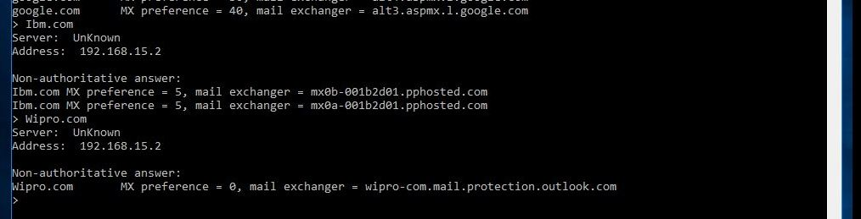

**2. Find the locations, where these email servers are located.**

Solution= To find out the locations of the mail servers, as discussed in the class we can use Email Tracker Pro application. But here we don’t have any mail header.

So, we can find the locations using a website called “my-addr.com”. And then typing [mail@ibm.com](mailto:mail@ibm.com) and [mail@wipro.com](mailto:mail@wipro.com) to find the location.

For IBM-

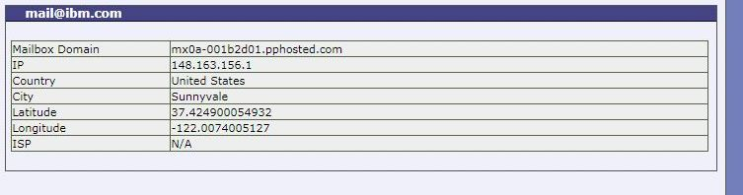

For Wipro-

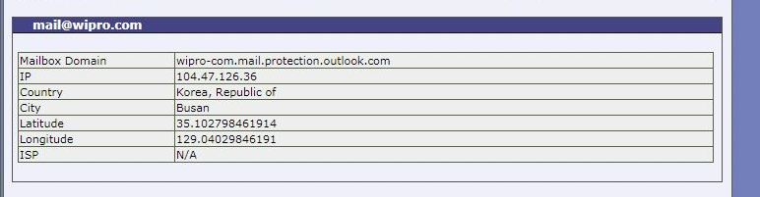

**3. Scan and find out port numbers open 203.163.246.23**

Solution=

* Open Kali Linux VM and then terminal.
* Type the command “sudo nmap -sT -p- 203.163.246.23” to scan all the ports for the given IP.

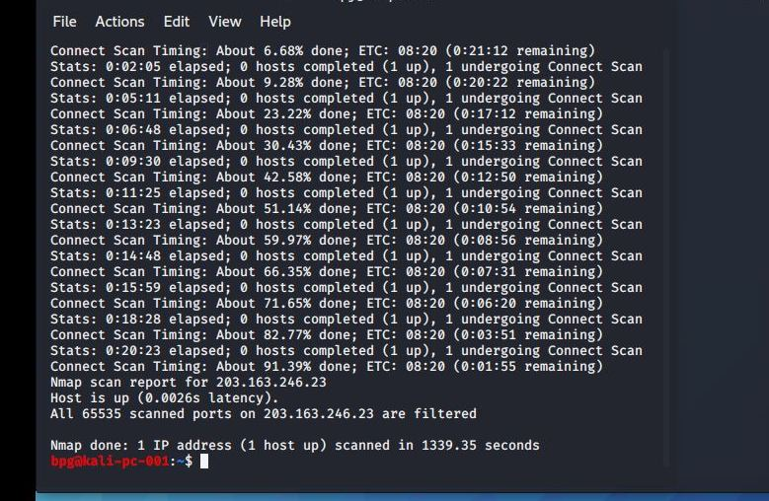

All 65535 ports are filtered.

**4. Install nessus in a VM and scan your laptop/desktop for CVE.**

Solution= I tried installing Nessus on Windows Pentester 2016 VM more than once but it still showed failed to download. So, I installed it on Kali Linux. But after taking more than three hours to load it still went back to its starting position and again it started to load which again took more time. I tried again a couple of times. So I was not able to complete the scanning part.

